A silver bullet for bullwhip effect; minimizing lead-time

Soochan Choi

Supply chain Management, Master’s degree of management department, Middle Tennessee State University, Murfreesboro, Tennessee.

Advisor Zhen Li, Assistant Professor

Supply chain Management, Middle Tennessee State University, Murfreesboro, Tennessee.

1. Abstract

The Bullwhip effect is information twisting that creates movement of wasteful products over what the market requires within a supply chain. There are four causes; demand signal processing, the rational game, batch ordering, and price variation (Lee at el, 2004). Current researchers are providing superior solutions, especially in coordination and information sharing methodology (Lee at el(1997), Moyaux at el(2007), Wu at ell(2006), Sahin at ell(2002), Disney at el(2008), Fiala at el(2005), Xu at el(2001) Paik at el(2007). However, the two prevailing solutions are required to “trust” to each other. Cooperation is hard to be accomplished until the companies fully open their information. In addition, the degree of trust is not easy to measure. Other problems arise when the trust is not fully accomplished. How could we measure cooperation? There are ways for measuring cooperation but it is not a general methods. In addition, it depends on analyzers point of view of cooperation. In this sense, I am going to provide another solution: decreasing lead time that it can be measured easily while proving that decreasing lead time is time saver and more cost effective than other suggested solutions.

Keywords: Bullwhip effect, Toyota Production System, Lead Time, Geographic Information System

1. Introduction

An impact of one percent of decreased internal cost is creating better profit than an impact of one percent of increased sales(citation). In this sense, we could say internal cost is critical for a company to make a net revenue. One of the biggest wastes of internal cost is caused because of the bullwhip effect. A key word of bullwhip effect is “Information distortion” that the distorted information among the supply chain creates unmeasurable waste of inventories than what it needed. Thus, it is one of the leading factors of wasting inventories on internal cost elements. Many researchers provide lots of great solutions to minimize the bullwhip effect. However, it is hard to apply every solution simultaneously to minimize the bullwhip effect because of limited resources and time shortage in a fast paced society. Furthermore, it is not efficient to apply all suggested movements to minimize the bullwhip effect. Because it creates more internal costs than actual benefit results from decreased impacts of the bullwhip effect when multi suggestions are applied simultaneously. In this sense, I am going to explain what the causes of bullwhip effects are, and find an effective solution or so called a silver bullet among Toyota Production System operation principles. We can see decreased lead time will minimizes four bullwhip effect causes at the same time. In this sense, I am going to explain how decreased lead time could counterattack the four bullwhip effect causes. In addition, this paper will provide practical method to make shorter lead time. Currently, one of the biggest retail companies Proctor and Gamble is putting lots of effort for locating distribution centers to make costs effective while it can get shorter lead time. I am going to explain Geographic Information System application for locating distribution centers with Proctor and Gamble as an example.

1. Literature review

Other than the original bullwhip effect author, Lee at el(2004), there are several solutions and analytic approaches for the bullwhip effect. Moyaux at el(2007), Fiala (2008) are saying that information sharing is good methodology for eliminating bullwhip effect. We al el(2006) arguing that insufficient cooperation can cause bullwhip effect. Sahin at el(2007) mentions that better integration among supply chain would be more beneficial, in addition, it can reduce bullwhip effect. Xu at el(2001) insists that coordination can reduce the error of information. Paik at el(2007) writes that information sharing and coordination can mitigate bullwhip effect, further, it is proving by simulation and statistical method. Kuk at el(2005) did research in a real field with Philips, and proves that collaboration among supply chain reduces bullwhip effect; it saves $300 million yearly. Other than coordination, information sharing, Desny at el(2003) describes how a vendor managed inventory system is decreasing the effect of bullwhip and it can minimizes bullwhip effect. Boute et al(2008) said that smooth ordering system can mitigate bullwhip effect. Su at el(2008) said that balanced replenishment inventory operation will mitigates bullwhip effect.

1. What is the Bullwhip effect?

The Bullwhip effect is a negative impact when companies deliver demand data to upper supply chain. The word the bullwhip effect is a term that first used by Jay Forrester (1958) who found “demand amplification”. He claims that demand information is amplified when it goes upper stream in the supply chain. Proctor and Gamble is the very first company where found in industrial case. The case of proctor and gamble shows that the amplified information caused the bullwhip effect in supply chain even when the demand is quite sustained. Lee at el(2004) are the first researchers who analyzed the bullwhip effect and articulated. According to Lee at el(1997), there are four causes of bullwhip effects. Demand signal, the rational game, batch ordering, and price variation.

4.1Demand signaling

The number of demand from end users is the primary data for forecasting that companies can make a production schedule for their future demand. <Figure 1> explains flow of demand information. Suppose that there are wholesaler, retailer and customer. The retailer is going to order products to wholesaler with the retailer’s forecasted demand from period t-1. When the wholesaler got the number of orders, the wholesaler will going to re-forecast over pre-forecasted data and deliver the revised data to upper supply chain members, such as manufacturers. In a big picture of the supply chain, we can see the number of orders will be keep over-forecasted by pass overing to upper steam (Lee at el, 1997). This is one of the bullwhip effect causes, demand signaling.

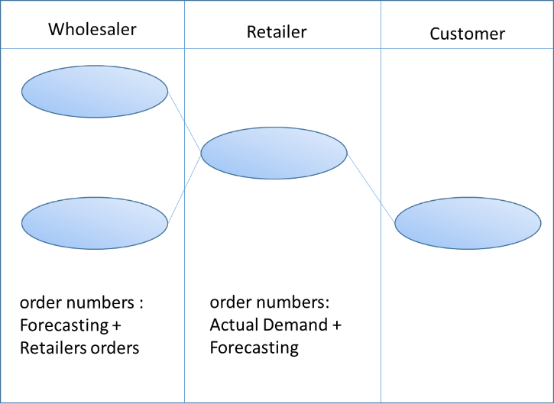

<Figure 1>

4.2 The rational game

Another factor that it creates the bullwhip effects is arising from the rational game, sometimes, known as beer game (Sterman, 1989). In this situation, we are assuming that resources are limited and a one wholesaler with multi retailers for simple understanding. Due to the fact of limited resources, each retailer would make an order more than what they need for future demand. Then, the wholesaler will assigned his limited resources along with the ratio of ordering number. For example, limited items are divided to N retailers by strategic allocating, simply as followings;

To get more proportions of wholesaler’s limited resources, each retailers will going to order more than they required. In this situation, we could see how demand ordering is amplified. The pure demand orders are amplified in the supply chain.

4.3 Ordering batch

According to Lee at el(2004), ordering batch system causes demand variation, and thus, it is one of the causes of the bullwhip effect. Unlike a pull system, ordering batch is filling inventory at certain point of repeated periods. Between ordering periods, we can see there is demand variation that it makes hard to be forecasted. For example, there is increased demand on period T, but decreased demand on period T+1. If the retailers schedule ordering quantity based on demand on period T, then there will be increased inventory level on period T+1 because the quantity of inventories is forecasted by term T. This situation makes information variation along with supply chain and it causes wasteful inventories.

4.4 Price variation.

Lee at el(1997) said that price variation is one of the causes of bullwhip effects. It has same principle as rationing game theory that has ordering quantity differential. Because the retailers are more willing to have inventories when there are limited resources, in the rationing game principle. Most of companies not only have level of minimum inventory as a safety stock, but also have maximum level of inventory. The Retailers are more willing to have minimum inventory level when the costs of materials is increasing. On the other hand, the retailers are willing to have maximum inventory level when the costs of materials is decreasing than that of other periods. The situation of buying more than the retailers’ needs is creating a demand information distorting. In this sense, a price variation causes the bullwhip effect (Lee at el, 1997)

1. Toyota Production System

Just In Time principle is motived from Toyota production system. A lot of Toyota production systems behaviors and activities are formulized as a Just In Time system. The most important concept is to get rid of wasteful activities. To be specific, eliminating non-value activities is the basic idea of how apply JIT system into industry. There are several activities that called “JIT principle” so I am going to see what specific behaviors, activities are at this point. The activities and terms are based on the article “Defining and developing measures of lean production”(Shah, Ward 2007). According to Shah at el(2007), the Toyota production system, the JIT and the lean manufacturing production had been formulized for a long time and the terms per se are used in different places for a long periods, so there are lots of confusing points that terms are misunderstood when it comes to international perspective (Shah, Ward 2007). In this sense, the author Shah and Ward organized the Toyota production system terms as a standpoint definition. They argues that there are 24 specified activities related with the Toyota Production System, the Lean Manufacturing Principles, and the JIP principles. I am going to explore a few of them in this paper.

5.1 Inventory reduction

The Inventory reduction implies that it is not only reduces the number of inventory but also increasing productivity (Lieberman, Demeester 1999). There are several types of inventory, but we are going to explore Work In Process inventory, and Finished Goods Inventory. By decreasing the number of WIP inventory, manufacturing system can find where the buffer is. Thus, the production manufacturing manager could assume where to improve in manufacturing system. Later part, we will discuss how Pull/Kanban process also got impacts from decreased inventory system.

5.2 Pull/Kanban system

The simple principle of Pull/Kanban system is that it has information card to deliver production level. In other words, the Kanban system controls Work in Process level. To be specific, by moving the information card from an empty cart to the item filled cart, the manufacturing system is able to recognize what item has been used. Meanwhile, the item filled cart moves toward departure section, so the item can be sold or assembled right after the previous item had been used. By doing so, manufacturers are able to understand the quantity of the demand, further, the producing level. The pull system has similarity with Kanban operations. To be specific, consumer’s purchasing is a producing signal for supplying time to file. For example, Toyota production system is representative manufacturer where it facilitates pull system. When a customer order came into manufacturing facilities, The Toyota starts their assemblies to meet customers demand. The purpose of Pull/Kanban system is one of the great strategies for minimizing inventory.

5.3 Cooperation

For human resource researchers’ perspective, it is important to create value of cooperation when team is organized with variety background people. However, we need to approach in different idea to apply cooperation in supply chain managing. In a supply chain, it is important to know what types of information are and how to update demand data between supply chains. A demand signal is keep flowing among supply chain line, and thus, the demanding information has to be shared in timely manner. In addition, the demand information has to be precisely delivered in right time. Further, TPS suggested that having a long term relationship can get better cooperation.

5.4 Fewer Suppliers

Contracting with fewer suppliers means companies are taking deeper relationship with suppliers. In addition, suppliers and demanders have higher possibility to have long term relationship. Toyota production system principle emphasizes on coordination between demander and supplier. By having consolidating relationship, both demander and supplier trust each other. In addition, both suppliers and demanders can get synergy effects on problem solving skills.

5.5 Heijunka

Heijunka refers to leveling production operations. A main purpose of Heijunka lies on reducing peak, valley production scheduling (Huttmeir et al, 2009). To be specific, manufacturing company make scheduling along with variety demand on fixed term. Heijunka principle helps manufacturers to have lower production variability. For example, lets say there are 600 demands from Monday to Wednesday, 300, 200, and 100 demands, respectively. Instead of producing 300 on Monday to meet Mondays’ demand, the production will be scheduled as 200 productions per day which is an average demand from Monday to Wednesday. In addition, the variety within the item will be organized along with weighted balance. For example, there are 300, 200, 100 demands, red, blue, and yellow respectively. It means, that leveling will be Red Red Blue yellow Red Blue, so production companies can meet customers demand as weighed rate. By doing so, manufacturing companies could produce products without wasteful inventory production while decreasing variability in production.

1. How to minimize bullwhip effect?

Bullwhip author, Lee at el(1997), provide solutions to minimize bullwhip effect in his article. Over forecasted demand signal flowing is solved by implanting cooperation. The author emphasize that information technology such as Vender-Managed-Inventory and Continuous Replenish Programs are recommended program to mitigate bullwhip effect (Lee at el, 2004). Especially, consolidated forecasting system would be appropriate as a tool of cooperation. The author continues that contracting, information sharing is a solution for problem of the rational game strategy.

|  |  |
| --- | --- |
| Bullwhip effect causes | Suggested solutions by Lee at el(2004) |
| Demand signal process | Cooperation; VMI, CRP system |
| The rational game | Strict policy, Information sharing |
| Ordering batch | Lowering order price; Electronic transaction  Activity-results contract |
| Price variation | ABC |

<Figure 2-1>

|  |  |
| --- | --- |
| Bullwhip effect causes | Lean Application |
| Demand signal process | Pull/Kanban System |
| The rational game | Inventory reduction, Pull/Kanban System |
| Ordering batch | Inventory reduction, Pull/Kanban System, Heijunka |
| Price variation | Inventory reduction, Pull/Kanban System, Heijunka |

<Figure 2-2>

<Figure 2-2> Shows lean application as a solution to Bullwhip effect.

6.1 Limitations of solutions that suggested by Lee at el(1997).

There are limitations that companies cannot afford to operate every solutions on their problems. A result of solving problem can be effective to company, but we are confronting resources limitation in reality. In this sense, we are going to see what solution can counterattack for four causes in same time. As a result, we found that shorter lead time can affects all four bullwhip effect causes. Thus, we are going to explore how the lead time affects bullwhip effect. A definition of lead time is variety along with industry, and researchers. To avoid confuse, Lead time is defined as time between provider and customer in this article.

6.2 Bullwhip effect problem solving suggested by lean Principle limitation

It seemed Toyota production system operations working well for bullwhip effect, but there are still problems existing. As same consideration suggested on author suggestions, it is impossible to apply all lean suggestions on bullwhip effect. In addition, inventory reduction, Kanban system application, Heijunka, having fewer suppliers are working as double edge sword. There are big risks that CEO or decision maker has to consider trading off to apply on their companies. For example, there is a risk that companies cannot meet customer demand when storage is reduced. Pull/Kanban system is hard to apply without “fully understanding”. Heijunka principle minimizes company’s flexibility, and sometimes, there are over workload problems, reordering problems (Huttmeir, 2009).

1. Lead time counterattack

The main causes of the bullwhip effect are more important than the other causes. Because the four basic causes are the main problems to bullwhip effect. For example, Bhattacharya(2011) mentions in his article that there are 20 causes other than the four original causes such as leadership skill, processing downtime. These are the general manufacturers’ problems that can be deal with other methods. In addition, the four causes are having biggest impact when the bullwhip effect is arising. In this sense, we are focusing on what Lee at el(1997) found of bullwhip effect causes. According to Lee at el(2004), the lead time delaying is direct factor of bullwhip effect. In this sense, we are going to see how shorter lead time can mitigate bullwhip effect.

7.1 Lead Time – Demand Signal Process

Before getting into details, we need to set up the three assumptions. 1) Downward supply chain party reviews inventory in shorter period than original assumption. For example, if the Author Lee at el(1997) said lead time is ‘1’, then our lead time is less than ‘1’: 0.5, 0.1 in this paper. 2) Cheaper delivery cost that is less burden to deliver 3) cheaper ordering cost that is not burden to order. With these three assumptions, we are able to see getting shorter lead time minimizes information distortion among supply chain. Lee at el (2004) mentions that forecasting is over calculated while demand information is going to upper supply chain. We are going to assume Kahn’s demand model (1987) like Lee at el(2004) did. Kahn’s demand model is showing as =d + q+ where D implies actual demand, d is forecasted demand, q is constant satisfying forecasting rate while absolute value of q is less than 1. U implies variables that are smaller impacts than q on forecasting. Simply, As we see, to be calculated demand D in t period, , the calculation requires variable demand and previous term of actual demand. Additionally, the term t-1 is significant factor because is changing significantly along with . Further, it implies that the longer term between t and t-1 means the demand information gap between and is getting bigger. To be specific, the gap of the accumulated demand on t-1 and the accumulated demand on t period are getting bigger exponentially. In this sense, it is important to decrease the gap between and . We are going to see with an extreme example for understanding. Suppose that the period between T and T-1 is closed to ‘0’. Thus, we can say and are almost identical, there is no difference is exists. As an assumption at the beginning, we are going to say this is the shorter lead time situation, in this case, lead time assumed as ‘almost zero’. Furthermore, we need to understand what and implies. Period T-1 demand, , is calculated by on term of demand of T-2. It implies that when you order items on T-2, you will get the item on T-1. We can say that the each term periods is symbolizing the lead time. In this sense, the difference will be mitigated when we make shorter lead time. Simply, I put a graph to see what the differences are.

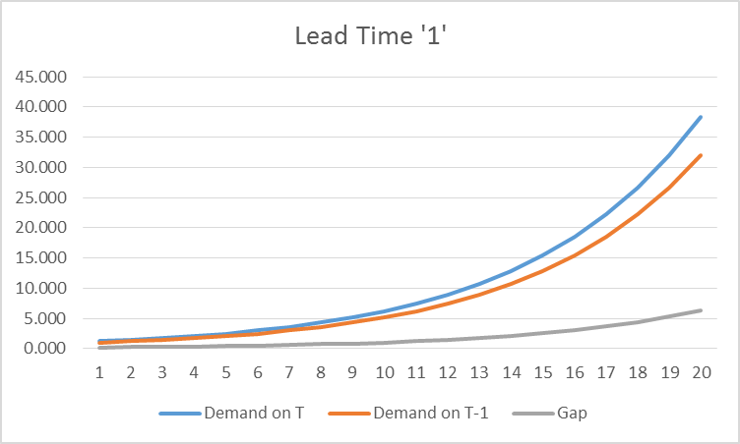

<Figure 2>

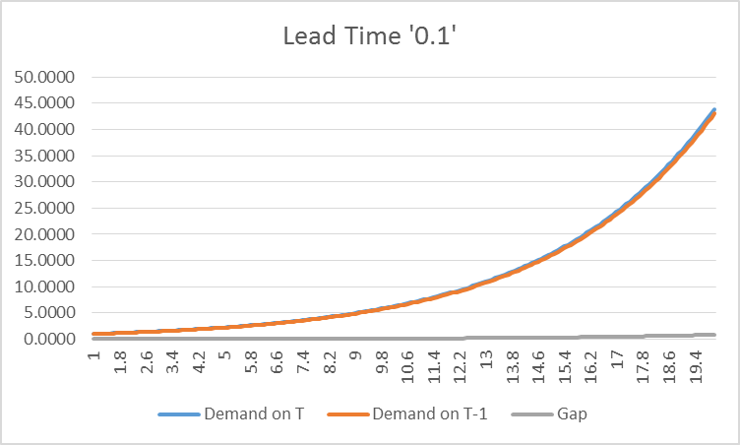

<Figure 3>

Both the graphs above are measurements of the difference between actual demand and forecasting period from 1 to 20. The Differences between <Figure 2> and <Figure 3> are; 1) Lead Time difference: <Figure 2> Lead Time is 1, and <Figure 3> Lead Time is 0.1. 2) Forecasting demand T is calculated by different numbers, 20 percent for <figure 2>, 2 percent for <figure 3>. Since the lead time on <figure 3> is one tenth of <figure 2>, forecasting variable, q, is calculated along with lead time ratio. In addition, the is defined to be ‘1’ for simplification. As we can see, <figure 2> shows that the gap is getting bigger by increasing periods. On the other hand, the gap on <Figure 3> is keep extremely lower than <figure 2>. The gap in here is symbolizing information distortion. We can conclude that there are less information distortion when lead time is decreased. When in a case as “zero” lead time, the gap would be closing to ‘0’, and thus, there cannot be no information distortion. In this way, we can mitigate one of the bullwhip effect causes, demand signal process. The graphs numeric information chart is attached at the end of paper <Figure 2-1, 3-1, 3-2>.

7.2 Lead Time – The rational game

Here are assumptions that are same as when we explains in demand signal process; 1) Cheaper ordering, delivering cost 2) shorter inventory review period 3) shorter lead time. 4) First in First out system. The shorter lead time means that there are the shorter replenishing time. Retailers can revise their rational ordering after when it gets replenished items. For example, backlogging items can be revised with flexibility.



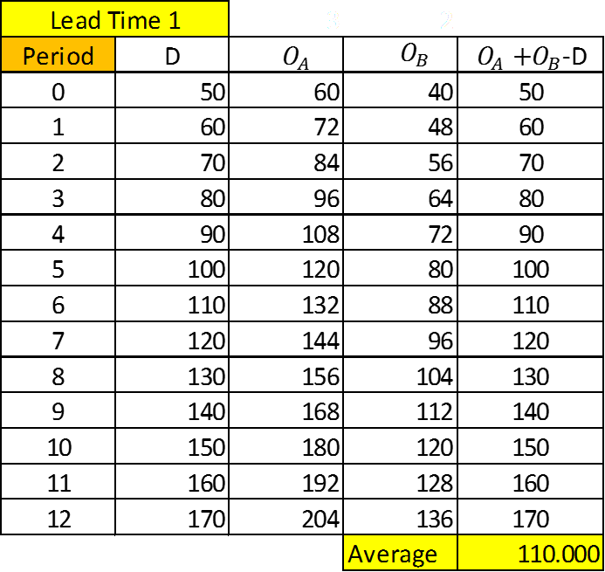

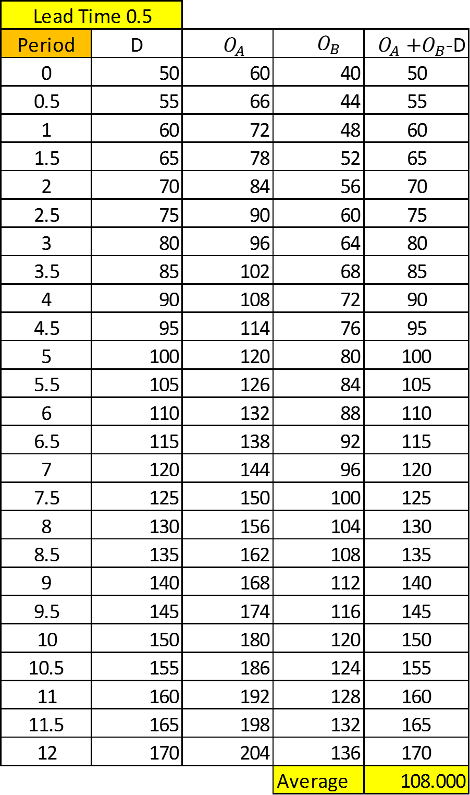

<Figure 4>

Table above is showing simple effect when Lead Time is decreased. In this situation, we assume that 1) Actual demand is increasing by 10 for each period from the first period demand 50, notice that Lee at el(1997) said that bullwhip effect caused by the rational game when the demand is increasing. And thus, when the period increased by 0.5, then it means actual demand is increasing by 5, because the lead time term is increased a half of previous case. , are the number of orders by retailer A and B, respectively. The last column for each table is difference between actual demand and the number of orders. The bottom row is average of the difference. As you can see, there is an average difference which is shorter lead time table’s average is smaller than the average on longer lead time. It is because shorter lead time is decreasing the number of backlog. Because, the orders on each period is showed, and it did not meet customer demand. Thus, the numbers showed as average on figure 4 means that the average number of backlog is smaller when it systems as shorter lead time.

7.3 Lead Time – Ordering batch

Like it mentioned above, ordering batch system caused by demand variation. Furthermore, it wriggle inventory level because of unexpected demand variation. The author Lee et all(1997) found that increased cycle ordering time creates bigger variation. However, this information distortion can be solved by decreasing lead time. Buyers are able to replenish their inventory level easier due to the shorter lead time. There are lots of possibility the reason why ordering batch causes information distortion, but, in this article, we are going to talk about an extreme case for easy understanding. The example case is that the number of demand is keep fluctuating on between each ordering cycle. It implies that the demand variation cannot be forecasted easily. To be specific, demand is waving while the order is on delivering and the gap of information twisting. For example, let us assume a cargo is delivering from Asia to America, and it takes a month. From the receiver’s perspective, the number of demand is variable while it is on delivering, for example, additional invoice from the customers. To prevent this situation from out-of-stock, retailer will order more than usual the number of orders, because increased safety stock will decrease a buffer to a customer.



<Figure 5>

Table above is an example that is created with random number function from excel. To understand the table we need to set up assumptions: 1) Less cost for ordering and delivering cost 2) Inventory is filled with same number of demands from previous term. Figure 5 shows simple example, where T.I.D is total information distortion, T.D is total demand on period, U.D is unmatched demand during the term. The demands are ranged between 0 and 20 per day randomly. The total inventory level is leveraged with maximum demand per date. In this sense, I put random 400 inventory for the left side table because maximum 20 demand per day implies that it has to be 400 maximum inventory during the period, and the second top yellow shaded inventory is calculated 400 divide by 4, because of the quarterly shorter lead time of the left side table. Right side table inventory on each term from second ordering period to last period is calculated from the total number of demand from previous demand. This is a simple example, but we can see total information distortion at the end of 20th period is a lot smaller when it is shorter lead time. By keep running the table above, we can see longer lead time table has lower T.D.I with extremely lower probability.

7.4 lead Time – Price Variation

The bullwhip effect is arising since supply chain members wanted to have inventory when the item is cheaper than usual price (Lee at el, 2004). At a first glance, it is hard to think if minimizing lead time can counterattack one of the bullwhip effect causes, price variation. Because, price variation is caused as material price variation, it is not because of flow of materials in supply chain. To make relationship between lead time and price variation, we need to assume that companies keep decreasing their level of inventory by passing time. It is inevitable that inventory level is decreasing when a supply chain from manufacturers to customers is getting short lead time. Each supply chain member does not need to have inventory when products are going through customer in short time. Because, it is likely to have pull/Kanban system when the supply chain members have shorter lead time. For example, retailer can order item from wholesalers when customers demand is recognized. In this sense, one of the bullwhip effect causes, price variation, can be decreased when lead time is shorter. Other than the effect of decreasing inventory level, minimizing lead time can decrease price variation causes in the other way like the way of decreasing ordering batch causes. To be specific, periodic backlog managing is the way for minimizing price variation causes. By keep updating both of inventory level and backlog, the information distortion impact is decreasing. Figure <6>,<7>,<7-1> shows simple example. Maximum inventory is 70 per period and minimum 20 per period. This number is random choose by function on excel. When the material price is considered as cheap (or expensive), then inventory is accumulated as maximum inventory (or minimum inventory). When the lead time is changed to 3 as figure 7-1, then maximum(minimum) inventory level is tripled.



<Figure 6>

Figure 6 is a simple example where D is demand range from 0 to 50, P is material price which is range from 1 to 10, C/E is decision tap that it shows cheap when it is less than 5, and expensive when it is more and equal to 5.



<Figure 7>



<Figure 7-1>

Figure <7>,<7-1> is the table for showing how the inventory is filing depends on price changing: B.I is beginning inventory, E,I is end inventory, O is the number of orders, I is total inventory, I/D is information distortion, ABS is absolute value of I/D on same row. As you can see, the average inventory distortion is a lot bigger when the lead time is tripled. Again, there is a possibility that ABS is shorter even if it shows longer lead time. However, it is extremely rare case.

1. Applying Geographical Information System into Distribution Center

GIS system is useful to see multi information in an one screen. Simply, it is creating linear line and shows up to one screen. In this article, we are using for lead time managing.

8.1 Importance of Distribution Center

Distribution center(DC) is multi-functional facility that it has lots of role. It is basically inventory function so companies can supply materials or items to destination without buffer. Other role is cost efficiency role and customer satisfaction role. According to Xu et al (2011), main considerations to locating DC are meeting customer demand, and cost efficiency. Daskin et al(2002) is analyzing how to locate DC by analyzing cost efficiency. Even if DC located based on customer satisfaction fulfillment and cost efficiency, it needs to be considered with lead time. Shorter lead time means that companies can supply products on time. In addition, having shorter lead time can save their internal cost so locating DC on right spot is correlated with cost efficiency.

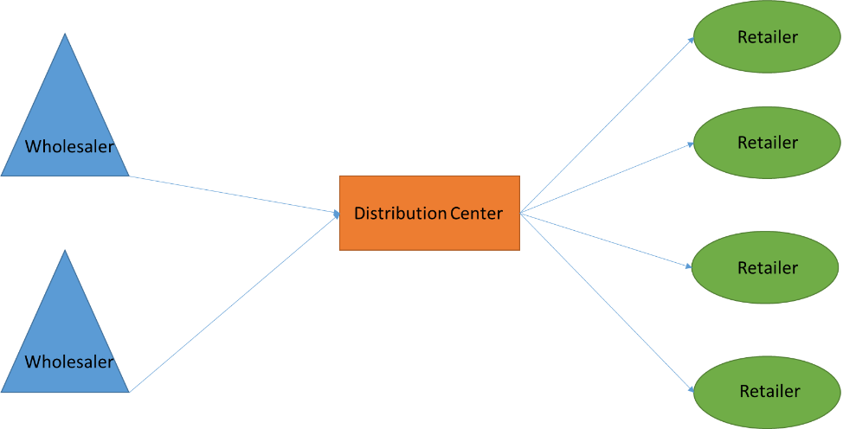

<Figure 8>

I am showing a simple relations between Wholesaler, Distribution center, and Retailer. It is easy to get a distance by using simple algebra “Pythagorean theorem”(), so we could get distance. . In here, we are going to assume that there are several limitations; 1) Wholesaler has to provide items only through DC. 2) Retailer cannot share their products with other retailers. 3) There are unlimited products flow.

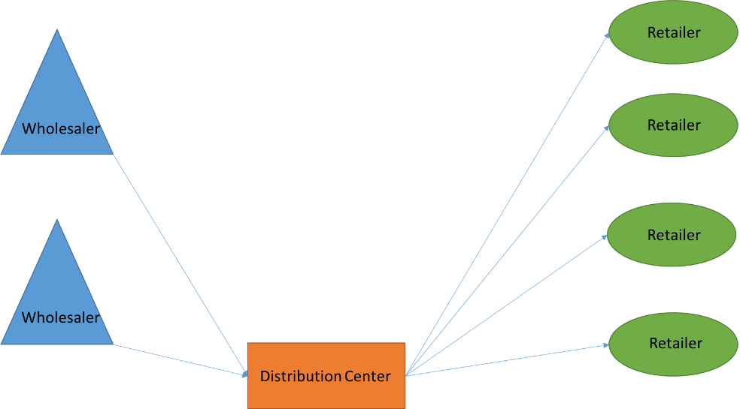

<Figure 8-1>

A sum of distances from figure 1 is much less than a sum of distances from figure 2. In this sense, locating distribution is really important in terms of lead time. Misunderstanding of locating distribution center causes not only increasing lead time but also increasing delivery cost.

8.1 Geographic Information Case studies

Geographic Information system (GIS) is an integrated computing system for analyzing data from what we can get on the Earth. It can be surface height, width, deepness of geologic ground. In addition, it is possible to see territorial population by GIS. According to Chen at el(2005), population can be analyzed by countering the number of mobile phone, and computer. Two elements, wireless internet access, and one person mobile echo, make it possible to see what population is in specific location. Proctor and Gamble is the company where utilizing GIS system into DC optimization. The company applied mathematical approach and further, applied GIS system for DC operations. As a result, the company saves 20 percent of internal cost (Camm at el, 1997). Djokic at el(1993) proves that GIS system can be used for analyzing the location of water, so the cattle can be distributed with nature data. JI at el(2009) analyzed locating DC with GIS. They are utilizing software, Arcgis10, and locating distribution center based on 3 dimensional analyzing method.

8.2 Locating DC consideration

The role of DC is not limited as a one role. Thus, locating right place is complex. According to Arntze at el(1995), it took more than a year to design distribution system. The case above, Proctor and Gamble, it took a month to analyze current supply chain data (Gamm at el, 1997). In this sense, we are considering a lead time as a primary factor in this article because we are on decreasing lead time purpose. So it will take less than previous case to optimizing a DC location. Here is considerations when DC is located by lead time decreasing goal that there are priorities that we need to consider; 1) like the case of Proctor and Gamble, current data and deep analyzing is needed. It can be current logistics movement, population and actual demand, current road infrastructures, DC locations with efficiency value such as cost, distance 2) Finding appropriate locations along with Lead Time as primary factor.

1. Discussion

When we apply shorter lead time for minimizing bullwhip effect, there are limitations for it. First, Definition of lead time should be clearly defined. Since lots of organizations are using similar definition for lead time, but the term lead time can be translated in different ways. Further, we have to be careful that the definition is keep evolving. Second, the way that is used in this paper method is for non-affordable companies for minimizing bullwhip effect. Even though minimizing lead time will decreases the effect of bullwhip, it cannot be the best solutions for big companies. With serious considering of their current environments, decision maker could create alternative options other than decreasing lead time. Further, decreasing lead time is not an easy method to operate. For example, once a location of distribution center is placed, it is hard to move DC to the other place, unless companies build another DC centers. In addition, companies have to consider other factors such as cost, instead of lead time. Third, Ouyang at el(1996) mentions that lead time is not a dependent variable, and thus, this independent variable, lead time, is hard to control to make sustainable factor. The author insists that lead time is un-controllable, so we need to explore whether it is uncontrollable factor or not. I explained how decreased lead time is decreases bullwhip effect along with four causes. However, we cannot ignore other possibilities that it can causes bullwhip effect. According to Croson at el(2003), the authors find that they found the bullwhip effect is not eliminated even though the causes are erased. Nienhaus at el(2006) said that human capital is one of the important factor to cause bullwhip effect. Likewise, we need to explore what other factors can cause bullwhip effect, and how lead time decrease bullwhip ‘other’ causes. In current researches, we can find other causes of bullwhip effect. According to (Bhattacharya, 2011), there are 16 operational causes, and three behavior causes; Other than four main causes, They are: longer lead time, inventory managing system, replenishment time managing, control system, transparency, delivering delays, education, lack of managerial skills, lack of capacity, unexpected processing down time, non-global vision, insufficient feedback, synchronization, and multi other variable causes. Paik at el(2007) found six causes on their simulation. Further, bullwhip effect is not raised by all four causes simultaneously. Sometime, the bullwhip effect is raised by more than four causes. In this situation, it may better to choose focused solutions as provided by previous researchers. In addition, it should be proven by practical information.

1. Conclusion

My question is started with variability law “more variability, lower performance”.

Bullwhip effect is caused by certain level of periodic reviewing system, and it is a reason of increasing variability. Thus, we can see the effect is decreased when it comes to frequency reviewing, which is decreasing variability. I explained with random numbers with examples how shorter lead time decreases an effect of bullwhip. As you can see, it is working as statistical principle. Lead time is making smaller variability in supply chain operations. It leads smaller level of inventory, more frequent inventory review system.

Minimizing lead time can be the first step to be profitable. Within the decisions, Decision maker has to consider other further factors such as quality, customers’ satisfaction to be a great company. However, minimizing lead time is not only solutions for bullwhip effect but also it is affecting overall performance of companies operations. In this sense, decreasing lead time can be one of the greatest suggestions that companies has to consider as a primary options.



<Figure 2-1>



<Figure 3-1>



<Figure 3-2>

1. Arntzen, B. C., Brown, G. G., Harrison, T. P., & Trafton, L. L. (1995). Global supply chain management at Digital Equipment Corporation. *Interfaces*,*25*(1), 69-93.
2. Bhattacharya, R., & Bandyopadhyay, S. (2011). A review of the causes of bullwhip effect in a supply chain. *The International Journal of Advanced Manufacturing Technology*, *54*(9-12), 1245-1261.
3. Boute, R. N., Disney, S. M., Lambrecht, M. R., & Van Houdt, B. (2008). A win–win solution for the bullwhip problem. *Production Planning and Control*,*19*(7), 702-711.
4. Camm, J. D., Chorman, T. E., Dill, F. A., Evans, J. R., Sweeney, D. J., & Wegryn, G. W. (1997). Blending OR/MS, judgment, and GIS: Restructuring P&G's supply chain. *Interfaces*, *27*(1), 128-142.
5. Chen, Z., Liu, X., Wu, Z., Liu, P., Cheng, J., & Xia, N. (2005, July). Research on magnoliaceae species geographic distribution and protect measures by using GIS of Guangdong province China. In *Geoscience and Remote Sensing Symposium, 2005. IGARSS'05. Proceedings. 2005 IEEE International* (Vol. 1, pp. 4-pp). IEEE.
6. Croson, R., & Donohue, K. (2003). Impact of POS data sharing on supply chain management: An experimental study. *Production and Operations management*, *12*(1), 1-11.
7. Daskin, M. S., Coullard, C. R., & Shen, Z. J. M. (2002). An inventory-location model: Formulation, solution algorithm and computational results.*Annals of operations research*, *110*(1-4), 83-106.
8. Disney, S. M., & Towill, D. R. (2003). The effect of vendor managed inventory (VMI) dynamics on the Bullwhip Effect in supply chains.*International journal of production economics*, *85*(2), 199-215.
9. Djokic, D., & Maidment, D. R. (1993). Application of GIS network routines for water flow and transport. *Journal of Water Resources Planning and Management*, *119*(2), 229-245.
10. Fiala, P. (2005). Information sharing in supply chains. *Omega*, *33*(5), 419-423.
11. Hüttmeir, A., de Treville, S., van Ackere, A., Monnier, L., & Prenninger, J. (2009). Trading off between heijunka and just-in-sequence. *International Journal of Production Economics*, *118*(2), 501-507.
12. JI, H. F., XU, A. G., & CHEN, X. (2009). Research on the selecting location model of logistics distribution center based on GIS [J]. *Science of Surveying and Mapping*, *4*, 031.
13. Kahn, J. A. (1987). Inventories and the volatility of production. *The American Economic Review*, 667-679.
14. de Kok, T., Janssen, F., Van Doremalen, J., Van Wachem, E., Clerkx, M., & Peeters, W. (2005). Philips electronics synchronizes its supply chain to end the bullwhip effect. *Interfaces*, *35*(1), 37-48.
15. Lieberman, M. B., & Demeester, L. (1999). Inventory reduction and productivity growth: linkages in the Japanese automotive industry. *Management science*, *45*(4), 466-485.
16. Lee, H. L., Padmanabhan, V., & Whang, S. (1997). The bullwhip effect in supply chains. *MIT Sloan Management Review*, *38*(3), 93.
17. Moyaux, T., Chaib-Draa, B., & Amours, S. D. (2007). Information sharing as a coordination mechanism for reducing the bullwhip effect in a supply chain.*Systems, Man, and Cybernetics, Part C: Applications and Reviews, IEEE Transactions on*, *37*(3), 396-409.
18. Nienhaus, J., Ziegenbein, A., & Schoensleben, P. (2006). How human behaviour amplifies the bullwhip effect. A study based on the beer distribution game online. *Production Planning & Control*, *17*(6), 547-557.
19. Ouyang, L. Y., Yeh, N. C., & Wu, K. S. (1996). Mixture inventory model with backorders and lost sales for variable lead time. *Journal of the Operational Research Society*, 829-832.
20. Paik, S. K., & Bagchi, P. K. (2007). Understanding the causes of the bullwhip effect in a supply chain. *International Journal of Retail & Distribution Management*, *35*(4), 308-324.
21. Sahin, F., & Robinson, E. P. (2002). Flow coordination and information sharing in supply chains: review, implications, and directions for future research. *Decision sciences*, *33*(4), 505-536.
22. Shah, R., & Ward, P. T. (2007). Defining and developing measures of lean production. *Journal of operations management*, *25*(4), 785-805.
23. Sterman, J. D. (1989). Modeling managerial behavior: Misperceptions of feedback in a dynamic decision making experiment. *Management science*,*35*(3), 321-339.
24. Su, C. T., & Wong, J. T. (2008). Design of a replenishment system for a stochastic dynamic production/forecast lot-sizing problem under bullwhip effect. *Expert Systems with Applications*, *34*(1), 173-180.
25. Wu, D. Y., & Katok, E. (2006). Learning, communication, and the bullwhip effect. *Journal of Operations Management*, *24*(6), 839-850.
26. Xu, J., Yao, L., & Zhao, X. (2011). A multi-objective chance-constrained network optimal model with random fuzzy coefficients and its application to logistics distribution center location problem. *Fuzzy Optimization and Decision Making*, *10*(3), 255-285.
27. Xu, K., Dong, Y., & Evers, P. T. (2001). Towards better coordination of the supply chain. *Transportation Research Part E: Logistics and Transportation Review*, *37*(1), 35-54.