A Freshman’s Tale: An Italian Travel Memoir

by
Madeleine Kurtz

A thesis presented to the Honors College of Middle Tennessee State University in partial
fulfillment of the requirements for graduation
from the University Honors College

Spring 2018

A Freshman’s Tale: An Italian Travel Memoir

by
Madeleine Kurtz

APPROVED:

Dr. Philip E. Phillips, Project Advisor
Associate Dean, University Honors College

________________________________________________
Dr. Fred Arroyo, Second Reader
Assistant Professor of Creative Writing

Dr. John R. Vile
Dean, University Honors College

This thesis is dedicated to my parents, who have been tireless in their love and support. They sacrificed much so I could fly free. To my father, John, who has always been my biggest cheerleader. To my mother, Jean, who has always pushed me to strive.

ACKNOWLEDGEMENTS
This thesis would not have existed without the incredible guidance and support of several people. First and foremost, I must thank my professor and thesis advisor, Dr. Philip Phillips. Not only did he take me to Italy on a trip that changed my life forever, but he also selflessly agreed to be my advisor, helping me to produce some of the best work I have ever made. Without his incredibly generous use of his time, energy, and expertise, I would never have been able to create this. He was tireless in his mentorship and support, and I will forever be thankful. I must also recognize the unflappable contributions made by my family and friends, whose unconditional love and kindness have sustained me through all trials and tribulations. I must thank my parents especially, who let me go to Italy and who always encouraged me to write and be the best I can be. I would be nothing without them. I must acknowledge the University Honors College, which was always so attentive and helpful to me, even when my life plans were altering daily. Without the support and guidance of Laura Clippard and Kathy Davis, I would definitely not be graduating. Lastly, I must thank God and my church community at Remnant Fellowship, where I was taught to see all the beauty in God’s Creation and use my gifts to express the wonder of the Lord’s majesty. Without God, I would be nothing. Thank you.

ABSTRACT
In the summer of 2016, I went on a two-week study abroad to Italy with the MTSU Honors College. Our trip was led by Dr. Philip Phillips and April Goers, and I was one of seventeen students. The goal of the journey was to study famous Italian writers and follow their footsteps in various cities. Our writers included Vergil, Boethius, and Dante Alighieri and our cities included Rome, Ostia Antica, Pompeii, Florence, Ravenna, Pisa, and Venice. This thesis is a creative writing account of my study abroad. It covers my thirteen days in Italy and the adventures I experienced. This work is an example of a literary memoir, a journey of a young person as she interacts with various texts and places. This work wrestles with various authors and literary works, as well as history and art, as they organically weave into the experience of being abroad. This is a creative project with an emphasis on perspective and the nature of memories as a person recounts past events. Also included are my hand-drawn illustrations depicting various events and works of art.

TABLE OF CONTENTS
LIST OF FIGURES viii
PREFACE 1
DAY ONE: ROME 6
DAY TWO: THE VATICAN 12
DAY THREE: THE VATICAN 17
DAY FOUR: OSTIA ANTICA 23
DAY FIVE: ROME 27
DAY SIX: POMPEII 36
DAY SEVEN: ROME 43
DAY EIGHT: FLORENCE 50
DAY NINE: RAVENNA 56
DAY TEN: FLORENCE 63
DAY ELEVEN: PISA 69
DAY TWELVE: VENICE 77
DAY THIRTEEN: FLORENCE 82
EPILOGUE 89
BIBLIOGRAPHY 92

LIST OF FIGURES
Fig.1. “The Colosseum” 6
Fig. 2. “Jada Muriel in front of the Vatican” 12
Fig. 3. “The Creation of Adam” 17
Fig. 4. “The Annunciation with St. Margaret and St. Ansanus” 23
Fig. 5. “Tess Shelton outside the Ara Pacis” 27
Fig. 6. “Honors Students” 36
Fig. 7. “Tatum England at Roman Drinking Fountain” 43
Fig. 8. “Florence Carousel” 50
Fig. 9. “Madonna and Child” 56
Fig. 10. “Madonna Magnificat” 63
Fig. 11. “Ugolino and His Sons”/”The World’s Best Ham and Cheese Sandwich” 69
Fig. 12. “Venetian Gondola” 77
Fig. 13. “Cellist by Florence Cathedral” 82
Fig. 14. “Self Portrait by Ponte Vecchio” 88

PREFACE
I began this project nearly a year and a half after I went on a two-week study abroad to Italy with the MTSU Honors College in the summer of 2016. During our visit, we passed though Rome, Ostia Antica, Pompeii, Naples, Florence, Ravenna, Pisa, and Venice. I was nineteen, a sheltered former homeschooler who had never before been out of the country. I was just finishing my first year of college, a dizzying experience for someone so new to the “real world.” Going abroad was a leap of faith, a way to prove that I was capable of going to an entirely different place and surviving. That may sound melodramatic for a two-week guided study abroad, but when one has never left home, just a few steps out one’s door becomes an incredible adventure. The experience for me was one of absolute wonder. As we traveled through the Italian countryside, my senses drank in all the fantastic sights and sounds. It was a whole new world for me, an older, more storied place where people grew up on the land of their ancestors and each worn cobblestone could date back to Julius Caesar.
I carried my backpack with me to Italy. It was a study abroad after all. It was filled with the four books that our professor, Dr. Philip Phillips, assigned to us during our four-week Italian literature course. Our texts included Vergil’s Aeneid, Boethius’ Consolation of Philosophy, Dante Alighieri’s La Vita Nuova and Inferno, and a number of excerpts and important passages from various authors like Machiavelli and Petrarch. It was a consciously literary excursion that traced through the history of Italy and the lives of the authors. Our group of seventeen students had torn through the texts in the breathless two weeks leading up to the trip, writing essays and taking tests in preparation for our academic immersion. For the duration of the trip, we were expected to keep a journal cataloguing our experiences and writing the occasional essay on an assigned prompt. Sometimes the essay would be about an Edgar Allan Poe poem about the Colosseum, other times it would be an examination of St. Augustine’s Confessions, which famously recounts the death of Saint Monica, the author's mother, in Ostia.
I wrote in my journal with surprising discipline for a girl for whom procrastination is an Olympic sport. It was a top priority for me to capture all the rich explosions of travel abroad. I scribbled in the pages for an hour or two every night, regardless of my exhaustion from the day’s activities. I had to capture all my experiences because I knew that if I slacked in my writing, all the memories would leak from my brain and be forgotten. I was terrified of forgetting. I needed to grasp the feeling of being away, of being in a place that was not home. As I scratched my desperate scribbles on paper, I had the feeling that my writing would be important somehow. It needed to be written to reinforce the connections I had made to each place and to each writer. In a way, I was tracing the steps of Vergil, Boethius, and Dante. To write where they wrote felt like I was connecting to them as well.
My two weeks in Italy changed me. That is a clichéd statement, but it was true for me. I came back feeling the delirious high of life, of independence and joy. It was an adventure, something so incredibly precious to a person who has always felt like she was watching life pass by from the sidelines, always an observer and never an actor. I needed to hold onto that feeling, press it against my chest and never let go. I needed to be reminded that I was capable of reaching some emotional or intellectual height, of experiencing the extraordinary.
Returning home was like returning to Earth from the Moon. One falls back into routines, into old patterns of life. The high fades, and existence goes back to normal. In those many days afterwards, one begins to forget what happened. It slides off the conscious mind like so much water, seeping away into the cool sand until it is all but gone.
It was the dog days of summer, August 2017, when I reopened my slightly threadbare travel composition notebook for the first time since June of 2016. I had written so extensively in Italy. It had been important to me, and I needed a topic for my senior thesis that felt important. I brushed off the dust and began reading what I wrote. As my eyes skimmed the black scribbles on thin lined paper, I felt my mind being transported back to that place, back to that time. I knew then why I had kept such a detailed account, why I had poured my heart and mind onto paper. I needed to remember. I needed to tell the story.
So I wrote my thesis based on my journal. On the whole, it was a pretty faithful recreation of the events I had described. I added other things, too. I expanded on parts where there had been vagaries or incomplete thoughts. I took my musings on various literary and historical persons on different paths and spent more time shaping my experiences into a literary and academic mold. My thesis was to be an exploration of literature and how it shapes a place and person. My writing was to be a literary memoir, how the worlds of books and reality blended together to give me a singular viewpoint on the world.
In my entries, I cited different authorities, quoted authors who spoke to me. In the preparation stage, I was assigned various travel memoirs, such as Mark Twain’s The Innocents Abroad, Michele Morano’s Grammar Lessons: Translating a Life in Spain, Geoff Dyer’s Jeff in Venice, Death in Varanasi: A Novel, Rebecca Solnit’s The Faraway Nearby, and Laurence Durrell’s Bitter Lemons of Cyprus. These were recommended to me by my thesis advisor, Dr. Phillips, and my second reader, Dr. Fred Arroyo. I explored the world of travel memoirs in an attempt to capture what my experience meant in the larger literary genre. Obviously, my small, limited experience in Italy was not on the scale of a whole lifetime as an expat, but I felt a certain kinship with the authors I read. They had a similar kind of wanderlust, a deep desire to be part of a foreign place, a need to remember what something meant when time had eroded all memory.
As I began writing, I tried to form what my story would be, how each entry in each place would shape itself around the overarching narrative of my life in those two weeks, and how that related to my life as a whole. Looking back on an event is different from experiencing it in the moment. My removed position of over a year and a half of distance shaped my tone and themes. In some places, there are hints of regret, shades of a different understanding from an older viewpoint. In others, there is more humor at a stressful situation. In many ways, my thesis is a memoir not only of who I was at nineteen at the beginning of my college education, but also who I am now at twenty-one, only a few short days away from the finish line of graduation. People can change so quickly in the span of a few weeks. Perhaps the goal of this thesis is not only to document a young woman’s journey of literacy and travel, but also to take a snapshot of a slightly older young woman looking back at the person she was and the person that she’s become in the brief space of two years.
My writing is, in many ways, a mirror to my soul in all its awkwardness, attempts at philosophy, and deep desire to find meaning. It is not just a reflection of who I am, but who I want to be. Perhaps that is the ultimate goal of a memoir, to reflect oneself in a place and time so others can see one’s experiences in their own.

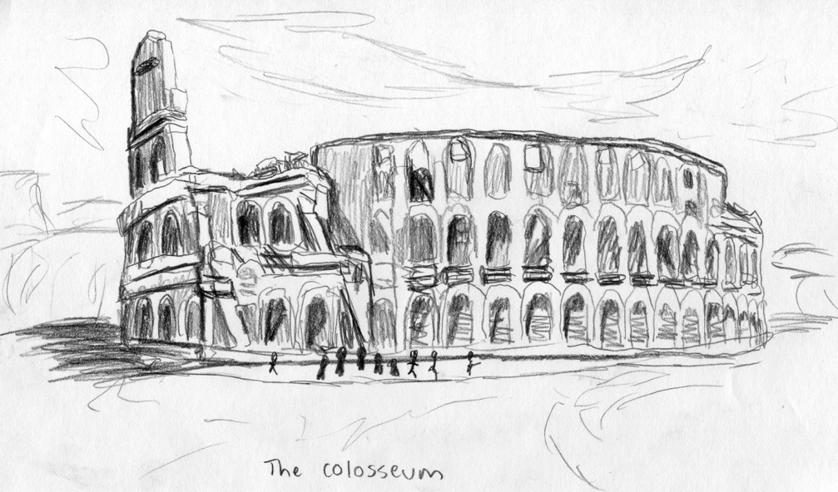
DAY ONE: ROME
Figure 1: The Colosseum
We arrived in Rome in the early morning, the seventeen of us, for two weeks of study abroad. We stepped out into the burning Italian sun, our faces drawn and appearances haggard from jet lag and 24 hours of being awake. Yet as I stood on Italian soil, I grinned like a kid in a candy store as I basked in the irrepressible excitement that comes with one’s first time abroad. We were here. After months and months of nervous anticipation and weeks of studying Italian literature and history, we had finally arrived.
We brushed our teeth and hurriedly changed clothes in the airport bathroom. I examined my reflection in the cloudy mirror. My hair was somehow flat and crazy at the same time. The curls had decided to knot into proto-dreadlocks after eight hours of tossing and turning (or at least as much tossing and turning was possible) in the sardine-packed tin can of economy class. We were supposed to sleep during the flight. It was necessary that we sleep. But we didn’t, not really. Unfortunately, not being of an equine nature, I couldn’t sleep standing up.
I touched up my makeup. I was certain that if I wore red lipstick and stayed quiet, I could pass as Italian. Never mind my hulking Nikon camera and gawping expression-- I was determined not to look American. I had specifically packed no sneakers because I heard from somebody’s cousin that Italians never wore sneakers. As we waited for the bus to pick us up, I nervously flipped through my handmade flashcards with common Italian phrases.
“Dove si manglia il miglior gelato?” I repeated, butchering the Italian language with an elegant ineptitude. “Quali gusti?”
Dr. Phillips, our group leader, told us that we had a pretty wild day ahead of us. A last-minute change of schedule meant that our crash day was adapted into a class day. While most of us longed to crash into our beds and sleep for an hour or twelve, we didn’t have time for such luxuries. Instead, we had what seemed like all of Rome to tour before we got to our hotel. Fortified on vending machine snacks, we headed out from Fiumicino Airport by bus to the Roman Forum. Navigating the narrow Italian streets in a massive Greyhound was an affront against basic geometry. Somehow our driver was able to wrap the enormous behemoth of a bus expertly around narrow alleys and through impossibly tight tunnels. As I pressed my nose against the glass window, I heard the violent honking of horns as drivers in tiny European cars jostled for positions in the Roman avenues. Traffic lights were seen, nodded to, then promptly ignored as a rule. Pedestrians took their lives in their hands each time they crossed the frantic roads, yet I watched as sharply-dressed locals plunged into the streets and walked without any fear at all.
As we were deposited in the city center, I was disoriented by the commotion. Rome is a true city, ancient and modern all at once. The city presses and compacts everything into a single space. Everywhere, streams of humanity flow, as if everyone in the world has congregated in one small spot. It was nearly impossible to comprehend. Every moment was frantic movement, my feet contouring around worn cobblestones as I ran to keep up with the group. I dodged and weaved through the river of people, desperately avoiding being splattered by zooming mopeds. My eyes were saucers, drinking in the immense variety of sights and sounds, overflowing from the endless spectacle. It was overstimulating and electrifying walking through those bustling streets. Everywhere, old and new was pancaked and crushed together. The city of Rome was not built on soil but on older incarnations of itself.
We arrived at the Roman Forum at noon. The sun was high in an impossibly blue sky. Everywhere we looked there were explosions of flowers. Red peonies tangling through the ruins of temples and civic centers, grasping vines growing strong around crumbling statues and worn marble stone. Our guide walked us through the long courtyards and towering triumphal arches of the Old Empire. All was a decaying monument to grandeur that instilled fear in all the nations of the known world. In ancient times this forum was a hive of commerce and civic affairs. Now the cats and pigeons roosted in the walls that once protected shrines and palaces of the most powerful rulers in the world.
As we walked, we caught the first furtive glimpse of that famed structure, the Colosseum, arching like a great sleeping beast in the afternoon sun, a sea of people swarming around it snapping photos and jostling in line to go inside. I was shocked by how big the Colosseum really is. Like every child in the Western world, I have grown up seeing countless images of this famous house of spectacle and slaughter.
Ringing through the crowd were Carabinieri, Italian Military police, their burly hands resting on the triggers of their heavy submachine guns. The atmosphere was tense from recent terrorist attacks that had burst out across Europe almost daily in the months leading up to our trip. No chances were being taken as we passed through the hulking arches. They carefully checked each bag, pawing through the contents for explosives and weapons, looking down at us with a practiced intimidation, as if goading the tourists to try something stupid. I kept my head down and tried to look nonthreatening, which admittedly isn’t hard when you’re five foot three and have the muscle mass of an uncooked biscuit.
We stepped through the vaulting ring and out onto the Colosseum proper. I inhaled sharply as we emerged into the ring. Hulking masses of stone stood in silent, ancient watch over the city that bustles around it. Tiny people streamed like ants through the tiered balconies bathed in the golden light of the sun. I traced my fingers on the smooth stone. It was so impossibly old, this structure that has stood for millennia. What can be said about this place that hasn’t already been said by countless other writers from antiquity on? My mind turned to Edgar Allan Poe’s poem, “The Coliseum.” We read it as one of our readings for the day. Poe wrote of “Gaunt vestibules” and “phantom-peopled aisles.” In this storied place “where a hero fell, a column falls… Here, where the dames of Rome their yellow hair/ Wav’d to the wind, now wave the reed and thistle.” The poem mourns and chides the long-lost glory of this stadium, bathed in blood for sport now crumbling from the ravages of time.
I stood overlooking that old stadium and felt a kind of sadness tinge my excitement. It’s a feeling you get when you enter a place filled with long-forgotten death. This great structure celebrating violence and brutality is a tourist attraction. We all smile and take our picture in front of it, but how many countless thousands of slaves were slaughtered here for the amusement of the Roman Senate and the populus? It’s a monument to a great and terrible empire, one that stretched from Britain to the Black Sea, an empire that forged the future of Europe. The impact of Rome on the West is immeasurable, yet this stadium, the pinnacle of its power, is but a ruin now. A place to be photographed and forgotten. Yet it still has such immense power. It’s beautiful despite its gory history. I remembered the lines of Poe’s poem speaking of this place:
We are not desolate — we pallid stones;
Not all our power is gone; not all our Fame;
Not all the wonder that encircles us,
Not all the mysteries that in us lie;
Not all the memories that hang upon,
And cling about us now and ever,
And clothe us in a robe of more than glory.
We left the Colosseum as the sun sat low in the sky. I looked back at it receded in view, tracing its form on the bus window.

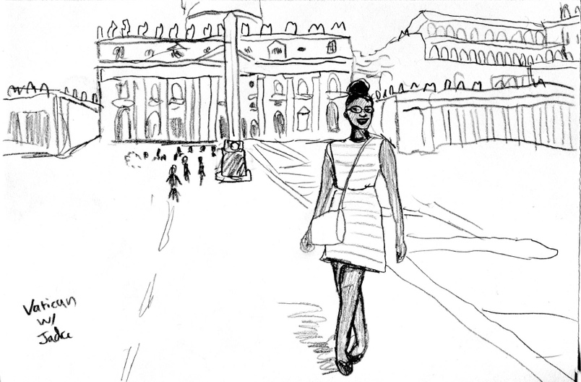
DAY TWO: THE VATICAN
Figure 2: Jada Muriel in front of the Vatican
I had never been inside a Catholic church before. Being of hardy Pennsylvania-Dutch Protestant stock, I am genetically predisposed to iconoclasm. My austere German ancestors had quite the kerfuffle with Catholicism back in the day, including my great-grandmother Witter, who had a lifelong prejudice against Catholics because they used too much sugar when they baked. My separatist forebears thought that all those saints and the hierarchical organization and holidays were idolatry and set out to abolish the Pope and Christmas in one sugar-free swoop.
I wonder what my great-grandmother would have thought about her third favorite great-grandchild standing in Saint Peter’s square, waiting for the Pope to appear like a white speck in a sea of tourists and believers? I probably would have been knocked down to fifth or sixth in the progeny rankings. Yet, as I stood in that moment among the teaming masses of humanity, I couldn’t help wishing I were Catholic. There’s something about the scale of the Vatican that brings out the believer in a person, as if, even for the briefest moment, one gets that primal awe.
We had left our hotel for a Papal Audience in the morning. I was feeling jittery from my morning espresso, courtesy of our breakfast banquet. I was more of a social coffee drinker then, with my primary drink of choice being the sweetest and least coffee-like pseudo-milkshake imaginable. I took a sip of the mysterious black liquid so I could feel like a real Italian and also to stave off the effects of sleep deprivation. I had yet to recover from the jet lag from coming over to Italy, and, as a result, hadn’t been able to sleep at all in thirty-six hours. One espresso down the hatch and I subsequently felt like someone had smacked me in the head with 120 milligrams of pure caffeine. I skipped my way down the Via della Conciliazione.
The road to the Vatican opened up like a highway stretching from the Tiber. As we walked across the Bridge of Angels, I watched the dome of Saint Peter’s rise over the city. People were streaming towards the basilica, nuns and priests in a rainbow of different colored vestments making their way closer to the great courtyard.
The two colossal colonnades arced around the swarming congregation like a stone embrace, beckoning the wonderstruck worshipers in to see the titanic sights within. It was hot, and we had to cover up to respect the strict dress code enforced by the halberd-weilding Swiss Guard. They stood around the plaza, their black and orange Renaissance uniforms originally designed by Michelangelo. Under the baking summer sun we stood in the plaza under the shadow of the obelisk that thrust out of the center of the pavement. Apparently, the obelisk also functioned as a huge sundial and it had been brought to the square by Emperor Caligula.
After an hour of waiting, the plaza was filled to the brim with tens of thousands of people. There was an intercom reciting prayers and blessings in multiple languages. Then Pope Francis stepped out onto the platform and gave a short homily. We could only see the distant figure in white far on the other side of the plaza, a dot against the multicolored sea of humanity that teemed around him.
He was like a rock star in many respects. Outside on the Via della Conciliazione, street hawkers were plying pictures of the Pope, figurines of saints, and post cards bearing the Papal seal among their usual trove of selfie sticks and umbrellas.
We left the Vatican in search of lunch. Our group broke up into fragments, and I followed Ms. April Goers and a gaggle of girls in search of sustenance. We were always supposed to go in groups for safety, but safety did not actually equal speed and accuracy of direction. Maps in our hands, we navigated the streets of Rome, trying to find a decent restaurant that was open at 3 in the afternoon. Many were closed till dinner, and we walked and walked until we found ourselves on the other side of the city. Another problem of being in a large group of girls is that deciding on a place to eat is an intense philosophical conundrum. My stomach growled angrily as I felt the effects of espresso begin to wane. Once more, I became conscious of my sleep deprivation and ache in my feet as they pounded against the cobblestone pavement.
We finally found a small restaurant near the Tiber, which had a courtyard in front exploding with pink flowers. It was called the Ristoranta Roma Sparita, and we all ended up ordering the same dish, cacio e pepe, a peppery pasta that was probably the best thing I have ever eaten.
On our way back to the hotel situated on the Trastevere neighborhood on the west bank of the Tiber, we detoured to see the Trevi Fountain. Tourists swarmed around the famous fountain like ants on a dropped piece of candy, and we had to fight to find a place in front, elbowing through the masses to get to the white marble edge. For the duration of our trip, we had a scavenger hunt of famous sites in Rome and Florence. Throwing a coin in the Trevi Fountain was high on the list. Fishing out a one euro coin from my purse, I turned my back to the fountain.
“So which shoulder do I throw it over?” I asked, warily standing with my back to the intricate marble carvings of the Roman god of waters, Oceanus, and a swirling company of nymphs and horses.
“I think it’s right over left,” said Leslie Sweeten, my roommate.
“My left or your left?”
“My left?” said Leslie, uncertain.
“Here we go!” I shouted as I tossed the coin in a high arc over one of my two shoulders, making a wish that I’d get a boyfriend this year.
I heard a metallic bounce and I saw my euro glance off the metal rock and into the jostling throngs of people where it disappeared from sight.
“Dang it,” I hissed, trying in vain to spot my coin in the crush of the mob. It was impossible. “Stupid fountain,” I whispered with a glare at Oceanus and his whimsical stone eyes. My ninth-grade gym teacher didn’t take as much pleasure in watching me fail at throwing things.
But, by now, my other classmates were gleefully throwing their coins into the fountain, unaware of my plight. “In buco al lupo!” called out Tess Shelton, as her coin plopped into the blue water, calling out an Italian idiom for luck meaning “In the mouth of the wolf.”
With the afternoon waning, we made our way back to the hotel. As I leaned against the railing of the balcony, I watched the vibrant life of the city below move like firing synapses, with buses, trucks, and mopeds darting through the busy streets with tourists and locals sauntering over the sidewalks. I felt the cool night breeze graze my cheeks and I smiled, feeling the pulsing beat of the city, like a giant heart pounding with life.
I took a sip of a strange Italian soda that I had bought at the little market near our hotel. I used a few words of my terrible Italian and managed to get a smile out of the old Italian man who ran it. There’s a certain wonderful inconvenience to traveling. An adventure and sense of opportunity. Sunset fell over Rome, and I couldn’t be happier.

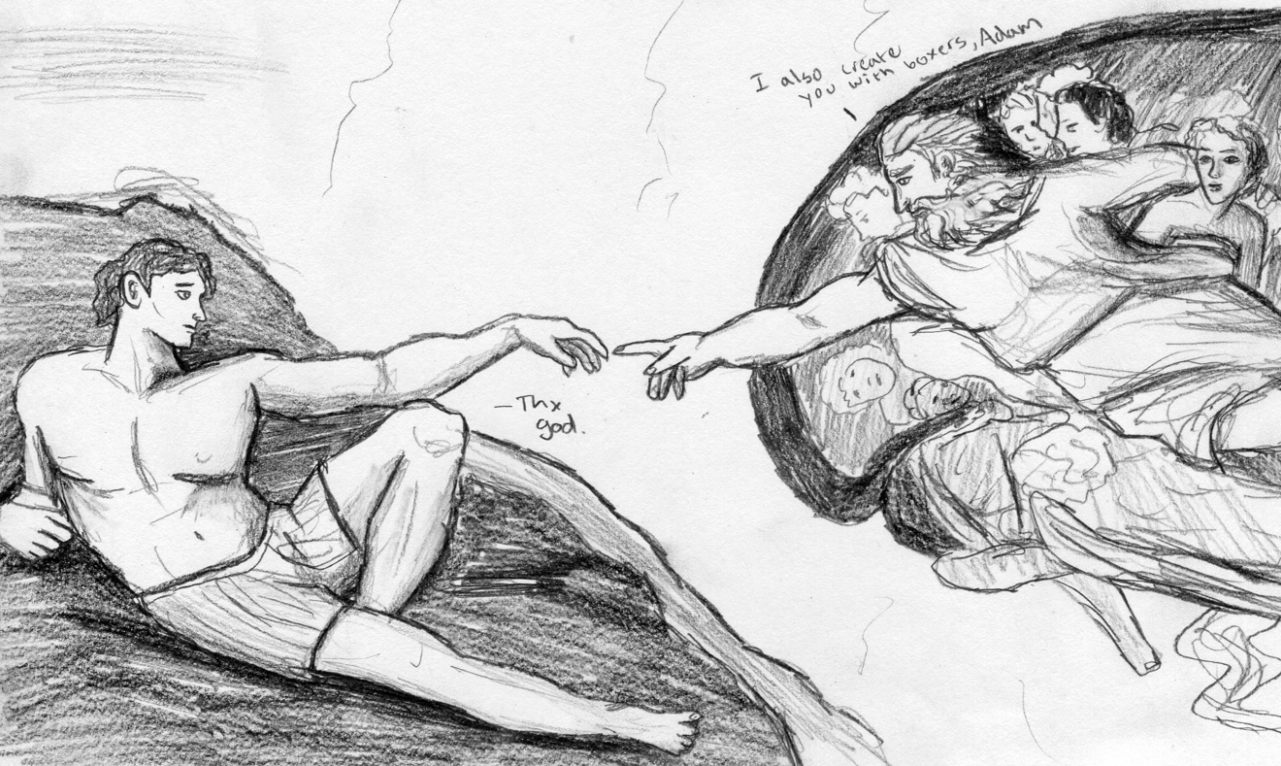
DAY THREE: THE VATICAN
Figure 3: "Creation of Adam" by Michelangelo
Our third day in Rome began with an interesting mix of sleep deprivation and pure caffeine. I still hadn’t adjusted to Italian time and thus had not slept in nearly twenty-four hours. To remedy this unfortunate condition, I ended up swigging multiple espresso shots from the coffee machine in the hotel. By the time we got to walking to the bus stop, I was practically hearing colors.
Now I’m loathe to admit this, but being an extremely sheltered suburban child of helicopter parents, I had never been on public transportation. Crazy, I know. I had never known the infinite joy of being squeezed into a tiny compartment with several dozen people as we lurched down the road. Our group of twenty somehow managed to smoosh ourselves in the impossibly full bus. I tried to find any available holdfast in the crush of humanity, desperately seizing anything solid so that the lurch of the vehicle wouldn’t send me breaking against the rock of the crowd like a wave. I tried to keep my eyes down, but I couldn’t avoid the caustic glare of the more seasoned riders, who could practically smell my ineptitude. I was smelling all sorts of things too, the pungent scent of a hundred human bodies sardined together -- and a great deal of cologne.
When April called out that we had reached our destination, the panic grew to a fevered pitch as we fought our way out of the crush to get to the doors in time. There was no thought in my mind except the incredible terror of missing my stop. The compartment filled with dozens of voices desperately muttering “Permesso” as we darted under limbs to get off the bus. Fortunately, we all made it off before the doors closed and found ourselves in front of the Vatican once more.
If the outside of the Vatican was opulent, the inside was a physical manifestation of grandiosity. I had been told that the scale of Saint Peter’s Basilica was unfathomably huge, but being inside those vaulting corridors was a mind boggling experience. The human brain cannot quite comprehend how things can be so large. When you look at a basin of holy water in the distance, it looks relatively tiny, but when you get close to it, you realize that it is wider than a hot tub. There’s something about the Vatican that plays with one’s sense of perspective. All the furnishings and architecture are designed to inspire awe of the Mother Church and make you feel like an ant in comparison. I glimpsed the Baldachin of Saint Peter's, a 94-foot pavilion that covers the apostle’s tomb. The bronze pavilion was taller than the steeple of my church back home, but even that was nothing compared to the height of the enormous dome.
We passed through the Vatican Museums in a barreling herd. It would have been nice to stroll through the endless galleries of priceless paintings and sculptures at a more leisurely pace, but the endless crush of the crowd moved us ever forward. I managed to get a glimpse of Laöcoon and his Sons, the famous sculpture depicting the frozen agony of this famous Trojan priest. In the Aeneid, Laöcoon tries to warn the Trojans not to trust gift-bearing Greeks, being the only one to see through this Trojan Horse funny business. For the sin of saying, “Hey guys, let’s not bring the giant hollow horse left by our mortal enemies into our city,” Laöcoon is punished by Poseidon via giant snakes strangling him and his kids. I studied this particular sculpture in art history class. It was amazing to see it in real life, actually to study the exquisite agony it depicted. The Romans were quite the masters at capturing movement, the desperate writhing of a man undone by the gods he served so faithfully. It is quite the wonderful sculpture. We moved rapidly through a succession of rooms, gazing at regal busts and intricate tapestries.
My personal favorite exhibit was the Gallery of Muses. The nine daughters of Zeus all stood in a circle displaying each of their respective gifts of art and science: Calliope with her stylus for epic poetry, Clio with her scrolls for history, Euterpe with her flute for lyric poetry, Thalia with her smiling mask for comedy, Melpomene with her sad mask for tragedy, Terpsichore with her lyre for dance, Erato with her cithara for love poetry, Polyhymnia with her veil for hymns, and Urania with her globe for astronomy. All the authors we studied invoked these muses when they began their works, and I felt like invoking them myself. “Oh Clio, hear my prayer. Let my pen be mighty as I write my essays. Melpomene, give me words to frame the inevitable tragedy of my last semester in the most compelling way possible so my parents don’t disown me.”
Eventually, we arrived at the entrance to the Sistine Chapel. Photography was strictly prohibited, so somehow I had to stuff my giant Nikon camera into my very small purse lest the guards confiscate it. I understood why they asked us not to take pictures in the Chapel. Walking through the Basilica as mass was going on, I felt self-conscious about the clicking shutter of my camera among the ceaseless buzz of other cameras. The low harmony of Gregorian chanting was profaned by noise of tourists chattering and laughing.
Entering the Sistine Chapel was a strange study in a silent mob. We were not supposed to speak in the Chapel, just mill around and gaze at the world-famous murals on the ceiling and walls. We saw Michaelangelo’s The Last Judgement and The Birth of Adam, but it was hard to concentrate on the beauty of the paintings amid the jostling and chittering of the crowd. Every few seconds a guard would growl, “Silenzio,” but the tourists never quieted for long. They snorted and laughed and pushed others around. I watched many patrons not-so-discretely snap photos of the murals with their phones, as if the world needed another blurry snapshot of a Michelangelo painting. Every thirty seconds or so, a guard would shout, “No photo! No video!” It was an endless chant that really killed the contemplative mood of the paintings.
The Sistine Chapel was beautiful, but I was happy to escape the tangled masses as we ascended the stairs up to the roof. I looked out from behind the giant statues of saints that encircle the main plaza of the Vatican at the sea of humanity below. The sun was high and bright in a breathtakingly blue sky, and it felt liberating to be free from the crowd. But that freedom was short-lived, as our next item on the docket was climbing the hundreds of stairs to get to the top of the cupola. We climbed up the dome, looking below at the ant-like humanity that were milling 130 feet down. I was shocked to see the size of the Latin writing that ringed around the dome. Each letter was nearly twice my height.
We filed into a narrow corridor with even narrower stairs that wound their way around the enormous dome, progressively growing tighter and more tilted with each spiral inwards. It was 320 steps in all, and by the time we reached the top we were all breathless and sweating. Yet the view from the top was magnificent. All of Rome stretched out before us in its terra-cotta glory. The Tiber, glowing blue green in the bright sun, twisted through the city like a languorous snake. In the distance, I could see the hills of Rome. It was a majestic view.
The inside of the cupola was an interesting testament to humanity in itself. On every available surface, names and initials had been written and carved. Lovers, friends, Instagram handles all blanketed the arching stones in fading sharpie and pen. Part of me wanted to scorn this illicit graffiti as stupid people doing thoughtless things to a beautiful building, yet another part smiled at the strangely whimsical nature of these messages left behind. People wanted to be remembered. They wanted their brief experiences to be recorded in stone. Maybe the relationship between “BD+LW, 9/3/06” only lasted a few weeks, but their initials on the stones of the Vatican lasted over a decade. I certainly thought about them, imagining who BD and LW were, why they were here. It’s like people want to hitchhike through history. Our insignificant lives won’t be remembered through our deeds, but perhaps in six hundred years our names could be preserved in a museum as an example of 21st century life. Graffiti covers every surface in Rome with vandals going back to the Ancient Romans themselves. Everyone is clamoring not to be forgotten in the vast sweep of time.
I looked out from the Dome and thought of my own life amid the masses, how quickly I would be forgotten among the countless millions. When you are up so high in the sky, you almost feel like God, looking down on the cities below. I looked at a name beside my hand that looked a bit like my own with a few misplaced letters. I paused, running my eyes over the scribbled lines. Then I went back down the stairs with my fellow classmates out of the Vatican.
Breaking free from the group, a couple of girls and I spent the rest of the day wandering the streets of Rome, browsing through boutiques and cafes. Yet my eyes would often wander back to the Dome.

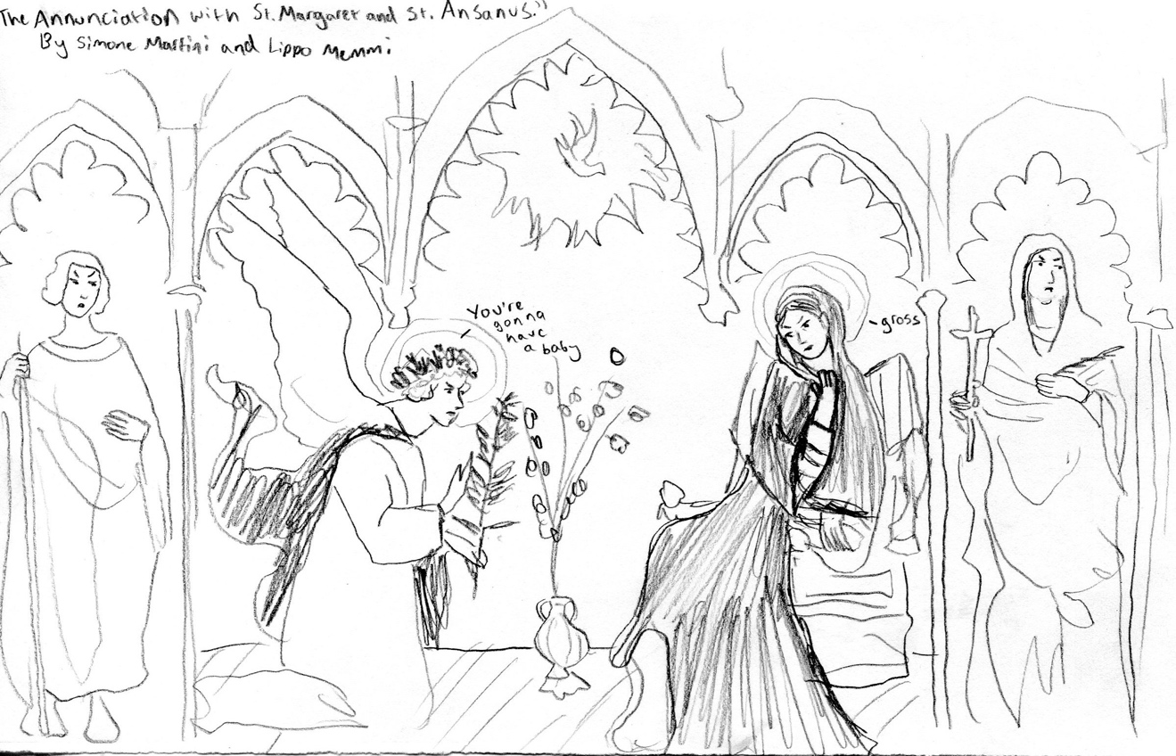
DAY FOUR: OSTIA ANTICA
Figure 4: "The Annunciation with St. Margaret and St. Ansanus" by Simone Martini and Lippo Memmi
Ostia Antica sits at the mouth of what was once the old Tiber River. Once, it was the bustling seaport of Rome, a coastal hub of imperial trade. Today, it sits several miles inland, cut off from the Mediterranean by millennia of silt deposits that turned the maritime city into a withering inland hamlet. I sat in the chartered bus, watching the rolling golden hills of Italy pass by. Little stone houses dotted the countryside under the shadows of the twisting cypress trees. Outside the hustle and bustle of Rome, there was a stillness to the land that was watchful and ancient.
We came to Ostia to see the Roman ruins. Here was a wonderfully preserved Roman city stretching out under the tall umbrella trees. Winding streets, remnants of columns, and gorgeous murals lay before us uncovered. Streaming through the cobblestone pathways and ducking under crumbling arches were hundreds of schoolchildren in blue caps and shorts, laughing and playing in the archaeological excavation under the watchful eyes of white-robed nuns. I listened to the rapid-fire chirping of their Italian, their grinning faces as they ran through the unburied city. I wondered what it was like to grow up living among so much history.
Our guide, Laura, led us through the vast complex of ruins, pointing out shops and restaurants, bakeries and bathhouses, brick and mortar structures preserved for millennia against the ravages of time. What was strange to me as an American was the fact that almost nothing was roped off. You could go ahead and touch it, walk inside the ancient buildings like you were just some Roman peasant popping in for today’s bread. We were led through a temple and large amphitheater. As we milled around the great teared steps of the ancient performance space, Dr. Phillips gave us a demonstration of the acoustic properties of the structure by reciting the opening lines of the Aeneid in Latin, “arma, virumque cano….” It was fascinating to hear his words reverberate through the structure as if he were speaking through a microphone. It’s quite the testament to the engineering capabilities of the Greco-Roman peoples.
My favorite part of Ostia Antica was the mosaics in the bathhouse. In beautiful black and white tile, hippocampi and mermen playfully stretched out in swirling waters, their features perfectly preserved. This had once been the center of Roman maritime commerce, the gateway to the greatest city in the world. In myth and legend, it was the landing place of the Roman forefather, Aeneas, who came to Italy with his refugees and warriors after the fall of Troy. Yet that same Tiber River that connected Ostia to Mother Rome proved to be her downfall. In the intervening years, centuries of sedimentation cut her off from the lifeblood of the sea. The city declined and eventually was sacked and abandoned.
We walked from the ruins of Ostia Antica across the way to the Church of Santa Aurea, a small basilica situated in a blooming courtyard in a very old village. Everywhere we turned, brilliant pink flowers were exploding from every window box and planter. Trellises of green and white snaked up the buildings and gave the town a feeling of vibrancy and beauty. The church itself was old and worn, but in a charming way. I liked the simplicity of its bare wooden beams and austere white walls. Sunlight filtered through high windows and seemed to make the altar painting of Saint Aurea’s martyrdom shine golden.
Apparently, Saint Monica had been interred here in the years after her death. A virtuous Christian woman who was married to a jerk named Patricius, Monica was known for her piety and alms. Her eldest son, Augustine, spent his youth being a typical hedonist with all the usual sex, drugs, and the Roman equivalent of rock and roll, but eventually converted to Christianity. Monica was obviously very happy about that and traveled with her son until she fell ill and died in Ostia, which was recounted famously in Book IX of Augustine’s Confessions. She is now the patron saint of difficult marriages and disappointing children.
After our sojourn to the church, we hopped on the bus and headed out to the beach in Ostia proper. I stood on the shores of the Tyrrhenian Sea. The sand was dark, the color of brown granite, hot like fire beneath my feet until I stepped in the cool waters of the Mediterranean. I looked out across the sapphire-blue water and grinned, feeling the gentle waves lap around my ankles. Striding farther out into the sea until the tips of my toes barely brushed the sand below, I let myself float, looking up into the impossible blue of the sky. In the peace of the water, there was no sound and barely any sensation. All that existed in that moment was the warm summer sun and the cool ripples of the sea. I could hear only the steady beat of my heart and the distant cawing of gulls as they swooped overhead. It was a small second of perfect peace in a crazy world, a moment that I will hold onto for a long time.
Swimming back to the shore, I joined a few of my classmates in splashing and playing in the water. Hannah Tybor suggested a game where we all stood in a circle and grabbed two random hands. The goal of the game was to untangle the chain without letting go of the original hands. It didn’t work too well, and we all eventually collapsed into the sand in a tangled knot of limbs and bodies. We laughed and stitched out in the hot sand, feeling the marvelous warmth sink into our skin. I obsessively applied and reapplied sunscreen, but later that day I was greatly vexed to find my cheeks and nose shaded lobster red.
As the hours passed by, I was ready to return to the hotel. I went with April and a few other girls on the train back to Rome. I leaned against the window. The glass was cool on my burning red skin. I watched the houses and people go by as drowsiness swept over me.

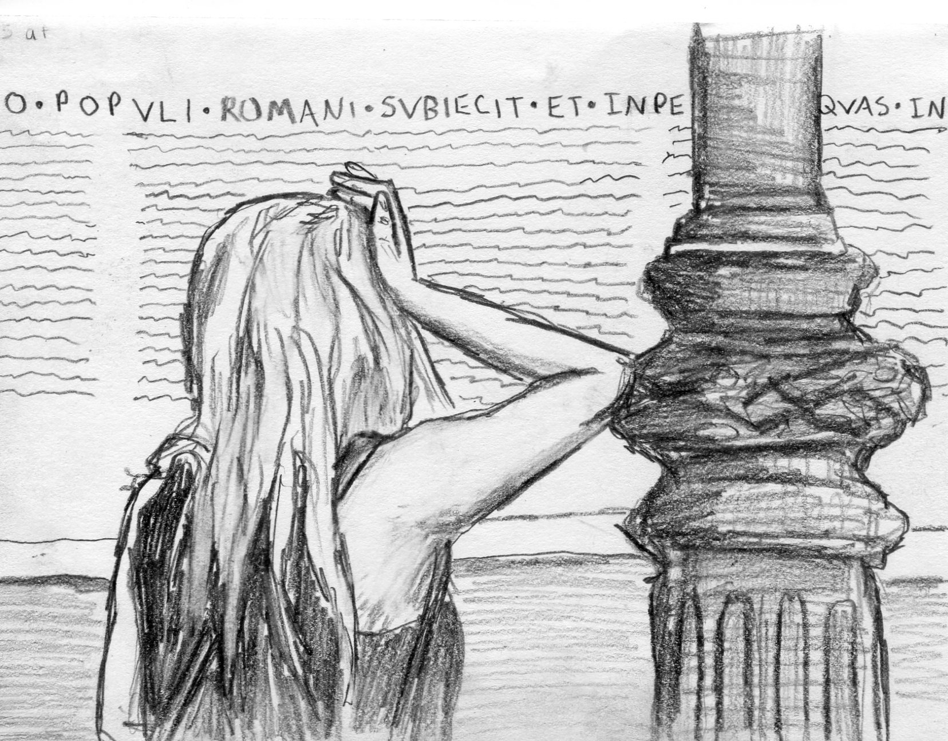
DAY FIVE: ROME
Figure 5: "Tess Shelton outside the Ara Pacis"
Rome in the early morning is a frantic cacophony of buzzing mopeds and honking horns. We were going to meet Dr. Phillips' friend, Professor Fabio Troncarelli, a reknowned scholar of Boethius and Medieval Italian literature and culture. As we walked towards the Pantheon, I let my senses escape into the strange chorus of the city streets. The hawkers were only just setting out their stands for a morning of proffering overpriced goods for tourists. Only one or two bothered to shout at us. Pigeons cooed and strolled down the street like pedestrians, waiting for the crosswalk sign to flash before bobbing to the other sidewalk. They were thoroughly evolved urbanites.
Rome smelled like smoke and fountain water being poured on ancient stone. There’s the acrid scent of bus exhaust mixing with espresso from nearby cafes, a mélange of odors that confuse and intrigue. After five days in our neighborhood of Trastevere, I had begun to recognize the series of landmarks that made up the road to the Tiber. Here was the house which was supposedly a residence of Dante (or at least that was the story the house’s owners propagated). There was the statue of Giacchino Belli, a famous Italian poet. On the other side of the street was the little market where I’d buy a Coke and some Abruzzo cookies from the nice old lady with the cat that sat by the door.
I loved the city. It had an invisible energy to it, pulsing through every moment like a vast network of electrical circuits. When I was a small child, I lived in Indianapolis, near downtown. We would walk to the market and bring our groceries back in cloth satchels. We had neighborhood delis and alleys for playing hockey, and the kids on my street would play together in roving packs under the searing summer sun. Then we moved away to the vast forest of subdivisions and acre lots of Brentwood, Tennessee, where everyone kept to their own Stepford house and the only glimpse of our neighbors was the SUVs pulling out of long driveways. In the American suburbs of my hometown, everything is clean, crisp, and perfectly manicured. Each house sits on its virgin land separated from the world. In the city of Rome, there is a gritty immediacy, a sense of grasping life and community. I loved the smoke and the crowded streets.
Bikes rushed passed us, and we rushed across streets before the trolleybuses wizzed by. We were walking towards the heart of the city. Eventually we made our way into the Piazza della Rotonda. At the center of the square was a large Egyptian obelisk perched over a fountain. As we waited for Professor Troncarelli, I let my hand skim the rippling surface of the water beneath a spouting statue of a fish-man.
When Professor Troncarelli arrived, he led us on a tour of the Pantheon. The external edifice was relatively unassuming. You can only barely see the top of the dome peering over the large pediment. Inscribed across the front of the building in giant Latin letters is the phrase, "M.AGRIPPA.L.F.COS.TERTIUM. FECIT" (Marcus Agrippa made this when consul for the third time). I thought that was kind of funny, like a giant signature imprinted on history, “Marcus was here!” Marcus reminded me of the guy in the office who writes his name in big letters all over his takeout and even carves his name into the tortilla skin of his burrito so no one will mistake it. Apparently, Marcus Agrippa was a famous Roman consul and general who fought in the Battle of Actium against Cleopatra and Marc Antony. He helped Augustus Caesar transform the city of Rome into a capital worthy of the new empire, clad in imperial marble instead of republican brick.
That was the Roman way, though. What can you expect from a people who believed the greatest earthly accomplishment imaginable was to lead a victorious army through a triumphal arch built in one’s name? We had seen many in Rome, the arches of Titus, Constantine, Septimus Severus. All dead Italian guys who lived only in the dusty pages of history and crumbling monuments to long-gone glory. It reminded me of the graffiti I saw in the Dome of Saint Peter's. Everyone wants to carve out a little chunk of history, everyone wants to be remembered. Whole cultures and religions are centered around keeping the memories of ancestors alive. Maybe it helps people get over their fear of mortality. Maybe that’s why people like Marcus Agrippa built huge structures of stone. So little in life outlasts the inevitable march of time. Maybe if you build something great enough, your life won’t seem so insignificant in the vast sweep of eternity.
We stepped into the Pantheon, through the grey granite pillars of the portico into the interior. Stepping into the rotunda was breathtaking. I have never been so awed by a structure before. Although the outside was relatively run-of-the-mill for Roman structures (much of the earlier marble had been hauled off and repurposed), the inside was something that boggled the mind. The vast dome stretched above us, over 4,500 metric tons of concrete with a height of 142 feet. Scientists are still trying to determine how the Ancient Romans pulled off such an incredible stunt of engineering. The honeycomb coffers around the interior were sparse and mostly unadorned, geometric shapes highlighted by lines and shadows. There was little, if any, gilded ornamentation.
Even though I had seen the Vatican in all its opulence a few days before, I was struck by the elegant beauty of the Pantheon. There was a lovely minimalism to it, as if the beauty of the structure could speak for itself without the ostentatious gold leaf and twisting bronze of Saint Peter’s. Standing in the pool of light beneath the oculus, I stared out into the eye of blue sky above. The Pantheon was built as a temple to all the gods. The Christians consecrated it into a church for Mary and the martyrs. The conversion saved the ancient building from becoming a ruin like most of the other abandoned temples. The building evolved to survive, and it has persisted mostly intact for over 2,000 years. That is quite an accomplishment in my book.
We walked to the Piazza del Louis de France, the French-owned portion of Rome. In the square was the Church of St. Louis of the French. It is an opulent church designed in the Baroque style. The interior is an explosion of gold and white, covered in priceless paintings by Caravaggio, who was quite the rock star in his day according to Professor Troncarelli. Not only did he revolutionize the world of art with his rich shadows and chiaroscuro, but he was also known to be a brawler who painted prostitutes as the Virgin Mary. Professor Troncarelli told us that Carravaggio had allegedly killed a man in a tussle and was exiled and forced to become a fugitive. He died at 38, possibly from foul play. I bought a few postcards of his artwork. My personal favorite was The Inspiration of Saint Matthew, a beautiful composition made of swirling fabric before a background rich darkness.
After visiting the umpteenth Catholic church in Rome, we made our way to the Biblioteca Angelica. Professor Troncarelli led us through the large library filled to the brim with priceless texts from the Middle Ages and Renaissance. All around us were hundreds of thousands of manuscripts, from illuminated codexes to first editions of historical narratives. We were introduced to the librarian, who showed us rare manuscripts of Dante’s Divine Comedy, The Consolation of Philosophy, and Orlando Furioso. All were inscribed by hand with beautiful gilded pages and illustrations. It was hard for me to imagine all the time and energy that went into copying a single page from those books. Professor Troncarelli spoke about the time-consuming production of these manuscripts, as well as how important and valuable these works were in a time when literature was a precious commodity. I had more books in my backpack than the average aristocrat owned in the Middle Ages, yet to them, books were created as a symbol of status and privilege.
After Professor Troncarelli finished his lesson on the value of books in history, his son, a teacher studying for his Ph.D., gave us a fascinating lecture on intertextuality. He explained intertextuality as how different works of literature create connections in the minds of readers and writers. Reading literature allows people mentally to intertwine stories and themes, creating a personal culture of influences. We all had our canon of classics in our minds, books we read over and over again, gleaning new meanings and interpretations with each revisitation. His centered on T.S. Eliot and The Wasteland. I liked his position that every person should have “a library of classics,” books that they personally love and from which they garner insight.
I thought about my favorite book from my Italian literature reading list, The Consolation of Philosophy. Ever since I read it, I heard references to it everywhere. A teacher would talk about the Wheel of Fortune in Medieval Romances, or a novel would ask the question of why bad things happen to good people. The strangest place I saw intertextuality with Boethius was in a podcast I listened to on the flight home. The hosts, two literature scholars, were ironically dissecting a Babysitters Club book, Mary-Anne and the Bad Luck Mystery, and one of them went on a long tangent about how the bad luck experienced by the 12-year-old protagonist of the story was related to the 6th-century philosopher’s notion of the fickleness of Fortune. I have weird taste in podcasts.
We left the library and stopped in the Piazza del Maddalena where Professor Troncarelli promised to show us the best gelateria in Rome. I smiled a bit when I saw the stone placard labeling the plaza. I liked the Italian spelling of my name quite a bit! Much nicer than being named after a cookie (curse you Proust). Speaking to the vendor in my best botched Italian, I ordered a cup of gelato de San Crispiano, a honey flavored gelato that came highly recommended by the proprietor of the Gelateria. I can say with absolute certainty that eating that gelato was a mistake because it forever ruined me to all lesser ice-cream. I Flowers-for-Algernon-ed my tastebuds so thoroughly that now I must live with the grim reality that all other confections will be a disappointment. The gelato was tragic in its magnificence.
In the warm glow of my post-gelato existence, I decided to split off from the main group with Jada Murriel, my exploration buddy. In the remaining six hours of the day, we walked all over Rome, exploring little shops, passing through an open-air market, and going into a Roman galleria mall that made any shopping center in America look like a garbage heap. The mall had stone gargoyles and gothic windows. It was nicer than most cathedrals. In the disturbingly elegant mall, Jada and I decided to stop in La Festrelli, a large chain bookstore full of mostly Italian literature.
We found our way to the relatively small English section and began flipping through the Penguin Classics that were neatly lined on the shelves with matching binding.
“I need a book to read on the train to Florence,” Jada said, scanning the hundreds of titles. “You’re an English major. What would you recommend?”
I bit my lip and brushed my finger across the navy spines of the books, going down the many lines of books I had read as a shy and studious high schooler who found making friends much more intimidating than Dostoyevsky.
“Well, that depends what you’re into. If you like romance, there’s Pride and Prejudice, always a classic and a much more immersive experience than the movie, though the 1997 BBC miniseries is quite excellent.” I pulled out a couple books and examined their covers like old friends, “Ooh! Tale of Two Cities is good! I had to read it in middle school and I absolutely hated it, but I read it again for fun a couple years later and it was very compelling. War and Peace is wonderful but unless you have an entire summer to work through it, it might be too much. Faust is philosophical but lovely… Grapes of Wrath changed my life in tenth grade…”
My fingers rested on the copy of Jane Eyre. I pulled it out carefully, a small smile playing on my lips. “This one. This was the book that made me love literature. It was like the gateway drug to hard classics. I read it over a weekend when I was thirteen. I know I sound like such a cliché but it really set me on the whole writing/English path.”
Jada asked what it was about and I gave her a breathless description of the plot and what it meant to me, how it made a lonely adolescent girl feel inspired and strong. Jada bought the book and we made our way back to the hotel as the sun began sinking low in the sky. The streets were cast in a beautiful orange glow as the shadows of street-lamps grew long on the cobblestones. We decided to walk alongside the Tiber, the green water swirling and lapping against the ancient stone bridges
I thought about literature. My mind turned to the younger Troncarelli’s words about creating one’s personal canon. The books a person thought of as classics didn’t have to be famous tracts of influential literature. They could be something simple or even embarrassingly trite in the minds of others. It just had to be something you could read and read again and find new meaning with each revisitation, like old friends.
As we wandered though the streets of Trastevere, Jada and I stopped in a bakery, still laughing and talking excitedly about all the different books we read as kids. I started speaking to the young store clerk in my broken Italian, trying out my best flashcard phrases. The clerk evidently thought we were very funny and we had a quite enjoyable back and forth dialogue in two languages. Jada ordered a muffin, but I ordered nothing, being completely out of euros at that point. The store clerk gave me a wink before surreptitiously passing me a free cookie. I blushed and stammered “Molto grazie.” The clerk gave me a smoldering smile and I noted that the stereotype about Italian guys being suave had a certain merit.
Going back to our hotel, I dug inside my backpack for the books I had brought to read on my trip. They were as varied as Dune, World War Z, and On the Road. I went out onto my balcony and sat in the plastic chair fold-up chair. I kicked my tired feet up on the railing and looked out at the city wrapped in a blanket of early dusk. Propping Dune on my lap, I began reading as the sounds of the city swirled around me.

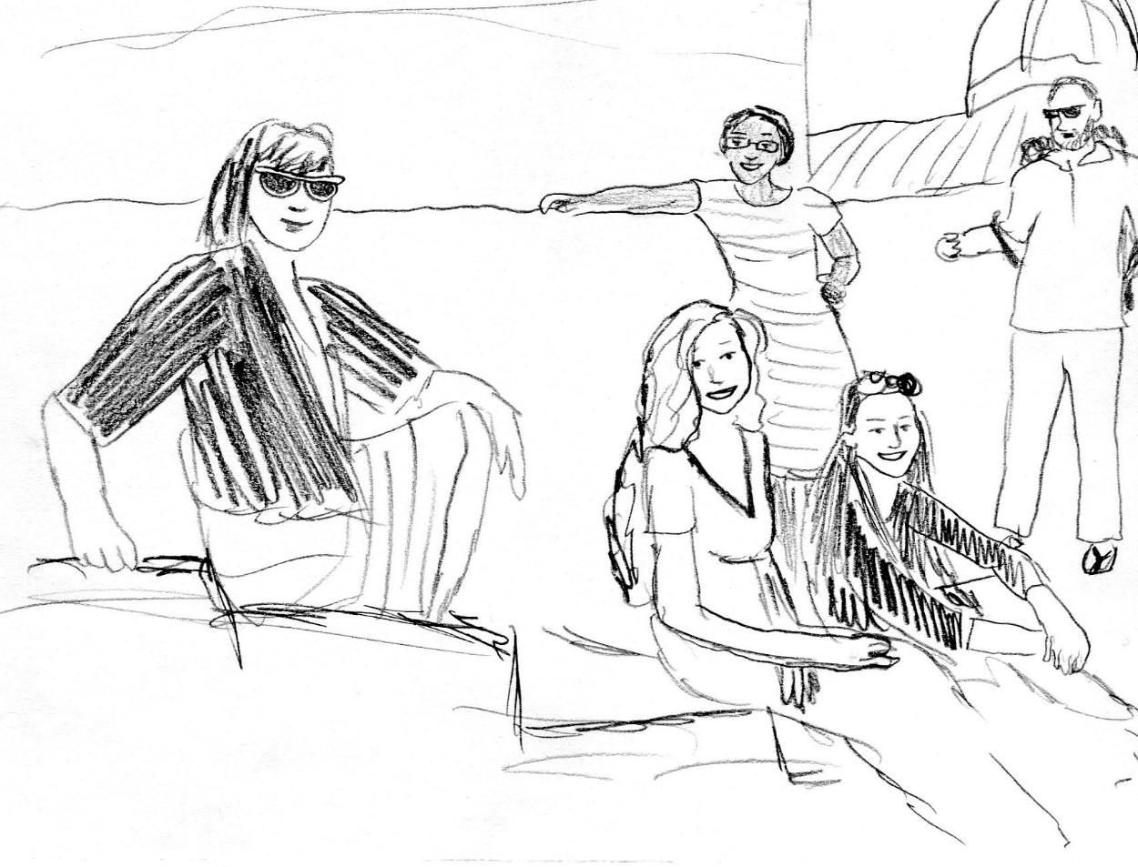
DAY SIX: POMPEII
Figure 6: "Honors Students”
I promise that we set our alarm. Before my roommate Lesley Sweeton and I went to bed the night before our trip to Pompeii, she set her phone to wake us up at 5:00 AM, allowing plenty of time to get ready and be down in the lobby by 6:30, after which the whole group would leave without any delay to the train station. We did tests to make sure we would not be late. We went to bed confident in the power of our clock to wake us up at the proper moment. Yet in an almost Shakespearean level of tragic fate, the alarm did not go off, and Lesley and I were only roused by the desperate sound of Jada banging on the door of our hotel room.
I glanced over at the clock and my heart froze. It read 6:30. I shook Lesley awake and pointed to the time in pure unadulterated horror, “We’re late!”
In a mad dash we threw on our clothes and rushed to the lobby. To our absolute panic, we found that the group had left without us. There was a train to catch, and there could be no waiting for stragglers.
“We have to get to the bus station!” Lesley shouted as she raced towards the door.
“There’s no way they’re still there!” I said as I breathlessly chased her out onto the cobblestone streets. “I don’t know which line even goes to the train station!”
We ran at top speed down the street, scanning the tall signs for the bus line that we were supposed to take. As an incredibly un-athletic person who was turned down by the bowling team in high school for sheer ineptitude at anything remotely physical, I ran remarkably quickly, keeping pace with the track-and-field-seasoned Lesley through sheer force of terror. As we turned the corner, our backpacks jolting and jostling with each footfall, we saw a blessed break in our string of bad luck. Our group was at the end of the street, still waiting for the bus to arrive. We sprinted down the street, our arms waving as we watched them board the bus. In the nick of time, Lesley and I dived into the crowded bus where our friends were waiting, and we made our way through the crowded limbs and bags to rejoin our group. Our friends cheered our hair-breathed sprinting.
“Next time…,” I panted as I leaned against the bar next to Lesley, “Next time we’re both setting alarms!”
“Agreed!” Lesley replied, completely out of breath.
Getting off the bus at the Roma Termini was quite the spectacle. A surge of young people in matching grey MTSU t-shirts descended onto the platform where we congregated like a school of fish with our large cameras and tourist sneakers and shorts. The train ride to Naples was an hour and a half long. I sat in my seat and watched the countryside flash by. The sky was overcast, a dense fog settling over the dark green hills and faded brown villas. The train was speeding at 193 kilometers per hour, making it hard to distinguish particular sights.
At the Napoli Central train station, we switched over to a smaller, slower train that went to Pompeii. This train was heavier, more meandering. It hugged the coastline, and I looked out to see the billowing green waves over the Bay of Naples. The buildings alongside the tracks were much more crumbling and dilapidated than in Central Italy. Hollowed out husks of apartments and concrete blocks of houses lined the railroad. There was more poverty in southern Italy, with fewer opportunities for economic advancement than in the north. In the distance, through the partition of mist, I saw Vesuvius rise over the Bay of Naples like a sleeping colossus. There was a recurring joke to be on the lookout for tremors, the next awakening of the sleeping volcano.
We arrived at the entrance of the Pompeii complex. The air was hot and muggy, much more oppressive than the previously breeze-filled climes of Rome. We waited in the sweaty wet heat as Dr. Phillips and April got our tickets to go inside. As we sat on the worn pavement, we were struck be the large number of stray dogs that milled among the ruins. They were flopped on their sides, panting in the thick heat. Abby Gray was determined to pet one. She crouched down, ready to pounce and cuddle, but being a sensible person, she changed tactics and asked an elderly Italian security guard if the dogs were nice.
“All them nice,” he said with a smile. His eyes rested on a huge black barrel of a dog lounging in the shade. “Except that one!” the man made chomping motions with his hands. “He bite!”
Naturally, we avoided the slumbering biter, and I watched Abby lean down and eagerly pet the grateful non-chomping dogs. There were lots of stray animals in Italy. My father once told me that when he went to Italy in the 80s, the Colosseum was a veritable cat shelter filled to the brim with purring, hissing felines. Near our hotel, there was a patch of ruins where Julius Caesar famously got a bad case of the stabs. Now it was a cat sanctuary covered with lounging animals, mostly cats, licking their paws in the warm sun. I looked out over the necropolis right outside of Pompeii. Dogs haunted the tombs instead of ghosts.
We finally got our tickets and entered Pompeii. It was a winding labyrinth of streets and buildings, many of them remarkably preserved by the pyroclastic flow of ash and blazing gas that wiped the once-thriving resort town off the map in 79 AD. In the cataclysmic eruption, Vesuvius buried thousands of her fleeing and terrified citizens, the shapes of their twisted and agonized bodies now frozen forever in time. I looked out over the sampling of human forms on display in the covered museum near the city proper. They weren’t actually dead bodies, just the plaster casts created by the void their decomposition created. They were only found when archeologists realized that they kept finding empty pockets filled with bones in the hardened ash. I can imagine the archaeologist pouring the liquid plaster in a small hole, chipping away at the layers of pumice until he found a contorted human face staring out at him. Their very last moments were captured like a full-body death mask. Some figures held each other. Some were crawling across the ground, clawing at their necks for air.
I remembered the account given by Pliny the Younger, an eyewitness whose adopted father, Pliny the Elder, rushed to the doomed city in an attempt to evaluate the terrified populace. The elder Pliny perished in the eruption, with his nephew watching in horror from the other side of the bay. We read the younger Pliny’s letter describing the event in class, yet seeing the agonized forms of the unfortunate denizens of Pompeii brought a sinking sense of immediacy:
You could hear the shrieks of women, the wailing of infants, and the shouting of men; some were calling their parents, other their children or their wives, trying to recognize them by their voices… there were some who prayed for death in their terror of dying. Many besought the aid of the gods, but still more imagined there were no gods left, and that the universe was plunged into eternal darkness for evermore. (Pliny)
I could not laugh and point like the other tourists crowding around me. All I could think about was the last terrified moments of thousands of people trapped here, awaiting a suffocating death from the hot sulfur gas that descended on their heads from the heavens.
I tore myself away from the casts and followed my fellow classmates into the winding streets of Pompeii. We split up into meandering groups, scouting out the interesting sights. I was in a group with Jada Murriel, Caitlin Couch, and Dr. Phillips. We followed our professor around
because he was the most knowledgeable about the site, though we had to be careful as unlicensed tour guides were strictly illegal in the complex.
“If anyone asks, just say he’s our dear Uncle Doctor Phillips!” Caitlin said to me under her breath. “No siree, this is not a tour guide, he’s just a guy who happens to be extremely knowledgeable about Pompeii!”
We explored the major sites of the city, hopping across the raised stepping stones that crossed the streets and made for precarious business if you happened to take a wrong step. In ancient times, the steps were so perfectly spaced that a cart could pass between and they were used to save pedestrians the trouble of soiling the togas when they crossed the river of muck and filth that drained through the streets. It took a certain measure of skill, though. More than once, I nearly twisted my ankle by miscalculating the distance between foot-worn pillars. It didn’t help that the stepping stones were covered by a slick sheen of water from the previous night’s rain.
We visited the amphitheater, the crowded houses, and inviting shops. All were remarkably preserved testaments to ancient Roman design. I was, of course, taken by the art. My personal favorite was The Battle of Issus, a large mosaic depicting Alexander the Great charging down the Persian King Darius. It was extraordinarily beautiful, with a marvelous sense of realistic form and color that was frankly shocking to see two thousand years before Realism hit the artistic scene. I was especially impressed by the writhing movement of Alexander’s horse, with its rich detail and effects as minute as veins and billowing cloth. Another impressive mosaic was Venus on the Half Shell, a sensuous depiction of the lounging love goddess resting on a shell and being attended to by cherubs on dolphins. Her legs were somewhat awkwardly propped, but it was a beautiful example of mural art nonetheless.
We toured the city until afternoon. Not having been fed all day due to our rushed escape out the door in the morning, my stomach was rightfully gnawing in on itself by the time our tour of Pompeii was wrapped up. We took the train back to Naples, and my abdomen grumbled embarrassingly loud. As we waited for the train back to Rome to arrive, some genius had the wonderful idea to get some genuine Neapolitan pizza. It was a no-brainer! Naples was the cheesy beating heart from which the most glorious pizza emanated. We stopped in a small restaurant where an Italian woman was rolling out fresh dough on the stone counter. Each of us ordered a plate-sized personal pizza, and my tastebuds soon sang uproarious songs about the majesty of pure Naples cuisine. My pizza was merely a thick, doughy crust with sauce, plops of mozzarella and basil, but that simple combination turned into the greatest piece of pizza I have ever eaten in my short life on this world. It was glorious! (Though as an aside, I also had the worst piece of pizza of my life in Italy, but that is a story for a later time.)
We got on the train back to Rome, the sight of Vesuvius’ arching form shrinking back into the distance. My joy was again visited by the grim memory of those forms in Pompeii. I turned away to the other side of the tracks where the sea was blue in the late afternoon sun. Pompeii was a city of ghosts. In a sense, the whole country was built on the graves of long-gone specters, a layered necropolis built on the bones of older civilizations.

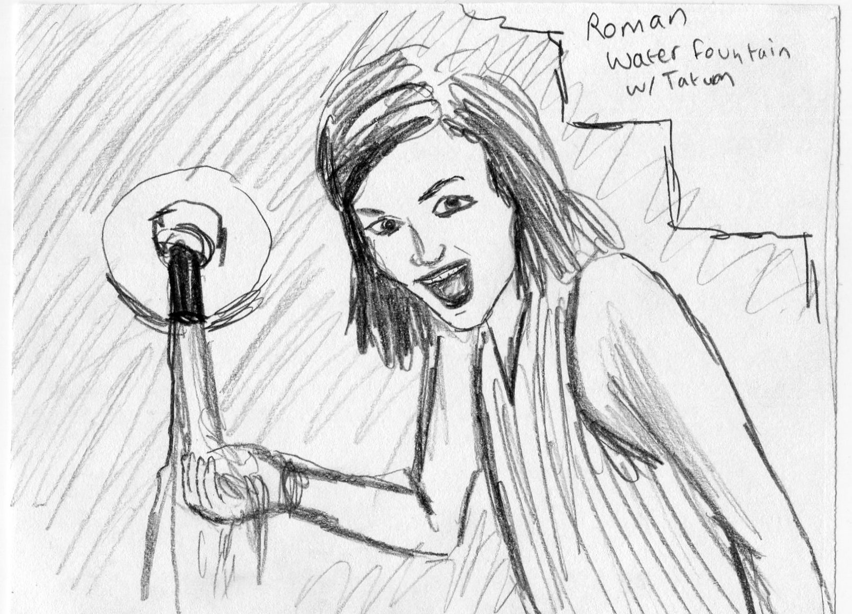
DAY SEVEN: ROME
Figure 7: "Tatum England at Roman Water Fountain"
It was early morning, and for once I was up early by my own volition. I rubbed my tired eyes and blamed the jet lag because in all my nineteen years I have never willfully awakened before nine unless I was forced to do so. I leaned on the balcony of my Roman hotel room, letting my arms hang casually over the railing. The sun was only barely up, but already people were on the move. What day was it even? Sunday? Monday? I had no idea.
I glanced at my watch which read 6:30 AM. I tried to guess what time it was back home in Nashville. Midnight, maybe? I didn’t really know. I wasn’t too good at the math. My parents would be expecting a morning text. My usual mode was to snap a shot of my morning cappuccino to prove I was still alive and un-kidnapped.
Today was a free day, which was good because it was our last day in Rome. There were no plans, no agenda with sights to see, just a space of time to do with as we pleased. Some of the other kids had big plans. Jada was going to Naples with a small group. Lesley was going to run out on the town finishing the scavenger hunt with a group of girls. I wasn’t too good at the whole scavenger hunt thing. You could blame it on my social awkwardness. Even though everyone was always kind and inclusive, I couldn’t help but feel a separation.
I’ve always been a quiet kid, not easily making friends or talking much in class. Sometimes it has served me well, like when I won every game of quiet mouse in elementary school, but other times it has made life challenging. People like me spend their whole lives feeling like outsiders even when the world beckons them forward. My mother was born with the gift of gab and the speaking skills to sell ice to polar bears. She never understood why being outgoing was so hard for me. She didn’t know why I always stood in the corner and parties and would prefer chewing off my own arm like a small animal with its leg caught in a trap rather than talk to “the People.”
I made my way down to the breakfast hall. As I waited for the coffee machine to spit out a hot, milky brew, I heard the familiar voices of my fellow students ring out. There was a group of girls who were already down and they sat together in the sunlight laughing uproariously and talking about their escapades the night before. I looked over at them and felt a wave of anxiety break over my brain. As I overheard their conversation, I felt a pang of regret. They had been out late, exploring Rome under the starlight and having all sorts of adventures in the midnight city. I had gone to bed early, taking particular pains to get my homework done and write everything down in my journal. I had not missed a single day in my recording. I detailed everything with minute detail, including illustrations of statues and names of restaurants that I saved the receipts from.
Yet, even as my meticulous side relished in completing all the work, another side wished I was braver. I wished I had invited myself to go with Hannah and Tatum on their late night exploration of the city. I knew they were going and I easily could have piped up and asked to go too, but I didn’t. I stayed in, more out of fear than exhaustion: fear of “the People,” fear of not knowing what to say when the conversation lulled, fear of being unable to connect, fear of being dead weight in a group of friends. I thought about what my dad had told me before I went on the trip. “Appreciate the now. You may never be here again. Life is too short to be scared.”
I took a deep breath. Holding the cappuccino in my trembling hand, I walked over to the group. “May I sit with you guys?” I asked in a somewhat wavering voice.
“Sure thing!” said Hannah Tybor, “Pull up a chair!”
I smiled and pulled up a chair. As I sipped my morning coffee, I listened to their stories, all the crazy things they had done on the trip so far.
“Where are you all going today?” I asked.
“We’re going to walk around the city!” said Alex Ingram, “You should come with us! I think we’re going to the market.”
I agreed to tag along, and we made our way out to the city. I followed along, happy to be included. The market in the Piazza del Testaccio was divine. Hundreds of stalls burst with color and smells of produce and delicacies from all over Italy. I passed through the endless corridors of fruits and vegetables, encountering some varieties that I have never seen before. I leaned over and made polite small talk with the vendor of a berry stand. He gave me a wink and a delicious cherry from the vat.
My favorite stall was a large spice emporium filled with dozens of huge barrels of fragrant spices. Dried herbs and chiles hung from the rafters of the stall. The air was rich with the delicious scent of oregano and cumin. I leaned in and smelled a large wooden vat of hot pepper flakes. I asked the shopkeeper in my best broken Italian what kinds of peppers were in the mix. He replied that it was very hot Arrabbiata spice: it would light your mouth on fire but it was very delicious in soup. He demonstrated this by pantomiming flames coming from his lips like a dragon. I laughed and bought a large bag to take home.
Hannah Tybor and April were sampling Italian cheeses from the huge blocks in the center of the courtyard. I bought some Parmesan to bring home for my dad and me. It was a rather large wedge that stuck out awkwardly from my purse, but I thought it would be nice to have in the coming months. After all, each time we used it I could say that we were grating real Italian Parmigiano-Reggiano on my pasta. The Arrabbiata flakes would prove to be much less popular than the cheese with my family, though I would enjoy them both immensely.
Meeting up with everyone by the large fountain, we showed off our wares. We decided to break up our larger group and get lunch in small groups. I partnered up with Alex, and we strolled down the sun-drenched streets towards the Vatican. We didn’t have an agenda; it was just nice to just explore the little side streets and talk to each other about our lives. She was a Video and Film Production Major with a love of animation and a desire to work for Disney one day. She asked me what I wanted to be “when I grew up.” I told her that I didn’t know. I was an English major who spoke a small smattering of French and had written a children’s book of amateur quality. I had no idea what the future held for me and I lived in a perpetual state of angst because of it.
“That's okay. I think everything usually works its way out,” Alex said with a wistful smile. She looked out over the Tiber River, which was lined by large weeping trees that arched over the road like an embracing bower.
We walked away from the main streets, through a maze of side alleys far from the touristy parts near the Vatican. We were deep into the real Rome, lost in the endless side streets and tall buildings knit tightly together over narrow roads. The cobblestone paving was more uneven back here, with little stones jutting out in random spots. We found a tiny hole-in-the-wall restaurant called Borgo Antico. It only had four tables and it was run by a single Italian woman and her grandmother in the kitchen. The proprietor did not speak any English, but she treated us like family, giving us a series of delicious appetizers and desserts for free. I fumbled through a few of my Italian phrases for gratitude, which she laughed off and eagerly helped with my pronunciation. We had marmelata samplers, pasta primavera with pesto, and fresh strawberry sorbet. We finished our lunch with a fruit tart and Alex and I thanked the woman profusely for a wonderful meal.
We explored Rome together for a few more hours. We sat next to the Tiber River and soaked up some sun as we watched the joggers and bicyclists pass us on the stone path that stretched adjacent to the riverbank. It was fun just to watch people, see the families walking with kids in school caps, the teenagers in their designer jeans, the tourists with their cameras. I realized as I sat on the steps going up from the river that I loved Rome. I loved the scent of the city, the buzz of excitement that filled the air. Maybe it was just the thrill of being away from home for the first time, but I loved being in a place that felt old but alive. People had roots here, and homes were passed down from generation to generation. I liked being far away from anyone who knew me. No one here would judge me as the quiet girl who had been sheltered her entire life. Here I could be someone different, someone friendly and capable.
We walked back to the hotel as the sun began to set. I ate a plate of cheese and various salamis that night with Jada. She spoke excitedly about Naples and their sojourn there.
“Can you believe it’s our last night in Rome?” she asked, looking out at the streets still humming with people. “I can’t believe we’re leaving for Florence tomorrow.”
“I know,” I replied tapping my fingers against the railing of the balcony. “I’ll miss it. We could never come back here.”
“That’s possible. But I guess we just have to enjoy the memories we have had.”
I propped my copy of Dante’s Inferno on my lap, scanning the pages. “So Florence is tomorrow.”
I sipped a sparking water and looked up at the sky. Even though the lights of the city had dimmed the constellations, a number of stars were shining defiantly out, twinkling into the night.

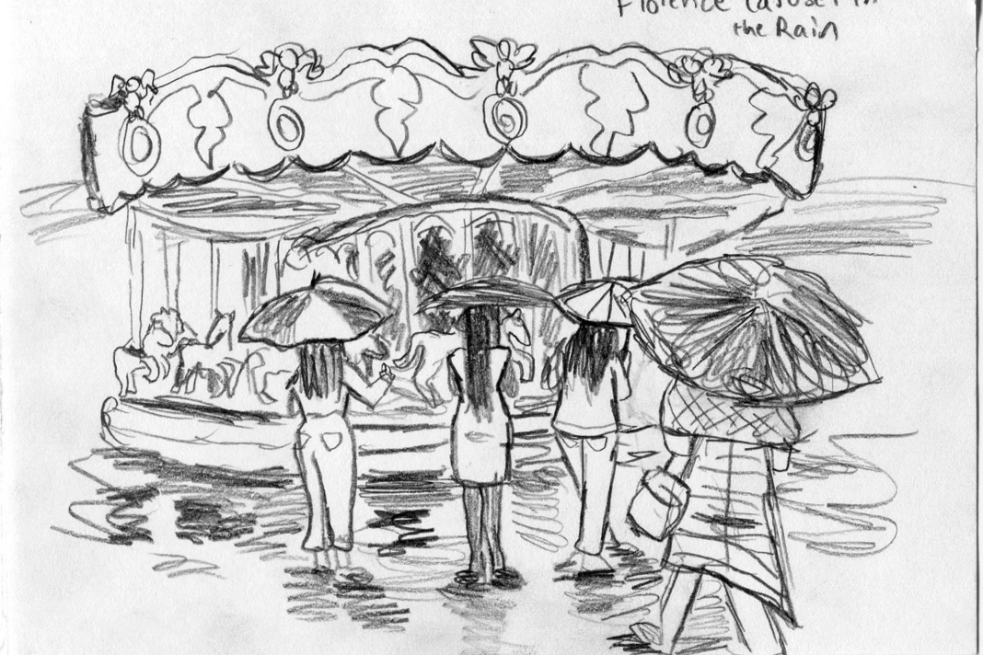
DAY EIGHT: FLORENCE
Figure 8: Florence Carousel in the Rain
Leaving Rome was a heartbreak. Just when I had fallen in love with the beautiful ancient city with its strange mixture of urbanity and archeology, I had to leave it. As I boarded the train, struggling to lift my heavy suitcase off the platform, I felt uncertainty building in my stomach. Florence would be next. I had heard so much about it, but a part of me was nervous about all the buildup. After nearly two decades of hearing the famous Italian city-state praised to the heavens as the most beautiful city in the world, I was worried that the hype wasn’t all it was cracked up to be.
I didn’t expect to love Rome as much as I did, yet in my brief week in the city I had come to adore the gritty energy of the place. Life struggled and fought for sunlight in a city built on the bones of ancestors. Blood and sweat had built the Eternal City, the center of a vast empire that once stretched like a red stain across the breath of Europe and the Middle East. The people of Rome were strong, brusque, and often unfriendly to strangers. Yet once you pierced the hard exterior with a warm word in Italian or a sheepish smile, you could find an explosion of warmth and grace. I liked that. I enjoyed finding beauty beneath harshness, some glorious treasure hidden beneath layers of dirt, forgotten and unpolished, but still as beautiful as ever. The old monuments were built into the foundations of the city itself, some swathed in layers of vines and mud, yet they were there providing the foundation for a modern urban city.
Florence was different. Ever since I was a young child leaning over my picture-book atlas, I have dreamed of Florence. The soaring heights of the Cathedral di Santa Maria del Fiore, the beautiful rolling hills separated by the glittering Arno River, and the stories of Dante and the Medicis were all popular fantasies of my studious youth. All the best artists were Florentines. Michelangelo, Botticelli, Raphael, and Donatello, all had been staples of my childhood passion ever since a Renaissance painters exhibition had come through the Children’s Museum of Indianapolis when I was a little girl of six years old. Yet I felt an anxiety welling up in my throat, a worry that perhaps some places might not be as magical as all the literature promised.
I sunk into my seat on the train with my copy of Dante’s La Vita Nuova propped up against the window. The train was going much too fast to see the countryside, but I watched the twisting cypress trees and stone cottages whiz by. I read Dante’s words regarding his great unrequited love, the beautiful Beatrice. I was reading Chapter 28 of the slim poetry book, where Dante Alighieri has a fever dream shortly after the death of his beloved. He has a vision of her dead body, and at first Dante is upset because he realizes that he too will die. Yet, as he looks upon her face, he sees only the most glorious expression of gentle humility and sweetness in her features. In that feverish vision, Dante loses his fear of death, seeing it only as a single step to pure understanding of God. He experiences a rebirth and resurrection from the horrible grief that has gripped him and emerges into his “new life.”
As the train pulled into the city of Florence, I wondered about the immortality of the written word. In a sense, Dante Alighieri made the object of his affections immortal, forever imprinted on the Western Canon by the sheer magnitude of his genius. Beatrice will never be forgotten, but would the real woman enjoy her posthumous deification? After all, she barely knew the strange young poet who was too afraid to speak to her. She was married to someone else. Would she have appreciated being made into a goddess and spirit guide by an obsessed stranger? I pushed these thoughts away as we got off the train.
Our hotel was only a block or two from the train station. It had a large neon sign hanging from the top of a corner building. We struggled to drag all our various suitcases and backpacks up the steep steps to the atrium. As Dr. Phillips and April Goers tried to figure out everyone’s rooms, I sat on my suitcase and looked out the window at the busy traffic coming from the station.
Everywhere I looked there were tourists. You could tell by their sneakers and Nikon cameras. They all had that gawping fish look, staring out at the Italian streets and snapping endless photos for posterity. They talked loudly and seemed to trample through the place. A few were eagerly buying up selfie-sticks from the aggressive hawkers. When they stretched out the stick with their phones attached, I couldn’t help but feel judgmental and annoyed. They were making us look bad. I chided myself for being hypocritical, though. I wasn’t much better. Even though I tried to disguise my Americanness with strappy sandals and an assumed European elegance, I couldn’t hide my own open-mouthed stares and touristy missteps. Anyone with eyes could tell that I was American.
We checked into the hotel before quickly walking out onto the town. We had sights to see and there was no time for freshening up. As I walked through the Florentine streets, I felt disappointment creep over me. All those little shops and exciting stores I saw in Rome seemed to be repeating themselves here. Everywhere there was the inescapable presence of knick-knacks and China-made baubles being peddled on every corner. It was always the same selection being aggressively proffered to you by the same seasoned salesmen. The worst offenders were obviously the selfie stick sellers. Nothing represented the ugly dregs of tourism more than those abominable sticks. I winced with annoyance every time I saw them. A part of me understood their usefulness. After all, who wanted to trust a random stranger with their iPhone to take a group picture in a foreign land? But another part of me seethed at the disgusting egocentricity.
Everyone seemed far more interested in capturing a selfie in front of a famous monument than actually looking at it. Millions of pictures must have been taken in front of the Florence Cathedral, in front of Michelangelo’s statue of David. How many people actually looked at the photos they took? How many people even took a second glance as the piece of art or architecture that they had spent so much time photographing?
I felt my inner old lady with a walker rise up, yelling at these kids to get off my lawn. “Appreciate art, you Barbarians!” I wanted to yell at every tourist spitting gum out onto a famous fountain. For once I was grateful that my phone was practically disabled and left at my hotel. It felt good not to be constantly staring at it like all the young travelers I saw with their constant Instagramming and Snapchats. Again, I am secretly 85, but I never understood why people feel so compelled to post everything they do on social media. If you don’t post a picture of something, did it really happen?
Again, it really didn’t matter, yet the touristy-ness of Florence was starting to grate on me. Something about the city was too clean and polished. It reminded me of the ride at Disney, “It’s A Small World.” Nothing seemed real, everyone there was either a tourist or catering to the whims of tourists, like little automatons who came out and pretended to be real for the crowds. This was an uncharitable opinion, yet I couldn’t help but feel a crushing sense of disappointment. It was far too sanitized and crowded, more like an amusement park than a living, breathing city. Florence was too small and too popular to accommodate the millions of tourists who crashed through her walls. People called it “walkable.” I called it cramped.
Yet I will not be wholly uncharitable to Florence. It is a very beautiful city. From the grand Duomo to the beautiful Ponta Santa Trinita, the city had some incredible sights. As we strolled along the Arno, I recognized the Santa Trinita as the bridge from a famous Henry Holiday painting in which Dante sees Beatrice and her friends walking down the street. She refuses to speak to him due to the rumors of Dante’s playboy nature. Dante is crushed by this. Henry Holiday had gone to Florence in the 1870s to research the setting of the famous rebuffing. His painting is said to be a remarkably faithful depiction of Florence.
As part of our scavenger hunt, a few girls and I reenacted the painting. We each played one of the four characters in the painting. I was Beatrice. We set out walking and Tatum England took the picture for us. I did not quite capture the cold dignity of the famous Beatrice. I was laughing too hard from Jada’s dramatic pose of the languid Monna Vanna to capture Holiday’s icy rejection scene.
It is hard to hate a beautiful city at sunset. As we walked across the covered bridge, I looked out over the river that glowed gold in the dusk. Florence was okay, I decided. Florence was okay.

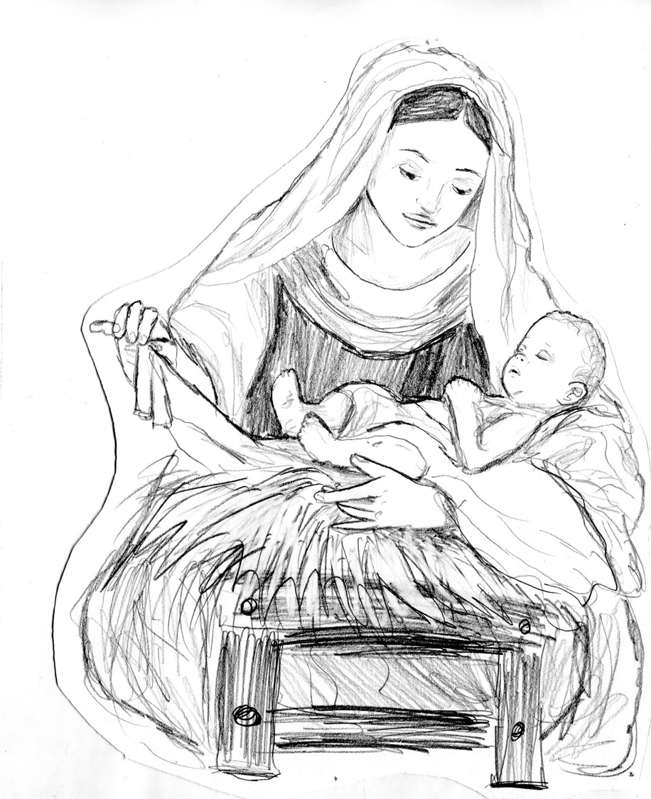
DAY NINE: RAVENNA
Figure 9: "Madonna and Child"

If I could remain in Italy for the rest of my life, I think I would live in Ravenna. Ten miles from the Adriatic coast, Ravenna is like a hidden jewel, nestled away from well-worn paths of Rome and Florence. Perhaps we went on an off-day, but Ravenna was strangely silent. As we stepped off our chartered bus, I was shocked to see almost no tourists tramping along the streets. Most of the people were locals, going about their daily business on bikes. There were no cars, as all motorized vehicles were forbidden in the city center. We walked from our bus to the great Byzantine churches of Ravenna, following our excited guide, Sylvia, who was eager to show off her beautiful home town. She was breathless in her passion for the ancient basilicas and tall towers of the final capital of the Western Roman Empire.
We went on a day trip to Ravenna because it was where Boethius, the Roman philosopher, patrician, and author of The Consolation of Philosophy, had lived and worked as Master of Offices for Theodoric, King of the Ostrogoths. I had gotten to know a little about Boethius when I read his work in the two weeks before our departure to Italy. His story was heartbreakingly tragic, almost Shakespearean in a way.
Boethius was born around the year 480, to a wealthy family of Patricians with a long and storied lineage. Like all tragic heroes, Boethius’ parents died when the boy was young, and he was adopted by another blue-blooded patrician named Symmachus. Boethius grew in wisdom and stature, studying several languages and reading the greatest writers of the time. Despite his youth, Boethius’ intelligence and education allowed him to move up the ranks rapidly. He became a senator at twenty-five and later consul at thirty. He married the daughter of his adopted father and settled into a life of public work and increasing influence in the court of King Theodoric in Ravenna.
However, Boethius’ life took a terrible turn. Many in the court were envious of his success and thought he was growing too powerful. Even Theodoric might have thought the charismatic and erudite Boethius was becoming too big for the court. Some jealous courtiers testified against Boethius, accusing him of treason. Boethius was put in prison where he awaited a harsh sentence for a crime he had not committed.
While in prison, Boethius was filled with despair. All his success, all his power, all his accomplishments had been stripped away in a moment. Now he was left to rot in a cell as liars and fiends sullied his name to the King. In prison, Boethius wrote The Consolation of Philosophy, which consisted of a long conversation between him and Lady Philosophy. In the book, the character Boethius is in utter desolation at his sudden fall. He turns to poetry to sooth his pain, but Lady Philosophy arrives and promptly banishes poetry from the discussion, calling the Muses, “harlots of the stage,” who will only increase his despair by pointing it out. When Boethius complains about how unfair the entire situation is, Philosophy chides him for being too attached to earthy things and offers her wisdom as a balm.
Philosophy declares that everyone is subject to the Wheel of Fortune. Fortune is a fickle goddess who will bring men up one day, then crush them in the mud on the next day. All the gifts that Boethius received were never really his to win or lose, but God’s. All the power, position, and wealth in the world could not really make a person happy. Only the pursuit of wisdom could truly bring contentment, as the ultimate form of satisfaction is in pursuit of the ultimate good.
The discussion travels through the nature of evil, God, and free will. Through the conversation, Boethius finds peace in his lot in life. Only through the cultivation of virtue can he find enlightenment. Shortly after writing The Consolation, Boethius was executed under the orders of Theodoric, along with his father-in-law Symmachus. The Ostrogothic king then issued a damnatio memoriae forbidding anyone to speak Boethius’ name or read his work. It seemed like Theodoric had won. Boethius was to be wiped out of history, a forgotten traitor. However, in the years after Boethius’ execution, it was Theodoric’s kingdom that crumbled. The Byzantines came in and erased Theodoric from walls of the churches. Boethius and his work were lifted up, and he went on to be one of the most influential authors for over a thousand years.
Most of the famous buildings in Ravenna were built around the time Boethius was around, when the Roman Empire was in its twilight years. Boethius was one of the last Roman writers, whose work would heavily influence the later authors of the coming Medieval period. We walked into the Mausoleum of Galla Placidia first. It was hard to believe that the relatively squat brown brick building before us was a UNESCO World Heritage site. It seemed a bit too nondescript from the outside.
We walked into the dark crypt. It was bizarre not to have to stand in a line to get in. Our group was one of the only ones touring around that day, so all twenty of us fit rather nicely into the oratory. What I can say about the Mausoleum is that it is breathtakingly beautiful in an intricate, subtle way. Across the domed ceiling is an incredible mosaic, a cerulean sky filled with stars, banded by boughs of fruit trees. They called this mosaic “The Garden of Eden.” According to Sylvia, the mosaic represented the eternal triumphing over the temporal. As I stared up into the mosaic, I was taken by how different the effect was in person compared to the photos I had seen. There was something incredibly captivating about the minute patterns of color and texture. It is hard to explain, but it had a kind of spiritual effect on me.
After gazing at the other lovely pictures of Christ as the Good Shepherd, we walked across the plaza to the Basilica of San Vitale. If I thought the mosaics in the mausoleum were beautiful, the mosaics in the basilica were in a class of their own. Stretching high into the vaulting ceilings were glorious explosions of colored glass. They were so complex and vivid in their design, so mesmerizing that I gaped at them like I was trying to catch flies in my mouth. Our guide told us that each of the mosaics were made up of hundreds of thousands of tiny squares of colored glass. The tiny pieces of color unite and merge together to form a glorious whole. In the sea of blues, yellows, and greens, there is a kind of universality. Our guide said that many Jews, Muslims, Protestants, Sikhs, Hindus, and Catholics reported feeling a kind of comfort in the Basilica. It reminded them of home, of the art styles of their own various peoples. Perhaps it has something to do with how the mosaics are made. They are not the singular work of one genius artist, but the product of hundreds of hands laying down shards of glass to make a vast image that cannot be comprehended at close range.
According to our guide, the Austrian painter, Gustav Klimt, called mosaics “the eternal painting,” and maintained that no other medium could capture the same spirituality as this art form. Each piece of glass on its own was dull, but together with thousands of others, it could form an image of great beauty and religious power. As light glanced off the shimmering glass, I felt like I understood that sentiment. The gold pieces glimmered against the shining blues and greens, an ocean of shapes and textures emerged. I found it intensely moving, like a universe lived inside those tiny pieces.
It is a shame that the monks of San Vitale in the 1700s thought it was a good idea to tear down half the mosaics in the church and replace them with gaudy baroque paintings. The more I explored Italy, the more I came to despise the overindulgent excess of the Baroque aesthetic. It is opulent to the point of grotesqueness with its gilded styles and flamboyant figures wrought in overly dramatic poses. I suppose it makes sense that the Baroque style was contrived by the Catholic Church as a counter to the purposeful blandness of the Protestant Reformation. The Church was doubling down in the face of growing criticism that it was crazy to spend all its gold on churches while the people starved. Perhaps I am again being uncharitable, yet I cannot help feeling drawn more to the elegant simplicity of the Pantheon or San Vitale than the overwrought golden calf that is Saint Peter’s.
After San Vitale, we visited the Basilica of Sant’Apollinare Nuovo. It was a church built by Theodoric, the same king who ordered the execution of Boethius. It was built as an Arian church, though later denominations thought Arianism was heretical and reconsecrated it as a good Catholic church. Hurray for heresy! The long galleries of Sant’Apollinare were a gorgeous example of Byzantine art, with the famous mosaics of the Emperor Justinian and his even more famous wife, the prostitute-turned-empress, Theodora. The Emperor and Empress looked out from their respective entourages, and I had to admire the skill that went into making them and the equality in scale between the husband and wife duo. The images of King Theodoric and his wife had once graced the halls as well, but after the fall of the Ostrogothic Kingdom, all pictures of the Arian heretics were removed by the Byzantines. Only the hands and feet remain.
We explored the rest of the city, from the Gothic Mausoleum of Theodoric to the tomb of Dante Alighieri. Dante had died here in Ravenna in 1321, after being exiled from his beloved Florence. Apparently, in the intervening centuries, the repentant Florentine government has battled with Ravenna to extradite Dante’s bones back to his home city, to little avail and many shenanigans. The Ravenesse have refused to relinquish the great poet to the city that cast him off. Apparently, Dante was so salty about his banishment that on his tomb, he had them call Florence a mother of little love. The Florentines have yet to get their famous son back.
We later visited a small school of mosaic making and spied the great canal that connects Ravenna to the sea. It was a beautiful day, and I sat with my classmates on the grass as we ate gelato and kababs. I really loved Ravenna. As we boarded our bus back to Florence, I took a last look at the beautiful city. It really was a hidden gem, subtle and lovely like the mosaics which made it famous. I will truly miss it.

DAY TEN: FLORENCE
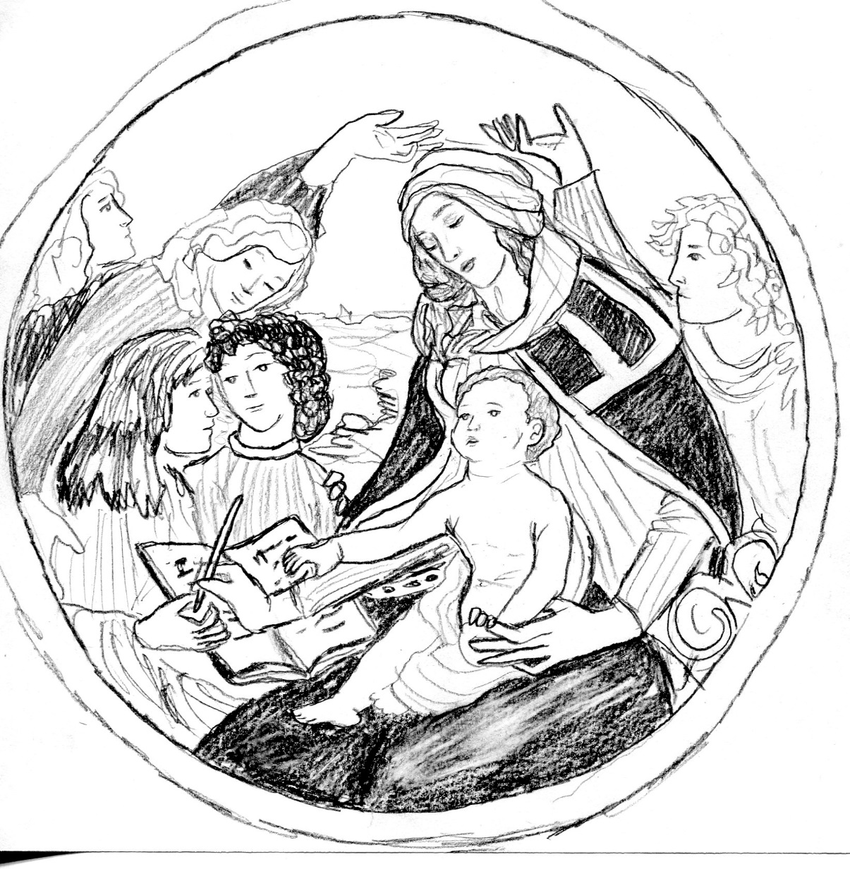
Figure 10: "Madonna Magnificat" by Sandro Botticelli
I woke up early in the hotel in Florence. It was hard not to. It was a small room right next to the air conditioning unit. I shared the room with Tess Shelton, and we both bemoaned the change in amenities. Gone was the balcony that overlooked the city. Also gone was the great bathtub and the Egyptian cotton sheets. Our hotel in Rome had been exceptional. In Rome, we had been served a daily breakfast spread of fresh cheeses and sausage with fresh pressed juices of various kinds. It was beyond luxurious to my teenage sensibilities. Here, we had the general American Continental spread of dry cereal and toast that could be found anywhere in the heartland of the United States. We had been thoroughly spoiled in Rome. But I was resolute not to complain too much and accept my lot in life. After all, I was in Italy and I would have enjoyed Italy in a cardboard box. Boethius would have been proud of my philosophical resolve in the face of Fortune’s fickleness. I ate my toast with the little packet of Smuckers grape jelly and decided that it was the best toast and jelly I had ever eaten.
We walked through the cobblestoned streets of Florence in the late morning on our way to the Uffizi. I had come to develop an affection for the city. Even though I had been disappointed with my first impression of the grand city-state, in the space of a few days I had come to enjoy Firenze’s unique charm. It was still overrun with humanity, but there was great beauty in the winding alleys and burnished red roofs. I liked tossing stones into the Arno, which flowed heavy and greenish brown from recent rains. I liked to watch the parade of faces.
The streets were teeming with people. Tourists of every nationality melded together on the narrow sidewalks in a veritable gumbo of ethnicities and social statuses. Every so often, a group would stop in the middle of the road to stare slack-jawed through the windows of a Versace or Prada store. I only glanced at the wares behind the large panes of glass. That red Valentino purse cost more than my college education. Some of the girls in my group were debating whether to bite the bullet and buy something designer. Italy was the fashion capital of the world after all. Florence, especially, was famous for its fine leatherwork, and it was imperative that we each buy something expensive to remember our voyage abroad appropriately. I was rather skeptical. Everything good I had seen so far was far too rich for my student budget and everything cheap was incredibly tacky. The trinket stalls all around Florence had an obsession with Michelangelo’s David. If the famous sculptor had known his statue was going to be quite so popular with the unwashed masses and marketeers, he might have added an ankle-length parka to his giant-slayer.
Of course, being in Italy meant one had to develop a certain comfort with marble nudity. I could only imagine how shocked the sheltered Christian homeschoolers of my youth would have been at the endless parade of scantily clad statuary. One of my more puritanical teachers in 8th grade had been compelled to cover the Vitruvian Man with a post-it-note to preserve our precious innocence. Europe apparently had little of our American Protestant squeamishness as a trip through any gallery would quickly prove.
We entered the courtyard of the Uffizi gallery. It overlooked the Arno, and it was quite the vibrant center for living artists as well as dead ones. Everywhere in the courtyard there were sketch artists and painters selling their services to passing tourists. Some sold prints of famous artworks, others sold watercolors of Florentine vistas. One man in the courtyard was painting little squares of glass with hazy views of Florence streets in the fog or at sunrise. I ended up buying a freshly painted square from him. It was a black-and-white painting of a misty morning in a narrow alley. Hazy figures could be seen against the backdrop of the Duomo shrouded in fog. I felt a certain affinity to that particular painting. Some of the other girls in the class bought pictures of vibrant sunsets and glorious summer days, but I liked the mystery and quietness of my glass picture. It was a Florence that I hadn’t seen, a cold, foggy city enveloped by a grey winter mist.
The massive line to get into the Uffizi stretched out into the street. Luckily, our trip leaders had gotten us special tickets to skip the line and go straight into the museum. The Uffizi holds the reputation of being one of the finest collections of artwork in the world and it didn’t disappoint. Everywhere around us there were priceless masterpieces from all the great artists. There were the Ninja Turtles of course: Donatello, Raphael, Michelangelo, and Leonardo. There was also a whole room dedicated to Sandro Botticelli. I had a certain affinity for great Early Renaissance painter. I liked his use of color and somewhat elongated forms. My personal favorite was Magnificat Madonna, a lovely circular painting of the Virgin and Child, even though seemingly every painting in Italy was of Mary and Baby Jesus. If it weren’t Baby Jesus and his mother, then it was some glassy-eyed saint dying an excruciating death. Sometimes in Italy, I found myself agreeing with Mark Twain. In The Innocents Abroad, he wrote that once you had seen one painting of a saint, you had seen them all. Twain wished one of the great masters had deigned to paint Shakespeare or Columbus instead of painting yet another Madonna or Saint Sebastian. I suppose, like Twain, I have a bit of that New World gracelessness. Yet I liked Magnificat Madonna. I also liked Raphael’s Madonnas. Both artists were able to capture a real sense of motherly affection in their artworks.
We passed the day wandering through the various galleries of the Uffizi. There were endless corridors of marble statuary, Medieval triptychs, and Renaissance paintings. There was so much beauty all around us that it was overwhelming. An artist, Paul Harmon, once told my mother and me that properly visiting a great European city like Paris or Florence necessitated pacing yourself. If you tried to see too much beauty in a day, then you would get “Cathedral Fatigue” and be unable to appreciate wonders as much. I considered this as I strolled through the galleries. Back home, the only good art museum is the Frist Center in Nashville. They only get one or two new exhibits every few months, always relatively limited by the smallness of the museum and lack of a permanent collection. Yet I had spent countless afternoons in that museum simply sitting in front of artwork for hours at a time with my journal and sketchbook. Going to the Frist was part of my journey into loving art. In some ways, Italy reminded me of a restaurant with a massive menu. There were thousands of options to choose from and a million peerless sights to see. How can one decide what is best from a whole country of master artists?
Art is important, yet sometimes I cannot adequately explain why. When I was in high school, I was fascinated by the Prehistoric paintings of Cueva de las Manos, Altamira, and Lascaux. I was enraptured by the idea that the earliest humans made art, that they took time out of their dangerous, deadly lives to press colors on the walls of their caves. It doesn’t have a necessary evolutional function yet every human culture creates art. There’s something hardwired in our species, this imagination and creativity that demands to be expressed. Before writing, people painted to share stories through time, to beat the inevitable decay of death and mortality. Even after the oral histories died out, the artwork lived on, a physical manifestation of human life and culture.
In Italy, art is a similar expression of culture, a tool to communicate ideas and access something beyond. For many painters and their patrons, art was a way of touching the divine, to create a connection to God through a depiction of righteousness. Though I may sometimes mock the overabundance of holy works, I must respect the ideas behind them. These painters and sculptors wanted to create a spiritual state through the work of their hands.
As we left the Uffizi, free to explore the city, I thought about the nature of human ingenuity and creativity. Florence and its masters knew that art had power, which is why the city is famed for its artists. Florence itself is practically a work of art, a city devoted to promoting culture. I smiled as I watched the people pass by. They all came here for the art, which meant it still carries importance in our globalized world. For that, I was happy.

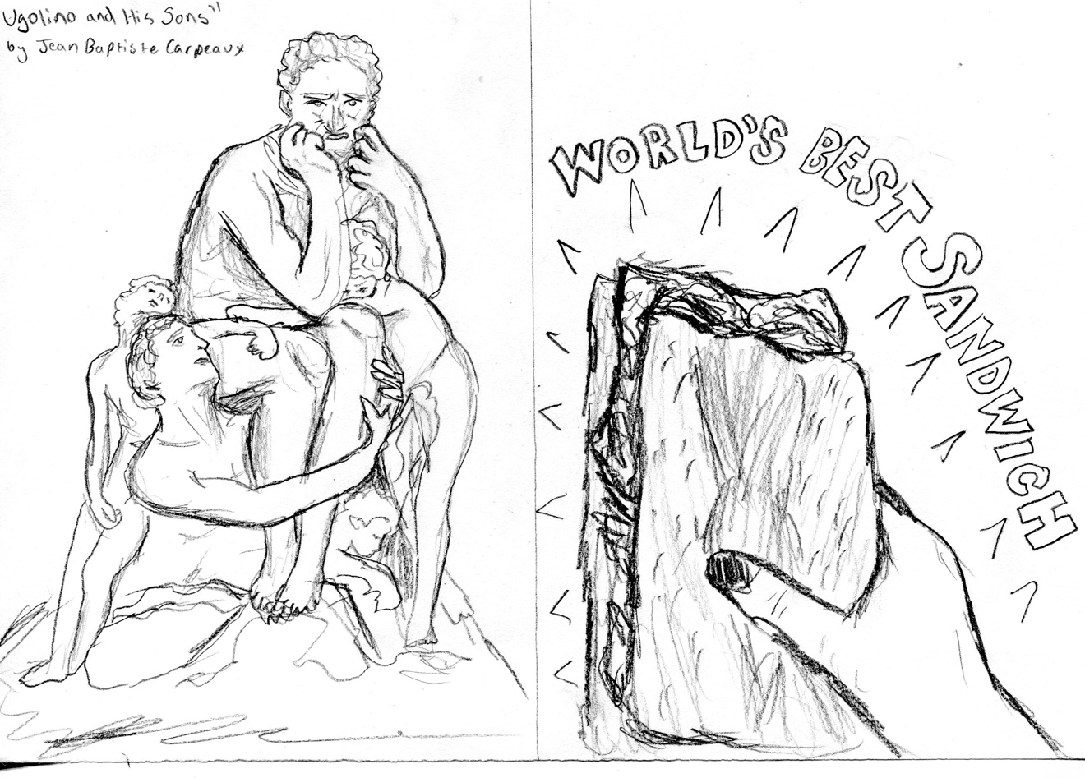
DAY ELEVEN: PISA
Figure 11: "Ugolino and his Sons" by Jean Baptiste Carpeaux; and "World's Best Ham and Cheese Sandwich"
Today we went to Pisa, a town famous throughout the world because of the lack of structural integrity in its cathedral bell tower. Apparently, the famous Leaning Tower is the most tilted building in the world not purposefully built that way. The more you know…
It was a rainy day. We walked from the train station into the city as a persistent drizzle painted the oddly quiet streets. I suppose most of the other tourists had decided not to go out into the soaking dampness that seemed to hover everywhere. Our group was a herd of multicolored umbrellas shuffling up the road, a swirl of rainbow hues reflected against the splashing puddles.
My umbrella was bright red, which looked pretty, but also completely useless when it came to quality. I had bought it the night before for ten euros. Tess and I had been caught in a sudden downpour on our way back from dinner when an omnipresent street hawker capitalized on the precipitation. He had secreted away his selfie sticks and yo-yos and replaced them with a variety of umbrellas and plastic ponchos. They were, of course, the most overpriced pieces of plastic garbage imaginable, but when you are nearly soaking wet and you have a twenty-five minute walk ahead of you, beggars can’t be choosers. He initially asked twenty euros for the umbrella, which I was ready to pay. Tess jumped in and shrewdly negotiated down to five, and we eventually settled on ten. I had yet to master the concept of bartering. In my shy American mind, I found the idea of confrontation so intimidating that I would have preferred to pay twenty euros then demand a better deal. That is probably what the street hawker was betting on, but Tess wasn’t having any of it.
I liked Tess. She was funny and bombastic. She made a good roommate and she always had a witty comment on hand. She was, however, not a big fan of heights, and she seemed visibly nervous about the prospect of climbing up the listing tower.
As we made our way towards the famous Pisa plaza, the crowds became thicker. On every street corner there were armed guards in berets who were watching the people pass with heightened scrutiny. There had been dozens of terrorist attacks in Europe over the last six months. Everybody was on high alert. A giant armored humvee drove past us to the tower, which we were beginning to see peak over the red tile roofs. The celebrated Leaning Tower was still shrouded in rain and mist, but you could spot the white marble arches even though the bad weather. The Pisa Cathedral and Bell Tower were ringed by many tank-like humvees and semi-automatic rifle wielding soldiers guarding the prized cultural landmark from terrorist attack.
I thought about my father’s stories of when he went to Europe in 1980, during the most tense days of the Iranian Hostage Crisis. He and his fellow student backpackers thought they were going to be drafted by President Jimmy Carter and were drunk on ouzo wine on the entire Italy-Greece leg of their trip. My dad told me that the port they sailed from to get to Greece was bombed a day later by anarchist insurgents, yet he had been surprised when I told him that there were soldiers everywhere in Italy. Even in the early 80s, my father had not seen that many guards in Western Europe. The only time they saw soldiers with their fingers on the triggers of their Kalashnikovs was when they crossed the Iron Curtain into East Germany. At one point, they were held at gunpoint by an East German guard after their teacher made the ill-advised mistake of addressing the German guard in Russian. Even then, the East Germans despised the Russians. My father managed to defuse the situation by using his two years of terrible high school German to explain haltingly that they were not spies. The guard let them go on their way. Good times.
The Italian guards were not so touchy. As we waited for our turn to go in the Tower, a couple girls in my group giggled about how cute one of the guards nearby was, daring one girl to talk to him. She said she would but then chickened out half way in her walk towards him. He evidently knew English, because he flashed her a devastating smile, which made her blush redder than a tomato.
We finally got into the Leaning Tower itself, and I found my brain subconsciously rebelling at the absurdity of the nearly four-degree tilt. Even the entrance is tilted. Walking into the inner room of the bell tower, I looked up and my mind reeled slightly from the incongruous sight of a leaning line. Tess furrowed her brow. She looked nervous about climbing to the top. I couldn’t blame her. As we climbed up the circling steps of the building, it was easy to get vertigo. The steps were also tilted, pulling you close to the cool stone wall, your mind feeling disoriented by the strange angle. The steps had worn grooves in them from where thousands of people had climbed for centuries. The steps were slightly wet, so I commanded myself to be extra careful. One false footfall and I could tumble down into the long line of people climbing up behind me and we’d all fall like dominoes. Tess was ahead of me. Every step she took was deliberate, yet her eyes were nearly closed.
We finally arrived at the first tier of the top. Pisa stretched out before us. It was a very green city. Everywhere there were the vibrant bushels of tree-lined boulevards and squares of lawns in parks. We looked out from behind tall metal fences. I suppose they were installed to prevent jumpers. Even from behind the fence, it was a surreal experience to look down 180 feet at the rain-stained concrete below. For a brief moment, a thought of falling off the side of the tower crossed my mind. It wasn’t hard to get that feeling. The tilt of the tower on the leaning side felt like a slide, pulling me over the edge. I leaned on the metal bars, but not too hard. In the back of my brain there was a paranoia of the bars breaking and pitching me over, down, down, down onto the hard pavement. Tess stayed firmly beneath the stone arches and columns. She had no pressing interest in walking down the incline to the edge where I stood. Yet the view was magnificent. The hills could be seen rising blue and hazy beneath the veil of mist and clouds. The city sprawled out like a red and tan monopoly pieces.
We climbed up to the second tier at the top, through a narrow spiral staircase made of stone. On the smaller top platform, the railing was only a waist-high barrier, which made the whole view even more impressive. We took our pictures from the top then returned back down the narrow steps to Earth. Outside, on solid, non-tilting ground, we took our obligatory group picture of all of us holding up the tower. With nearly twenty people in the photo, it looked more like a pile up on the interstate than the Flag Raising at Iwo Jima, but it was cute and people can’t see the Leaning Tower without taking that picture.
It was funny to look at the sea of tourists doing the exact same thing. Everyone was standing around like statues, silly without the perspective context of the tower in their outstretched hands. But I was doing it too, so I can’t really judge them for being ridiculous. It’s an old joke that is funny because it is so old and silly, a meme from the pre-internet days.
We spent the afternoon in Pisa. I walked around the picturesque streets with Alex, Caitlin, and Tess looking for somewhere to eat. We had been dillydallying in the shops, and we soon realized that we had less than an hour to grab lunch before we needed to meet at the train station. Caitlin argued that we didn’t have enough time for a sit-down meal, so we settled on a small deli nestled tightly between a church and a scarf emporium. The deli was so narrow that you could touch either side with outstretched arms. It was run by one Italian woman who was manically trying to prepare the orders, take requests, serve the outside customers, and cut the huge slices of cheese and salami. She was absolutely frantic, but we were hungry and we didn’t have time to find somewhere else to go. Tess and I decided to split a simple ham and cheese sandwich.
The proprietor and sole cook was so busy that she wasn’t able to get to our sandwich for forty-five minutes. I think the reason was that all her dishes were freshly sliced off enormous rounds of cheese and roast lamb legs. Her food was fresh to the point of absurdity. I half expected her to be growing the tomatoes out back and planting them from seed to fruit for optimum deliciousness. We browsed the selections of preserves and salamis in the deli while we waited, our stomachs gnawing all the time. Occasionally the woman would yell to her 13-year-old daughter, Francesca, to bring out the plates to the seated customers outside. Francesca would slowly stop texting on her phone and even more slowly take the plates out, exuding the maximum amount of teenage surliness with each action before returning to her phone. I suppose teenagers are the same everywhere.
When we finally got our sandwiches, we looked at the clocks with horror. We had to meet at the train station in five minutes! We grabbed our food and began jogging to the meeting spot. Strangely enough, our haste caused us to be the first people there. While we waited for the other students to arrive, we sat on the cobblestone and sank into our sandwiches. One bite in and I knew all the hardship I had endured to get this sandwich was worth it a thousand times over. This was, without a doubt, the greatest ham and cheese sandwich that I have ever put in my mouth, and I have eaten a lot of ham and cheese sandwiches. It was just a thick loaf of salted Italian bread with fresh prosciutto and a couple different cheeses with a drizzling of olive oil, but it was a masterpiece of simplicity. I nearly cried while I was eating it. Tess had a similar reaction. She was practically furious that her sandwich was so good.
We reunited with our group and recounted the tale of the amazing sandwich. We boarded the train back to Florence. For the rest of the day, Tess, Caitlin, Alex, and I explored Florence looking for items on our scavenger hunt. We spent a good three hours looking for a picture of a giraffe, including a point where we pretended to go to mass in order to look for a giraffe in a church. We did not manage to find the giraffe, so we settled on taking a picture of a giraffe on a merry-go-round. The city of Florence looked lovely in the rain, shiny, and romantic. As I went to bed that night, I swore that I would savor these memories for a lifetime.
On a separate note, while we were in Pisa we visited the infamous “Tower of Hunger,” that was described by Dante Alighieri in the Inferno. It was pretty nondescript on the outside, just a basic stucco building with a large clock in which the remains of the original stone tower can be found, but during the Renaissance it was the scene of a most gruesome fate. In the late 1200s, a politician and soldier named Count Ugolino della Gheradesca was accused of treason by the Pisan government for allegedly opening up Pisan castles to the invading Genoese. Whether Ugolino did such a thing is undetermined, but he and his two sons and two grandsons were locked in the Torre della Mudo where the Archbishop Ruggieri threw away the key and ordered the guards to let the family starve to death.
In Dante’s Inferno, the poet protagonist finds Ugolino in the lowest circle of Hell, home to betrayers. He finds both the traitor and the Archbishop encased together in the ice. According to Dante, Ugolino and his family were slowly dying of starvation when his children pleaded with him to eat their flesh and lessen his pain. Ugolino watched them die, and eventually “the hunger had more power than even sorrow,” implying that Ugolino did partake in the cannibalism of his own children. In the icy ring of Hell, Ugolino now devours the skull of his own betrayer, the wicked Archbishop who punished the sons for the alleged sins of the father.
I had read the ghastly story in the weeks before we left for Italy. It haunts me that the character of Ugolino has great pathos in Dante’s work. His crimes against the state were great, but his punishment was too cruel and unusual for Dante to bear. So, in Hell, Ugolino gets the small consolation of being able to torture his own oppressor. In the Inferno, Man’s punishment can be wrong, but God’s justice is always right.
It is interesting that when I now think of Pisa, I think of two different things. I think of the “Tower of Hunger,” where a Pisan politician might have cannibalized his own children, and I think of the best ham and cheese sandwich I have ever tasted.

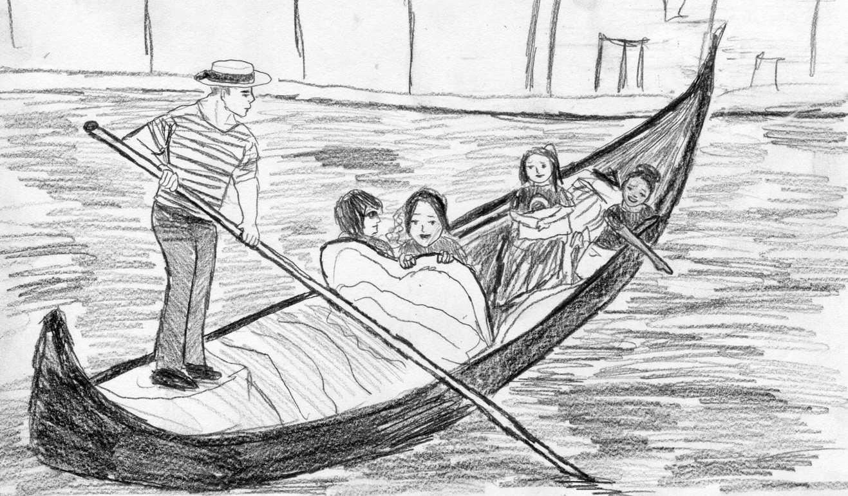
DAY TWELVE: VENICE
Figure 12: "Venetian Gondola"
There’s an old adage that there’s nothing to say about Venice that hasn’t been said already. I think it comes from Henry James in his book, Italian Hours, but I came across that quote in another book called Jeff in Venice, Death in Varanasi by Geoff Dyer. In Dyer’s book, the protagonist bemoans the fact that there’s nothing to write about Venice that hasn’t already been said by Henry James. When James was tooling around the old Floating City, he wrote that it was imprudent even to try to add anything to its description: “Venice has been painted and described many thousands of times, and of all the cities of the world is the easiest to visit without going there.” What can I add to the description of Venice? I didn’t get to see it in the moonlight like Mark Twain in The Innocents Abroad. I did not see it at sunrise like Dyer. I saw Venice in the bright noon sun. I think Twain would argue that Venice has no romance in the harsh light of day. It only slips into the dress of greatness when the stars shine bright and the moon reflects silver onto the endless maze of canals and lagoons.
I felt more love for Venice in the daylight than Twain, perhaps because the daylight was all I got to experience of the storied Republic on the water. We had precious little time to spend in that city so greedily snatched from the sea. As we walked along the sidewalks girded by inky canals, I felt a rush of wonder sweep over my mind. I had dreamed of Venice as a child, read countless novels and articles about the city. It was like a different world, a magic world of boats and bronze lions hovering lightly over the bright blue Adriatic Sea. What Midwest suburban kid doesn’t dream of going to school by boat?
We walked over the bustling Rialto Bridge, over the Grand Canal that teamed with gondolas, water buses, and speedboats buzzing over the gently lapping water. We skirted around large puddles in the sidewalk, remnants of the week-long rain. My fingers traced the high watermarks that darkened the sides of the buildings. Some rose taller than me, marking times when the sea sought to reclaim the stolen buildings. The Venetians call it acqua alta, or “High Water.”
According to scientists, the city is sinking a few centimeters each year. Some of the lower tiers of buildings have sunk so much that they are permanently underwater. Yet people keep building upon the layers below. I wonder if there is a whole underwater world beneath the canals, layers of old flooded buildings that hold up the new ones. Someday the entire city may be underwater.
We came to the vast Saint Mark’s Square. It was incredible how wide the piazza was. It was packed with people. Tourists, huge flocks of pigeons, and more than four different wedding parties were ambling around the courtyard in front of Saint Mark’s Basilica. The tall Campanile loomed over it all, jutting 323 feet into the air, dwarfing the other buildings in the city. We waited in the plaza for an hour or so. I watched the endless parade of humanity as I sat on the sunbaked grey flagstone. They passed in front of the white stone arches of the Doge’s Palace, the glittering gold gilding on the basilica shining in the bright noon sun.
I went with four girls to wait in line for a ride up the elevator of the Campanile. As we stood in line, I took photos of the cherubs and warriors that populated the metalwork outside the building. It was a beautiful day. A short rainstorm in the morning had passed to allow the sun to shine bright and warm on our faces. There was a nice breeze coming off the lagoon as well. I felt the delicious sunshine sink into my skin, such a welcome change from the cloudy days of rain.
We ascended the huge bell tower. The view from the top was nothing short of exquisite. The sky was a swirl of thin clouds hanging over a heartbreakingly beautiful blue sea. The red rooftops snakes in twisting patterns around the city below, interrupted by the darkness of canals. You could see the tiny people like ants below, as well as the white trains of motorboats making the water froth as they sped through the labyrinth of channels. The city was a mosaic of islands connected by bridges and narrow straights. It was a glorious sight, though in the distance, I could see the hulking masses of cruise ships in the distance, larger than city blocks, floating their massive bulk in the lagoon. A guide had told us that the cruise ships would dock tomorrow. In a few hours, the entire city would be overrun with people disembarking from the white behemoths. It was good that we arrived when we did.
My small group left the bell tower and spent our remaining hours exploring the complicated maze that is the Venetian streets. I ate squid cooked in its own ink at a small restaurant along the canal. Then we browsed through the glass shops. I spent an inordinate amount of money on glass beads, but strangely enough, my only regret is that I didn’t spend more. I loved the pretty multicolored Murano beads that all the vendors sold. We were told to keep an eye out for Chinese knock-offs. I ended up buying a black and white jewelry set from a vendor in a dusky shop tucked away an a puddled alleyway. I ran my fingers over the smooth surface of the glass, feeling the wonderful coolness of the beads on my skin.
With the day waning, we decided as a group to split a gondola ride to end our trip to Venice in true style. The ride cost more than 80 euros, and we divided the cost among the four of us. Our tattooed and musclebound gondolier helped us into the boat, then set off poling us down the canals. Caitlin and Jada had a bet on whether or not the gondolier would sing. After all, what is a Venetian gondolier without his singing voice? As we skimmed over the surface of the water, we waited for the gondolier to sing. Caitlin was somewhat disappointed to learn that he could not sing, but he could whistle a jaunty tune as he pushed his gondola under the arching bridges. It was decided that whistling, while musical, was not singing, and the bet was voided.
I leaned back into the soft cushions of the gondola, watching the city pass around me like a dream. It really was magical. The breeze gently kissed my face and I let my camera rest in my lap. Sometimes you don’t need to take photos. Sometimes it is necessary just to experience a moment with your own eyes and your own ears.
When the ride was over, we were deposited near the train station. After a light dinner of paninis at a local pub, we made our way tensely through the narrow streets until we met the rest of our class by the train. The sun was low in the sky when we left the city to return to Florence. I still could barely believe that I had been there, to the wonderful Floating City of Dreams.
DAY THIRTEEN: FLORENCE
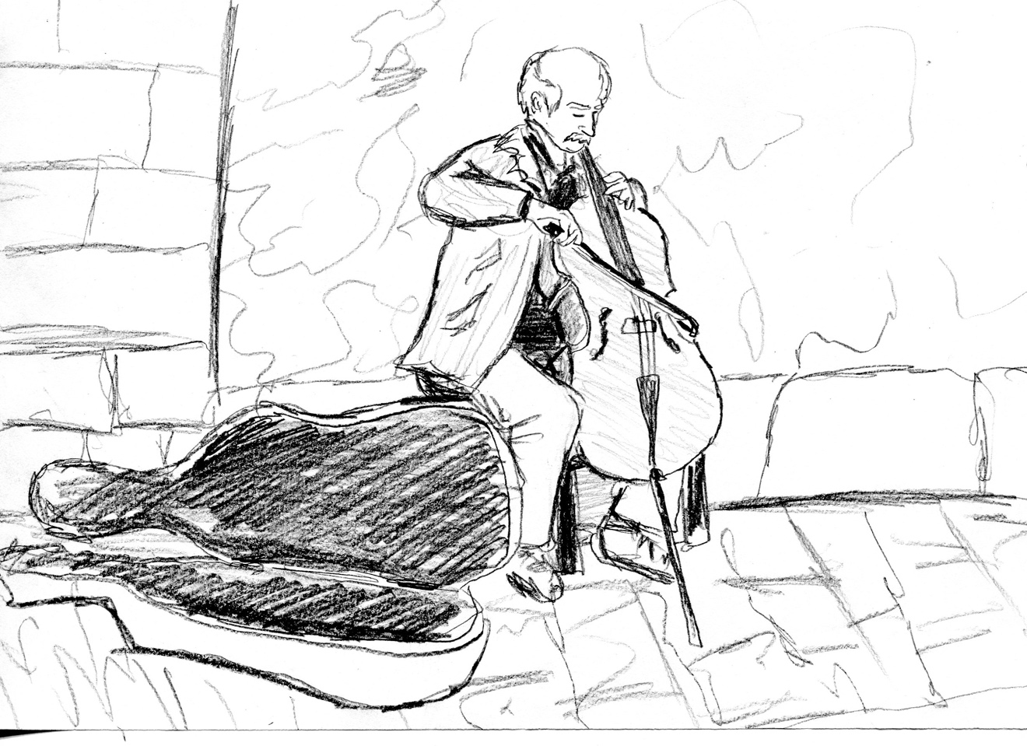
Figure 813: "Cellist by Florence Cathedral"
We didn’t have much of an agenda on our last day in Italy, but I woke up early anyway. Maybe it was the lingering effects of jet lag, or maybe it was just my awareness of how fleeting my final hours in Italy were, but I woke up at six AM and let the soft light of morning filter in through the blinds. Tess was still sleeping. She had gone out the night before with a group to the city center. I stayed in to finish my journal entry on Venice. I sat cross-legged on the floor of our hotel room with my notebook propped up on my knees. As the distant sounds of cars and trucks filled the air outside with the music of a city waking up, I sat and tried to sum up the whole experience in my mind. What did it all ultimately mean? All the adventures, all the sights, all the fantastic people I had met, what was the grand purpose? I scratched extra notes into my journal, trying to put it all into words. I sacrificed moments and memories to write things down, to spend the one or two hours a day feverishly scribbling the story of my trip in my notebook. A part of me wondered if I did it out of fear. Maybe it was easier for me to write things down than experience them. Maybe I was afraid that my short time in Italy would slip through my fingers like so much water.
For some reason, the word “estuary” was on my brain. An estuary is a place where saltwater and freshwater meet, like a river delta or a bay. The lagoons of Venice were estuaries. The Floating City’s brackish waters glowed turquoise in the high noon sun, but they were just another example of a maritime transition zone, an estuary. Transition was the key aspect of the definition. I couldn’t escape the feeling that my whole life at nineteen was a transition from something small to something great, a gentle winding river opening up to the vast blue sea. Time was weighing on me heavily. These precious few moments sitting on the floor of my Florence hotel would pass away as gradually as fresh water diffuses into the ocean until nothing remained.
My father once told me to take each moment, each new place, and hold it in your mind. “Just be aware that you may never be there again,” he said to me as I hugged him goodbye before going to the airport. “Enjoy it.”
I missed him. I missed my mother too. Even though I gave them a call nearly every night, I knew that they were eager for me to come home. My mom had promised that if I didn’t come back soon, our house would be overrun by dogs my dad would adopt to fill the void. That’s the life of an only child, though. I had never been so long away from them. Even though I was nominally an adult, with voting rights to boot, I did not feel like an adult most of the time. In many ways, being abroad felt liberating. I was thousands of miles away, fending for myself in a strange city, yet I loved every second of it. I heard Tess stirring in her bed. She laughed at how sheltered I was. She had lived on her own for a while and there seemed to be nothing new under the sun for her.
The Arno river was dark green in midmorning as Tess and I walked down the bustling streets to the Ponte Vecchio. It reminded me of a garter snake, slithering through the Italian countryside on its slow journey to the Ligurian Sea. Tess wanted to visit the leather merchants in the Artisan Quarter. She had her eye on a leather coat. Since it was the last day, she was willing to shell out the lucre for it. We entered a cramped little shop packed with all the dead cow skin goods imaginable. Each piece was stamped with the fleur de lis symbol of genuine Florentine handicraft. My fingers stroked the smooth surface of a satchel, feeling the raised cording and intricate patterns of rivets. Tess balked at the exorbitant cost of a leather jacket, and instead settled on a gorgeous purse. I considered buying a purse, too, but settled on a black wallet. It was simple and plain. The man who worked in the store said it was a man’s wallet, but that did not dissuade me. We exited the shop after purchasing our wares and set out to absorb our last few hours in Italy like a piece of bread soaking up the final drops of sauce from a fine meal.
We met up with Jada, Alex, and Sidney in the Piazza del Duomo. Alex was holding up our list of final scavenger hunt items that we needed to find before the trip was up. I looked at the yellow paper on the list and felt daunted by the number of unfound items remaining. We had been on so many day trips during our week in Florence that my group had been unable to make a decent dent in our daily to-dos. That’s what happens when one procrastinates, I suppose. We set off into the city, scrambling to gain photographic evidence of our exploration. First, we visited the church where Verrochio was buried, which proved to be slightly difficult as the church had a strict dress code banning exposed knees, and we all wore shorts. Luckily, I had done the slightly ridiculous thing of wearing not one, but two scarves on an 85-degree day. One was wound around my hair in a kind of 1940s headscarf, the other was on my neck for fashion purposes. Jada and I took my scarves and tied them around our waists in a sort of weird tie-skirt to hide our blasphemous legs from view. We looked very silly, but the guards let us through without comment. We slipped into the Basilica of Sant’Ambrogio, knees unnoticed, and took a picture of the interior where the famous painter was buried.
We then set out in search of the outdoor market. We had to eat a piece of fruit in the vicinity. To our horror, we discovered that the market was closed. The empty stalls hung around the plaza like skeletons, bare of covering wares. With no fruit to be found, we decided to play with the wording of our scavenger hunt demand.
“So we have to have a picture of one of us about to eat a piece of fruit,” I said, tapping my fingers reflexively against the case of my phone. “What can we do?”
“I know!” said Tess quickly, taking my phone in a fluid motion. “This is an Apple iPhone, isn’t it? You can pretend to eat an Apple!”
I grinned at Tess’ ingenuity. I pressed my teeth against the smooth case, being sure to show the Apple logo, and bit into my “market fruit.”
We crossed the last few items off our list and spent the rest of the afternoon strolling around Florence. I leaned against the stone railing overlooking the river. We were in a small square on the left bank of the Arno, where we had found a gelateria with 55 flavors (another item on our checklist). I ordered my green cup of dark chocolate and fresh raspberry gelato and ate it standing up as I watched the people pass on the street. The air was sweet with the promise of summer and the warm sun washed into me as I tasted the bittersweet bite of dark chocolate on my tongue. On the corner of the bridge, a cellist had set up shop by a statue of an angel. He drew his bow across the vibrating strings of his instrument and a classical refrain swept over the city. I didn’t know which composer wrote it. I imagined it was some famous Italian virtuoso. I smiled and closed my eyes, letting the music take me up into the sky so blue it seemed to be one great ocean above.
“This is a moment, Madeleine,” I said softly to myself. “Don’t forget.”
I stood there, eyes closed until the cellist ended the song. I tossed a couple euros into his case as I walked away. Back to the hotel, I looked at my face in the mirror. I was much tanner after thirteen days in Italy, the bronze in my skin speaking to something I had lost. It reminded me of my childhood, when long summer days in the broiling heat of Tennessee summers would cook my skin as brown as caramel. I would be as dark as my Croatian father from spending countless hours outside, building my own little worlds in the mud and stones of the dry creek bed in my backyard. Back then, I had no cares about the future or worries about the present. In those long gone times, I had been happy to play until the sky grew dark and my mother would call me in for dinner.
How much of our lives are built on memories? How many of those memories are true, not fabrications we create to fill in the blanks, to make our stories sound cohesive? I wrote for a while in my journal as I waited for Tess to get ready for our final dinner in Italy. I wrote about feeling completely and utterly joyful for the first time in a long time.
We went to dinner. We gave toasts to a successful study abroad. I ate rabbit for the first time, drowned in red wine sauce. Yet my mind was elsewhere. I looked around the table at all those faces, all those people whom I had come to know in our four weeks together. Would I ever see them again after this? I wanted to say that we would stay in touch, that our bonds forged in Italy would remain unbroken. But I doubted this. Even as I sat among them, making toasts and speaking of adventures, I knew that most of us would never speak again. Our lives would diverge once more and we would be little more than strangers with familiar faces who would occasionally pop up on each other’s Facebook feed, to be glanced at and forgotten. Friends for a season, then no more.
I knew who I was, how cagey I can be when it comes to human connection. I watched Tess and Jada laugh together, sharing an inside joke over bread dipped in oil. I wanted to be with them, in their moment of friendship and intimacy, but I felt separate. This was all coming to an end. In a day all would be back to normal. We would all return home to our lives wondering what had changed, if anything.
I wanted to say that the trip had changed me. I wanted to say that I had been enlightened. But the truth was, I did not know. I was afraid that going home would mean reverting to the status quo. I sighed and stared into my cup of mineral water, wishing it was wine. One needs wine when pondering whiney thoughts. But as I sat there, looking at all my classmates, I had to smile and be grateful. So few people are given the opportunity to go abroad. Even fewer people take that opportunity. Yet I was here in a little restaurant in Florence, sitting and laughing with my classmates as the sun set low in the west. I could not resist the warm feelings spreading over me. At that moment, I knew I was happy.
Even the next morning, as I stepped on the plane to Germany and then to America, I remembered how lucky I was. When we flew over the Alps, I looked down through the clouds at Italy, one last look. I smiled and finished my journal with a flourish. I wasn’t going to forget.
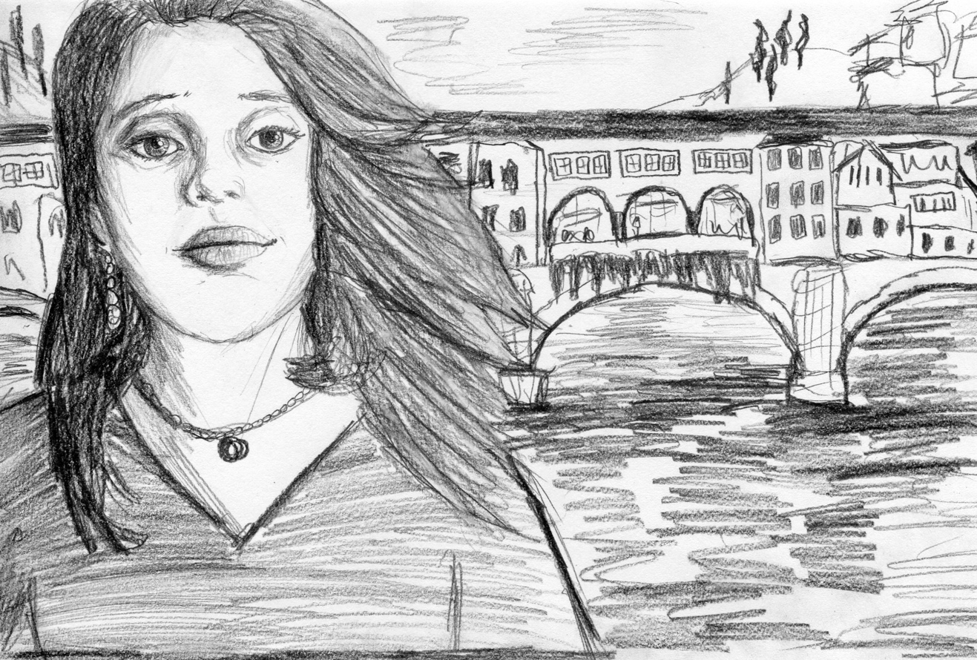
Figure 14: "Self Portrait by Ponte Vecchio"
EPILOGUE
It is a funny experience to revisit memories. Even the space of one or two years can color an event in a new hue. Reflection has a way of changing one’s point of view. What is one moment’s triumph can become another moment’s regret. What is horrifically embarrassing at nineteen can be uproariously funny at twenty-one. I feel that now. During the summer of 2016, I did something relatively daring. Of course, taking a two-week trip to Italy with a bunch of classmates is not some dangerous solo expedition into the Amazon, but for a girl as sheltered as I was at nineteen, any new place was the darkest jungle.
I had to fight for this trip. I had to convince my parents that Italy was safe in the midst of almost daily terrorist attacks in Europe. I had to convince parents’ friends that I was fully capable of making sound choices. I had to convince myself that this whole experience was worth the time, money, and risk when many other people in my life were telling me it was not worth it. To them, travel was silly. Why leave when you have everything you could ever want here? Wanderlust was not an admirable quality. They were discouraging my parents from letting me go. It was too expensive, too frivolous, too dangerous. They said I couldn’t handle being away from home for so long. I was too delicate.
I fought for it. I was a girl who never stood up to her elders for anything, but I stood up for this. They could not take it from me. I wanted to go on this trip, and I went on it. Even if I was going to do battle for every inch of freedom, every scrap of independence, I learned that fighting was better than rolling over. I was an adult, and I could make my own choices. For me, the greatest lesson I learned through my time abroad in Italy was that I could choose my own path. After our morning of group activities, I was free to wander the city, explore what I wanted to explore, do what I wanted to do. I could make up my mind and do something even with opposition because it was my decision. I got a high just from the sheer rush of independence.
In the months after I returned, the high gradually faded. I returned to my routines, and gradually those memories of the more independent person I was in Italy faded too. Six months later, my Venetian glass beads broke from my neck while I was at work. The string that held them to my throat snapped and all the black and white beads spilled from the thread onto the concrete floor. I froze with one hand outstretched and one hand on my neck as a dozen of the little glass spheres shattered on the floor. A few of the beads had been saved by my other hand pressed to my neck; however, the necklace was gone. Only a few sharp shards of glass and dust remained on a kitchen floor.
Is that what memories are like? Just a few glass beads that we save when the others are destroyed? How much of this trip would I remember in a year? How much would I remember in ten? My parents had gone on Eurotrips when they were young. Their recollections are fractured and contradictory. The only vivid images they still have are in those moments that have become repeated stories, snapshots in time. The act of telling a story saves that story. I carry a few of my parents’ stories with me. Before I was born, they used to travel the world. When they were single and recently married, their treks spanned four continents. They did not write anything down, though. There was no detail, no memoir, no record of their experience or thoughts or feelings.
I wrote my travel journal as a way to capture a moment. I wrote my thesis as a way to capture the experience of I looking back. Looking back is important. In this process of rewriting my little memoir, I have seen how much has changed, as well as what has endured. I am glad that I wrote it all down when I was there. I am even more pleased that I typed it all out here, capturing it for the future. It was only two weeks in the life of a naive college freshman, but those are two weeks that will not be lost in the sweep of time and loss of memory. I will have these memories for a lifetime.
I think a part of being a writer is a desire to be remembered, that maybe if you can create something beautiful, your struggles and pain can matter. The works we read from Vergil, Boethius, and Dante all deal with talented writers grappling with what a legacy means after you are gone. Will your stories survive the erosion of time? Will you find immortality in the written word? I think people write because they want to make something that might lasts longer than they will. They want to put a little bit of their soul into the universe so a part can live on even after death.
There’s an egotism to it. I certainly don’t have the genius of a Vergil or Dante. But I feel like they also wanted to make something great and lasting. Perhaps, like me, they too feared that their minds would be weathered by time until nothing remained but dust and forgotten shapes.
It is good to remember those moments when one feels fully alive. I cling to them in the times when the world seems dark and cold. That is what writing is to me, a reminder of what life can be if a person really takes the time to take it in. The world can be so heartbreakingly beautiful if people just look out and see it.
BIBLIOGRAPHY
Primary Texts
Alighieri, Dante. La Vita Nuova. Translated by David R. Slavitt. Harvard University Press, 2014.
Alighieri, Dante. Inferno. Translated by Robert Hollander and Jean Hollander. Doubleday, 2000.
Boethius. The Consolation of Philosophy. Translated by P.G. Walsh. Clarendon Press, 1999.
Poe, Edgar Allan. “The Coliseum.” The Poems of Edgar Allan Poe. Edited by Thomas Ollive Mabbott. The Belknap Press of Harvard University Press. 1980. 226-231
Poe, Edgar Allan. “The Philosophy of Composition.” Critical Theory: The Major Documents. Edited by Stuart Levine and Susan F. Levine. University of Illinois Press, 2009. 55-76
Maugham, William Somerset. The Gentleman in the Parlour. Random House, 2010.
Moreno, Michelle. Grammar Lessons. University of Iowa Press. 2014.
Pausanias. Description of Greece, Volume 1: Books 1-2 (Attica and Corinth). Translated by W. H. S. Jones. Harvard University Press. Revised Edition 1918.
Petrarch, Francis. “The Ascent of Mount Ventoux.” Petrarch: The First Modern Scholar and Man of Letters. Translated by James Harvey Robinson. G.P. Putnam, 1898. 307-320.
Polo, Marco. The Book of Ser Marco Polo: The Venetian Concerning Kingdoms and Marvels of the East. Vol 1 and 2. Translated and Edited by Colonel Sir Henry Yule. John Murray. 1903.
Twain, Mark. The Innocents Abroad. Collins Clear-type Press, 1869.
Vergil. Aeneid. Translated by Sarah Ruden. Yale University Press, 2008.

Secondary Texts
Durrell, Lawrence. Bitter Lemons of Cyprus. Faber & Faber, 2000.
Dyer, Geoff. Jeff in Venice, Death in Varanasi. Vintage Press, 2010.
Lamott, Anne. Bird by Bird: Some Instructions on Writing and Life. Pantheon Books, 1994.
McDonald, Jane Taylor. Living to Tell the Tale. Penguin Books. 1998.
Welty, Eudora. On Writing. Random House Publishing Group, 2011.

