Self-Leadership Strategies & Performance Perspectives Within Student Aviation Teams
Christopher R. Bearden
Middle Tennessee State University

A thesis presented to the University Honors College of Middle Tennessee State University in partial fulfillment of the requirements for graduation from the University Honors College

Spring 2017

Self-Leadership Strategies & Performance Perspectives Within Student Aviation Teams

by

Christopher R. Bearden

APPROVED:

____________________________ Dr. Michael Hein Psychology Department

____________________________ Dr. Greg W. Schmidt Psychology Department

___________________________

Psychology Department
Honors Council Representative

____________________________
Dr. Philip E. Phillips, Associate Dean
University Honors College

Acknowledgements
I would like to acknowledge the FOCUS lab team, including the graduate assistants, professors, supporting faculty, and even students. Their incredible expertise, selfless service, and esprit de corps have created a place of fantastic growth as well as provided me with the opportunity to conduct this study. I would also like to thank my thesis advisor, Dr. Michael Hein, to whom I owe a great deal for taking me on as his first undergraduate mentee on an undergraduate thesis project.

Abstract
The use of teams to achieve organizational goals requires companies to employ individuals that are competent at both performing individual tasks and working well with others. This study examines the relationship between performance strategies and the performance perceived by teammates and supervisors. Participants were aerospace students at a southern university engaged in operating a simulated flight dispatch center for course credit. A positive, statistically significant relationship was found between perceived team member effectiveness and expert-rated individual performance; however, the self-leadership strategies measured in this study were unrelated to the criterion variables. A follow-up investigation using confirmatory factor analysis indicates that the self-leadership measure did not adequately capture the construct.
Keywords: self-leadership, team member effectiveness, individual performance
Table of Contents
Acknowledgements iii
Abstract iv
Glossary vi
CHAPTER I: Introduction 1
CHAPTER II: Methodology 7
CHAPTER III: Analyses & Results 12
CHAPTER IV: Discussion 16
CHAPTER IV: Conclusion 22
Tables & Figures 30
List of Appendices 37

Glossary
Psychological and Statistical Terms
Behaviorally-anchored rating scale | Survey technique that uses statements about specific behaviors to guide responses. This technique tends to increase the reliability of responses.
Confirmatory factor analysis | Statistical test used to measure the degree data collected fits a theorized or hypothesized model.
Likert scale | A survey scale that provides respondents with pre-coded numerical values.
Meta-analysis | Powerful statistical technique that combines the results of multiple studies.
Reliability | In statistics, the degree of consistency in results.
Self-leadership | Comprehensive self-influencing process that includes self-control while addressing the reasons for behavior.
Task analysis | Process by which job duties are broken down into various steps and explicitly connected to various requisite knowledge, skills, and abilities.
Validity | In statistics, the degree of confidence in the correctness or applicability in the measurement tools.

Statistical Symbols
α | - Alpha level: The probability that the finding is a false positive.  - Cronbach’s alpha: A measure of internal consistency or is interpreted as the lower-bound of the scale’s reliability.
β | Beta weight: The slope of a line in a regression equation.
r_{wg} | An index of within-team agreement: r, as in the correlation coefficient, and within-group (wg).
r | Pearson product-moment correlation coefficient: A measure of the linear relationship between two variables.
R² | Squared multiple correlation coefficient: Represents the proportion of variability in each item explained by the latent variable.
SD | Standard deviation: The average deviation of values around the mean.
N or n | Capital N represents the total number of participants in the study. Lowercase n indicates the number of participants in a subgroup within the study.
p | p value: A statistic derived from data that indicates the probability of an observed (or more extreme) result, assuming the null hypothesis is true.
SE | Standard error: A measure of statistical accuracy.
X̄ | Mean: The mathematical average.
χ² | Chi-square: A statistical test that compares the distribution of values to a theoretical distribution.

Tables & Figures
Table 1 | Descriptive Statistics
Table 2 | Correlations Between Measured Variables
Table 3 | Within-Team Rater Agreement (r_{wg}) on CATME-B Item 1: Contributions to the Team’s Work
Table 4 | Within-Team Rater Agreement (r_{wg}) for CATME-B Item 2: Contributions to Teammate Interaction
Table 5 | Within-Team Rater Agreement (r_{wg}) for CATME-B Item 3: Possession of Knowledge, Skills, and Abilities
Figure 1 | Diagram of student roles in the research setting.
Figure 2 | Model of self-leadership proposed by Houghton, Dawley, and DiLiello (2012) and tested by this study.

CHAPTER I

Introduction
Manz (1986) expanded upon his pre-existing theory of self-management (Manz & Sims, 1980) by incorporating many developments in psychology to explain a comprehensive self-influence process. He calls this process self-leadership, which entails both proactive behaviors and thought processes geared towards engineering more productive and positive affective experiences. It is literally leadership of the self toward “personal standards and natural rewards” (Manz, 1986, p. 585). Many of the underlying theories are descriptive in that they provide an explanation for how phenomena occur. For example, Bandura’s (1986) social cognitive theory explains the mutually influential interaction between personal behavior, the environment, and personal qualities. However, self-leadership is a normative theory, which means it is prescriptive, describing how individuals should act rather than explaining why they do.
Organization-level outcomes may be contingent upon individual-level performance strategies (Krokos, Baker, Alonso, & Day, 2009), and self-leadership strategies may be able to improve individuals’ effectiveness at work (Andressen, Konradt, & Neck, 2011). The aim of the present study is to explore the psychometric properties of a measure of self-leadership and compare how self-leadership relates to both individual performance and perceived team member effectiveness in a team-based work setting. Finally, since performance is perceived differently by peers and supervisors (Murphy & Cleveland, 1991), the study will provide a comparison between the perspectives of team members and outside observers on work role performance using a correlational design.

Literature Review
Self-leadership rests on the assumption that learning is an internal mental process and that individuals use feedback from the environment to inform behaviors. Social cognitive theory (Bandura, 1986) describes this process through reciprocal determinism, wherein the environment influences individual behavior and personal qualities such as self-efficacy, i.e. the belief in one’s capacity to succeed. According to Manz (1986), a person utilizing self-leadership “chooses externally controlled situations to achieve personally chosen standards” (p. 589). Houghton, Dawley, and DiLiello (2012) use the example of choosing to routinely jog down a scenic trail. This example embodies the way in which individuals structure their environment in order to enjoy a task or activity and increase personal motivation.
Self-leaders are able to incorporate intrinsic motives into tasks that are typically not naturally motivating through self-goal setting (Manz, 1986). Locke, Shaw, Saari, and Latham’s (1981) seminal work on the power of goal setting suggests that merely establishing reasonable goals increases performance and intrinsic motivation. According to intrinsic motivation theory (Deci, 1975), this is because individuals develop specific intrinsic motives in order to meet a need for competence or self-efficacy, and goal achievements provide the recipient with positive feedback on performance, which both meets the need for self-efficacy and enhances intrinsic motivation (Deci & Ryan, 1985). Therefore, by incorporating tangible accomplishments into tasks, self-goal setters may be more engaged in tasks they find difficult or even unpleasant (Houghton et al., 2012).

Behavior Strategies
Self-leadership encompasses several behavior-focused strategies related to self-regulation and self-management (Andrasik & Heimberg, 1982; Luthans & Davis, 1979; Mahoney & Arnkoff, 1978; Manz & Sims, 1980). Manz suggested that several processes extant in the literature can be functions of a more comprehensive system of self-influence, i.e. self-leadership. For instance, self-punishment, self-cueing, and rehearsal are self-management strategies proposed by Mahoney and Arnkoff, which Manz and Sims hypothesized could motivate future performance by a desire for favorable long-term consequences. However, the self-influence process proposed by Manz (1986) suggests that these strategies are adopted to reduce reliance on external factors and include intrinsically appealing aspects of work. Therefore, self-leadership includes behavioral components of self-management theory and expands them by incorporating a higher level of rationale for guiding behavior, providing reasons for behavior management.
Cognitive Strategies
Several cognitive-oriented strategies in self-leadership are explained by Vygotsky’s (1986) verbal theory of self-regulation and the positive psychology movement (Burns, 1980; Ellis, 1977; Seligman, 1991). Functional strategies associated with self-leadership include evaluating assumptions and eliminating dysfunctional beliefs (Burns, 1980; Ellis, 1977) and consciously initiating positive internal dialogues (Seligman, 1991). In support of the usefulness of these types of cognitive process, Driskell, Copper, & Morran’s (1994) meta-analysis of 62 studies on mental imagery found that mental task practice has a significant positive effect on performance. Self-talk has also been shown to improve performance for children in tasks (Lee, 1999; Winsler, Manfra, & Diaz, 2007). Moreover, Brinthaupt, Hein, and Kramer (2009) conclude that self-talk does serve a vital role in adult self-regulation. Further, their results show that individuals who engage in higher levels of self-reinforcing self-talk report more positive self-esteem.
Rationale
Self-Leadership & Individual Performance
Since its inception, several studies have seized self-leadership and tested its implications to determine if self-leaders exhibit better individual performance. In fact, several studies have identified a significant positive relationship between self-leadership and the user’s performance (Andressen, Konradt, & Neck, 2011; Hauschildt & Konradt, 2012; Neubert & Wu, 2006; Prussia, Anderson, & Manz, 1998; Stewart & Barrick, 2000). Hauschildt and Konradt found that individual self-leadership is related to the individual work role performance of team members in a variety of interdependent teams in Germany. Positive relationships between self-leadership and individual performance have also been discovered in an academic setting when students’ academic performance was rated by an instructor (Prussia et al., 1998) and in organizations when team leaders rate overall job performance (Andressen et al., 2011). Hence,

Hypothesis 1: Self-leadership will be positively and significantly correlated with observer-rated individual performance.

Self-Leadership & Perceived Team Member Effectiveness
An efficacy judgement (i.e. a judgement of competence) is one of the two universal ways individuals automatically assess one another (Fiske, Cuddy, & Glick, 2007). Further, for contexts in which influence is shared, Burke, Fiore, and Salas (2003) assert that team members must have confidence in the abilities of one another. Therefore, perceptions of other members are an important perspective when determining overall performance. Behavioral self-leadership strategies, such as engaging in audible self-talk, may affect how the user is perceived by his or her teammates, and while previous research suggests performance can be predicted by the cognitive-behavioral performance strategies subsumed under self-leadership, no empirical study to date has confirmed whether these strategies manifest in performance as perceived by teammates. Nevertheless, a current theoretical paper suggests individual level self-leadership strategies may lead to overall enhanced team efficacy, trust, and commitment over time through member-to-member interactions (Bligh, Pearce, & Kohles, 2006). Therefore, the following hypothesis was formulated,

Hypothesis 2: Self-leadership will be positively and significantly correlated with perceived teammate effectiveness.

Individual Performance and Perceived Team Member Effectiveness
Individual work behaviors are perceived differently by peers and supervisors (Murphy & Cleveland, 1991). For example, team member talking may lead to perceived competence by team members (Littlepage, Schmidt, Whisler, & Frost, 1995); however, talking may not lead to increased job performance on individual taskwork or job duties. Vance, MacCallum, Coovert, and Hedge (1988) provide evidence that there can be multiple valid perspectives on team member performance. Ratings may differ because the focus of supervisors is on an overall effectiveness, while team ratings may be influenced by other factors (Holzbach, 1978). Furthermore, supervisors may be able to recognize and distinguish performance behaviors better due to their greater awareness and sensitivity (Holzbach). However, team members (i.e. peers) and supervisors should observe and favorably rate constructive behaviors in a workplace setting, and although individual behaviors could be interpreted slightly differently by peers and observers, ratings should display some convergence. Therefore,

Hypothesis 3: Observable individual performance will be correlated with peer-rated/perceived team member effectiveness.

CHAPTER II

Methodology
Participants
All participants (N = 98) were students enrolled in a southern university’s Aerospace Seminar. The pool of participants is from Spring semester 2016 and Fall semester 2016. No data on participant demographics were collected; however, all participants were enrolled in an undergraduate senior-level aerospace capstone course designed to be completed the semester prior to graduation. Participation in the laboratory portion of the class is required for graduation; however, participation in the research portion was voluntary. Institutional review board approval and informed consent was obtained before commencing data collection. No compensation was provided to participants. Participants were assigned to teams of approximately ten by the instructor of the aerospace seminar according to their major discipline/concentration within the aerospace program. Data from participants in a total of 10 teams are included. Six teams were formed in the Spring semester of 2016 and four teams were formed in the Fall semester of 2016. The average team size was 10 participants (SD = .63).
Procedure
Laboratory. The Flight Operations Center – Unified Simulation (FOCUS) lab itself incorporates multiple software components and technologies to simulate a regional flight dispatch center (Lester, 2015). Large-screen monitors display weather, radar, and the airline’s flight schedule. Students are situated at computers with headsets, access to job-aid materials, and have operational control of the simulated airline. Each semester, every student enrolled in the Aerospace Seminar is assigned to a team. Students receive an onboarding brief as well as job and team training. The training process in the FOCUS lab is designed to build cross-specialization coordination (Littlepage, Hein, Moffett, Craig, & Georgiou, 2016). Each team completes a minimum of three simulations during the course of the academic semester.
See Figure 1 for a layout of the research setting. Dispatching flights within the lab requires coordination and information sharing from every student position. The positions featured in the lab include: flight operations coordinator, weather and forecasting, crew scheduling, flight operations data 1 – scheduling, flight operations data 2 – planning, maintenance, and pilot. Outside the nuclear team (central positions seated within the lab), several student positions make contributions to the team’s work and facilitate creating a more realistic experience. These positions include student pilots operating a Canadair Regional Jet (CRJ) flight simulator at the campus airport and a duty pilot performing the duties of the ramp tower coordinator. The CRJ flight simulations and communications are incorporated into the dispatching simulations of the FOCUS lab.
Measures
Abbreviated self-leadership questionnaire (ASLQ). The ASLQ is a 9-item scale used to briefly measure self-leadership. It was first published by Houghton and his colleagues (2012) and is supported as a reliable and valid measure of global self-leadership (Nel & Zyl, 2015; Şahin, 2015). Self-leadership is assessed using three 3-item subscales. Each subscale can be traced to the self-leadership literature: behavior awareness and volition (Georgianna, 2007), constructive cognition (Anderson and Prussia, 1997), and task motivation (Houghton & Neck, 2002). An example of an item measuring behavior awareness and volition is “I make a point to keep track of how well I’m doing at work,” and an example of an item measuring constructive cognition is “Sometimes I talk to myself (out loud or in my head) to work through difficult situations.” Lab participants self-reported on the ASLQ using a 5-point Likert scale from 1 (rarely) to 5 (usually) during the final class meeting of the semester.
Behaviorally-anchored comprehensive assessment of team member effectiveness (CATME-B). Each lab participant rates his or her team members (i.e. peers) using the CATME-B (Ohland et al., 2012). The CATME-B is a behaviorally-anchored rating scale (BARS) ranging from 1 (below average) to 5 (excellent). In a BARS, participants are given a list of “anchors” describing behaviors that would typify or represent each category of excellent, average, or below average. Team members did not rate themselves because self-ratings tend to be overly biased (Holzbach, 1978), especially for poor performers (Murphy & Cleveland, 1991). Each team member is reported on by his or her peers using three dimensions: contributions to the team’s work, teammate interaction, and possession of related knowledge, skills, and abilities (KSA):
- Contributions to the team’s work: does high-quality work; helps teammates; completes tasks; is timely in completing assignments.
- Teammate interaction: is supportive; asks for teammate contributions; respects others; communicates clearly; shares information.
- Possession of related knowledge, skills, and abilities (KSAs): acquires skills needed to meet requirements; is able to perform duties of other teammates; demonstrates skill in contributing to the team’s work.
Every dimension is measured with a single item and has its own set of relevant behavior-anchors. In the following example question, “Rate each team member on his or her contributions to the team’s work,” some anchors for excellent are as follows: “Does more or higher-quality work than expected; makes important contributions that improve the team’s work; helps teammates who are having difficulty completing their work.” Contrastingly, some anchors for below average on the same item are: “Does not do a fair share of the team’s work; misses deadlines; does not assist teammates.” The scale is a published, reliable, and valid measure of team member effectiveness (Ohland et al.). Team member effectiveness data was collected after the third simulation.
Individual performance measures. A series of 8-, 9-, and 10-item scales were used to assess participants’ individual performance during the simulations. The number of items varies by position within the lab: flight operations coordinator, 10 items; weather and forecasting, 9 items; crew scheduling, 9 items; flight operations data 1 – scheduling, 8 items; flight operations data 2 – planning, 9 items; and maintenance positions, 9 items. Each scale was created by researchers in the lab through the process of task analysis, in which essential work role behaviors were identified for each position. The task analysis information was translated into items that assess the frequency with which each participant engages in these behaviors. Each scale contains three items related to communication that remain the same, but all other items are unique because they relate to the specific behaviors that each respective position must perform. Individual performance is not measured for pilots who operate the flight simulator connected to the FOCUS lab.
After every simulation, trained observers (i.e. research staff) rate how often an individual performed the essential functions during the simulation on a Likert scale from 1 (never) to 7 (always). Some example items are “Shares relevant information as needed with other team members” and “Performs dispatch duties in a timely manner.” As each participant engages more frequently in each of his or her work role behaviors, the overall team performance in the lab is increased, demonstrating the criterion validity of the measures (Ivakh, 2013). Ratings of individual performance presented in the study were assigned during the participants’ third iteration in the simulation.
Data Management
Not all participants completed all portions of the research. Further, students who were in either a pilot position (19.4%; n = 19) or the ramp tower coordinator (8.2%; n = 8) provided data that were not used in comparison of performance analyses or in calculating rater agreement; however, their data were used in the factor analysis of the self-leadership instrument. These positions are situated outside the immediate physical lab, and their perspectives, while arguably valid, may be markedly different and could greatly impact reliability. Therefore, most analyses do not include the full number participants (N = 98). The instruments previously mentioned were either already in use within the lab or selected by the researcher specifically for minimizing the time burden to the participants without compromising the value of the possible contributions to the research literature. All surveys of team member effectiveness and self-leadership were administered via Qualtrics under the supervision of a researcher in the aerospace computer lab. Researcher ratings of individual performance were completed on personal electronic devices during or immediately following the simulations. Data analyses were conducted using IBM SPSS, Amos 23.0.0, and R version 3.3.2.

CHAPTER III

Analyses & Results
Initial Analyses
Unless otherwise denoted, all analyses were conducted using SPSS. See Table 1 for descriptive statistics. Cronbach’s alpha (α) is widely accepted as a measure of internal consistency or is interpreted as the lower bound of the scale’s reliability (Cortina, 1993). It describes the degree of interrelatedness a set of items possesses on a scale from .00 to 1.00. Typically, values of .70 are considered acceptable levels of reliability on a unidimensional scale (Cortina, 1993). The scales for individual performance demonstrated acceptable levels of reliability (α = .70 - .97). The lowest estimate of reliability for a measure of individual performance was the “flight operations data 1 – scheduling” position (.70) and the highest estimate was the “weather & forecasting” position (.97). The overall abbreviated self-leadership questionnaire demonstrated acceptable reliability (α = .78); however, when assessing the subscales of behavior awareness and volition (α = .70), task motivation (α = .64), and constructive cognition (α = .38), the reliability estimates were at or below an acceptable value.
Because participants do not rate their own effectiveness themselves, there are missing values within the matrix of ratings. Therefore, Cronbach’s alpha could not be calculated for the CATME-B because the calculations require no missing values. To achieve a metric of interrelatedness for team member ratings similar to coefficient alpha, an index of within-team agreement was calculated using R version 3.3.2. The correlation of ratings within a group (r_{wg}) must be calculated per item and provides a value between .00 (no agreement) and 1.00 (perfect agreement; James, Demaree, & Wolf, 1984). Ideally, each team would have at least a moderate level of consensus on the ratings of effectiveness per position. If there is perfect agreement, then each rater assigned the same score to the team member rated. Generally, a minimum value of .70 is considered an acceptable level of agreement (James et al.; Woehr, Loignon, Schmidt, Loughry, & Ohland, 2015). Ratings assigned by a participant in either the Ramp Tower or Pilot position were not used in these calculations. The average level of within-team agreement on the CATME-B for all teams (across all positions) is listed sequentially here: .81, .87, .79, .88, .84, .78, .94, .54, .85, .72 (min. = .00, max. = 1.00).
On average, across the three CATME-B items, the ten teams generally had the most agreement on the maintenance position, r_{wg} = .89, and the least amount of agreement on the weather position, r_{wg} = .70. Agreement, per item, was weakest on contributions to teammate interaction, r_{wg} = .79. On average, both of the other items, contributions to the team’s work (r_{wg} = .82; min = .73, max = .92) and possession of knowledge, skills, and abilities (r_{wg} = .82; min = .71, max = .88), had strong agreement across teams (Woehr et al.). Ratings on which the teams did not have sufficient agreement (r_{wg} < .70) were removed before correlations were calculated. For instance, Team 9 had no within-team agreement (r_{wg} = .00) on their ratings of the flight operations coordinator for CATME-B Item 1 (rating contributions to the team’s work). Team nine’s flight operations coordinator rating was removed via listwise deletion.
Each measure varies slightly in rating scale: the abbreviate self-leadership questionnaire contains nine items rated on a one-to-five scale, and the individual performance measures vary for each position (8 to 10 items) on a scale from one to seven. Therefore, the average scores were used for each participant (rather than an aggregate score) to calculate correlations. Average scores for self-leadership (X̄ = 4.10, SD = 0.45, n = 59), team member effectiveness (X̄ = 4.42, SD = 0.33, n = 57), and individual performance (X̄ = 5.43, SD = 0.88, n = 42) are displayed with descriptive statistics in Table 1.
See Table 2 for correlations. Self-leadership of participants was not correlated with perceived team member effectiveness as rated by his or her peers (r = .14, p = .23). Similarly, self-leadership was not correlated with individual performance as rated by the lab supervisors (r = -.06, p = .65). Therefore, insufficient evidence was provided by the study to support Hypothesis 1 and Hypothesis 2. However, team member effectiveness was positively correlated with individual performance (r = .41, p < .001), which provides support for Hypothesis 3.
Confirming the Abbreviated Self-Leadership Questionnaire
See Figure 2 for factor model. In confirmatory factor analysis (CFA), the covariance structure implied by the theoretical model is compared to the covariance matrix of the sample data (Cheung & Rensvold, 2002). The abbreviated self-leadership questionnaire data were analyzed using CFA in SPSS AMOS version 23.0.0. Each item was loaded onto a single factor, or latent variable (i.e. self-leadership), and the model was estimated using maximum likelihood. Values seen in Figure 2 indicate most of the items were poorly accounted for by the latent variable, with squared multiple correlation coefficients (R²) displayed above the box representing each item. Typically, values above .70 or 70% are desirable. Additionally, several of the items were not explained by self-leadership, namely constructive cognition Item 1 (CC_1) “I try to mentally evaluate the accuracy of my own beliefs about situations I am having problems with,” β = .23, SE = .11, R² = .06 and task motivation Item 1 (TM_1) “When I have successfully completed a task, I often reward myself with something I like,” β = .24, SE = .13, R² = .05.
Further, the model is evaluated by how well the sample data “fits with” the model-implied matrix. This is accomplished using goodness-of-fit indices, which are used in determining whether the model is a plausible explanation for the observed data. The CFA results indicated a lack of fit, χ² (27, N = 85) = 48.82, p = .006, comparative fit index (CFI; Bentler, 1990) = .88; Tucker-Lewis Index (TLI; Tucker & Lewis, 1973) = .83; and root mean square error of approximation (RMSEA, Steiger & Lind, 1980) = .10. A minimum value of .90 for the CFI and the TLI are generally required for the model to be accepted as plausible (Cheung & Rensvold, 2002). Furthermore, the rule-of-thumb for an acceptable RMSEA value is typically a maximum of .08 (Thompson, 2004). Combined, these results suggest that the abbreviated self-leadership questionnaire (ASLQ) does not adequately measure self-leadership in the sample.

CHAPTER IV

Discussion
The full measure of self-leadership demonstrated acceptable internal consistency using Cronbach’s alpha; however, when examining the constituent subscales, two of the subscales had poor reliability (task motivation, α = .64; constructive cognition, α = .38). All of the individual performance scales demonstrated acceptable levels of reliability (α = .70 - .97). Moreover, there was sufficient within-team agreement across the 10 teams to compare perceived team member effectiveness with other constructs such as participant self-leadership and individual performance. Although the CATME-B scale was designed so that a 3.00 on the scale would represent average team member effectiveness (Ohland et al.), the average across the three items in this study was 4.00. Despite the behavior anchors provided to the raters, it appears that they did not utilize the full scale. Team members may have been unwilling to rate their teammates as below average or did not perceive their teammates as below average. Another interpretation is that the behavior anchors do not generalize to the work setting in such a way as to allow the raters to assign accurate ratings of effectiveness.
Average inter-rater agreement was weakest on contributions to teammate interaction (r_{wg} =.79), which could indicate a need for more specific or different behavior anchors for teammate interaction. This could also reflect discrepancies in the way that individuals define teammate contributions to team interaction in certain positions within the lab. For example, the flight operations coordinator has a clearly defined role in team interaction (average r_{wg} = .75) through dispatching of flights at regular intervals, and therefore may be judged more on supportive statements or solicitations for teammate contributions. Contrastingly, the weather and forecasting position does not require systematic information exchange in the same way, and therefore his or her contributions to teammate interaction (average r_{wg} = .65) may be evaluated more on information sharing or clear communication.
The strong average agreement across the 10 teams on contributions to the team’s work (r_{wg} = .82; min = .73, max = .92) and possession of knowledge, skills, and abilities (r_{wg} = .82; min = .71, max = .88) could indicate a shared perception of overall general effectiveness of team members, which may be easier to rate using these items. Another explanation is that it reflects participants’ shared understanding of the valuable contributions of the various aviation specialties to the success of the team in running the dispatch center. Across the three items, teams generally shared the most amount of agreement on the effectiveness of the maintenance position (r_{wg} = .89) and the least amount of agreement on the effectiveness of the weather and forecasting position (r_{wg} = .70).
Individual performance was found to be significantly and moderately correlated with team member effectiveness (r = .41, p < .001), which supports Hypothesis 3. On average, as team members were perceived as more effective by their peers, they were also rated more favorably by their supervisors on the frequency of job-related behaviors. Therefore, team members seen by their peers as possessing superior knowledge, skills, and abilities, and contributing to teammate interaction and contributing to the team’s work were also rated as higher performers by the researchers in the lab. This third comparison between team member effectiveness and individual performance provides evidence for the convergent validity of the individual performance measures. Team member effectiveness was measured using an established instrument, the comprehensive evaluation of team member effectiveness (Ohland, et al.), and individual performance was measured using an instrument developed by researchers within the lab. Because individual performance and team member effectiveness were found to be positively related, this suggests that the instrument developed in the lab is a viable measure of performance.
The first and second hypotheses, stating that self-leadership would be positively and significantly correlated with both individual performance and team member effectiveness, were not supported by the initial analyses. Team member effectiveness was positively correlated with self-leadership (r = .14, p = .23), but the correlation was not statistically significant. Interestingly, self-leadership’s correlation with individual performance was also not statistically significant (r = -.06, p = .65). However, results from the CFA determined self-leadership was not reliably captured by the abbreviated self-leadership questionnaire, especially task motivation and constructive cognition strategies. Therefore, it is not clear whether self-leadership is truly unrelated to performance in the FOCUS lab.
Overall, the abbreviated self-leadership questionnaire (ASLQ) performed poorly when compared to previous psychometric evaluations (Nel & Zyl, 2015; Şahin). The reliability estimates reported by Nel and Zyl for the questionnaire and its subscales were much higher than the results presented in this study: the 9-item scale reliability decreased from .89 to .78. Further, the coefficient alphas decreased in each of the subscale dimensions: behavior awareness and volition from .85 to .70, constructive cognition from .78 to .64, and task motivation from .71 to .38. Moreover, the same model, as tested in Nel and Zyl’s research (2015; N = 405), had higher CFA fit-indices (indicating a better statistical fit of the model to the data) than in the present, e.g., CFI = .99 versus in the CFI = .88 in this study, and RMSEA = .07 versus RMSEA = .10 in the present study. Şahin’s reliability estimates for the self-leadership subscales (between .42 and .76) were lower than those reported by Nel and Zyl and similar to those found in this study. However, the CFA conducted on the ASLQ by Şahin (N = 324) resulted in fit-indices that closely approximated Nel and Zyl’s findings, CFI = .98 and RMSEA = .06. While is it not possible to test the statistical significance of the disparate fit indices across the three studies, the previous studies indicate the model is plausible, and the fit indices in this study indicate the model is not plausible. The fit indices may be better in both of the previous studies due to their larger sample sizes.
The ASLQ was selected to establish a quick measure of performance strategies that could be used to predict individual performance in the research setting while minimizing the burden to participants. As an established measure, the reliabilities of the scale and subscales should supersede the minimum values (.70). Results from this study show that the three factors of behavior awareness and volition, constructive cognition, and task motivation, as measured by the ASLQ, may not be specifically relevant to the sample of participants. Another possible reason for failed reproducibility of the studies in the literature is this study’s small sample size. Still, this sample of participants in this study is markedly different from those in Nel and Zyl’s study, as well as Şahin’s examination. Therefore, results from this study could reflect sample characteristics rather than a global self-leadership construct. The generalizability of the results of this study is not known, but future attempts to utilize the ASLQ as a measure of self-leadership (especially in the aviation industry) should consider a pilot study to test whether the measure will adequately capture the construct.
The positive relationship between self-leadership and individual performance has been found using self-reported individual performance (Hauschildt & Konradt) and more extensive measures of self-leadership (Andressen et al.), but not with the shorter 9-item abbreviated self-leadership questionnaire. The studies by Andressen et al. and Hauschildt and Konradt provided the basis for hypotheses one and two, yet because the self-leadership construct was measured in both studies using a more diversified instrument that included a wider scope of dimensions identified by Manz to be associated with the construct of self-leadership, future research in a similar setting should consider utilizing a more robust measure. Item sampling error is error introduced into the analysis because the specific set of items selected failed to measure the intended construct within the sample and is one of the possible explanations for why the abbreviated self-leadership questionnaire failed to reliably measure the constructs included. More specifically, participants may use task motivation or constructive cognition to improve their performance, but the specific items included in the instrument did not accurately represent the construct to the sample of participants.
The first several psychological instruments to be used to measure self-leadership included a minimum of 34 items that spanned nine dimensions of self-leadership (Cox, 1993; Manz, 1993). Additional scales for measuring self-leadership have been designed by researchers since 1993, including those presented by Anderson and Prussia (1997) and Houghton and Neck (2002). Most of these scales include more factors, and may be more appropriate to measure self-leadership within the research setting. Some example constructs included in these measures are self-problem-solving initiative and self-observation. Participants in the lab may utilize several of these strategies, which are associated with self-leadership, but were not included in the abbreviated self-leadership questionnaire. In other words, future research should widen the scope of the instruments to ensure that enough sample characteristics are measured, which will require more items that measure additional dimensions to ensure the construct of self-leadership is adequately captured.

CHAPTER IV

Conclusion
Initial results investigating the internal consistency of the abbreviated self-leadership questionnaire were questionable; however, upon further review, the results presented in this study suggest that the abbreviated self-leadership questionnaire is not a reliable measure of self-leadership in the present research setting. The generalizability of these results is unknown, but future application of the abbreviated self-leadership questionnaire in an aviation science or aviation work setting may require a pilot study to determine if the measure is able to capture the self-leadership construct. A more robust measure of self-leadership, such as the self-leadership questionnaire (Anderson & Prussia), may be a better measure because not all dimensions of self-leadership or items measuring these dimensions may generalize to various settings (Neubert & Wu). Additionally, peer ratings of team member effectiveness were found to be positively correlated with observed individual performance as rated by lab researchers. This provides evidence supporting the construct validity (especially convergent validity) of the individual performance measures, which were designed within the lab.
References
Anderson, J. & Prussia, G. (1997). The self-leadership questionnaire: Preliminary assessment of construct validity. The Journal of Leadership Studies, 4, 119-143. doi:10.1177/107179199700400212
Andrasik, F., & Heimberg, J. (1982). Self-management procedures. Handbook of Organizational Behavior Management, 219, 247.
Andressen, P., Konradt, U., & Neck, C. P. (2011). The relation between self-leadership and transformational leadership: Competing models and the moderating role of virtuality. Journal of Leadership & Organizational Studies, 19(1), 68-82. doi:1548051811425047
Bandura, A. (1986). Social foundations of thought and action: A social cognitive theory. Englewood Cliffs, NJ: Prentice-Hall.
Bentler, P. M. (1990). Comparative fit indexes in structural models. Psychological Bulletin, 107(2), 238. doi:10.1037/0033-2909.107.2.238
Bligh, M., Pearce, C., & Kohles, J. (2006). The importance of self-and shared leadership in team based knowledge work: A meso-level model of leadership dynamics. Journal of Managerial Psychology, 21(4), 296-318. doi:10.1108/02683940610663105
Brinthaupt, T., Hein, M., & Kramer, T. (2009). The self-talk scale: Development, factor analysis, and validation. Journal of Personality Assessment, 91(1), 82-92. doi:10.1080/00223890802484498
Burke, C., Fiore, S., and Salas, E. (2003). The role of shared cognition in enabling shared leadership and team adaptability. In C. L. Pearce and J. A. Conger (Eds.), Shared Leadership: Reframing the Hows and Whys of Leadership (pp. 103-22). Thousand Oaks, CA: Sage Publications.
Cheung, G. W., & Rensvold, R. B. (2002). Evaluating goodness-of-fit indexes for testing measurement invariance. Structural equation modeling, 9(2), 233-255. doi:10.1207/S15328007SEM0902_5
Cortina, J. M. (1993). What is coefficient alpha? An examination of theory and applications. Journal of Applied Psychology, 78(1), 98. doi:10.1037/0021-9010.78.1.98
Cox, J. F. (1993). The effects of superleadership training on leader behaviour, subordinate self-leadership behaviour and subordinate citizenship. (Unpublished doctoral dissertation). University of Maryland, College Park, MD.
Deci, E. L., & Ryan, R. M. (1975). Intrinsic motivation. Hoboken, NJ: John Wiley & Sons.
Deci, E. L., & Ryan, R. M. (1985). Intrinsic motivation and self-determination in human behavior. New York, NY: Plenum.
Driskell, J. E., Copper, C., & Moran, A. (1994). Does mental practice enhance performance? Journal of Applied Psychology, 79(4), 481. doi:10.1037/0021-9010.79.4.481
Ellis, A. (1977). The Basic Clinical Theory of Rational-emotive Therapy. New York, NY: Springer.
Fiske, S. T., Cuddy, A. J., & Glick, P. (2007). Universal dimensions of social cognition: Warmth and competence. Trends in Cognitive Sciences, 11(2), 77-83. doi:10.1016/j.tics.2006.11.005
Furtner, M. R., Rauthmann, J. F., & Sachse, P. (2015). Unique self-leadership: A bifactor model approach. Leadership, 11(1), 105-125. doi:10.1177/1742715013511484
Georgianna, S. (2007). Self-leadership: A cross-cultural perspective. Journal of Managerial Psychology, 22(6), 569-589. doi:10.1108/02683940710778440
Hauschildt, K., & Konradt, U. (2012). Self-leadership and team members' work role performance. Journal of Managerial Psychology, 27(5), 497-517. doi:10.1108/02683941211235409
Holzbach, R. L. (1978). Rater bias in performance ratings: Superior, self-, and peer ratings. Journal of Applied Psychology, 63(5), 579. doi:10.1037/0021-9010.63.5.579
Houghton, J. D., Dawley, D., & DiLiello, T. C. (2012). The abbreviated self-leadership questionnaire (ASLQ): A more concise measure of self-leadership. International Journal of Leadership Studies, 7(2), 216-232.
Houghton, J. D., & Neck, C. P. (2002). The revised self-leadership questionnaire: Testing a hierarchical factor structure for self-leadership. Journal of Managerial psychology, 17(8), 672-691. doi:10.1108/02683940210450484
Ivakh, A. (2013). Team performance in airline simulations (Unpublished master’s thesis). Middle Tennessee State University, TN.
James, L. R., Demaree, R. G., & Wolf, G. (1984). Estimating within-group interrater reliability with and without response bias. Journal of Applied Psychology, 69(1), 85-98. doi:10.1037/0021-9010.69.1.85
Krokos, K. J., Baker, D. P., Alonso, A., & Day, R. (2009). Assessing team processes in complex environments: Challenges in transitioning research to practice. In E. Salas, G. F. Goodwin, & C. S. Burke (Eds.), Team effectiveness in complex organizations: Cross-disciplinary perspectives and approach (pp. 383-408). New York, NY: Routledge.
Lee, J. (1999). The effects of five-year-old preschoolers’ use of private speech on performance and attention for two kinds of problems-solving tasks. Dissertation Abstracts International Section A: Humanities and Social Sciences, 60(6-A), 1899.
Lester, E. (2015). NASA FOCUS lab—Operations manual. (Unpublished undergraduate honors thesis). Middle Tennessee State University, TN.
Littlepage, G. E., Hein, M. B., Moffett, R. G., Craig, P. A., & Georgiou, A. M. (2016). Team training for dynamic cross-functional teams in aviation behavioral, cognitive, and performance outcomes. Human Factors: The Journal of the Human Factors and Ergonomics Society, 58(8), 1275-1288. doi:10.1177/0018720816665200
Littlepage, G. E., Schmidt, G. W., Whisler, E. W., & Frost, A. G. (1995). An input-process-output analysis of influence and performance in problem-solving groups. Journal of Personality and Social Psychology, 69(5), 877. doi:10.1037/0022-3514.69.5.877
Locke, E. A., Shaw, K. N., Saari, L. M., & Latham, G. P. (1981). Goal setting and task performance: 1969–1980. Psychological Bulletin, 90(1), 125. doi:10.1037/0033-2909.90.1.125
Luthans, F., & Davis, T. R. (1979). Behavioral self-management—The missing link in managerial effectiveness. Organizational Dynamics, 8(1), 42-60. doi:10.1016/0090-2616(79)90003-2
Mahoney, M. J., & Arnkoff, D. B. (1978). Self-management: Theory, research and application. State College, PA: Pennsylvania State University.
Manz, C. (1986). Self-leadership: Toward an expanded theory of self-influence processes in organizations. Academy of Management Review, 11, 585-600. doi:10.5465/AMR.1986.4306232
Manz, C. (1993). Becoming a self-manager: Skills for addressing difficult, unattractive, but necessary tasks. Upper Saddle River, NJ: Prentice Hall.
Manz, C., & Sims, H., Jr. (1980). Self-management as a substitute for leadership: A social learning perspective. Academy of Management Review, 5, 361-367. doi:10.5465/AMR.1980.4288845
Murphy, K. R., & Cleveland, J. N. (1991). Performance appraisal: An organizational perspective. Boston, MA: Allyn & Bacon.
Nel, P., & Zyl, E. (2015). Assessing the psychometric properties of the revised and abbreviated self-leadership questionnaires. South African Journal of Human Resource Management, 13(1), 1-8. doi:10.4102/sajhrm.v13i1.661
Neubert, M. J., & Cindy Wu, J. C. (2006). An investigation of the generalizability of the Houghton and Neck revised self-leadership questionnaire to a Chinese context. Journal of Managerial Psychology, 21(4), 360-373. doi:10.1108/02683940610663132
Ohland, M., Loughry, M., Woehr, D., Finelli, C., Bullard, L., Felder, R., Layton, R., Pomeranz, H., & Schmucker, D. (2012). The comprehensive assessment of team member effectiveness: Development of a behaviorally anchored rating scale for self and peer evaluation. Academy of Management Learning & Education, 11(4), 609-630. doi:10.5465/amle.2010.0177
Prussia, G., Anderson, J., & Manz, C. (1998). Self-leadership and performance outcomes: The mediating influence of self-efficacy. Journal of Organizational Behavior, 19(5), 523-538.
Şahin, F. (2015). The convergent, discriminant, and concurrent validity of scores on the abbreviated self-leadership questionnaire. The Journal of Human and Work, 2(2), 91-104. doi:10.18394/iid.25158
Seligman, M. (1991). Learned optimism. New York, NY: Alfred Knopf.
Steiger, J. H., & Lind, J. C. (1980, May). Statistically based tests for the number of common factors. In Annual Meeting of the Psychometric Society, Iowa City, IA, Vol. 758 (pp. 424-453). Iowa City, IA.
Stewart, G. L., & Barrick, M. R. (2000). Team structure and performance: Assessing the mediating role of intrateam process and the moderating role of task type. Academy of Management Journal, 43(2), 135-148. doi:10.2307/1556372
Taylor, S. E., Pham, L. B., Rivkin, I. D., & Armor, D. A. (1998). Harnessing the imagination: Mental simulation, self-regulation, and coping. American Psychologist, 53(4), 429. doi:10.1037/0003-066X.53.4.429
Thompson, B. (2004). Exploratory and confirmatory factor analysis: Understanding concepts and applications. Washington, DC: American Psychological Association.
Tucker, L. R., & Lewis, C. (1973). A reliability coefficient for maximum likelihood factor analysis. Psychometrika, 38, 1–10.
Vance, R. J., MacCallum, R. C., Coovert, M. D., & Hedge, J. W. (1988). Construct validity of multiple job performance measures using confirmatory factor analysis. Journal of Applied Psychology, 73(1), 74. doi:10.1037/0021-9010.73.1.74
Vygotsky, L. (1986). Thought and language (rev. ed.). Cambridge, MA: MIT Press.
Winsler, A., Manfra, L., & Diaz, R. (2007). “Should I let them talk?”: Private speech and task performance among preschool children with and without behavior problems. Early Childhood Research Quarterly, 22(2), 215-231. doi:10.1016/j.ecresq.2007.01.001
Woehr, D. J., Loignon, A. C., Schmidt, P. B., Loughry, M. L., & Ohland, M. W. (2015). Justifying aggregation with consensus-based constructs: A review and examination of cutoff values for common aggregation indices. Organizational Research Methods, 18(4), 704-737. doi:10.1177/1094428115582090

Tables & Figures
Table 1
Descriptive Statistics

 | n¹ | α | No. of items | X̄ |  | SD |  | Min. |  | Max.
Self-Leadership | 73 | .78 | 9 | 4.07 |  | 0.52 |  | 2.67 |  | 5.00
Team Member Effectiveness | 97 | - | 3 | 4.00 |  | 0.57 |  | 3.10 |  | 5.00
Individual Performance | 70 | .70 - .97² | 8-10 | 5.21 |  | 0.94 |  | 2.78 |  | 7.00
Note. α = Cronbach’s alpha. X̄ = scale mean. SD = scale standard deviation. ¹Sample size varied across scales due to missing data points. ² = Sample size for calculating individual reliabilities varied from 5 (flight operations data - scheduling) to 13 (maintenance). The lower bound for overall individual performance was flight operations data – scheduling (.70) and the upper bound was the weather position (.97). Self-leadership was measured on a 1 (rarely) to 5 (usually) Likert scale. Team member effectiveness was measured on a 1 (below average) to 5 (excellent) Likert scale. Individual performance was measured on a 1 (never) to 7 (always) Likert scale.

Table 2
Correlations Between Measured Variables

 | No. of Items | X̄ | SD | 1 | 2 | 3
Self-Leadership | 9 | 4.10 | 0.45 | 1 | - | -
Team Member Effectiveness | 3 | 4.42 | 0.33 | .14 | 1 | -
Individual Performance | 8-10 | 5.43 | 0.88 | -.06 | .41* | 1
Note. * = Correlation is significant at the .001 level (two-tailed). X̄ = scale mean. SD = scale standard deviation.

Table 3
Within-Team Rater Agreement (r_{wg}) on CATME-B Item 1: Contributions to the Team’s Work

 |  | Position
 |  | FOC | FOD1 | FOD2 | CX | WX | MX
 | Team | FOC |  |  |  |  |  | Team Average
 | 1 | 0.850 | 0.650 | 0.600 | 0.750 | 0.867 | 0.875 | 0.77
 | 2 | 1.000 | 0.850 | 0.850 | 0.517 | 0.850 | 1.000 | 0.84
 | 3 | 0.833 | 1.000 | 0.833 | 0.750 | 0.833 | 0.833 | 0.85
 | 4 | 1.000 | 0.881 | 0.938 | 0.866 | 0.867 | 0.762 | 0.89
 | 5 | 1.000 | 0.900 | 1.000 | 1.000 | 0.150 | 1.000 | 0.84
 | 6 | 0.917 | 1.000 | 0.900 | 0.667 | 0.250 | 1.000 | 0.79
 | 7 | 1.000 | 1.000 | 0.600 | 1.000 | 1.000 | 1.000 | 0.93
 | 8 | 0.607 | 0.650 | 0.000 | 0.875 | 0.833 | 0.850 | 0.64
 | 9 | 0.762 | 0.917 | 0.830 | 0.917 | 0.917 | 0.917 | 0.88
 | 10 | 0.717 | 1.000 | 0.600 | 0.650 | 0.650 | 0.875 | 0.75
Position Average |  | 0.885 | 0.872 | 0.728 | 0.816 | 0.730 | 0.915
Note. Agreement level below the acceptable value .70 are italicized. FOC = flight operations coordinator, FOD1 = flight operations data 1 – scheduling, FOD2 = flight operations data 2 – planning; CX = crew scheduling; WX = weather and forecasting; MX = maintenance position.

Table 4
Within-Team Rater Agreement (r_{wg}) for CATME-B Item 2: Contributions to Teammate Interaction

 |  | Position
 |  | FOC | FOD1 | FOD2 | CX | WX | MX
 | Team |  |  |  |  |  |  | Team Average
 | 1 | 0.850 | 0.717 | 0.650 | 1.000 | 0.800 | 0.833 | 0.808
 | 2 | 1.000 | 0.850 | 0.900 | 0.667 | 0.850 | 0.900 | 0.861
 | 3 | 1.000 | 1.000 | 0.833 | 0.750 | 0.500 | 0.833 | 0.819
 | 4 | 1.000 | 0.857 | 0.866 | 0.917 | 0.714 | 0.938 | 0.882
 | 5 | 1.000 | 0.900 | 1.000 | 0.875 | 0.150 | 0.900 | 0.804
 | 6 | 0.900 | 0.900 | 0.650 | 0.667 | 0.400 | 0.875 | 0.732
 | 7 | 1.000 | 1.000 | 1.000 | 1.000 | 1.000 | 1.000 | 1.000
 | 8 | 0.000 | 0.666 | 0.000 | 0.833 | 0.542 | 0.600 | 0.440
 | 9 | 0.000 | 0.917 | 0.917 | 0.917 | 0.917 | 0.917 | 0.764
 | 10 | 0.875 | 0.900 | 0.000 | 0.150 | 0.650 | 0.541 | 0.519
Position Average |  | 0.750 | 0.867 | 0.757 | 0.847 | 0.652 | 0.866
Note. Agreement level below the acceptable value .70 are italicized. FOC = flight operations coordinator, FOD1 = flight operations data 1 – scheduling, FOD2 = flight operations data 2 – planning; CX = crew scheduling; WX = weather and forecasting; MX = maintenance position.

Table 5
Within-Team Rater Agreement (r_{wg}) for CATME-B Item 3: Possession of Knowledge, Skills, and Abilities

 |  | Position
 |  | FOC | FOD1 | FOD2 | CX | WX | MX
 | Team |  |  |  |  |  |  | Team Average
 | 1 | 0.850 | 0.867 | 0.850 | 0.900 | 0.867 | 0.833 | 0.86
 | 2 | 1.000 | 0.900 | 1.000 | 0.650 | 0.850 | 1.000 | 0.90
 | 3 | 1.000 | 0.000 | 1.000 | 1.000 | 0.333 | 0.833 | 0.69
 | 4 | 0.928 | 0.857 | 0.857 | 0.866 | 0.867 | 0.857 | 0.87
 | 5 | 1.000 | 0.900 | 1.000 | 0.875 | 0.500 | 1.000 | 0.88
 | 6 | 1.000 | 0.900 | 0.600 | 0.867 | 0.616 | 1.000 | 0.83
 | 7 | 0.900 | 0.875 | 0.850 | 0.900 | 0.875 | 0.875 | 0.88
 | 8 | 0.000 | 0.500 | 0.875 | 0.667 | 0.542 | 0.600 | 0.53
 | 9 | 0.900 | 0.917 | 0.917 | 0.867 | 0.917 | 0.917 | 0.91
 | 10 | 1.000 | 1.000 | 0.875 | 0.833 | 0.600 | 1.000 | 0.88
Position Average |  | 0.842 | 0.746 | 0.883 | 0.843 | 0.707 | 0.879
Note. Agreement level below the acceptable value .70 are italicized. FOC = flight operations coordinator, FOD1 = flight operations data 1 – scheduling, FOD2 = flight operations data 2 – planning; CX = crew scheduling; WX = weather and forecasting; MX = maintenance position.

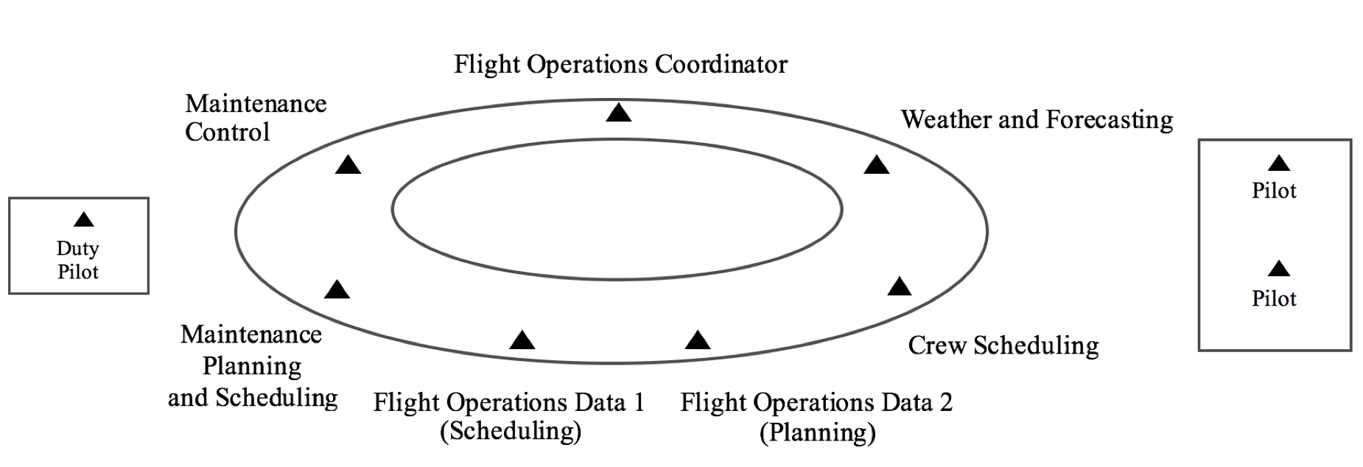

Figure 1. Student roles in the Flight Operations Center – Unified Simulation lab. Each student role is represented by a triangle (). In the immediate lab, seven key positions are situated in close proximity to simulate a regional flight dispatch center. These positions interact face-to-face and electronically to share information and complete the team’s work. Outside the nuclear team, several positions make smaller contributions to the team’s work and facilitate creating a more realistic lab experience, including pilots operating a flight simulator and a duty pilot inside the ramp tower.

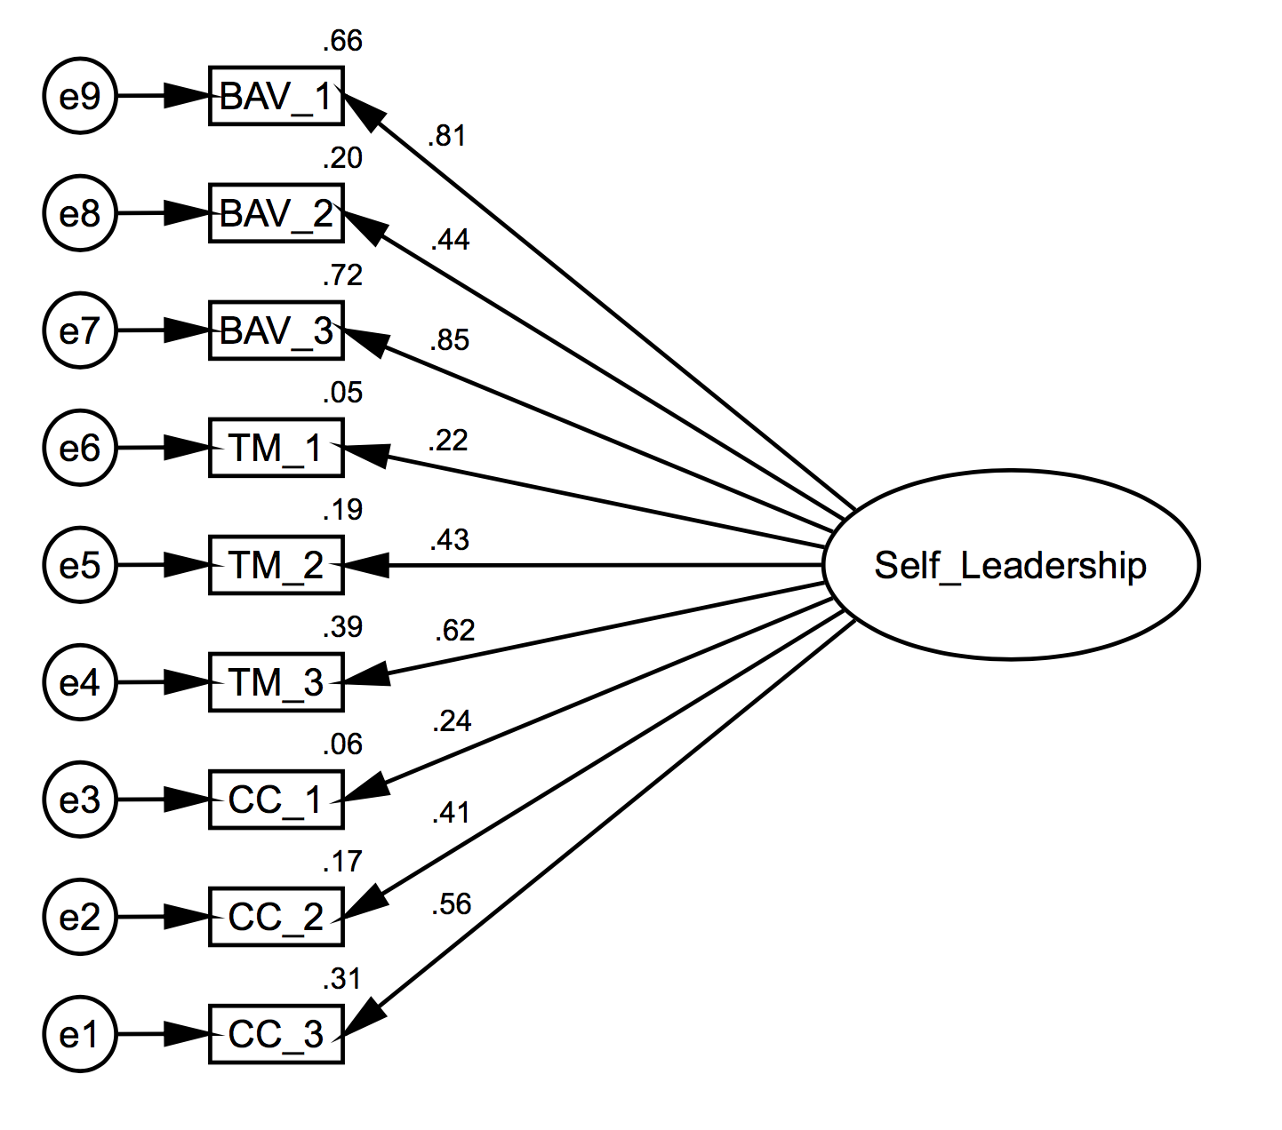
Figure 2. Model of self-leadership as proposed by Houghton, J. D., Dawley, D., & DiLiello, T. C. (2012). The abbreviated self-leadership questionnaire (ASLQ): A more concise measure of self-leadership. International Journal of Leadership Studies, 7(2), 216-232. The model was created in IBM SPSS Amos version 23.0.0 and estimated using Maximum Likelihood. Standardized estimates are depicted, χ² (27, N = 85) = 48.82, p = .006, CFI = .88; TLI = .83; and RMSEA = .10. BAV = Behavior awareness and volition; TM = Task motivation; CC = Constructive cognition.

List of Appendices
- Appendix A: Institutional Review Board Approval Form
- Appendix B: Informed Consent Form
- Appendix C: Abbreviated Self-Leadership Questionnaire
- Appendix D: Comprehensive Assessment of Team Member Effectiveness

Appendix A: Institutional Review Board Approval Form
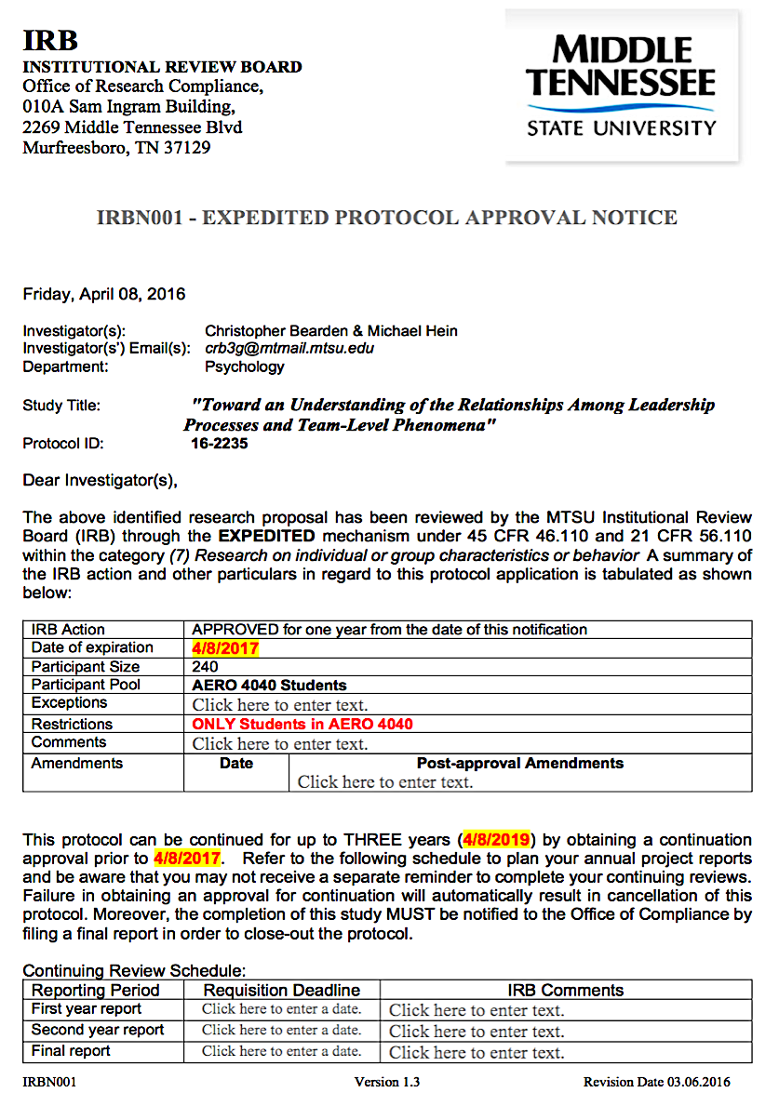
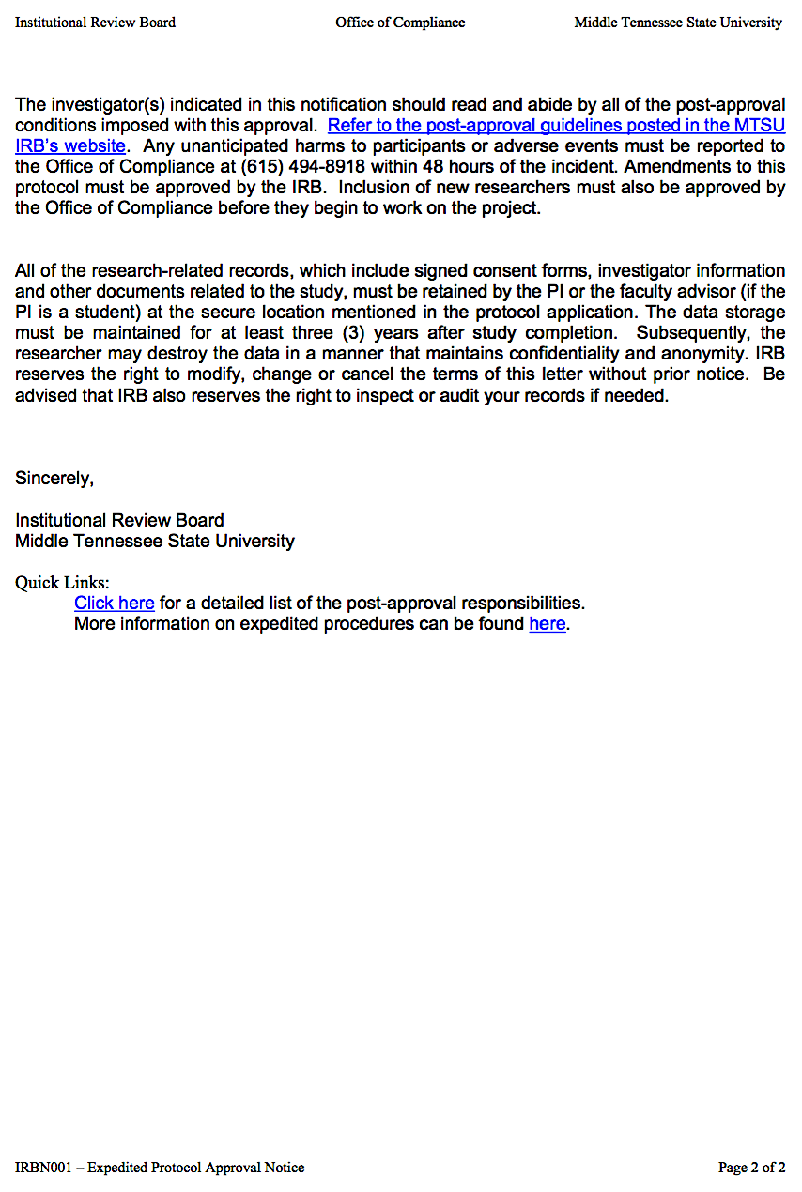
Appendix B: Informed Consent Form

Principal Investigator: Ryan Bearden
Study Title: Toward an Understanding of the Relationships Among Leadership Processes and Team-Level Phenomena
Institution: Middle Tennessee State University

Name of participant: ___________________________________________________ Age: ___________

The following information is provided to inform you about the research project and your participation in it. Please read this form carefully and feel free to ask any questions you may have about this study and the information given below. You will be given an opportunity to ask questions, and your questions will be answered. Also, you will be given a copy of this consent form.

Your participation in this research study is voluntary. You are also free to withdraw from this study at any time. In the event new information becomes available that may affect the risks or benefits associated with this research study or your willingness to participate in it, you will be notified so that you can make an informed decision whether or not to continue your participation in this study.

For additional information about giving consent or your rights as a participant in this study, please feel free to contact the MTSU Office of Compliance at (615) 494-8918.

- Purpose of the study:
You are being asked to participate in a research study because the Principal Investigator is interested in your perceptions, work habits, actions, and experiences pertaining to your overall experience while working in the Flight Operations Center. Specifically, the Principal Investigator is interested in examining the relationships among leadership processes, various team perceptions, and team performance.

- Description of procedures to be followed and approximate duration of the study:
You will be provided a link to a survey via email. The survey takes approximately 30 minutes to complete. This survey has several sections which will ask you to respond to questions based on how frequently you or someone else engaged in a particular behavior: either (1) rarely, (2) occasionally, (3) sometimes, (4) frequently, or (5) usually.

- Expected costs:
n/a

- Description of the discomforts, inconveniences, and/or risks that can be reasonably expected as a result of participation in this study:
There are no foreseeable risks, discomforts, or inconveniences associated with participation in this study.

- Compensation in case of study-related injury:
MTSU will not provide compensation in the case of study related injury.

- Anticipated benefits from this study:
a) The potential benefits from this study include a better understanding of leadership in aviation psychology.
b) The potential benefits to you from this study are a better understanding of yourself and leadership in general.

- Alternative treatments available:
n/a

- Compensation for participation:
You will not receive any compensation for participation in this study.

- Circumstances under which the Principal Investigator may withdraw you from study participation:
None, but you may stop at any time.

- What happens if you choose to withdraw from study participation:
Information provided will be immediately purged. Additionally, withdrawal from the study will not affect any class grade (past or present) or your standing for future classes in anyway.

- Contact Information. If you should have any questions about this research study or possible injury, please feel free to contact Ryan Bearden at (615) 653-2167 or my Faculty Advisor, Michael Hein at (615) 898-2127.

- Confidentiality. All efforts, within reason, will be made to keep the personal information in your research record private but total privacy cannot be promised. Your information may be shared with MTSU or the government, such as the Middle Tennessee State University Institutional Review Board, Federal Government Office for Human Research Protections, if you or someone else is in danger or if we are required to do so by law.

- STATEMENT BY PERSON AGREEING TO PARTICIPATE IN THIS STUDY
I have read this informed consent document and the material contained in it has been explained to me verbally. I understand each part of the document, all my questions have been answered, and I freely and voluntarily choose to participate in this study.
Appendix C: Abbreviated Self-Leadership Questionnaire (ASLQ)
The following questions ask you about your habits and thoughts during the FOCUS Lab simulation exercises. Please respond to each question using the scale below. Please answer openly and honestly. There are no right or wrong answers.
DIRECTIONS:
- READ each item carefully.
- THINK about how frequently YOU engage in the behavior described by the item.
- DECIDE whether YOU (1) rarely, (2) occasionally, (3) sometimes, (4) frequently, or (5) usually engage in the described behavior.
- SELECT one of the five numbers…

1 | 2 | 3 | 4 | 5
Rarely, in less than 10% of instances. | Occasionally, in about 30% of instances. | Sometimes, in about 50% of instances | Frequently, in about 70% of instances. | Usually, in about 90% of instances.

Behavior Awareness and Volition
- I establish specific goals for my own performance (self-goal setting).
- I make a point to keep track of how well I’m doing at work (self-observation).
- I work toward specific goals I have set for myself (self-goal setting).

Task Motivation
- When I have successfully completed a task, I often reward myself with something I like (self-reward).
- I visualize myself successfully performing a task before I do it (visualizing successful performance).
- Sometimes I picture in my mind a successful performance before I actually do a task (visualizing successful performance).

Constructive Cognition
- I try to mentally evaluate the accuracy of my own beliefs about situations I am having problems with (evaluating beliefs and assumptions).
- Sometimes I talk to myself (out loud or in my head) to work through difficult situations (self-talk).
- I think about my own beliefs and assumptions whenever I encounter a difficult situation (evaluating beliefs and assumptions).

Appendix D: Behaviorally-Anchored Comprehensive Assessment of Team Member Effectiveness

- Rate each team member on his or her contributions to the team's work.
Below are three statements describing excellent, three describing average, and three describing below average work. Rate each position by selecting one of the circles in the ROW corresponding to the level of performance of the person in that position. For the position you held, keep the line blank.
Below Average  -Does not do a fair share of the team's work. Delivers sloppy or incomplete work.  -Misses deadlines. Is late, unprepared, or absent for team meetings.  -Does not assist teammates. Quits if the work becomes difficult. | Demonstrates behaviors described immediately left and right. | Average  -Completes a fair share of the team's work with acceptable quality.  -Keeps commitments and completes assignments on time.  -Helps teammates who are having difficulty when it is easy or important. | Demonstrates behaviors described immediately left and right. | Excellent  -Does more or higher-quality work than expected  -Makes important contributions that improve the team's work.  -Helps teammates who are having difficulty completing their work.

- Rate each team member on his or her contributions to teammate interaction.

Below are four statements describing excellent, four describing average, and four describing below average teammate interaction. Rate each position by selecting one of the circles in the ROW corresponding to the level of performance of the person in that position. For the position you held, keep the line blank.

Below Average  -Interrupts, ignores, bosses, or makes fun of teammates.  -Takes actions that affect teammates without their input. Does not share information  -Complains, makes excuses, or does not interact with teammates.  -Is defensive. Will not accept help or advice from teammates. | Demonstrates behaviors described immediately left and right. | Average  -Listens to teammates and respects their contributions.  -Communicates clearly. Shares information with teammates.  -Participates fully in team activities.  -Respects and responds to feedback from teammates. | Demonstrates behaviors described immediately left and right. | Excellent  -Asks for and shows an interest in teammates' ideas and contributions.  -Makes sure teammates stay informed and understand each other.  -Provides encouragement or enthusiasm to the team.  -Asks teammates for feedback and uses their suggestions to improve.

- Rate each team member on his or her possession of related knowledge, skills, and abilities.
Below are three statements describing excellent, three describing average, and three describing below average possession of related knowledge, skills, and abilities. Rate each position by selecting one of the circles in the ROW corresponding to the level of performance of the person in that position. For the position you held, keep the line blank.

Below Average  -Missing basic qualifications needed to be a member of the team.  -Unable or unwilling to develop knowledge or skills to contribute to the team.  -Unable to perform any of the duties of other team members. | Demonstrates behaviors described immediately left and right. | Average  -Demonstrates sufficient knowledge, skills, and abilities to contribute to the team's work.  -Acquires knowledge or skills as needed to meet requirements.  -Able to perform some of the tasks normally done by other team members. | Demonstrates behaviors described immediately left and right. | Excellent  -Demonstrates the knowledge, skills, and abilities to do excellent work.  -Acquires new knowledge or skills to improve the team's performance.  -Able to perform the role of any team member if necessary.

