Caregivers or Drug Pushers?: An Examination of Medical Practitioner Stigma and Empathic Communication towards Opioid Abuse

by
Tatum England

A thesis presented to the Honors College of Middle Tennessee State University in partial fulfillment of the requirements for graduation from the University Honors College

Fall 2019

Caregivers or Drug Pushers?: An Examination of Medical Practitioner Stigma and Empathic Communication towards Opioid Abuse

by
Tatum England

APPROVED:

______________________________
Dr. Mary Beth Asbury
Communication Studies

______________________________
Dr. Heather Hundley
Department Chair, Communication Studies

______________________________
Dr. Betsy Dalton
Communication Studies

______________________________
Dr. Philip E. Phillips, Associate Dean
University Honors College

For dad, who persevered through an incredibly difficult season,
and for mom, who taught me how to always see the best in everyone.
I’m incredibly proud to be your daughter.

Acknowledgements

To Dr. Asbury: Thank you for taking a chance on a student you did not know.
Thank you for being the constant light that guided her through this process.
Through patience and encouragement, you instilled a passion for research and understanding deep within her.

Abstract

The opioid crisis has reached a boiling point in Tennessee. As a result, a comprehensive plan, entitled TN Together, was launched by the State of Tennessee to address the growing epidemic. However, an area remarkably overlooked by the plan is patient practitioner communication, which is an underlying cause of the opioid crisis. This study analyzes the extent of stigmatization demonstrated by medical practitioners towards patients they suspect of opioid abuse and examines its effect on empathic communication.

Keywords: opioid abuse, patient-provider communication, empathic communication, stigma
Table of Contents
Dedication iii
Acknowledgements iv
Abstract v
Introduction 1
Research Questions and Hypotheses 8
Methods 9
Results and Analysis 12
Discussion 19
Conclusion 24
References 26
Appendices 29
Appendix A 29
Appendix B 31
Appendix C 32
Appendix D 35

Caregivers or Drug Pushers?: An Examination of Medical Practitioner Stigma and Empathic Communication towards Opioid Abuse
Since 1999, annual reports showcase the frequency of deaths from synthetic or prescription opioids in Tennessee progressively increasing each year (TN Department of Health, 2018b). According to the Tennessee Department of Health, a record-breaking 1,268 Tennesseans died of an opioid overdose in 2017 (TN Department of Health, 2018a). In fact, more Tennesseans died from drug overdoses than from automobile accidents that year (Kelman, 2018).
Due to its pervasive nature, opioid abuse affects all Tennessee residents, since it is highly likely that they, at some point in their lives, will personally experience or know someone struggling with opioid addiction (Kelman, 2018). Therefore, lawmakers, public health officials, and everyday citizens are scrambling to understand the deepest depths of the opioid crisis in order to find a sustainable solution before more Tennesseans succumb to its fatal effects.
After extensive investigation, two groups of people have been identified as key stakeholders in this crisis: medical practitioners and their patients. Practitioners (i.e., doctors, nurse practitioners, nurses, and physician assistants) commonly prescribe opioids for pain management despite research-based guidelines suggesting the ineffectiveness of this practice. Indeed, each year, more opioid prescriptions are written in Tennessee alone “than there are people living in Tennessee, with more than 1 million prescriptions left over” (Tennessee Together, 2018). Unfortunately, the consequences of this trend are evident.
It is nearly impossible to estimate the number of Tennesseans addicted to opioids, but the Tennessee Department of Health reported in 2018 that nearly 11 nonfatal overdose hospital visits occurred for every identified fatal overdose (TN Department of Health, 2018c). As a result, a responsibility has been placed on healthcare practitioners to limit the amount of opioids in circulation, but at the same time, they must respect a patient’s report of pain. This is a difficult task that could easily taint a practitioner’s empathetic nature, especially when dealing with patients they believe are axfbusing the system to acquire opioids.
This study seeks to examine how medical practitioners stigmatize patients they suspect of opioid abuse. Specifically, this study will examine providers’ empathic communication and its influence on stigmatization of patients who they suspect are addicted to opioids.
Opioid Crisis

The opioid crisis has gained national attention in the last 20 years and has been studied extensively. For example, Toye, Seers, Tierney, and Barker (2017) analyzed various themes of thought that a majority of healthcare practitioners considered before prescribing opioids to patients with chronic non-malignant pain. Overwhelmingly, healthcare practitioners felt ill-equipped to treat pain of unknown etiology; one doctor asserted that he only discussed pain management in one lecture during one advanced pharmacology class. Therefore, when a patient claimed to have pain of unknown biological origin, healthcare practitioners relied on non-clinical, gut feelings to make judgements about the validity of claims.
Similarly, Kolodny, Courtwright, Hwang, Kreiner, Eadie, Clark, and Alexander (2015) highlighted the need to educate prescribers about the risks associated with long-term opioid use and alternative treatments for pain management. With this valuable information, prescribers can make more informed cost-benefit analyses when considering opioid prescriptions. The authors theorized that less opioids would be prescribed as a result, which would subsequently reduce the number of people initially exposed to opioids and reduce the supply of excess opioids (Kolodny et al., 2015).
Despite being undereducated on pain management options and how to identify individuals truly in pain, healthcare practitioners believed it was inhumane not to treat pain expressed by the patient (Toye et al., 2017). However, practitioners described prescribing opioids as constantly walking a fine line since every case was different and unpredictable. They could neither trust nor predict what a patient would do with their medication; many of them worried that their name would appear on an opioid prescription bottle illegally “sold or used for unintended purposes” (Toye et al., 2017, p. 8). Therefore, due to the long-term consequences of opioids, more scrutiny was placed on patients with chronic, non-malignant pain rather than malignant pain (Toye et al., 2017).
Some scholars (e.g., Kolodny et al., 2015) suggested restructuring the narrative of the opioid crisis from one of patients abusing the system to one of addiction. Even though they wanted help, most patients imprisoned in opioid addiction were scared to tell their healthcare practitioner about their struggle because they feared being “judged, cut off from a legitimate supply, or labeled as malingerers for feigning pain” (Kolodny et al., 2015, p. 567). Consequently, the authors advised healthcare practitioners to strengthen their relationship with patients by viewing them as captives to addiction instead of swindlers, so patients would be more comfortable disclosing the nature and depth of their addiction and get the necessary help that they needed.
Tennessee Opioid Crisis. Since 1999, opioid-related deaths have increased every year in Tennessee (TN Department of Health, 2018b). According to the Tennessee Department of Health, a record-breaking 1,268 Tennesseans died of an opioid overdose in 2017 (TN Department of Health, 2018a). More specifically, 200 of those 1,298 victims were residents of the Mid-Cumberland region, which includes Dickson, Montgomery, Robertson, Rutherford, Stewart, Williamson, and Wilson counties (TN Department of Health, 2018b).
According to a recent epidemiological survey conducted by McPheeters et al. (2018), individuals in Tennessee aged 35 to 54 had higher rates of fatalities due to opioid overdose than any other age group. Specifically, Tennesseans within the 45 to 54 age bracket overdosed on prescription opioids (i.e. hydrocodone and oxycodone) at higher rates than any other age category, which is a reflection of the national trend (McPheeters et al., 2018). Researchers (e.g., Kolodny et al., 2015) identified this age group as the most common users of opioids for medical therapies. Therefore, one can say that overdose deaths appear to be the most prominent among individuals who use opioids for medical rather than recreational purposes.
Due to these staggering statistics, Bill Haslam, former governor of Tennessee, announced on January 22, 2018 a comprehensive plan, entitled TN Together, to combat the state’s opioid crisis. The 30 million-dollar plan has three subcategories: prevention, treatment, and law enforcement. In regard to prevention, the plan regulates the dosage of opioids healthcare practitioners can prescribe, educates the public on the dangers of opioid addiction, and funds research to discover best practices for managing non-malignant, chronic pain (Tennessee Governor’s Office, 2018). “More than 26 million dollars” in funding will be allocated towards identifying individuals who already suffer from opioid addiction and enrolling them in recovery services (Tennessee Governor’s Office, 2018). Finally, additional funds will increase the amount of law enforcement officers and improve their training about opioid drugs (Tennessee Governor’s Office, 2018). In addition, every Tennessee state trooper will be armed with naloxone, a drug that “rapidly blocks and reverses the effects of an opioid overdose” (National Institute of Drug Abuse, 2018).
Patient-Provider Interaction
While the former governor’s plan has good intentions, one area that it overlooks is provider-patient interaction, which is a root cause of the opioid crisis. In a groundbreaking study, Hughes et at. (2014) noted the importance of effective communication between patients and providers, especially when using opioids as a pain management therapy. Using transcripts from actual patient visits and post-visit questionnaires with providers, they discovered that healthcare providers possessed “more negative attitudes towards patients with whom they discussed opioids” at length with during the appointment (Hughes et al., 2014, p. 457). However, the same providers did not report poor attitudes after appointments where opioids were briefly mentioned but not discussed.
Upon examining their results, Hughes et at. (2014) concluded that healthcare providers were intimidated by the difficult nature of conversations regarding opioids. The providers who demonstrated effective communication skills (e.g., verbalized concern for the patient’s pain level, discussed the risks of opioid usage, or suggested alternative treatments) reported lower levels of frustration than the practitioners who demonstrated poor communication skills (e.g., ignored the patient’s claim of pain, avoided the topic of opioids, or abruptly ended conversations of pain management therapies). Therefore, the researchers suggested that training providers in communication skills “specifically related to conflict management and negotiation” might result in more effective treatment for patients addicted to opioids and decrease provider frustration (Hughes et at., 2014, p. 457).
Empathic Communication. Furthermore, the researchers realized that the conversations where opioids were discussed were characterized by “low provider empathy” (Hughes et. al., 2014, p. 457). In Communication Skills in Health and Social Care, Moss (2017) defines empathy as “trying to see the world from another person’s point of view; [understanding] how the person really feels, so that you can begin to see things through their eyes” (p. 98). The Institute for Healthcare Communication (2011) insists that empathy is a fundamental component of patient-provider communication, indicating that a provider’s ability to empathize improves a patient’s satisfaction, adherence to treatment, and overall health outcome.
Despite this, the study conducted by Hughes et al. (2014) seems to suggest that empathy is missing in dialogue about opioids. This outcome could be the result of providers’ inability to relate personally to the experiences of patients addicted to opioids. Ha and Longnecker (2010) discuss the importance of shifting perspectives during patient-practitioner interactions. They encouraged patients and practitioners alike to step outside of their own scope of knowledge and consider the perspective of the other individual in the room to enhance the effectiveness of medical visits (Ha & Longnecker, 2010).
Stigma. In addition to lower empathy, providers also stigmatize patients suspected of opioid abuse. In Stigma: Notes on the Management of Spoiled Identity, Goffman (1963) defines stigma as any characteristic that is deeply shameful to its possessor. He detailed three different types of stigma: abominations of the body (e.g. physical deformities), tribal stigma (e.g. stigmas attached to race, religion, and social class), and blemishes to individual character (e.g. mental illnesses and addiction). These stigmatizations discredit the reputation of an individual, which Goffman refers to as spoiled identity. As a result, the stigmatized learn how to fit into society by adapting their behavior and controlling the image they project to others (Goffman, 1963). However, this performance is not always beneficial.
Du Prè (2014) details the consequences of stigmatizing diseases. She suggests that patients with stigmatized conditions experience social rejection; they are treated as less than or ignored altogether by practitioners, coworkers, neighbors, friends, and even family due to the “shameful” label attached to their illness. Since they fear being shunned and rejected by society, individuals literally die of embarrassment, “too afraid or ashamed to seek care for stigmatized medical illnesses” (Du Prè, 2014, p. 179).

Research Questions and Hypotheses

Based on the aforementioned literature, I proposed the following research questions and hypotheses:
RQ₁: Do practitioners have less empathy for those they suspect of opioid addiction than those who do not?
H₁: Practitioners who have worked longer in the field will show more stigma towards suspected opioid addicts than those who have not worked as long in the field.
H₂: Practitioners who have received less education will show less empathy towards suspected opioid addicts.
H₃: Practitioners who have received less education will show more stigma towards suspected opioid addicts.

Methods

Participants and Procedures

To recruit participants, an on-line survey evaluating stigma and empathy was emailed directly to healthcare practitioners (i.e. doctors, nurses, nurse practitioners, and physician assistants) and different clinics throughout the Middle Tennessee region. Also, a few of the participants noted that they had forwarded the survey’s link to their co-workers and other interested acquaintances within the medical field. After a few months, the survey link was posted on the researchers’ social media platforms to recruit more participants upon noticing a low-response rate.
In all, 32 participants completed the survey. However, 4 surveys were discarded because these participants did not complete the entire survey, failing to provide input for important scales. Therefore, our study’s sample size consisted of 28 participants (22 women and 6 men) with a mean age of 49 (SD = 11.28). Collectively, the sample was 89.3% White, 3.6% Hispanic/Latino(a), and 7.1% “other.”
When addressing the type of healthcare practitioner, our sample included 32.1% Doctors, 35.7% Nurses, 25% Nurse Practitioners, and 7.1% Physician’s Assistants. In terms of highest level of education completed, 3.6% of participants had their Associate’s Degree, 21.4% of participants had their Bachelor’s Degree, 21.4% had their Master’s Degree, and 53.6% had attained their M.D. or Ph.D. In addition, the average years of experience as a healthcare practitioner (including internships) for our sample was 23 years (SD = 12.60); the minimum years of experience reported by a participant was 2.3 years and the maximum number of years reported by a participant was 40 years.
At the end of the online survey, participants were given the option to sign up for an in-person interview to gain further qualitative data about the cognitive, affective, and behavioral reactions of healthcare practitioners in regards to patient opioid abuse. In all, 6 participants signed-up to be interviewed; however, only 4 completed the entire interview. As a result, the sample (3 women and 1 male) included two nurses, an urgent care nurse practitioner, and an emergency room doctor; therefore, only two had the licensure to prescribe prescription opioids to patients.
Measurements
Physician Empathy Scale. To evaluate empathy, the online survey directed participants to fill out a modified version of the Jefferson Scale of Physician Empathy (Hojat et al., 2001). This scale was originally written as a tool to measure empathy in physicians. For the purposes of this study, the term physician was replaced with healthcare practitioner to account for physicians, nurse practitioners, nurses, and physician assistants. Participants completed 20 items that assessed empathetic constructs such as compassion, warmth, and dutifulness (Hojat et al., 2001). Sample items included: “a [healthcare practitioner] who is able to view things from another person’s perspective can render better care”; “for more effective treatment, [healthcare practitioners] must be attentive to their patients’ personal experiences”; “a patient who feels understood can experience a sense of validation that is therapeutic in its own right” (Hojat et al., 2001, p. 359). All items were scored on a 7-point Likert scale, with 1= (strongly disagree) to 7 = (strongly agree). In terms of reliability, Cronbach’s alpha for this scale was .795.
Stigma Scale. The next part of the survey assessed stigma using a modified version of Bresnahan and Zhuang’s (2016) Stigma Scale. The scale was originally developed to measure levels of stigma towards people affected by HIV, but the authors noted that it could be “adapted to any form of stigma” (Bresnahan & Zhuang, 2016). For the purposes of this study, the scale was rewritten to evaluate opioid addiction. The participants answered 20 items that measured constructs such as negative attribution (“a person who is addicted to opioids has no will power”), labeling (“opioid addiction is a loaded gun”), distancing (“I would stay away from a person addicted to opioids”), status loss (“people who are addicted to opioids are judged negatively”), and controllability (“opioid addiction is controllable”) (Bresnahan & Zhuang, 2016, p. 240). All items were scored on a 7-point Likert scale, with 1 = (strongly disagree) to 7 = (strongly agree). The overall scale achieved a reliability of .822. Moreover, the subscales displayed a reliability of α = .834 for labeling, α = .865 for negative attribution, α = .910 for status loss, and α = .382 for controllability. There was only one question in regards to distancing, so it was ultimately discarded since reliability could not be determined.

Results and Analysis

Hypothesis 1 examined the relationship between years of experience within the healthcare field and level of stigma and predicted that practitioners who have worked longer in the field will show more stigma towards opioid addicts. Correlation coefficients were computed among the following scales: years of experience as a healthcare practitioner (including internships) and stigma. Based on the results, there was a non-significant slight, negative correlation between years of experience as a healthcare practitioner and level of stigma, r = -.221, p > 0.5. Based on this result, hypothesis 1 was not supported.
Hypothesis 2 examined the relationship between level of education and empathy and predicted that practitioners who have received less education will show less empathy towards opioid addiction. Correlation coefficients were computed among the following scales: education level and empathy. Based on the results, there was a significant moderate, positive correlation between level of education and level of empathy, r = .481, p < .05. Based on this result, hypothesis 2 was supported.
Hypothesis 3 examined the relationship between level of education and stigma and predicted that practitioners who have received less education will show more stigma towards opioid addicts. Correlation coefficients were computed among the following scales: education level and empathy. Based on the results, there was a non-significant slight, negative correlation between level of education and level of stigma, r = -.049, p > 0.5. Based on this result, hypothesis 3 was not supported.
Using the transcribed interviews and free-response answers, the researcher attempted to further analyze practitioners’ reactions, emotions, and opinions about Tennessee’s ongoing opioid crisis and patient opioid addiction by pinpointing consistent themes. The following themes emerged from the interviews.
Sadness. This theme was identified in all four interviews that were conducted; however, it presented itself in two different ways. Every interviewee expressed sadness for the patients addicted to opioids. They lamented at the thought that their lives were essentially wasted, tainted by turmoil and hardship as their addiction attempts to overcome them. From interview 1, the participant said, “I’m saddened. It’s such a waste. There are so many lives that are ruined because of opioid addiction.” Similarly, the participant in interview 3 noted, “I try to remind the medical residents I work with and myself that this isn’t a life that anyone wants. It’s just sad.”
Furthermore, three out of the four interviews mentioned sadness for the addicted patient’s family. The practitioners noted how this addiction not only affects the individual who is addicted, but also has the potential to destroy their families. Moreover, these individuals are virtually powerless as they are forced to endure the consequences of another’s decisions. The participant from interview 1 also noted, “I’m sad not only for [those addicted] but for their families and loved ones because it’s their disease but it affects the whole family.” Additionally, the interview 4 participant said, “I would say I feel a lot of sadness about opioid addiction because you see a lot of families who are broken up by this.”
Frustration/Anger. This was another apparent theme throughout the open-ended survey responses and three out of the four interviews conducted; in addition, the participants identified multiple targets for their anger and frustration. Some expressed frustration towards the addicted patients. One participant during the open-ended portion of the survey wrote, “I feel frustrated when a patient asks for opioids but I can’t identify the biological source of pain because I feel as though I am being manipulated by them”. The participant from interview 3 reiterated this notion by remarking, “it sometimes feels like the patient is playing a game to get me to give them a prescription, it’s frustrating”. The participant from interview 4 noted, “I view [patients addicted to opioids] as complicated. Frankly, I get kind of angry with them. They are wasting time and resources.”
Frustration was also directed towards opioids and the devastating effects of this potent class of drugs. The participant from interview 3 stated, “My number one feeling about this issue is frustration. I want to help people, but opioids and opioid prescriptions hurt people. I try to explain to my patients that [opioids] are not the right medicine for them. That they will end up hurting them more.”
Lastly, other participants disclosed feelings of frustration and anger towards pharmaceutical companies, who were identified by the participants as key players in the overall opioid crisis and therefore deserving of proper consequences. The participant in interview 2 declared, “I wish that the pharmaceutical companies would step up and use their money to give these people, whose livelihoods they destroyed, treatment.” Likewise, the participant from interview 3 noted, “I wish that the pharmaceutical companies have to pay a whole lot of money, like it looks like they are going to have to do if they don’t go bankrupt, to help pay for all of this and the damages they have done.”
Hopelessness/Lack of Control. This theme presented itself in the majority of open-ended survey responses and all four interviews. When asked, “What do you wish you could do for those addicted to opioids?,” the participants unanimously voiced that they wanted to liberate their patients from the burden of addiction; however, they could not comprehend how. For example, the participant in interview 2 said, “Boy, I wish I could just fix it. I have no idea what the fix is. I have no idea.”
A few participants addressed simple actions, like additional resources, that could be implemented to alleviate some of the consequences of Tennessee’s opioid crisis. For example, the participant in interview 3 noted, “ I wish I could build some rehab centers, and I wish that the patient could stay six to eight weeks instead of only one week like a lot of insurances cover. I wish that we could build up a peer program with other people who have been addicted to opioids, so they can see someone who has gotten off of opioids.” However, these same participants suggested that they felt hopeless about the prospect of rehabilitating patients addicted to opioids since steps in the right direction involved multiple parties coming together to act.
Notably, the participants emphasized that the addicted patient was the party with the most influence. They ultimately decide for themselves if they want to change, which the practitioner cannot control. The participant in interview 4 stated, “ I wish I could snap my fingers and make these individuals not addicted to opioids because there are resources out there. There is all the material in the world that they can read and educate themselves on, but until [the addicted patient] is willing to make the change and head in the right direction, they are probably not going to change.”
Patient-Provider Communication. This was a common theme since the interview questions were geared to gather qualitative data about patient-provider interaction. In the open-ended survey responses, some participants confessed that they are initially “skeptical” and “suspicious” when conversing with a patient who asked for prescription opioids but their biological origin or cause of pain cannot be identified. Moreover, a smaller portion of participants disclosed labeling these patients as “drug seekers” or identifying them as individuals with “addiction problems.” The participant in interview 4 noted, “I feel like they are probably seeking, honestly. I mean, I work in an environment where we see a lot of that. I use CSMD a lot, which is a website designed to track opioid usage. That has been a huge help for me, so a lot of the times I have an idea before I go into the room whether or not someone is actually seeking. But yes, a lot of the times unfortunately, I probably label them as a drug seeker.”
At the same time, many participants, including those who were initially skeptical or biased, revealed their aspirations to have real, honest conversations with individuals they suspected suffered from opioid addiction. The participants agreed that convincing the patient to see his or her problem was a primary objective of these difficult conversations. The participant in interview 3 stated, “I try not to be judgmental, and I try not to confront. But, I try to be honest that their use of opioids has become a problem. They’ve been to the emergency room four times in the last two weeks for opioids. That isn’t what most people do. I try to talk directly to them about why it’s a problem.”
Furthermore, the participants unanimously agreed that offering other pain management options and effective resources to liberate these patients from opioid addiction was another primary objective of these patient-provider conversations. The participant in interview 3 said, “I tell these patients why [opioids] are not the right medicine for them. That they are addictive and will need more and more and more. I try to convey that we have none opioid prescriptions like patches for pain management. And then, if I see a huge component of anxiety with it, I recommend for them to try to get a form of counseling.” The participant in interview 1 noted, “I try to listen to these patients and offer them help. I find out resources that are available and hope they seek the help they need.”
This statement showcases the notion, cited my numerous participants, that patients must be active participants in the conversation since they ultimately must be willing to see their problem, take advantage of the resources offered to them, and modify their behavior. The participant in interview 4 noted, “I definitely try to have a real conversation with patients about opioid addiction. We try to see if there are other options, if they have ever tried to come off of them before, and if they have ever been through withdrawals. If they are addicted, then we do have the ability to set them up with rehab if they are willing. But, they have to be willing.”
Interpreting Empathy. This theme was apparent due to the nature of our first research question, which asked, “Do practitioners have less empathy for those they suspect of opioid addiction than those who do not?”
The definition of empathy was generally consistent when the participants were asked, “How would you define empathy?”, during the interview portion of our study. Participant 1 and 3 both defined empathy as “putting yourself into other people’s shoes”. Participant 2 stated, “Empathy is putting yourself in someone else’s position. Whether its opioid addiction or whatever.” Likewise, participant 4 noted, “The ability to relate to someone on an emotional level, I would say is empathy best defined.”
Even though the participants defined this similar concept of empathy, a common theme of struggling to relate to individuals addicted to opioids arose in our interviews. When asked, “How do you relate to patients addicted to opioids?” the participant in interview 3 confessed, “I am trying to do better. I try not to be judgmental. I try to listen to what they are saying and what their worries are. I’m trying.”
Additionally, it must be noted that some of the participants who battled addiction or endured similar circumstances as patients addicted to opioids stated that they still struggled with relating to the plight of those addicted. For example, the participant in interview 2 said, “I don’t think I can relate to patients addicted to opioids, I mean the only thing I’ve ever been addicted to is cigarettes, but I mean I don’t have any idea.” The participant in interview 4 noted, “My father had some issues with opioid addiction for a brief period of time, so that does help me be a little bit more sympathetic to patients. But if they are repeat offenders or have young children with them, I tend to be much more critical of the situation than maybe I should be.”
Conversely, the participants were asked, “How do you think patients addicted to opioids view you?,” to measure the participants’ perception of patient empathy levels. The responses were once again similar but overwhelmingly negative. Participant 4 responded, “ [Patients addicted to opioids] probably don’t like me.” Furthermore, there was an underlying theme that a patient’s lack of empathy towards healthcare providers was due to their exploitation of them. The participant in interview 2 stated, “That’s a good question. I have never really thought about how they view me. I think they view most of us as someone that can help them, but I think on the other hand too they look at us and think ‘maybe I can pull one over on them”. In a similar manner, participant 3 noted, “I know [patients addicted to opioids] see me as a roadblock.”

Discussion

This study recruited healthcare practitioners (i.e. doctors, nurses, nurse practitioners, and physician assistants) from Middle Tennessee. The participants took an on-line survey that included two scales to measure baseline levels of empathy and stigma towards patients they suspected were addicted to opioids. To gain additional qualitative data, some participants took part in a follow-up interview that further assessed patient-practitioner interactions about opioids and practitioners’ pre-existing beliefs about opioid addiction. The results indicated that healthcare practitioners did not express more stigma towards opioid addicts, despite their years of experience or level of education. However, the study did conclude that less educated healthcare practitioners displayed less empathy towards opioid addicts.
The researcher initially theorized that experienced healthcare practitioners would exhibit more stigma towards opioid addicts than their co-workers with less experience. This prediction was largely based on the Hughes et at. (2014) study, which showcased healthcare practitioners possessing negative attitudes towards patients who discussed opioid usage. Therefore, the researcher hypothesized that a practitioner’s negative attitude towards opioid addicts would strengthen over time as the practitioner encountered more patients struggling with this disease. However, this hypothesis was not supported by the results of this study. Healthcare practitioners who have worked longer in the field did not showcase more stigma towards opioid addicts.
This result occurred despite the participants displaying negative attitudes, including frustration and anger, towards patients suspected of opioid addiction during the interview and free-response portion of the study. Upon further analysis, the researcher noted that some of the participants expressed frustration towards patients addicted to opioids, but most of the participants directed their frustration towards the addictive nature of opioids and the crisis as a whole. In other words, the negative attitudes displayed by practitioners in this present study and the Hughes et at. (2014) study could actually be directed towards the problem and not the people affected by the problem.
This coincides with the suggestion by Kolodny et al., 2015 that practitioners should view their patients as captives to addiction rather than con artists looking to take advantage of the system. By seeing these patients in the best light, practitioners move towards empathy. Placing oneself in another’s position and truly trying to see the world from their perspective can be a meticulously developed skill; therefore, the researcher theorized that practitioners who received less education would show less empathy towards opioid addicts. The results of this study supported this hypothesis. This is likely due to education increasing understanding about an issue. When pondering the reasoning behind this, the researcher concluded that one must be knowledgeable about the aspects and components of another’s position before placing himself or herself in it. Therefore, practitioners who receive more education about the calamitous effects of opioids and devastating nature of addiction could be more likely to follow the advice of Ha and Longnecker (2010) and “step outside of their own scope of knowledge and consider the perspective of the other individual in the room” (p.5).
Furthermore, a notable obstacle of empathy is fear. One will not try to see the world from the perspective of another if they are scared of them; instead, they will act in defense. In this study, the participants expressed fear that the opioid crisis was out of control and they were defenseless against it derailing their communities. This phenomenon was showcased in the Hughes et at. (2014) study when healthcare practitioners ignored the patient’s claim of pain or shut down conversations about opioids because they felt ill-equipped to handle the difficult nature. Thus, increased education about the clinical concerns of opioids, additional pain management options, and interpersonal skills could dispel fear, help practitioners regain some sense of control, and foster an environment for empathy to develop.
In addition, many interviewed participants thought they were viewed in a negative light by their patients addicted to opioids. This skepticism and distrust showcase the ramifications of fear on empathy. Ha and Longnecker (2010) discussed the importance of shifting perspectives during patient-practitioner interactions; however, it is important that the shifted perspective is not tinged with bias. As a result, further research needs to be conducted on how opioid addicts truly view healthcare practitioners in order to enhance patient-practitioner interactions and dispel prejudices that hinder empathy.
In regard to empathy, it was peculiar that participants who once battled addiction themselves or had family members fall prey to opioid addiction were less empathetic in their interviews. This anomaly stood out to the researcher because one would think enduring a situation would increase understanding about it; however, these participants struggled to relate to patients addicted to opioids in order to see them in the best light. This bias could be attributed to the participants knowing the worst side of addicts since they themselves had previously struggled with addiction. It could have been difficult to mentally place themselves in the addict’s shoes since they would have to remind themselves of their own tough past. Furthermore, some participants personally understood the repercussions of opioid addiction on families, friends, and other innocent parties; therefore, they could have been less likely to place themselves in the addict’s position since they could easily place themselves in the position of the addict’s family or friends.
As empathy for an individual decreases, it is only natural for stigmatization to increase. Therefore, the researcher hypothesized that practitioners who have received less education will show more stigma towards suspected opioid addicts. Shockingly, this hypothesis was not supported by the results of the study. Even though there was a significant, moderate positive relationship between level of education and empathy, a significant correlation did not exist between level of education and stigma.
Limitations and Future Research
The first limitation of this research is the sample size. The researcher did not anticipate such a low response rate from directly emailing healthcare practitioners; in addition, only 4 participants showed up to be interviewed further about the topic. Therefore, the results gathered from this small sample size are not fully representative of healthcare practitioners in Tennessee. The data can contribute to the State’s ongoing conversation about opioid addiction and provide a direction for future research, but it cannot be identified as a definitive contributing factor to the ongoing opioid crisis at hand. Future research on this topic needs to be conducted in partnership with local clinics and hospitals to increase practitioner participation. A larger more diverse sample size would produce more accurate results.
In addition, education was not properly defined in the study, thus limiting the research. The results yielded a significant, moderate positive relationship between level of education and empathy. However, one cannot accurately determine what aspects of education increases or decreases a practitioner’s empathy. Furthermore, our results could be skewed because doctors are the participants with the highest level of education since a doctoral degree is a terminal degree. Therefore, are doctors just innately more empathic, or did they receive extra training about pain management options and communication skills that increased their ability to empathize?
Future research needs to control for the type of healthcare practitioner, so the results are not skewed. In addition, future research needs to break down the aspects of education to better define it. Participants should indicate additional pain management classes, communication classes, etc. that they received, so researchers can pinpoint aspects of education that practitioners did not receive that may contribute to their decreased levels of empathy towards opioid addicts.

Conclusion

This study demonstrates the impact of patient-provider interaction on the opioid crisis in Tennessee. Previous research has demonstrated that opioid addicts are more likely to disclose the full extent of their addiction to their healthcare practitioner and get the necessary help required if the practitioner demonstrates high levels of empathy and low levels of stigma throughout their interaction. In this current study, researchers analyzed the impact experience and education had on a provider’s stigma and empathy levels towards their patients addicted to opioids. The results of this study demonstrated that a healthcare practitioner’s experience within the medical field and level of education did not have an impact on his or her degree of stigma towards patients addicted to opioids. However, healthcare practitioners (i.e. doctors, nurses, nurse practitioners, and physician assistants) who had received less education showcased less empathy towards suspected opioid addicts.
Therefore, more emphasis should be placed on educating healthcare practitioners as Tennessee seeks to end its opioid crisis. The prevention and treatment subcategories of TN Together should include trainings for healthcare practitioners, designed to increase their knowledge about the opioid crisis within their community, information about other pain management options, and interpersonal skillset. As a result, their ability to empathize, or place themselves in the position of, their patients addicted to opioids would increase, fostering a healthier clinical environment for productive communication about the harmful effects of opioids and recovery options from addiction. As noted before, the
two key stakeholders in the opioid crisis are medical practitioners and their patients; therefore, their empathic interaction with one another is key to solving this devastating issue.

References

Bresnahan, M., & Zhuang, J. (2016). Stigma. In D.K. Kim & J.W. Dearing (Eds.), Exploration and validation of the dimensions of stigma (232-246). New York, NY: Peter Lang
Bulmer, M. (1979). Concepts in the analysis of qualitative data. The Sociological Review, 27, 651-677. Doi: 10.1111/j.1467-945X.1979.tb00354.x
Du Prè, A. (2014). Communicating about health: current issues and perspectives. New York, NY: Oxford University Press.
Glaser, B., & Strauss, A. (1967). The discovery of grounded theory. Chicago, IL: Aldine de Gruyter.
Goffman, E. (1963). Stigma: Notes on the management of spoiled identity. Englewood Cliffs, NJ: Prentice-Hall.
Hojat, M., Mangione, S., Nasca, T.J., Cohen, M.J.M., Gonnella, J.S., Erdmann, J.B., and Veloski, J. (2001). The Jefferson scale of physician empathy: development and preliminary psychometric data. Educational and Psychological Measurement, 61(2) 349-365.
Hughes, H.K., Korthuis, P.T., Saha, S., Eggly, S., Sharp, V., Cohn, J., Moore, R., and Beach, M.C. (2014). A mixed methods study of patient-provider communication about opioid analgesics. Patient Education and Counseling, 98, 453-461. Doi: 10.1016/j.pec.2014.12.003
Institute for Healthcare Communication (2011, July). Impact of communication in healthcare. Retrieved from https://healthcarecomm.org/about-us/impact-of-communication-in-healthcare/
Kelman, B. (2018, August 20). Drug overdoses killed more Tennesseans than ever last year, fentanyl deaths up 70 percent. Retrieved from https://www.tennessean.com/
story/news/2018/08/20/tennessee-overdose-deaths-2017-opioid-fentanyl/1044057002/
Kolodny, A., Courtwright, D.T., Hwang, C.S., Kreiner, P., Eadie, J.L., Clark, T.W., and Alexander, G.C (2015, January 12). The prescription opioid and heroin crisis: a public health approach to an epidemic of addiction. Annual Review of Public Health, 36(5), 559-574. Doi: 10.1146/annurev-publhealth-031914-122957
Moss, B. (2017). Communication skills in health and social care. Thousand Oaks, CA: SAGE
McPheeters, M.L., Nechuta, S., Miller, S., Tyndall, B., McKennley, T., Mukhopadhyay, S., Krishnaswami, S., Durand, Z., Golladay, M., Rickles, M., and Yenerall, J. (2018, February 6). Prescription drug overdose program 2018 report: understanding and responding to the opioid epidemic in Tennessee using mortality, morbidity, and prescription data. Retrieved from https://www.tn.gov
/content/dam/tn/health/documents/pdo/PDO_2018_Report_02.06.18.pdf
National Institute of Drug Abuse (2018, April). Opioid overdose reversal with naloxone. Retrieved from https://www.drugabuse.gov/related-topics/opioid-overdose-reversal-naloxone-narcan-evzio
Tennessee Department of Health (2018a). Tennessee deaths from drug overdoses increase in 2017. Retrieved from https://www.tn.gov/health/news/2018
/8/20/tennessee-deaths-from-drug-overdoses-increase-in-2017.html
Tennessee Department of Health (2018b). Tennessee drug overdose data. Retrieved from https://www.tn.gov/content/tn/health/health-program-areas/pdo/pdo/data-dashboard.html
Tennessee Department of Health (2018c). 2017 Tennessee Drug Overdose Deaths. Retrieved from https://www.tn.gov/content/dam/tn/health/documents
/pdo/Fatal%20Drug%20Overdose%20in%20TN%20Report_2017.pdf
Tennessee Governor’s Office (2018). TN together: a comprehensive plan to end the opioid crisis in Tennessee. Retrieved from https://www.tn.gov/content/dam/tn
/governorsoffice-documents/governorsoffice-documents/OpioidOnePager.pdf
Toye, F., Seers, K., Tierney, S., and Barker, K.L. (2017). A qualitative evidence synthesis to explore healthcare professionals’ experience of prescribing opioids to adults with chronic non-malignant pain. BioMed Central Family Practice, 18(94), 1-13. Doi: 10.1186/s12875-017-0663-8

Appendix A

IRB Approval Letter
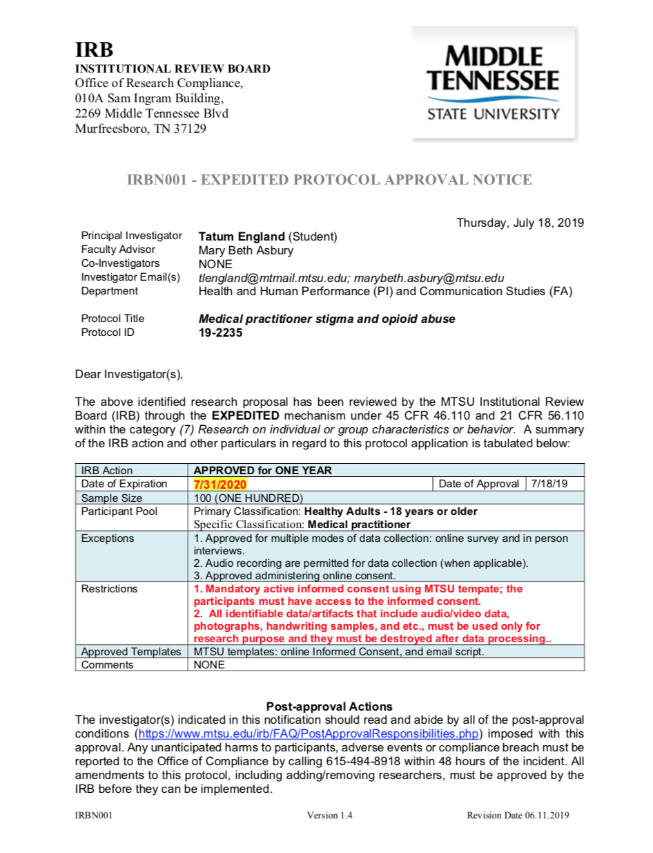

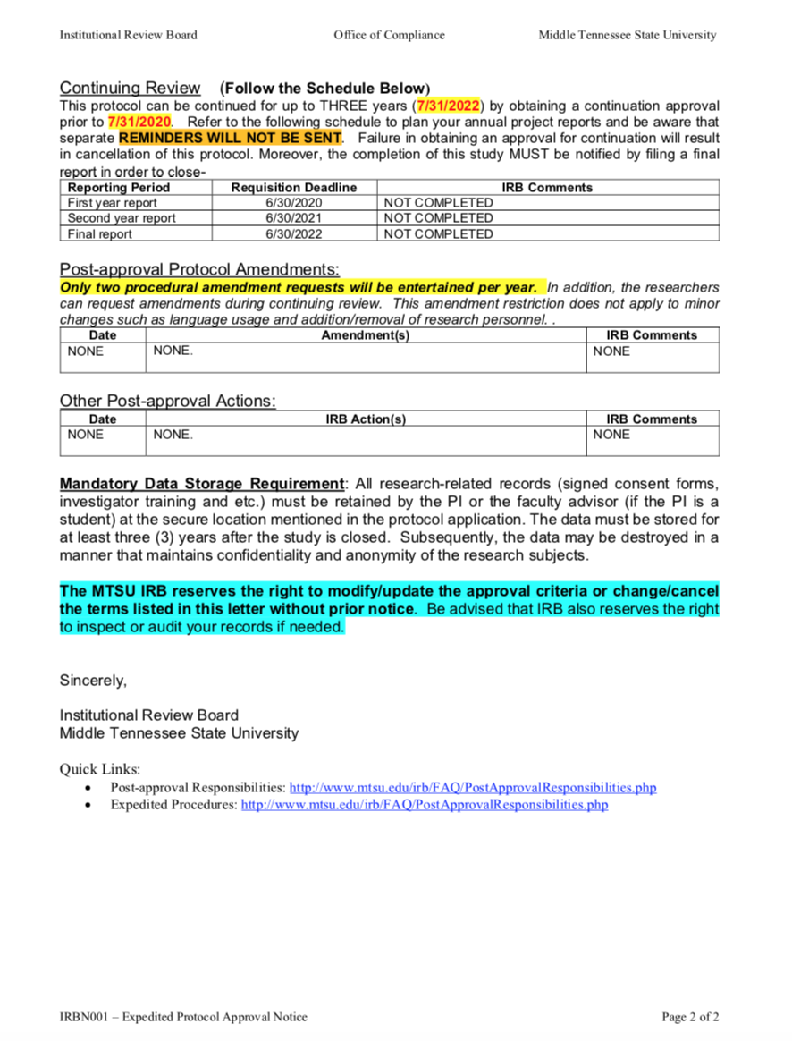

Appendix B

IRB Approved Recruitment Email

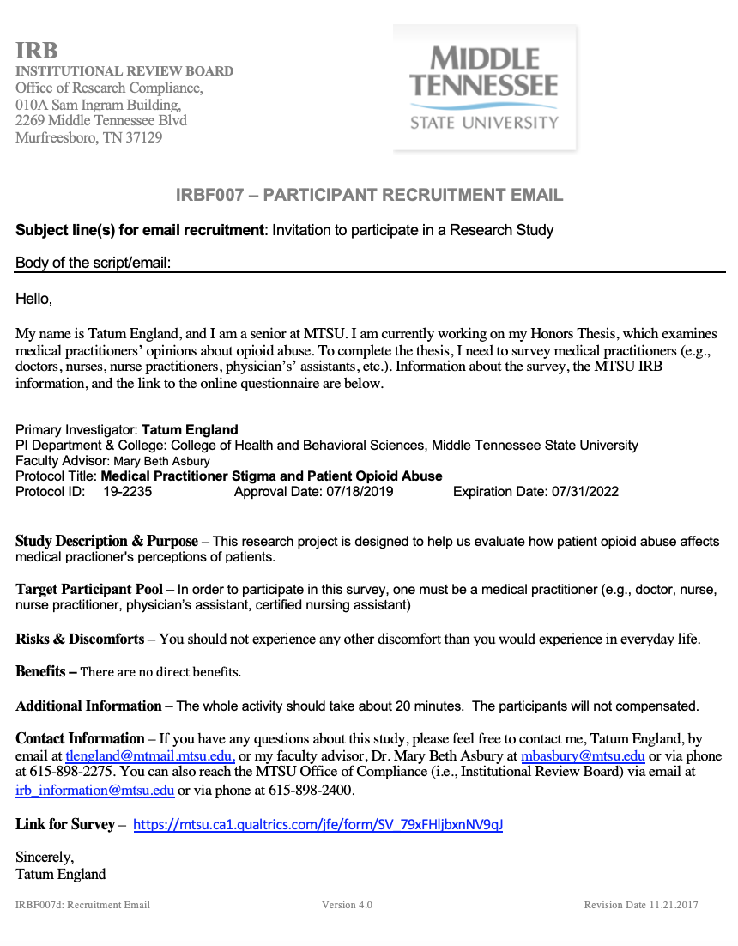

Appendix C

IRB Approved Informed Consent for Interviews
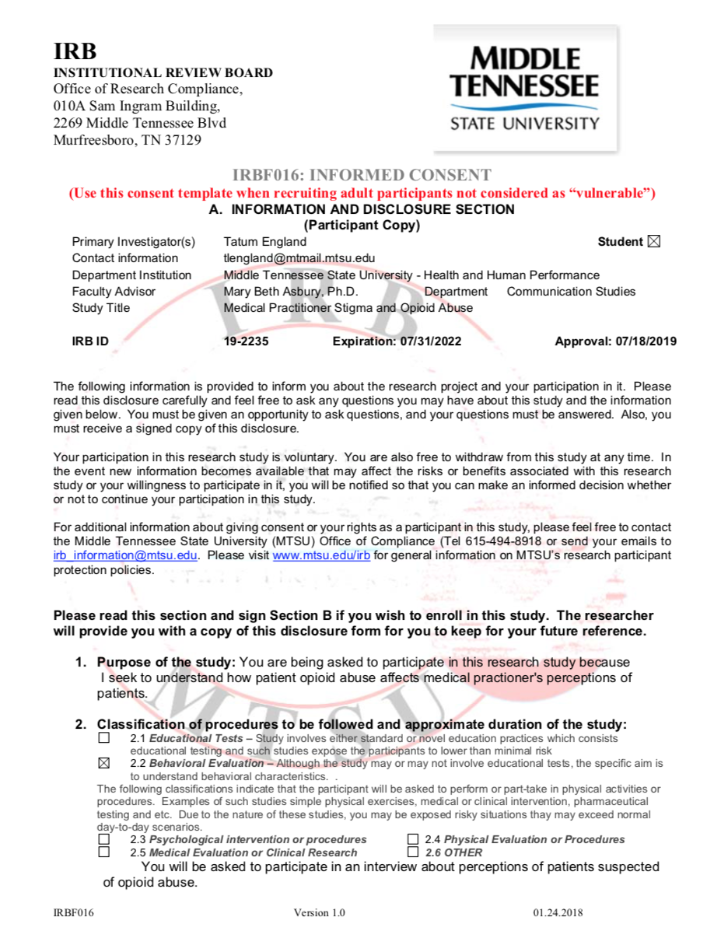

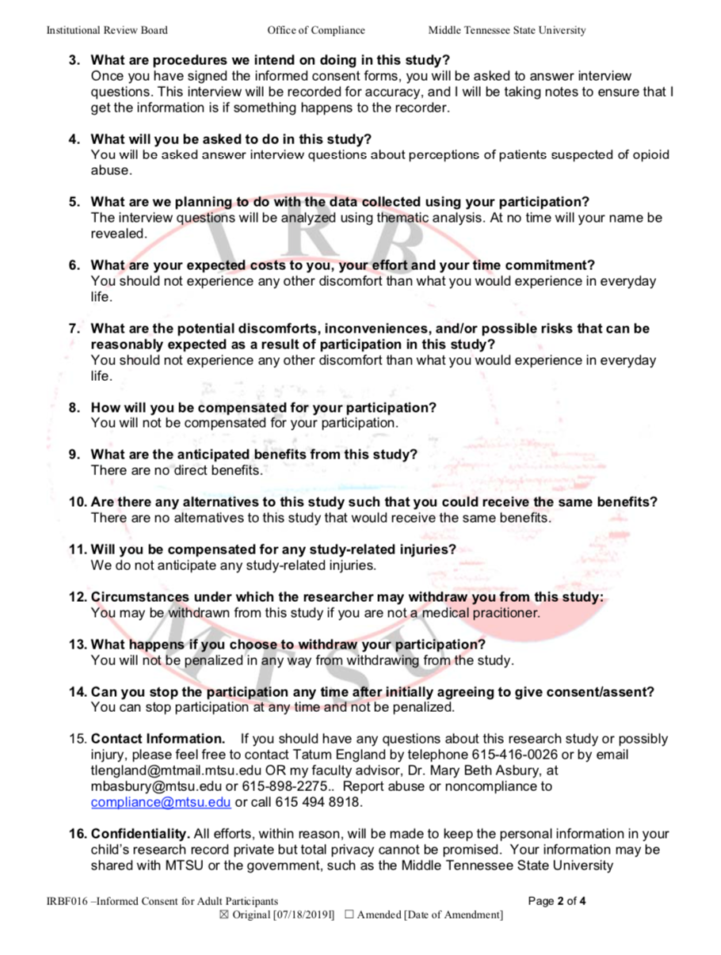

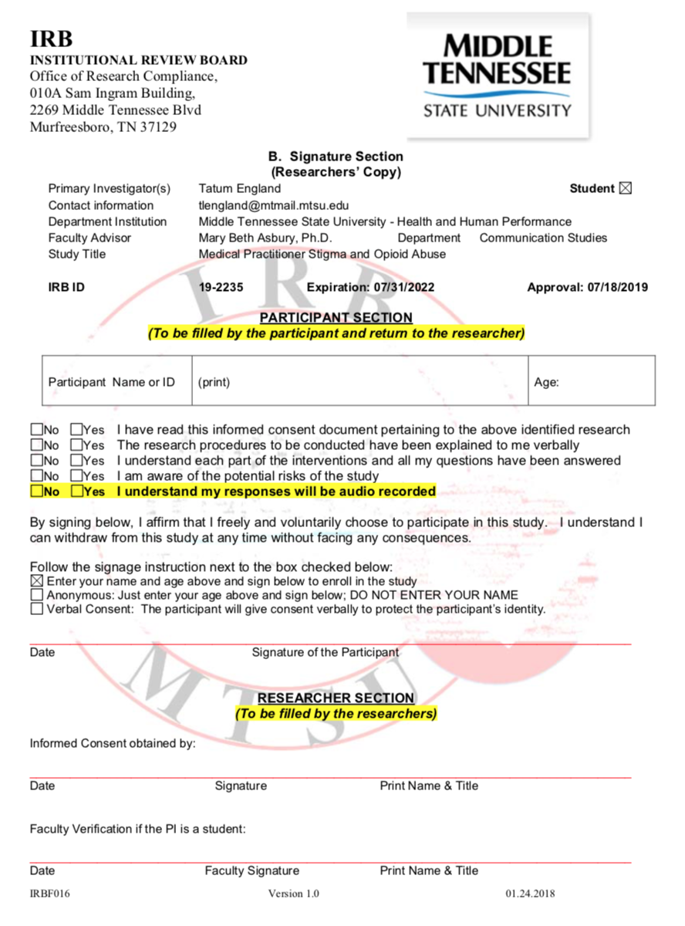

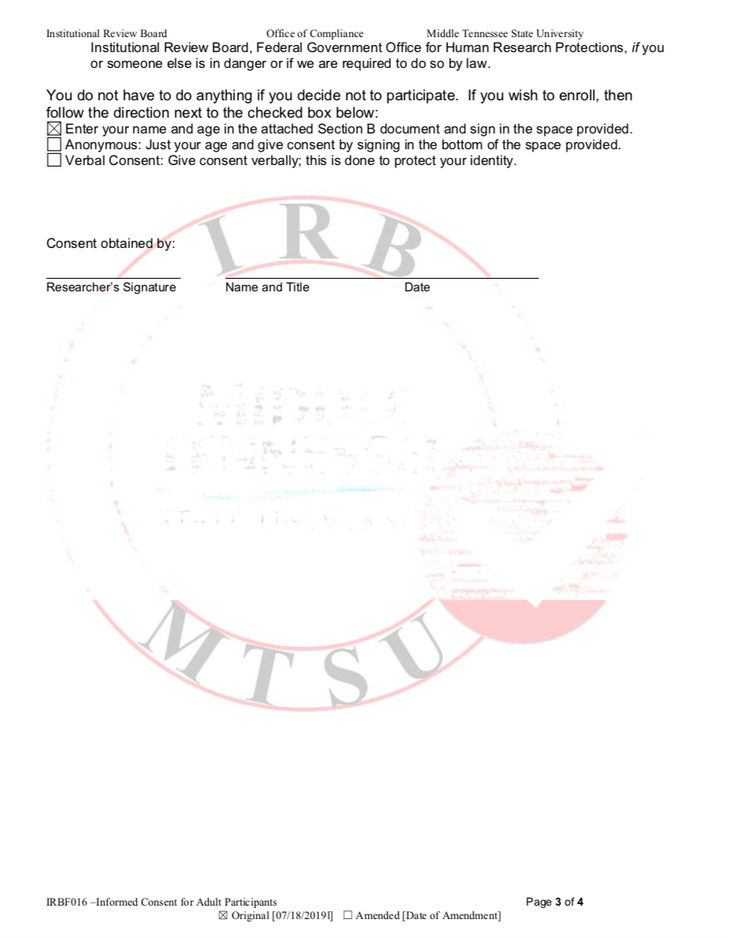

Appendix D

Scales and Interview Questions

Demographic Information
- What is your age?

- Please specify your ethnicity.
  - Asian / Pacific Islander
  - Black or African American
  - Hispanic / Latino
  - Native American or American Indian
  - White/Caucasian
  - Other
  - Prefer not to answer

- What is your gender?
  - Female
  - Male

- What type of healthcare practitioner are you?
  - Doctor
  - Nurse
  - Nurse Practitioner
  - Physician’s Assistant

- How many years of experience do you have as a healthcare practitioner (including internships)?

- Please indicate the highest level of education you have completed.

  - High School or GED
  - Vocational School
  - Some College
  - Community College (Associate’s Degree)
  - Bachelor’s Degree
  - Master’s Degree
  - M.D. or Ph.D.

- On a scale of 1-4, with 1 = None, 2 = Little, 3 = Some, 4 = Substantial, indicate the amount of training you have received about pain management.

1 | 2 | 3 | 4

- Please describe some of the pain management training you experienced.

Bresnahan and Zhuang’s (2016) Stigma Scale
On a scale of 1-7, with 1 = Strongly Disagree, 2 = Disagree, 3 = Somewhat Disagree, 4 = Neither Agree Nor Disagree, 5 = Somewhat Agree, 6 = Agree, 7 = Strongly Agree, indicate the extent to which you agree or disagree with the following statements.

- Opioid addiction is a loaded gun. | 1 2 3 4 5 6 7
- Opioid addiction is a death sentence. | 1 2 3 4 5 6 7
- Opioid addiction is a ticking time bomb. | 1 2 3 4 5 6 7
- Opioid addiction is a thief stealing people’s life. | 1 2 3 4 5 6 7
- Opioid addiction is a disaster. | 1 2 3 4 5 6 7
- A person who is addicted to opioids has no will power. | 1 2 3 4 5 6 7
- A person who is addicted to opioids likes instant gratification. | 1 2 3 4 5 6 7
- A person who is addicted to opioids took the path of least resistance. | 1 2 3 4 5 6 7
- A person who is addicted to opioids is weak in character. | 1 2 3 4 5 6 7
- A person who is addicted to opioids is self-indulgent. | 1 2 3 4 5 6 7
- People who are addicted to opioids bring the disease upon themselves. | 1 2 3 4 5 6 7
- People who are addicted to opioids take high health risks. | 1 2 3 4 5 6 7
- I would stay away from a person who is addicted to opioids. | 1 2 3 4 5 6 7
- Other people look down on people who are addicted to opioids. | 1 2 3 4 5 6 7
- People who are addicted to opioids are judged negatively. | 1 2 3 4 5 6 7
- People who are addicted to opioids often suffer status loss. | 1 2 3 4 5 6 7
- Opioid addiction makes a person disempowered. | 1 2 3 4 5 6 7
- I know what needs to be done to prevent opioid addiction. | 1 2 3 4 5 6 7
- Opioid addiction is controllable. | 1 2 3 4 5 6 7
- I can control opioid addiction by not engaging in risky behaviors. | 1 2 3 4 5 6 7
Open-Ended Questions
- How do you feel when patients ask for prescription opioids, but you can’t identify the biological origin or cause of their pain?
- What do you do when you suspect a patient is addicted to opioids?
- What do you wish you could do for those addicted to opioids?

Interview Questions:
If participants agree to participate in a follow-up interview, these questions will be used:
- What symptoms/signs come to mind when you think of patients addicted to opioids?
- What emotions come to mind when you think of opioid addiction?
- How do you think patients addicted to opioids view you?
- Compared to other illnesses, such as chronic migraines, how do you view patients addicted to opioids?
- What do you believe the patient is feeling when they are addicted to opioids?

- How do you relate to patients addicted to opioids?
- Who do you think is responsible for the opioid crisis in Tennessee?
- How would you define empathy?

