Introduction
The Fischer indole synthesis is one of the best and most commonly used chemical methods to produce indole${s.}^{1}$ Indole is an aromatic compound that features a benzene ring fused with a five-membered ring with a nitrogen atom within the ring, as seen in Figure 1.
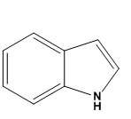
Figure 1. Indole structure with aromatic and five-membered ring sections.
There are several naturally occurring indole derivatives that are used in healthcare today, such as the amino acid tryptophan, the plant hormone heteroauxin, the neurotransmitter serotonin and skatole an indole found in citrus oils and jasmine, which is used for fragrance (figure ${2).}^{2}$ Indoles have found other uses as well, including 4,6-diamidino-2-phenylindole dihydrochloride which is used for staining DNA in agarose gels and also used for photofootprinting of ${DNA.}^{3}$ In addition, nalidixic acid, ciprofloxacin, and levofloxacin are also the products of the Fischer indole synthesis. These antibiotics are used to treat urinary tract ${infections.}^{4}$ The most noticeable use of the Fischer indole synthesis in healthcare is the synthesis of agonists for the neurotransmitter serotonin, which can be used to treat migraine headache${s.}^{5}$ Imitrex, Alsuma, and Sumatriptan are examples of indole-containing antimigraine drug${s.}^{6}$
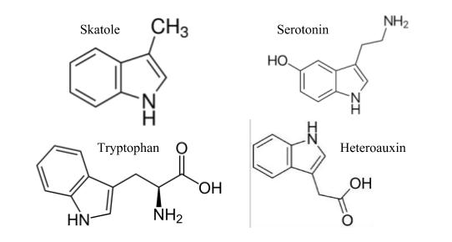
Figure 2. Biological molecules containing indole as the base
In the Fischer indole synthesis, indole is produced by the reaction of an arylhydrazine with a ketone or aldehyde, most typically under strongly acidic conditions. The acidic environment (Bronsted or Lewis acid) speeds up the reaction process, with common acids including hydrochloric acid, sulfuric acid and zinc chloride. An example of this reaction is seen in figure 3.
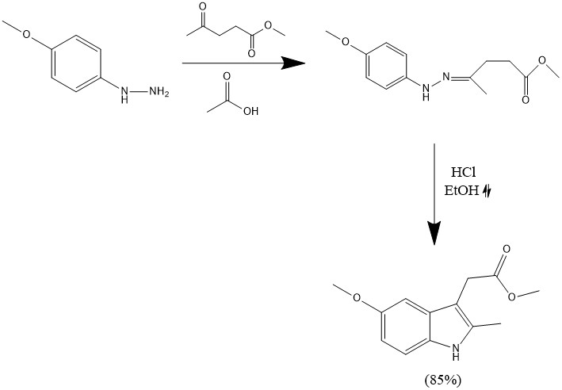
Figure 3 Representative Fischer Indole Synthesis reaction.
To improve the functional group tolerance and expand the scope of the reaction, there has been continuing research for milder reaction conditions. In particular, current options virtually all employ strongly acidic catalysts, which means that acid-sensitive functionality cannot be used. One recent report in this area that shows promise to overcome this limitation was reported by Gore and co-worker${s.}^{7}$ Gore et al used various ketones such as cyclic, acyclic, and aromatic ketones under similar conditions with various milder acids to test productivity. Interestingly, they found that Fischer Indole Synthesis reactions with the designated ketone reactants had the highest percent yield (97%) with the tartaric acid. While the conditions of Gore show definite promise, they do have some limitations. For one thing, they are still acidic (though fairly mild). In addition, the two solvent components (${DMU}^{8}$ and tartaric ${acid}^{9}$) are not inexpensive: one 100-gram bottle of tartaric acid is about $40 and one 25-gram bottle of DMU is $90. Based upon prior work in the Handy group with non-acidic deep eutectic solvents and the possibility of carbonyl activation via hydrogen-bonding, we were interested in exploring either other deep eutectic solvents without acidic components or a simple hydrogen-bonding solvent such as glycerol.
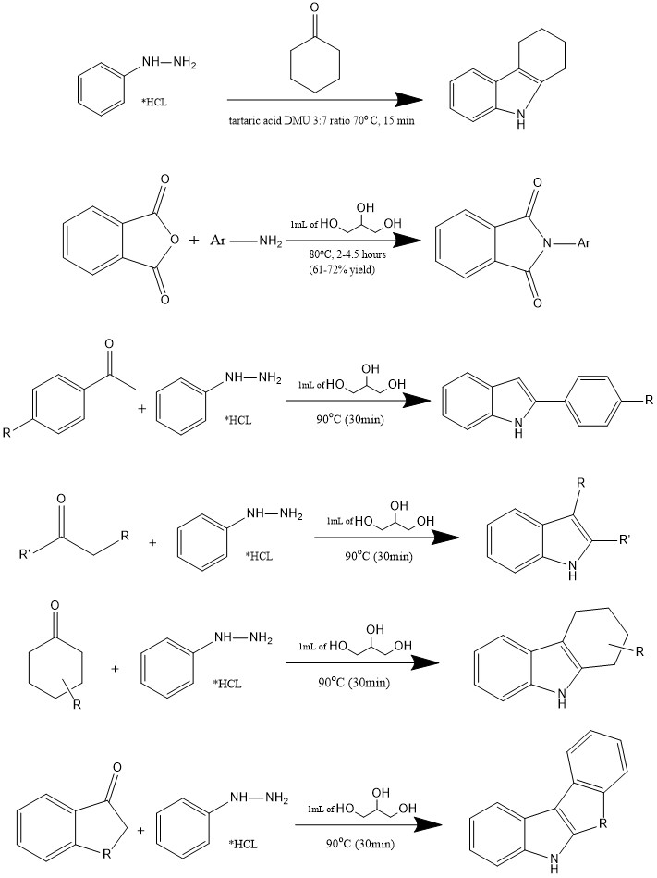
Figure 4 Low-melting Salt Synthesis
According to Diaz-Alvarez and colleagues, green chemistry has been a recent movement in chemistry to shift towards environmentally friendly reagents, where glycerol is especially unique, nicknamed the “organic wate$r^{10}$”. Furthermore, glycerol is able to be used efficiently in catalyst free environments. Glycerol is a simple polyol compound and has actually been used for thermal Fischer indole synthesis reactions, which proceed at very high temperatures (>180$℃$) and is an interesting option for a ${solvent.}^{11}$ Benefits of glycerol include low cost, low flammability and volatility, easy removal via extraction, and the potential for catalytic hydrogen-bonding properties. It has been explored as a solvent for various organic reactions, but not for milder Fischer indole synthesis reactions. Furthermore, glycerol, which is a byproduct generated in the biofuel industry, has the ability to be reused as a “green” solvent, reducing the amount of waste ${produced.}^{12}$ Glycerol, while being largely available at a low price, also possesses beneficial intrinsic characteristics such as high solubility in water as well as non-${toxicity.}^{13}$ Cons when using glycerol as a solvent include its high boiling point, eliminating distillation as a method to evaporate the solvent to separate from product${s.}^{14}$
Figure 5. Phthalimide formation using glycerol as the solvent.
Based upon the readily availability of glycerol and its potential to act as a nonacidic catalyst for the Fischer Indole synthesis, we decided to undertake a study of glycerol as both a reactant and catalyst in this key transition.
Experimental
A standard set of reaction conditions was employed for all of the Fischer Indole synthesis reactions and has not been optimized with respect to time or temperature. Thus, the carbonyl compound and phenylhydrazine hydrochloride were combined in a microwave tube with a stir bar and dissolved in 1 mL of glycerol. The reaction was heated in a microwave at 90$℃$ for 30 minutes and then cooled to room temperature. The reaction mixture was then diluted with water and filtered in cases in which a solid product formed or extracted with methylene chloride in the case of oily products. In most cases purification by chromatography was not necessary. When purification was necessary, the product was cleaned on a silica column in 10 to 20% ethyl acetate in hexane. To determine the location of the product in the fractions, the fractions were tested using a TLC plate. Fractions containing the sample were combined, and the solvent was evaporated off using Rotovap. Product identity and purity was established by ¹H NMR and comparison with the data reported in the literature.
Spectra Data:
- 2,3,4,9-Tetrahydro-1H-carbazol$e^{15}$. Solid product. Yield 93.6%. ¹H NMR (300 MHz, CDCl₃): δ 7.68 (br s, 1H), 7.45 (d, J=15 Hz, 1H), 7.28 (d, J=18 Hz, 1H), 7.13-7.02 (m, 2H), 2.78-2.68 (m, 4H), 1.95-1.81 (m, 4H).
- 1,​2,​3,​4-​tetrahydro-Cyclopent[b]​indol$e^{16}$. Solid product. Yield 83.4%. ¹H NMR (300 MHz, CDCl₃): δ 7.81 (br s, 1H), 7.45 (d, J = 15 Hz, 1H), 7.31 (d, J = 13 Hz, 1H), 7.19-7.03 (m, 2H), 2.92-2.80 (m, 4H), 2.60-2.48 (m, 2H).
- 3-ethyl-2-methylindol$e^{17}$. Solid product. Yield 66.0%. ¹H NMR (300 MHz, CDCl₃): δ 7.65 (br s, 1H), 7.55 (dd, J=12.1, 8.8 Hz, 1H), 7.25 (dd, J=9.6, 7.5 Hz, 1H), 7.16-7.07 (m, 2H), 2.75 (q, J = 8.5 Hz, 2H), 2.38 (s, 3H) 1.25 (t, J = 9.7 Hz, 3H).
- 3-Isopropyl-2-methylindol$e^{17}$. Liquid product. Purification with a packed silica column and 10% ethyl acetate in hexanes. Yield 46.2%. ¹H NMR (300 MHz, CDCl₃): δ 7.65 (br d, J=12.9Hz, 1H), 7.28-7.24 (m, 1H), 7.11-7.01 (m, 2H), 2.38 (s,1H), 1.63 (s, 3H), 1.40 (d, J=18.2Hz, 6H)
- 5,6-dihydroindeno[2,​1-​b]​indol$e^{19}$. Solid product. Yield 99.1%. ¹H NMR (500 MHz, CDCl₃): δ 8.35 (br s, 1H), 7.64 (d, J=10.0Hz, 1H), 7.54 (d, J=10.2Hz, 1H), 7.45 (dd, J=11.6, 7.2 Hz, 2H), 7.33 (t, J=15 Hz, 1H), 7.19 (m, 5H).
- 3-Methyl 2-propyl indol$e^{15}$. Solid product. Yield 87.9%. ¹H NMR (300 MHz, CDCl₃): δ 7.72 (br s, 1H), 7.52 (dd, J=12.1, 8.9 Hz, 1H), 7.29-7.24 (m, 1H), 7.13-7.05 (m, 2H), 2.69 (t, J=21.2 Hz, 2H), 2.35 (s, 2H), 2.15 (s,1H), 1.72-1.61 (m, 2H), 0.95 (t, J=15.3Hz, 3H).
- 2,2-Dimethyl-2,3-dihydro-1H-carbazol-4(9H)-on$e^{20}$. Solid product. Yield 80.8%. ¹H NMR (300 MHz, CDCl₃): δ 9.15 (br s, 1H), 7.28-7.19 (m, 2H), 6.89 (t, J=9.31 Hz, 1H), 6.71 (d, J=9.12 Hz, 1H), 2.82 (s, 2H), 2.45 (s, 2H), 1.18-1.13 (m, 6H).
- Benzonitrile, 4-​(1H-​indol-​3-​y${l)}^{21}$. Solid product. Yield 63.6%. ¹H NMR (500 MHz, CDCl₃): δ 8.05 (d J=9.3Hz, 1H), 7.89 (d, J = 8.01Hz, 1H), 7.68-7.64 (m, 2H), 7.31 (t, J=14.8Hz, 1H), 7.26 (s,1H), 7.20 (d, J = 9.06 Hz, 2H), 6.97-6.92 (m, 2H).
- 1H-​Carbazole, 2,​3,​4,​9-​tetrahydro-​2-​methy$l^{22}$. Solid product. Yield 86.4%. ¹H NMR (300 MHz, CDCl₃): δ 7.72 (br s, 1H), 7.45 (d, J=11.2 Hz, 1H), 7.25 (d, J=12.1 Hz, 1H), 7.15-7.11 (m, 2H), 2.88-2.74 (m, 3H), 2.38-2.26 (m, 1H), 2.22-1.96 (m, 2H), 1.62-1.59 (m, 1H), 1.15 (d, J=9.2Hz, 3H).
- 3-(4-Bromophenyl)-1H-indol$e^{23}$. Solid product. Purification with a packed silica column and 20% ethyl acetate in hexanes. Yield 69.9%. ¹H NMR (300 MHz, CDCl₃): δ 7.82 (d, J=8.2Hz, 1H), 7.68-7.63 (m, 1H), 7.55-7.46 (m, 4H), 7.38 (dd, J=13.2, 6.3 Hz, 1H), 7.32-7.27 (m, 1H), 7.22-7.17 (m, 1H), 6.92 (t, J=12.9Hz, 1H).
- 10H-benzofuro[3,2-b] indol$e^{24}$. Liquid product. Purification with a packed silica column and 20% ethyl acetate in hexanes. Yield 96.6%. ¹H NMR (300 MHz, CDCl₃): δ 8.52 (br s, 1H), 7.82 (d, J=12.3Hz, 1H), 7.68-7.65 (m, 1H), 7.62-7.59 (m, 1H), 7.46 (d, J=11.3 Hz, 2H), 7.31-7.22 (m, 3H).
- 5,10-Dihydroindeno[1,2-b] indol$e^{7}$. Liquid product. Purification with a packed silica column and 10% ethyl acetate in hexanes. Yield 73.2%. ¹H NMR (300 MHz, CDCl₃): δ 8.25 (br s, 1H), 7.89 (dd, J=6.9, 3.6 Hz, 1H), 7.68 (d, J=18.3 Hz, 1H), 7.46-7.37 (m, 3H), 7.28-7.24 (m, 1H), 7.12 (t, J=13.8Hz, 2H), 1.35 (d, J=18.2Hz, 2H).
- 6,7,8,9,10,11-Hexahydro-5H-cycloocta[b]indol$e^{7}$. Liquid product. Purification with a packed silica column and 10% ethyl acetate in hexanes. Yield 95.9%. ¹H NMR (300 MHz, CDCl₃): δ 8.17 (br s, 1H), 7.59 (d, J=9.6Hz, 2H), 7.39 (d, J=6.3Hz, 2H), 7.32-7.19 (m, 3H), 3.13-2.98 (m, 5H).
- 2-(4-Methoxyphenyl)-1H-indol$e^{25}$. Liquid product. Purification with a packed silica column and 20% ethyl acetate in hexanes. Yield 76.2%. ¹H NMR (300 MHz, CDCl₃): δ 7.95 (d, J=24.1Hz, 1H), 7.75 (d, J=27, 1H), 7.30-7.15 (m, 3H), 6.92 (t, J= 18.1 Hz, 1H), 3.85 (d, J = 18.1 Hz, 1H), 2.56 (s, 1H), 2.2 (s, 3H), 1.65 (s, 2H).
Results and Discussion
Initially, some preliminary reactions were performed that demonstrated great potential for the use of glycerol as a solvent and catalyst when coupled with the use of microwave heating. Thus, the reaction in Figure 6 was performed. After 30 minutes of heating at 90$℃$ in the microwave, an excellent 95% yield of the anticipated indole product was isolated simply by diluting the reaction with water and then filtering the resulting solid. A few other reactions were attempted as well – all of them giving good results. With the success of this first reaction, more variations were tested using the same method to understand the limitations of the Fischer Indole Synthesis in glycerol. 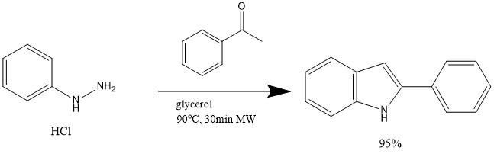
Figure 6 Phenylhydrazine hydrochloride is treated with acetophenone in glycerol
In exploring the development of new synthetic methods, one important aspect to keep in mind is the separation of the products from the byproducts and reaction solvent. With glycerol as a solvent, not only is the method of synthesizing indole more cost efficient and easier for research laboratories, but glycerol can also be removed simply by washing with water. This increased efficiency in laboratory procedure allows for a chain reaction increasing the efficiency of other necessary laboratory experiments. This includes the synthesis of neurotransmitters and other organic compounds.
The main reactants tested can be separated into acetophenones, acyclic ketones, fused cyclic ketones, and cyclic ketones. The acetophenones had decent success with yields in the 60-76% range (Table 1). While the success of the reactions did not produce as high a percent yield as some of the other ketone reactants, the ease and speed with which these compounds can be made is certainly promising. The first reactant displayed in the table below producing 2-(4-Methoxyphenyl)-1H-indole with percent yield of 76.2% displayed some residual starting materials, indicating that the reaction of more electron-rich compounds may be slower and thus need either a longer reaction time and/or a higher temperature.

Reactant | Product | Percent Yield
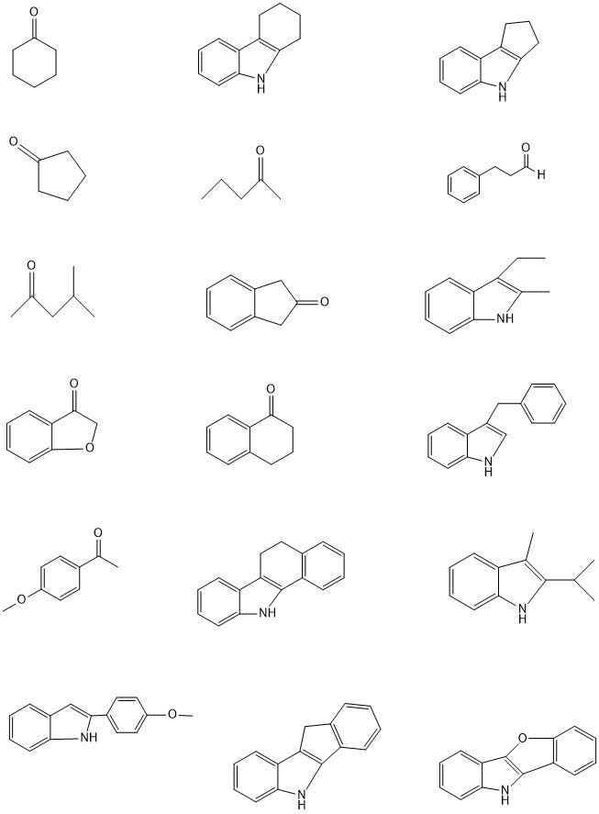 | 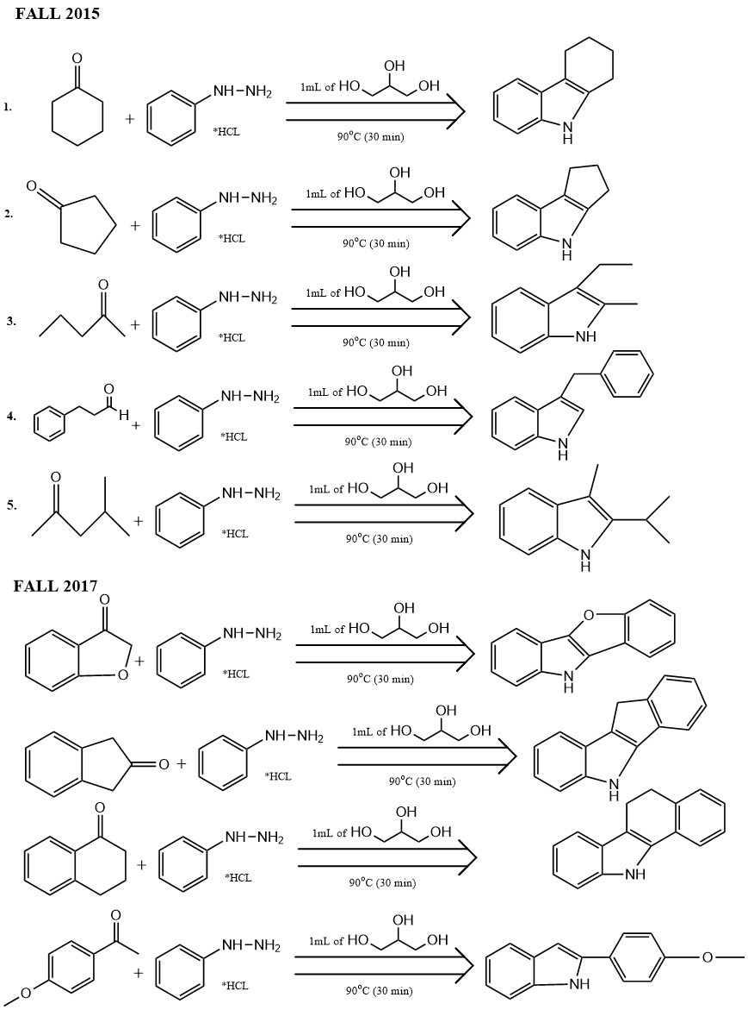 | 76.2%
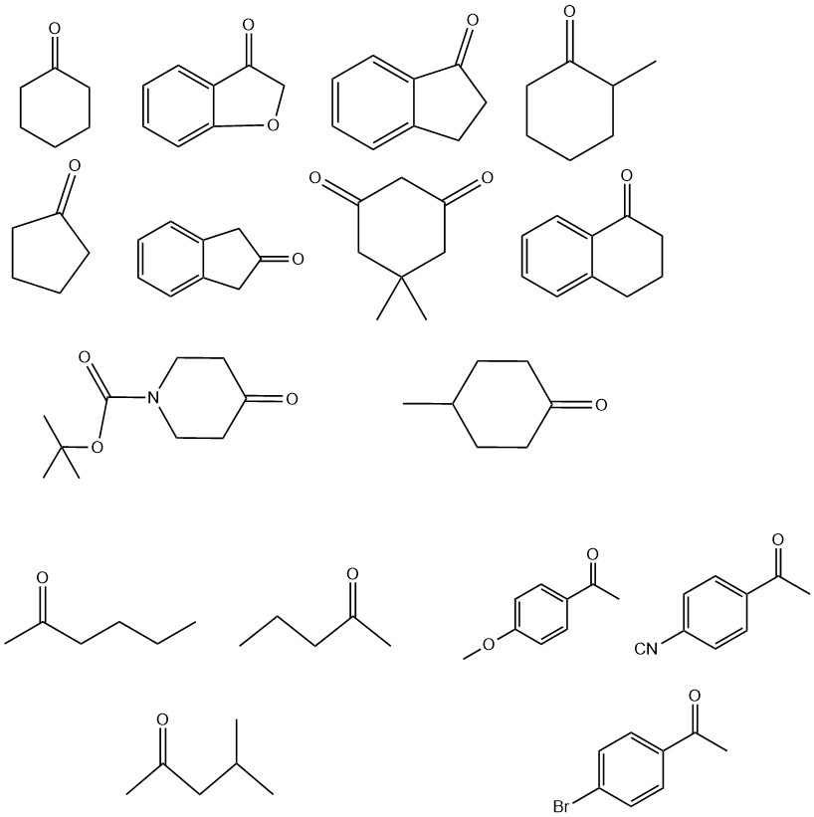 | 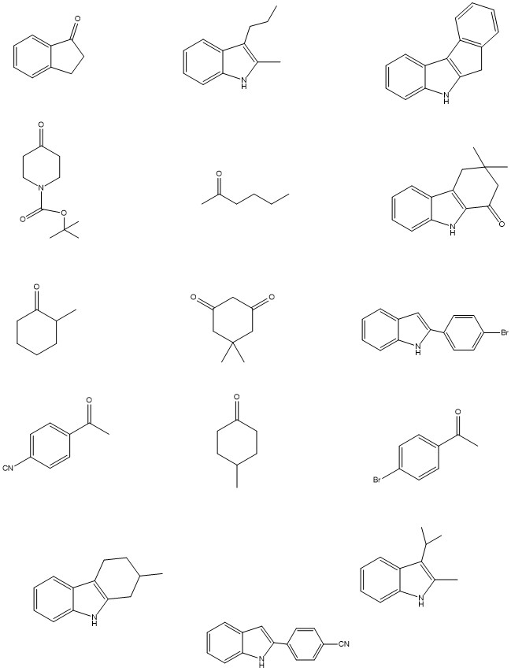 | 63.6%
 |  | 69.9%

Table 1. Fischer Indole Synthesis with Acetophenone Reactants and Percent Yield

Other synthesis reactions were completed using acyclic ketones as reactants. These reactions were successful, but produced highly variable yields (Table 2). Some of this could be due to ketone volatility, as the best result was obtained with the least volatile ketone (entry 3). Also, the use of an aldehyde failed to afford any indole product, in keeping with the results of most studies of the Fischer indole synthesis (entry 4).

Reactant | Product | Percent Yield
 |  | 46.2%
 |  | 66.0%
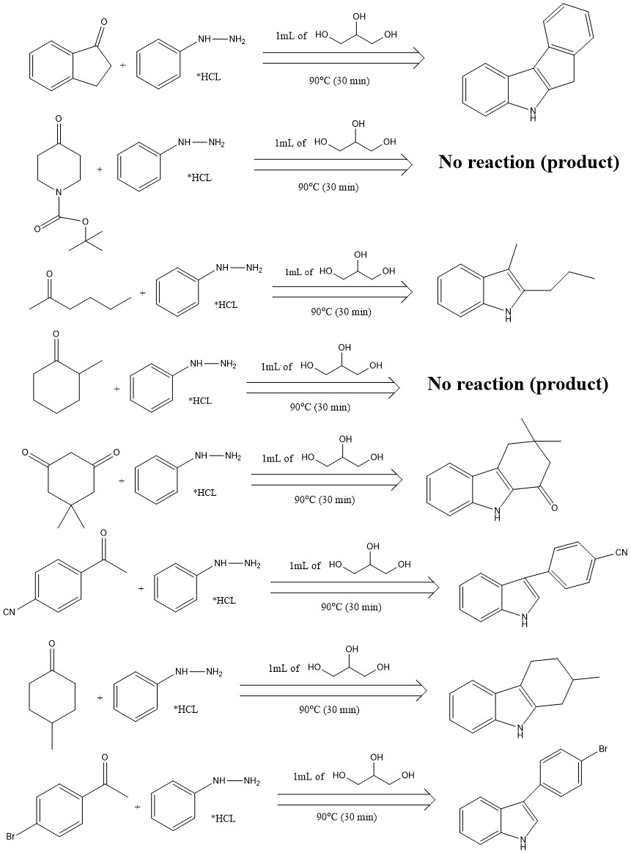 |  | 87.9%
 | No product isolated | -

Table 2. Fischer Indole Synthesis with Acyclic Ketone Reactant with Percent Yield
Further ketone reactants were tested using cyclic ketones. The non-fused cyclic ketones as reactants generally produced products in good yield with the exception of two reactants that were unsuccessful based on NMR spectra (Table 3). The cyclic ketones produced indole rings with indole fused to another ring. These particular ketones should be further explored to gain a better understanding of which cyclic ketones work best for Fischer Indole Synthesis reactions. In terms of the two ketones that failed to afford indole products, the fourth reactant seen in Table 3 is known to not aromatize and be a reversible reaction, which could explain the failure to observe any product. For the entry in Table 3, it is possible that the tert-butoxycarbamate group is being lost thermally, affording a ketone that is capable of undergoing numerous side reactions. Further, even if this ketone were to react, the final product might be too water soluble for easy isolation.
Reactant | Product | Percent Yield
 |  | 83.4%
 |  | 93.6%
 | No product isolated | -
 | No product isolated | -
 | 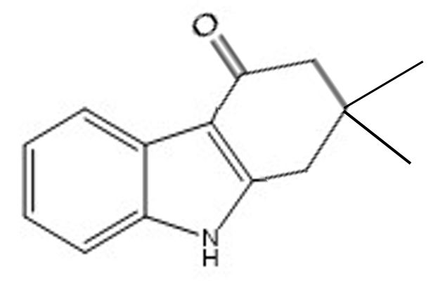 | 80.8%
 |  | 86.4%
Table 3. Fischer Indole Synthesis with Cyclic Ketone Reactants and Percent Yield
Fused cyclic ketones were also used as reactants for Fischer Indole Synthesis reactions (Table 4). These reactions afforded excellent yields. These ketones proved very successful in creating viable indole products. Further experimentation should be done exploring the limits and expanses of using fused cyclic ketones for Fischer Indole Synthesis. The reactants, products, and percent yields for fused cyclic ketones can be seen in Table 4.
Reactant | Product | Percent Yield
 |  | 99.1%
 |  | 96.6%
 |  | 73.2%
 |  | 95.9%
Table 4. Fischer Indole Synthesis with Fused Cyclic Ketone Reactants and Percent Yield

Conclusion
This experiment tested a series of ketones in Fischer Indole Synthesis using glycerol as a reagent. The NMR spectra were analyzed and compared to those reported in the literature to conclude overall success of creating the desired indole products. Going further with experimentation, testing more ketones in each of the groups: acyclic, acetophenone, cyclic, and fused cyclic, can provide more insight into which ketones work best with glycerol. In order to get better percent yields, a different method for washing the products could be helpful as extraction (for oily products) was not always successful at completely removing the glycerol. Further, a potential source of error for this experiment was the potential to lose the desired product during the washing process since water was used. For further experimentation, the aqueous waste products should also be tested for product. Then, experiments should be done to find a more suitable method for washing specific indole products that could be lost in the water.
Appendix A: Definitions of Terms
- Indole-a benzene ring that is fused with a five membered ring with a Nitrogen group
- Benzene Ring- a six membered carbon ring with six aromatic π electrons
- Functional Group- a group of atoms that give particular chemical characteristics to a compound
- Phenylhydrazine-a benzene ring with an NHNH₂ side chain
- Ketone- a hydrocarbon molecule where the carbon chain backbone has atleast one double bond to an oxygen
- Aldehyde- a carbonyl at the end of a carbon chain with a hydrogen attached to the carbonyl carbon
- Acidic- a solution with high concentration of hydrogen ions, causing a low pH (<7)
- Agonist- a substance that chemically mimics another organic substance to stimulate an action
- Neurotransmitter-chemical messengers
- Solvent- the material (usually liquid) that dissolves another compound
- Catalyst- a compound that increases the rate of reaction by lowering the activation energy without being consumed in the reaction
- Glycerol- a three carbon chain (propyl) with three alcohol groups
- Organic Compounds- a large class of chemical compounds in which multiple carbon atoms are covalently bonded to each other and other elements (hydrogen, oxygen, or nitrogen)
- Regiochemistry- the regioselectivity of an overall reaction
- Regioselectivity- the preference reaction at one site above all other possible sites
- NMR- Nuclear Magnetic Resonance

Appendix B: NMR Spectra
- 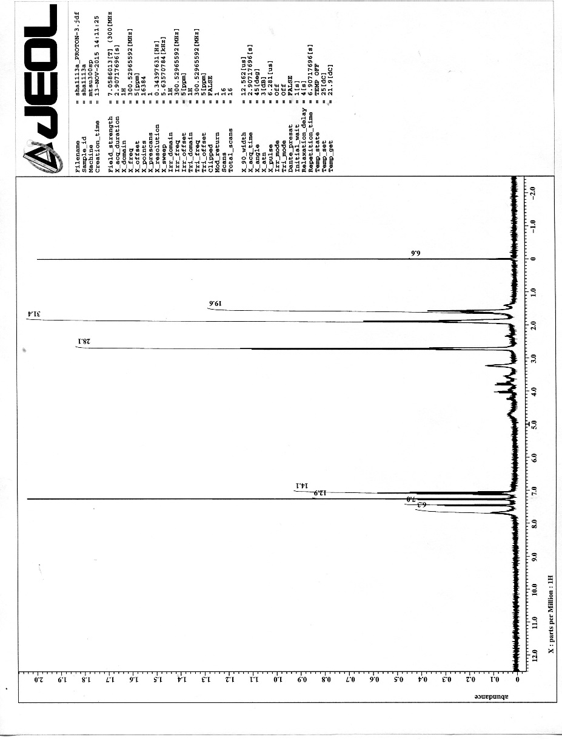
- 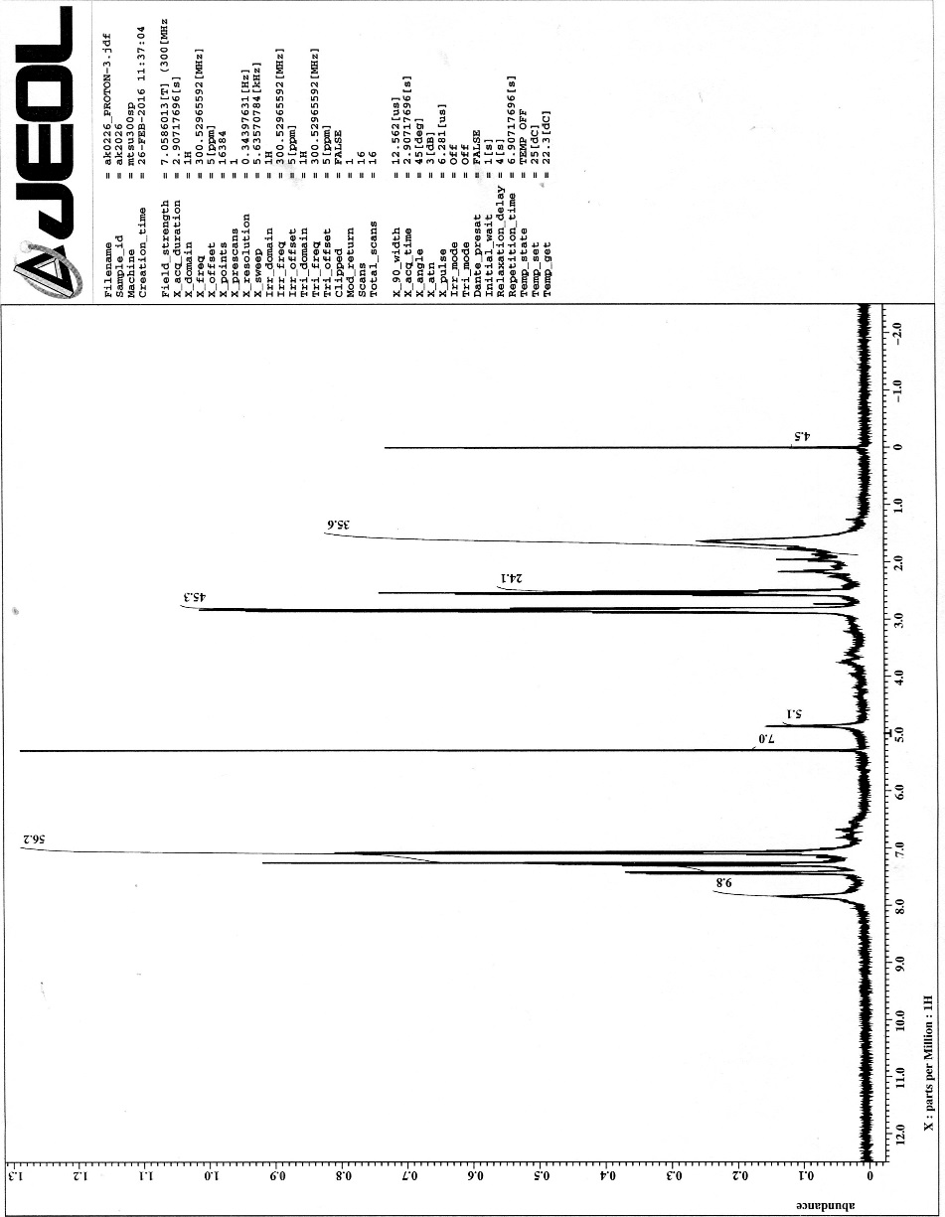
- 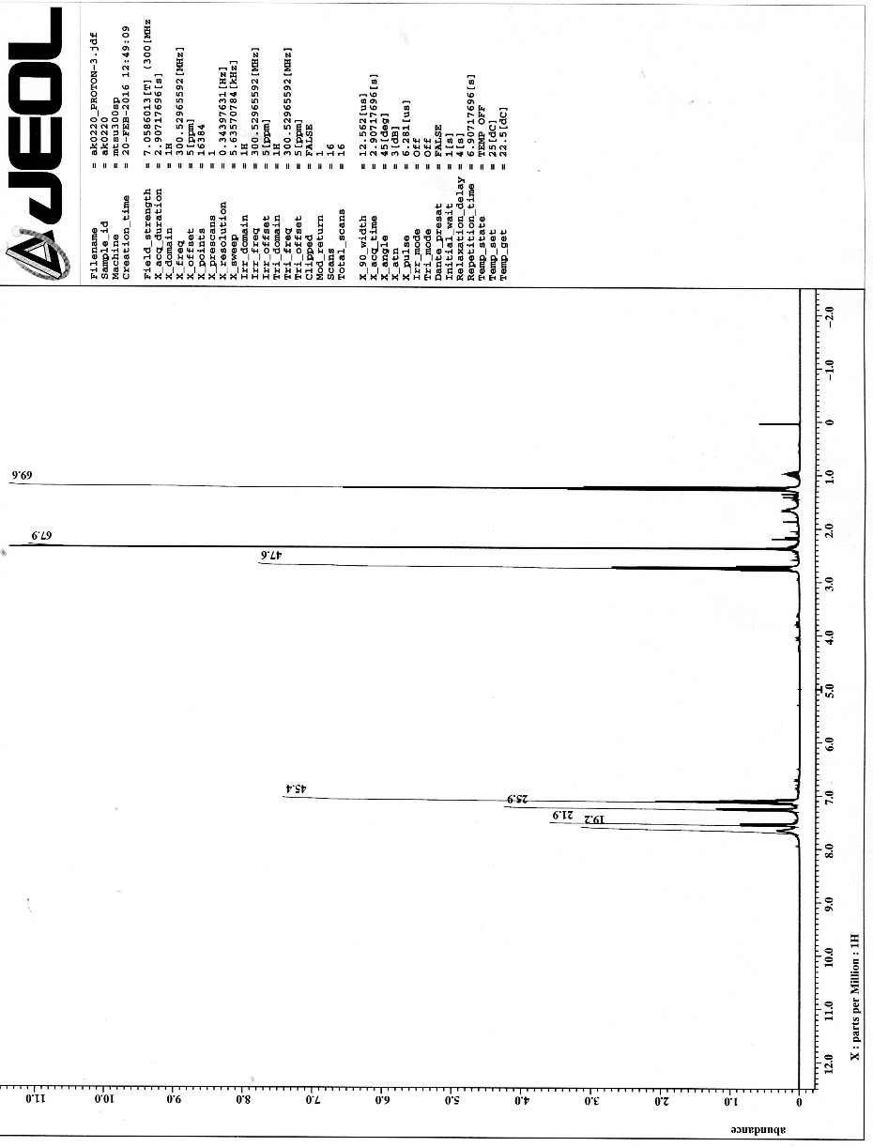
- 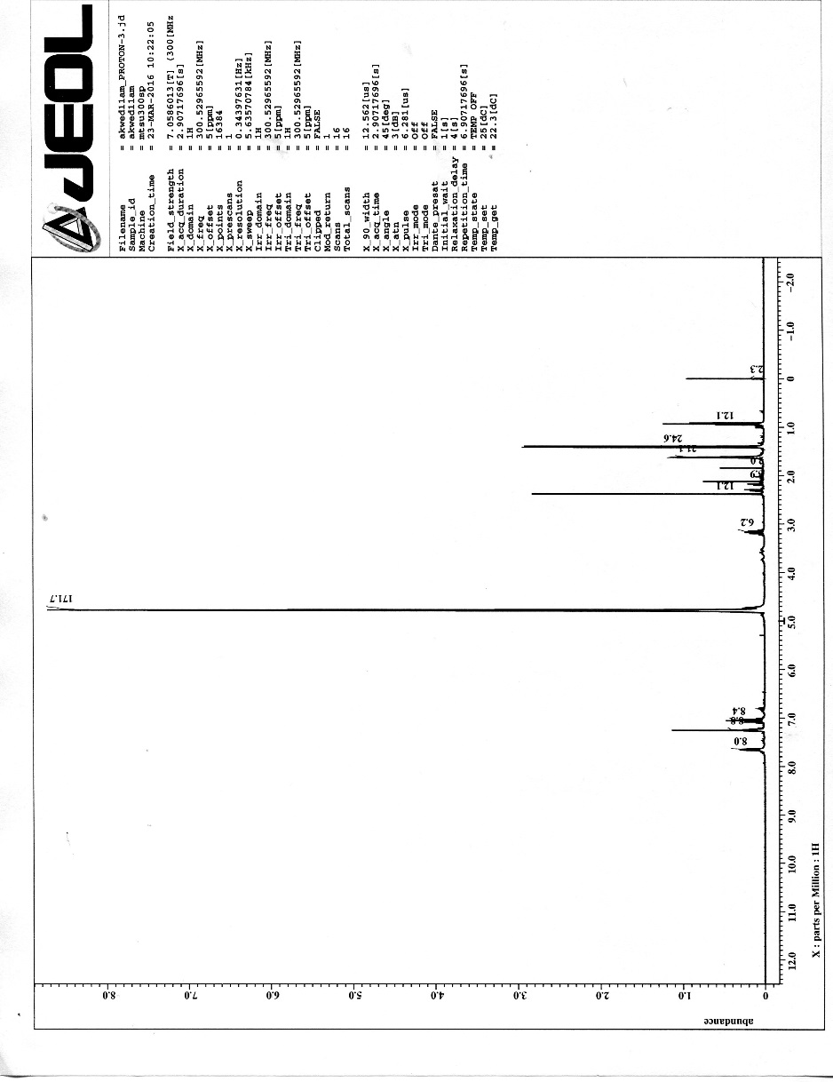
- 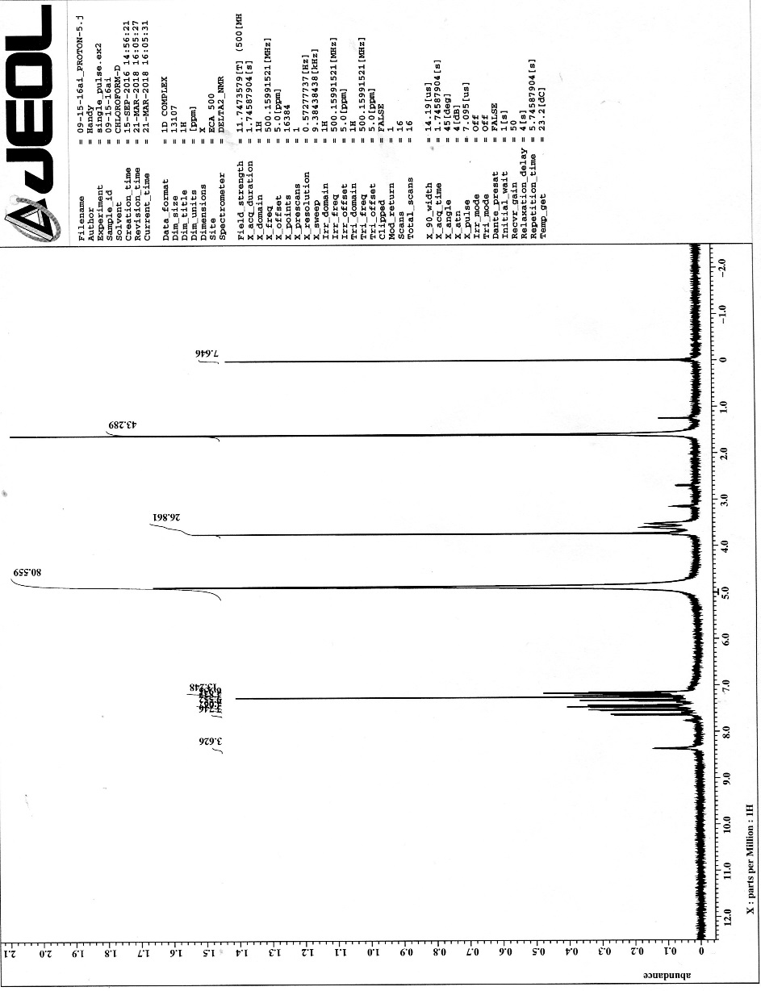
- 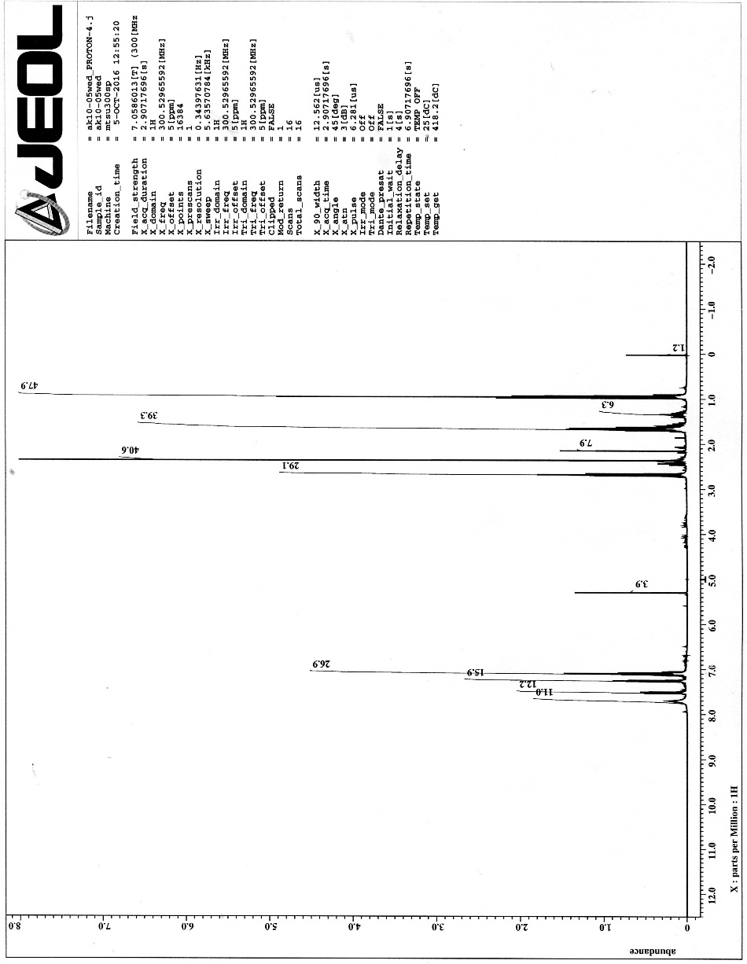
- 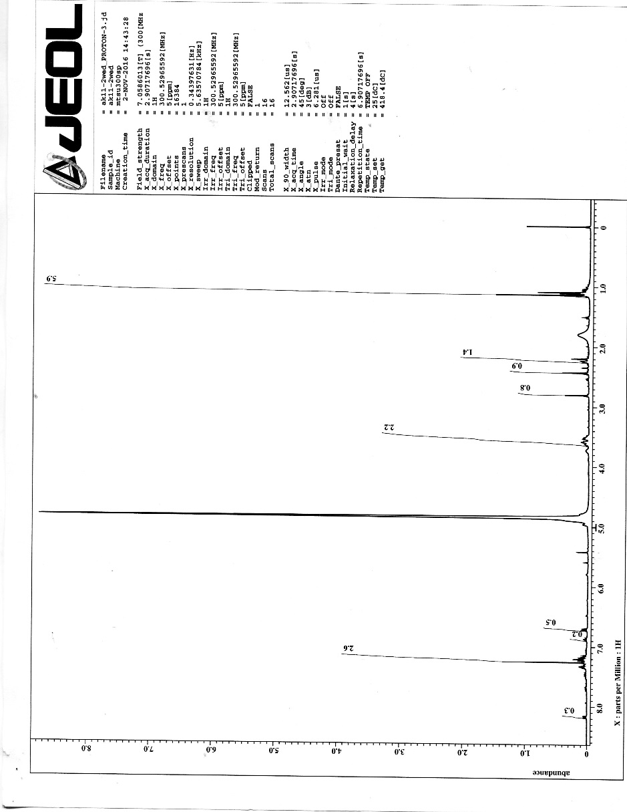
- 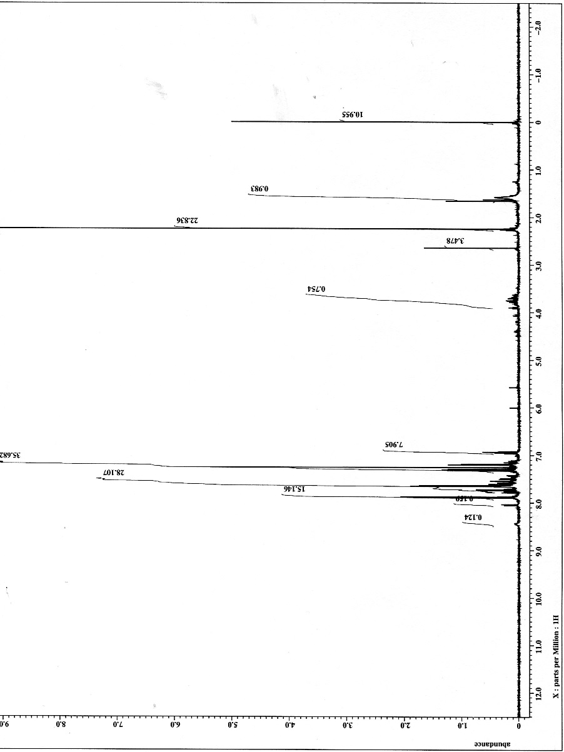
- 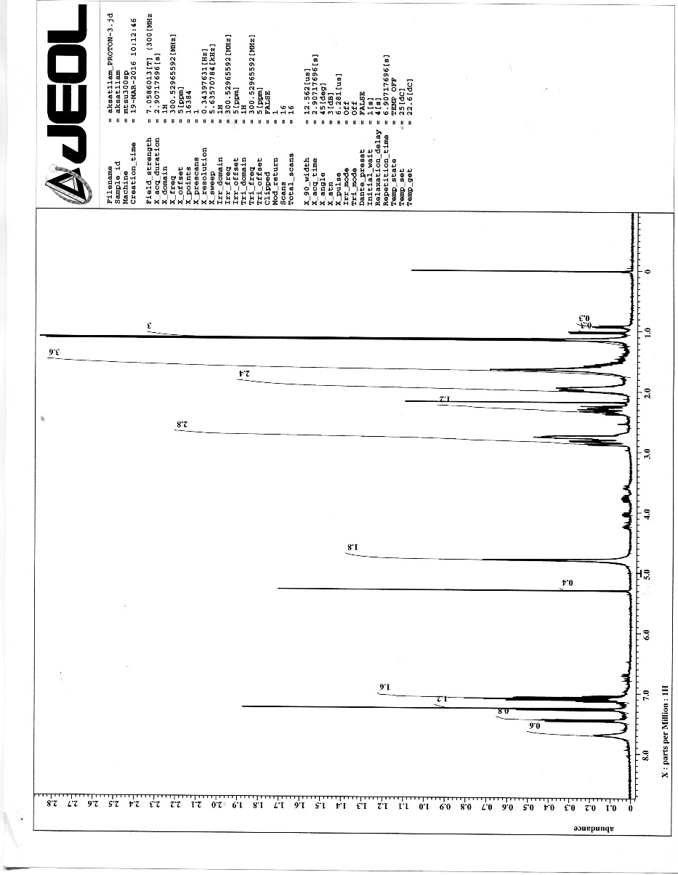
- 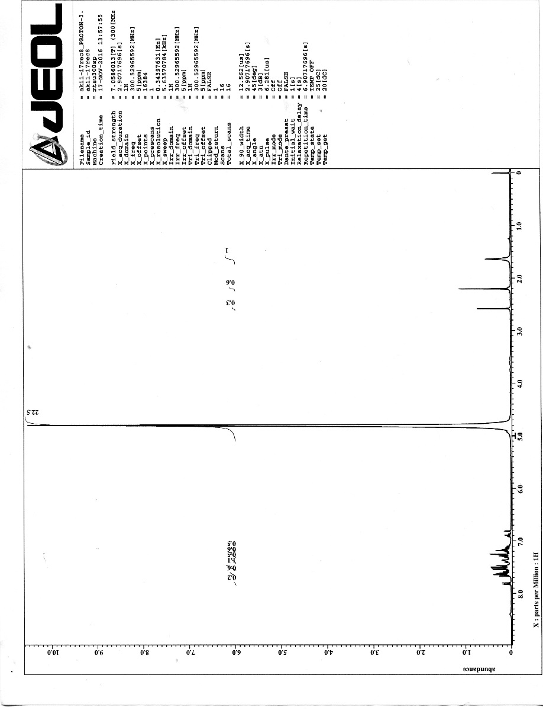
- 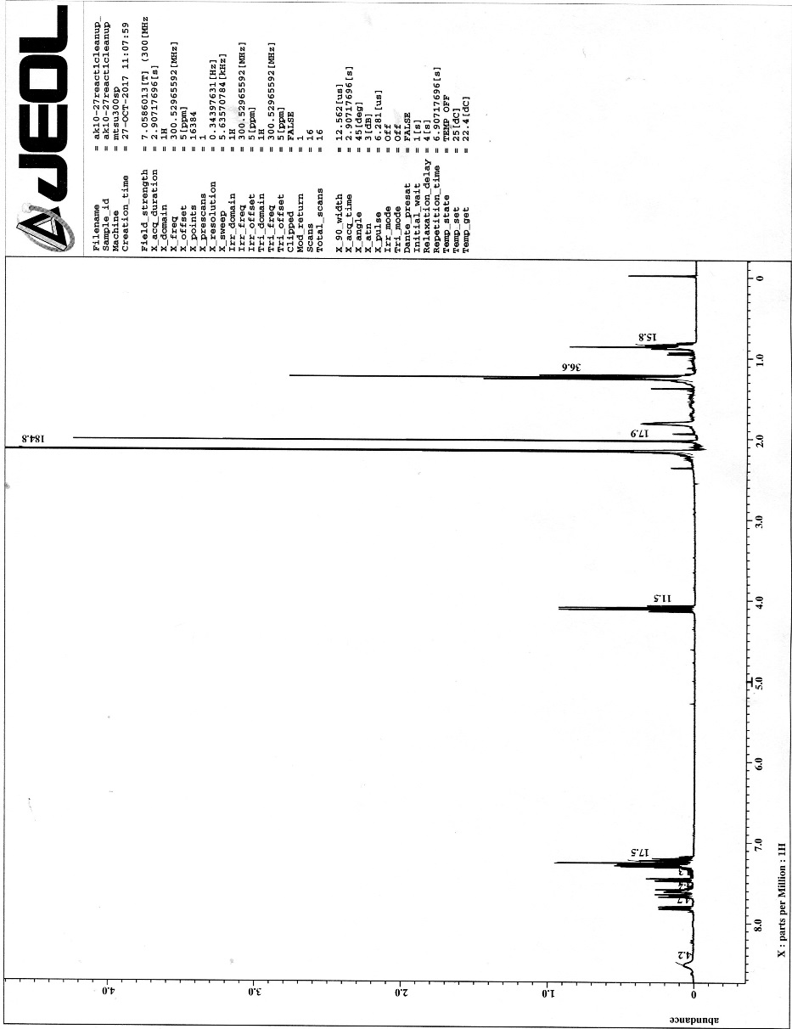
- 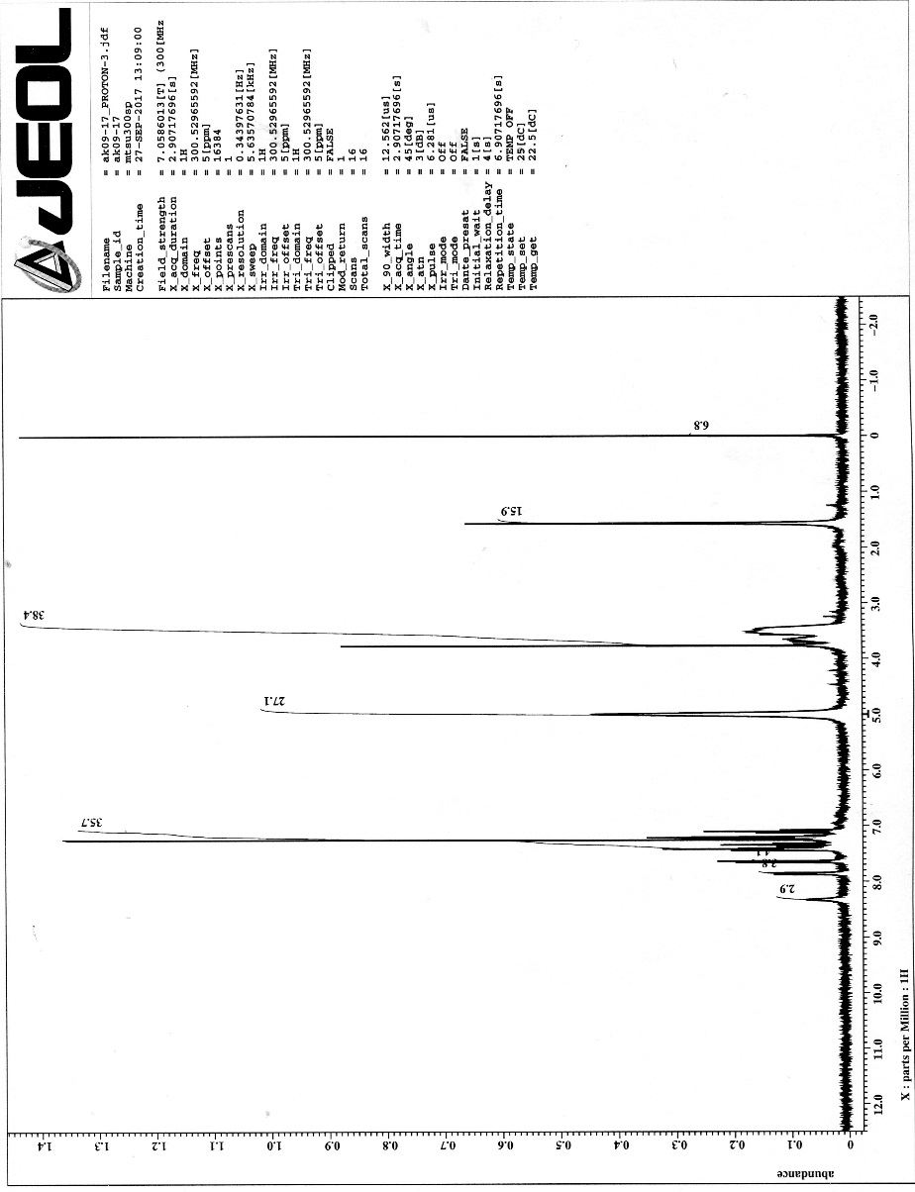
- 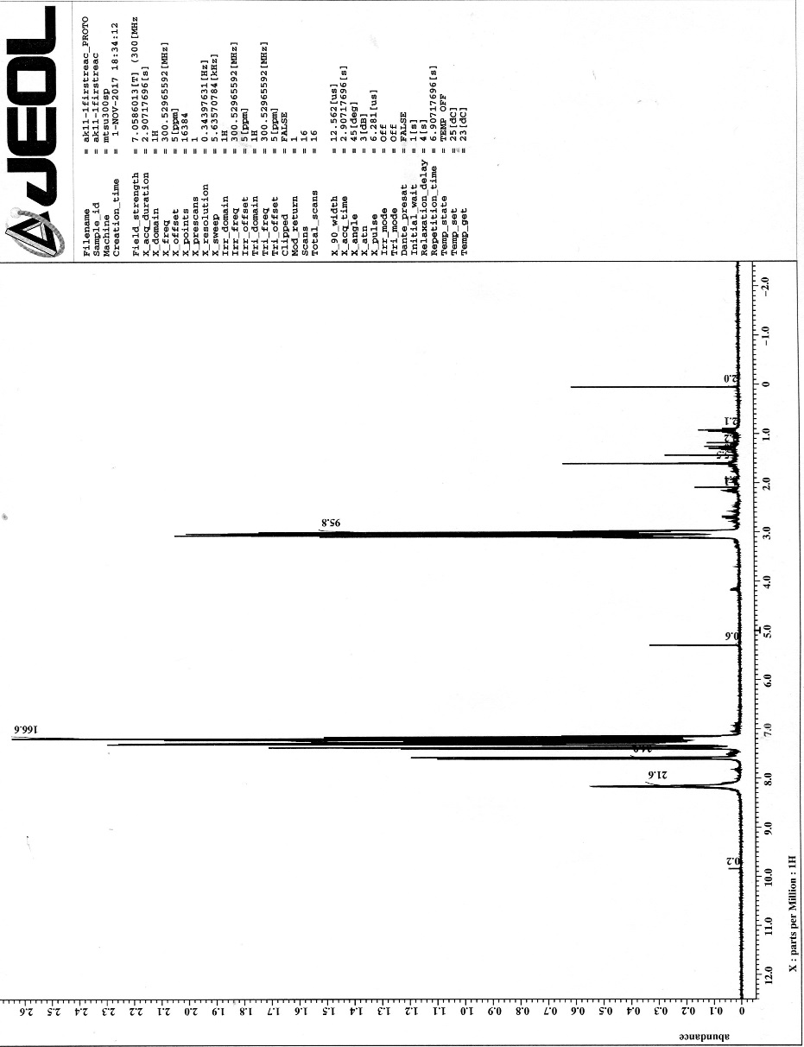
- 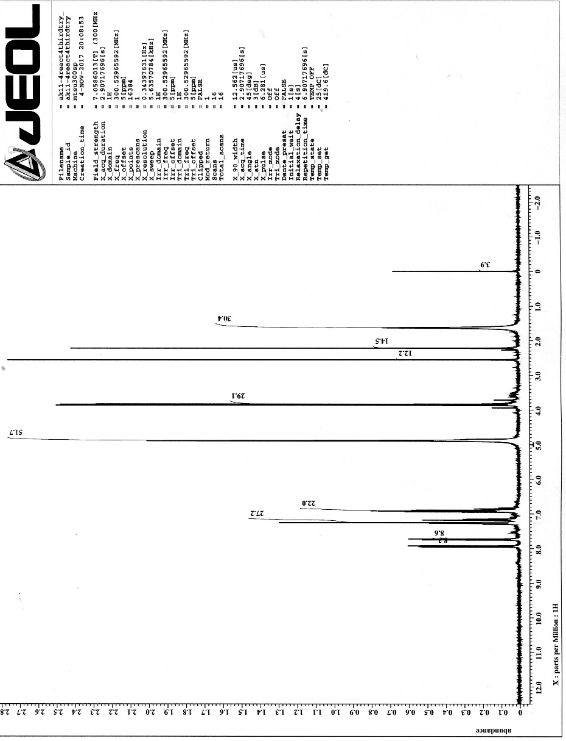

References
- Hughes, D.L. Progress in the Fischer Indole Synthesis. A review. Org. Prep. & Proced. Int. 1993, 25, 607-632.
- Yutov, M. Indole:the Maestro is Decomposing. Fragrantica. 2016. Retrieved from: http://www.fragrantica.com/news/Indole-The-Maestro-Is-Decomposing-8000.html
- Sigma-Aldrich. Product Information: DAPI. Retrieved from: https://www.sigmaaldrich.com/content/dam/sigma-aldrich/docs/Sigma/Product_Information_Sheet/d8417pis.pdf
- Mayo Clinic. Urinary Tract Infection (UTI) Treatment and Drugs. Mayo Clinic. 2016. Retrieved from: http://www.mayoclinic.org/diseases-conditions/urinary-tract-infection/basics/treatment/con-20037892
- Ferrari, M. D., Goadsby, P. J., Roon, K. I., & Lipton, R. B. Triptans (serotonin, 5‐HT1B/1D agonists) in migraine: detailed results and methods of a meta‐analysis of 53 trials.Cephalalgia, 2002. 22, 633-658.
- Knittel, J. L., Vorce, S. P., Levine, B., Hughes, R. L., & Bosy, T. Z. (2015). Multidrug Toxicity Involving Sumatriptan. J. Anal Toxicol, 39, 75-79.
- Gore, S.; Baskaran, S.; Koenig, B. Fischer Indole Synthesis in Low Melting Mixtures. Org. Lett. 2012, 14, 4568-4571
- Sigma-Aldrich. Product Information: DMU. Retrieved from: https://www.sigmaaldrich.com/catalog/product/aldrich/261394?lang=en&region=US
- Sigma-Aldrich. Product Information: Tartaric acid. Retrieved from: https://www.sigmaaldrich.com/catalog/substance/tartaricacid150098769411?lang=en&region=US
- Díaz-Álvarez AE, Francos J, Croche P, Cadierno V. Recent advances in the use of glycerol as green solvent for synthetic organic chemistry. Curr. Green Chem. 2014, 1, 51-65.
- Fitzpatrick, J.T.; Hiser, R.D. Non-catalytic Fisher Indole Synthesis. J. Org. Chem. 1957, 22, 1703-1704.
- Gu Y, Jérôme F. Glycerol as a sustainable solvent for green chemistry. Green Chem. 2010, 12, 1127-1138.
- Pagliaro M, Rossi M. Glycerol: properties and production. in “The future of Glycerol: New Usages for a Versatile Raw Material.” 2008, RSC Publishing, London.
- Abbott AP, Harris RC, Ryder KS, D'Agostino C, Gladden LF, Mantle MD. Glycerol eutectics as sustainable solvent systems. Green Chem. 2011, 13, 82-90.
- Cabrera A, Sharma P, Ayala M, Rubio-Perez L, Amézquita-Valencia M. [(S)-BINAP] PdBr 2-catalyzed direct synthesis of 2, 3-disubstituted indoles via a tandem reaction between arylamines and α-diketones. Tetrahedron Lett. 2011, 52, 6758-6762.
- Desroses M, Wieckowski K, Stevens M, Odell LR. A microwave-assisted, propylphosphonic anhydride (T3P®) mediated one-pot Fischer indole synthesis. Tetrahedron Lett. 2011, 52, 4417-4420.
- Tursky M, Lorentz-Petersen LL, Olsen LB, Madsen R. Iridium-and ruthenium-catalysed synthesis of 2, 3-disubstituted indoles from anilines and vicinal diols. Org. & Biomolec. Chem. 2010, 8, 5576-5582.
- Di Gregorio G, Mari M, Bartoccini F, Piersanti G. Iron-Catalyzed Direct C3-Benzylation of Indoles with Benzyl Alcohols through Borrowing Hydrogen. The J. Org. Chem. 2017, 82, 8769-8775.
- Barolo SM, Lukach AE, Rossi RA. Syntheses of 2-substituted indoles and fused indoles by photostimulated reactions of o-iodoanilines with carbanions by the SRN1 mechanism. J. Org. Chem. 2003, 68, 2807-2811.
- Xu DQ, Wu J, Luo SP, Zhang JX, Wu JY, Du XH, Xu ZY. Fischer indole synthesis catalyzed by novel SO 3 H-functionalized ionic liquids in water. Green Chem. 2009, 11, 1239-1246.
- Zhang Z, Hu Z, Yu Z, Lei P, Chi H, Wang Y, He R. Direct palladium-catalyzed C-3 arylation of indoles. Tetrahedron Lett. 2007, 48, 2415-2419.
- Chen CY, Lieberman DR, Larsen RD, Verhoeven TR, Reider PJ. Syntheses of indoles via a palladium-catalyzed annulation between iodoanilines and ketones. J. Org. Chem. 1997, 62, 2676-2677.
- Singsardar M, Chakraborty A, Jana S, Hajra A. Metal‐Free Synthesis of Indoles from Arylhydrazines and Nitroalkenes at Room Temperature. ChemistrySelect. 2017, 2, 8893-8897.
- Srour H, Doan TH, Da Silva E, Whitby RJ, Witulski B. Synthesis and molecular properties of methoxy-substituted diindolo [3, 2-b: 2′, 3′-h] carbazoles for organic electronics obtained by a consecutive twofold Suzuki and twofold Cadogan reaction. J. Mater. Chem. C. 2016, 4, 6270-6279.
- Shevlin M, Guan X, Driver TG. Iron-Catalyzed Reductive Cyclization of o-Nitrostyrenes Using Phenylsilane as the Terminal Reductant. ACS Catalysis. 2017, 7, 5518-5522.

