Investigation into Timing of Cuttings for Maximum Propagation Efficiency of Vitis aestivalis ‘Norton/Cynthiana’ Grapevines

by
Nolan Jolley

A thesis presented to the Honors College of Middle Tennessee State University in partial
fulfillment of the requirements for graduation from the University Honors College

Fall 2017

Investigation into Timing of Cuttings for Maximum Propagation Efficiency of Vitis aestivalis ‘Norton/Cynthiana’ Grapevines

by
Nolan Jolley

APPROVED:

_______________________________________
Dr. Tony V. Johnston
School of Agribusiness and Agriscience

_______________________________________
Dr. Jessica Carter
School of Agribusiness and Agriscience

_________________________________________
Dr. John DuBois
Department of Biology

________________________________________
Dr. Philip Phillips
University Honors College Associate Dean

Acknowledgments

I thank the Rutherford County Agricultural Extension Services/MTSU for allowing me to use its vineyard for my research and the MTSU Biology Department for allowing me to use the greenhouse and environmental growth chamber to house my cuttings and conduct my evaluations. I give a special thanks to greenhouse worker and researcher Xoe Thacker for keeping my cuttings watered throughout this study. MTSU URECA funding made this project possible by providing the required materials. I would not have been able to effectively use the Biology greenhouse without protocol training and general guidance from Dr. DuBois. Finally, I thank Dr. Tony V. Johnston for lending his expertise and direction to this study.

Abstract

Vitis aestivalis ‘Norton/Cynthiana’ is a grape found as far north as southern Ontario, as far east as Maine, as far west as Oklahoma, and as far south as Florida. The goal of this research was to determine the optimal time of year and/or time after last freeze that will yield the highest traditional propagation rate for ‘Norton/Cynthiana’. Previous research determined that the best time of year traditionally to propagate was in June, ten weeks after the last temperature below 0° C or eight or nine weeks after the first bud break. Samples were collected weekly from a local vineyard, treated with 0.1% indole-3-butyric acid, planted in a 1:1 Perlite:Vermiculite mix, and placed in the plant growth room located in the MTSU Biology greenhouse. The conditions of the controlled-environment growth room were light/dark: 12hr/12hr, 70% relative humidity, day/night temperature: 22º C/15 º C. Daily high and low temperatures in Murfreesboro were recorded. After six weeks, cuttings were evaluated for root growth. Rooting success rates were highest in the month of June at 10%, 12 weeks after the last frost and 10 weeks after bud break.

TABLE OF CONTENTS
Acknowledgements…………………………………………………………………..….…..iii
Abstract…………………………………………………………………………..…………..iv
List of Tables…………………………………………………………………..…………….vi
List of Figures….……………………………………………………………………..…….vii

Introduction………………………………………………………………………..…………..1

Materials and Methods
- On-Site Sampling……………………………………………………..……….3
- Preparation of Cuttings………………………………………………..………3
- Evaluation of Cuttings…………………………………………………..…….3
- Temperature and Vine status log Log…………………………….……..…….4
Results
- Sampling Dates……………………………………………………..………....5
- Successful Rooting Percentage…………………………………..…………....6
- Daily High and Low Temperatures……………………….…………………..7
- Seasonal Look at Norton/Cynthiana…………………….…………….………9
Discussion……………………………………………………………………………………11
Conclusion…………………………………………………………………..……………….14
Literature Cited………………………………………………………………………………16

List of tables

Table 1: The sampling and analysis dates over the duration of the study, from April 4 – September 4, 2017………………………………...…………………………......………........5

List of figures

Figure 1: The percent successful rooting versus date sampled from April 4, 2017 to September 4, 2017.………..………………………..………………………….....……….......6
Figure 2: The daily high and low temperatures in Murfreesboro, TN from March 1, 2017 to September 4, 2017……………………………………………………………….....................7
Figure 3: The daytime high temperatures from February 23 to July 22, 2017………..…..….8
Figure 4: The daytime high temperatures from June 5 to July 22, 2017……..…………...….8
Figure 5: Seasonal look at Vitis aestivalis ‘Norton/Cynthiana’ vines during this study….....9

Introduction
Vitis aestivalis ‘Norton/Cynthiana’ (Norton) is an eastern North American grape species found as far north as southern Ontario, as far east as Maine, as far west as Oklahoma, and as far south as Florida (GRIN 2017). Commercial wine producers are interested in V. aestivalis for its high-quality grapes, low acidity, disease resistance, and resilient nature (Varietal Character: Norton/Cynthiana 2017). These high quality grapes grow in medium clusters and are dark blue-purple in color. Wine made from Norton contains many antioxidants, which have been shown to neutralize harmful free radicals (Hogan and Zhang 2009). A microscopic fungal endophyte lives within the plant and may play a role in its overall toughness (Wilson et al. 2016). Norton protects itself from pests and diseases. The plant also does well in times of drought due to its high heat and sun tolerance (Edible Lanscaping 2017). Though this grapevine has many appealing qualities, it has one overwhelmingly negative quality—it does not propagate well via traditional methods. The vineyard industry standard practice of taking cuttings from dormant adult vines does not work well with Norton. Normally, dormant cuttings are taken before buds break open on the plant to achieve the highest rates of propagation (Avery 1999). However, when this practice is applied to Norton, the rates of propagation are very low (Hartman et al. 2009), between 9.4 and 22.0% (Portz et al. 2004). This makes it difficult for commercial vineyards to utilize Norton.
This issue is widely known and there is speculation on the best method of propagation to use on Norton. One method tried by researchers at Iowa State University involved the use of bottom heat and rooting hormone treatment on Vitis aestivalis cuttings (Enderton et al. 2002). Their study concluded that bottom heat increased the propagation rate, but only to 40.9%. While this is almost double the highest propagation rate achieved using traditional practices, it is not a viable method for commercial vineyards to use. It would be unrealistic to use bottom heating for the large-scale purposes that commercial vineyards demand. Keely et al. studied the propagation rates of Vitis aestivalis when the bases of the cuttings were treated with the rooting hormone indole-3-butyric acid (IBA) (2003). The study showed that cuttings treated with IBA increased root initiation by up to four times those of untreated cuttings. Both studies demonstrate how difficult it is to propagate this specific cultivar of grapevine from dormant cuttings.
In 2007, an MTSU study was conducted to investigate the effects of different concentrations of the rooting hormone auxin used in the propagation of Norton cuttings (Phillips et al. 2007). The study found auxin treatment only minimally increased rooting vigor and successful propagation. During the spring and summer of 2015, a second MTSU study investigated the effects of timing of propagation on V. aestivalis at the Rutherford County Agricultural Extension Service (Johnston, T and DuBois, J, personal communication). Clippings were collected from March through June. The cuttings were treated with IBA, planted in a Perlite/Vermiculite medium, and incubated in a growth chamber set to mimic spring lighting and temperature conditions. The cuttings taken in June had greater propagation success than the cuttings taken in March. An additional study was conducted from 2015-2016 wherein cuttings were taken semimonthly for a year (Uhls 2016). By default, this study involved both dormant and vegetative cuttings. Again, the cuttings taken in June yielded the highest rates of successful propagation (27.5%).

Materials and Methods
I. On-site Sampling
The same Norton vineyard located at the Rutherford County Agricultural Extension Service used in previous MTSU studies was used in this study. From April 1, 2017 to October 1, 2017 fourty clippings were collected each week. In total, 880 cuttings were collected. The forty weekly cuttings were taken from random Norton vines in the vineyard. Each individual cutting was collected from at least the fifth basal node on an individual shoot using shears. The fresh cuttings were placed cut end down in a bucket of water to prevent them from drying out on the trip back to the MTSU campus.
II. Preparation of Cuttings
Every set of cuttings was immediately taken from the vineyard to the MTSU Biology greenhouse for treatment and planting. The rooting hormone, 0.1% IBA was applied to each cutting before it was planted in a 1:1 Perlite:Vermiculite mix housed in a six-inch plastic pot, with six-to-seven cuttings per pot. The perlite/vermiculite medium provides desirable aeration and water retention for the cuttings during rooting (Grant 2014). The cuttings were then incubated in a controlled-environment growth room (light/dark: 12hr/12hr, 70% relative humidity, day/night temperature: 22º C/15 º C) for six weeks.
III. Evaluation of Cuttings
After incubation for six weeks, each cutting was removed from its 1:1 Perlite:Vermiculite rooting medium and inspected for root growth. Any root growth was recorded.

IV. Temperature and Vine Status Log
Local daily high and low temperatures according to the weather service AccuWeather were recorded from March 1, 2017 to October 1, 2017. The goal of recording the high and low temperatures in March, a month before the first collection of cuttings was taken, was to ensure that the last day in late winter or early spring with a temperature at or below freezing is recorded and could be correlated to rooting results in the form of degree-days. Degree days were not calculated in this study.
The physical appearance and general vine status of the Norton grapevines at the Rutherford County Agricultural Extension Service was assessed and photographed during every visit to the vineyard. These weekly vine statuses were monitored so the rooting results of cuttings could be correlated to the physical condition of the plants from which they were collected.

Results
I. Sampling Dates
Sampling dates were as close to 7 days apart as possible to further narrow down the best time of year to traditionally propagate Norton. Due to inclimate weather, some collection trips had to be postponed or performed early by one day. Therefore, every collection falls within six to eight days of the previous collection. The collection scheduled for August 14, 2017 was missed due to personal illness.
Table 1. The sampling and analysis dates over the duration of the study, from April 4, 2017 – October 18, 2017. Samples were analyzed 6 weeks after collection.
Sampling Dates | Analysis Dates
April 4, 2017 | May 16, 2017
April 10, 2017 | May 22, 2017
April 17, 2017 | May 27, 2017
April 24, 2017 | June 5, 2017
May 1, 2017 | June 12, 2017
May 8, 2017 | June 17, 2017
May 15, 2017 | June 25, 2017
May 22, 2017 | June 30, 2017
May 27, 2017 | July 8, 2017
June 5, 2017 | July 17, 2017
June 12, 2017 | July 24, 2017
June 17, 2017 | July 31, 2017
June 25, 2017 | August 7, 2017
June 30, 2017 | August 20, 2017
July 8, 2017 | August 28, 2017
July 17, 2017 | September 4, 2017
July 24, 2017 | September 11, 2017
July 31, 2017 | September 18, 2017
August 7, 2017 | September 25, 2017
August 20, 2017 | October 1, 2017
August 28, 2017 | October 9, 2017
September 4, 2017 | October 18, 2017

II. Successful Rooting Percentage
Rooting success was determined by dividing the number of cuttings that grew roots by forty, which was the total number of cuttings taken at every collection. The highest successful propagation rates were from June 2017 (Figure 1). The June 5, 2017 sampling date showed a 5% successful rooting rate. Cuttings taken on June 12, 2017 yeilded the highest rates of propagation at 10%. Cuttings taken on June 17, and July 8, 2017 showed a 7.5% successful rooting rate. The successful propagation rates of cuttings taken on June 5, June 12, June 17, and July 8 were found to be statistically significant (t-test; p < 0.001). All other sampling dates yielded 0-2.5% successful rooting rates.

Figure 1. The percent of successful rooting versus date sampled from April 4, 2017 to September 4, 2017.

III. Daily High and Low Temperatures
The daily high and low temperatures were recorded for Murfreesboro, TN (Figure 2). The last temperature below 0 °C was recorded on March 19, 2017.

Figure 2. The daily high and low temperatures in Murfreesboro, TN from March 1, 2017 to September 4, 2017 (Accuweather 2017). Orange circle indicates last day recorded below 0 °C.

Figure 3. The daytime high temperatures from February 23 to July 22, 2017. Dotted line shows line of best fits with a slope of 0.1142.

Figure 4. The daytime high temperatures from June 5 to July 22, 2017. This is the time frame that yielded the highest rates of propagation. Dotted line shows the line of best fits with a slope of 0.0643.
IV. Seasonal Look at the Norton Vines
Figure 5 includes views of at the grape vines at important dates throughout this study. The plants consistently looked normal throughout the sampling period. There were no visually obvious changes in the plants that indicated or could be correlated to cuttings rooting efficiency.
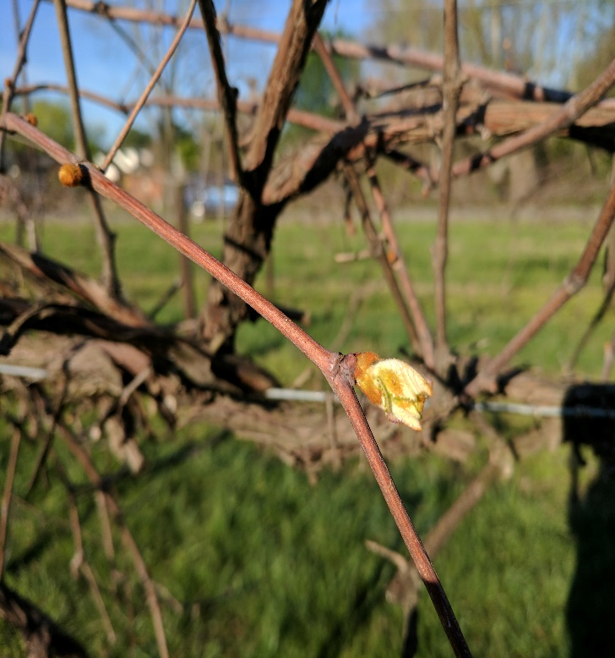  April 4, 2017 | 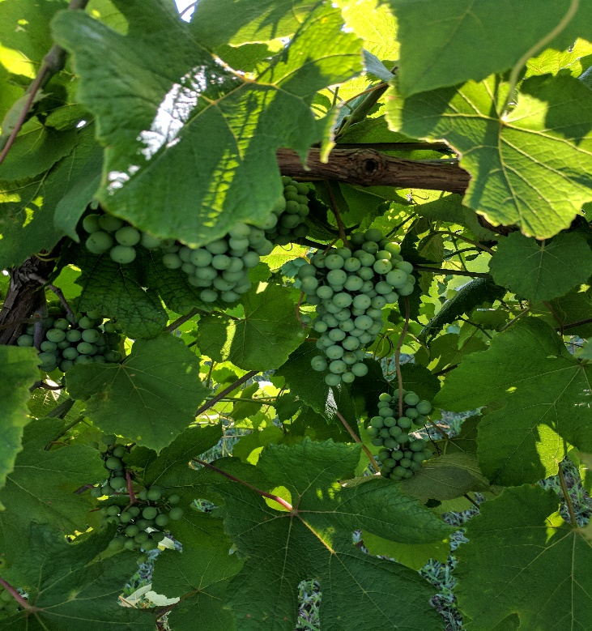June 12, 2017
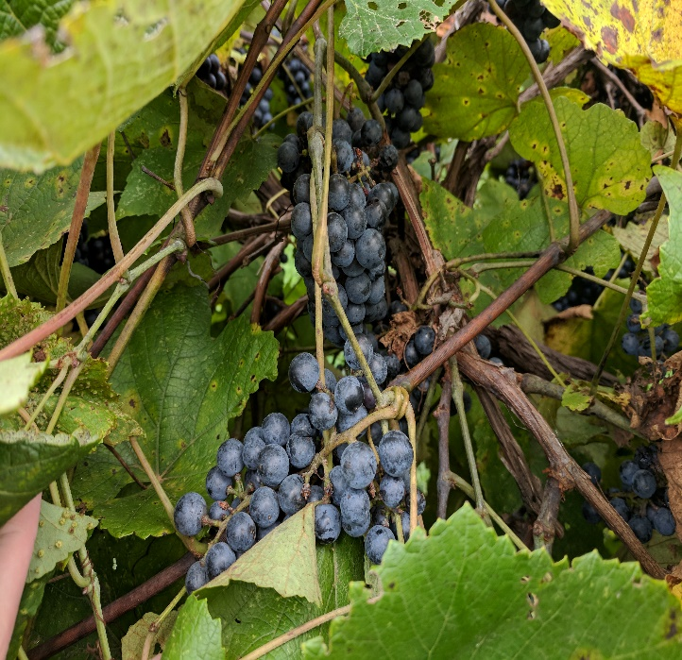  August 20, 2017 | 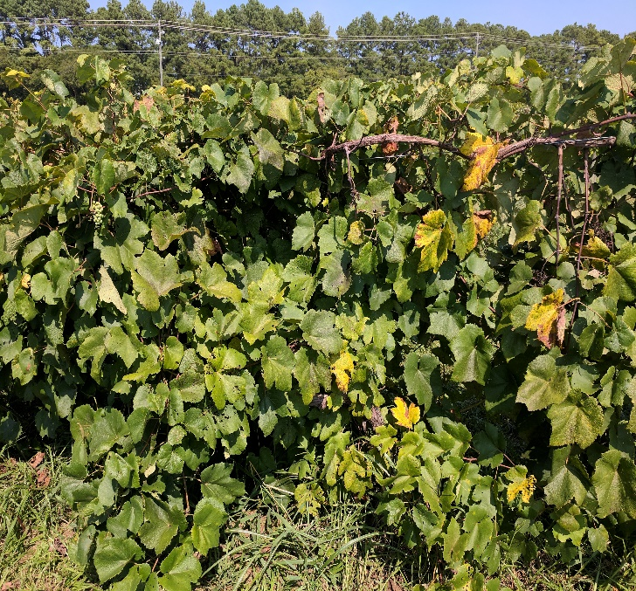  September 4, 2017
Figure 5. A seasonal look at the Vitis aestivalis Norton vines in the Rutherford County Agricultural Extension Service/MTSU vineyard. The first budding was observed on April 4, 2017. The highest propagation rate was observed June 12, 2017. The fruit was ripe and ready for harvest August 20, 2017. The last collection date was September 4, 2017.

Discussion
This study was designed as a continuation and further refinement of previous research to determine the best time to traditionally propagate Vitis aestivalis ‘Norton’ grapes (Uhls 2016). Cuttings were taken weekly from April 4 through September 4, 2017. The August 14, 2017 collection was missed due to personal illness, but preceeding and following sampling yielded a maximum successful propagation rate of 2.5%, so it is hypothesized that this omission did not affect the overall conclusions of the study.
The difficult propagation nature of Norton limits widespread production of this grape. Tradionally, vineyards take cuttings after the vines go completely dormant and before the first bud opens. In middle Tennessee, this is usually some time between December and April. Results from the Uhls study suggest that the tradional timeframe to take cuttings for successful propagation in most grapevines is not the best time to propagate Norton (Uhls 2016). Results of this study corroborate that cuttings taken during April yield no more than a 2.5% successful propagation rate. May cuttings also never surpassed 2.5% successful propagation. Excluding June and July, all other sampling dates yielded propagation success rates of 0.0-2.5%. June cuttings held the highest overall propagation rates, peaking at 10% (Figure 1).
Other methods of propagating Norton such as the bottom heating method employed by Enderton et al. (2002) reached higher rates of propagation at 40.9%. The implementation of bottom heat to a commercial vineyard’s nursery may be more effort than a producer is willing to spend. This study indicates that traditional propagation of Norton should be shifted from dormancy to June-July.
The fungal endophyte that lives within Norton may play a role in its difficult propagation, although the role the endophyte plays in the plant is currently unknown. A protocol for endophyte-free callus tissue of Norton was developed recently by MTSU researchers (Wilson et al. 2016). The endophyte may play a role in the grape’s disease and drought resistance, but it may also be the reason for its difficult propagation. A proposed study inquiring further into the peculiarities of Norton propagation might involve taking cuttings using the same aforementioned methods and vineyard and comparing there rooting success rates to cuttings taken from endophyte-free plants. Because the rooting success of endophyte-free plants is totally unknown, a year-long study would be recommended to establish a baseline for rooting behavior.
Daily high and low temperatures were recorded for the duration of the sampling and the first budding date was noted, so that regions outside of middle Tennessee can obtain an optimal time to take cuttings. Every region has its own unique growing season based on the last day below 0 °C and daily temperatures. In this experiment the highest successful rate of propagation occurred 12 weeks after the last day below 0 °C (March 19, 2017). Commercial vineyards or nurseries at higher or lower lattitudes would need to shift their propagation dates accordingly. The highest successful rate of propagation occurred 10 weeks after the first day buds opened (April 4, 2017). The Uhls study found that the highest successful rates of propagation occurred 10 weeks after the last day below 0 °C and 8-9 weeks after budding. In both the Uhls and this study the highest rates of successful propagation fell in the month of June (Uhls 2016).
High temperatures were evaluated over the period from February 23 to July 22, 2017 by calculating a trendline using Microsoft Excel. Over this period the slope of the trendline was 0.1142, indicating rising temperatures (Figure 3). As spring gives way to summer, rising daily high temperatures are expected and normal. In addition, daily high temperatures were plotted from June 5 to July 7, 2017, the period of time during which propagation rates were highest. The slope of this trendline was calculated to be 0.0643 (Figure 4). This indicates that the time period during which the highest propagation efficiency occurred during the time period when daily high temperatures were essentially steady and unchanging.
Visual evaluation of the vines over the course of the sampling period did not indicate changes that could be used to determine the optimum time for traditional propagation. This technique is, therefore, not recommended for use as a tool for determining traditional propagation timing.

Conclusion
The results of this study suggest that the best time to take cuttings of the Vitis aestivalis ‘Norton’ grape is in the month of June. This study corroborates the results of the Uhls study that the best time of year in middle Tennessee to take cuttings for propagation is June (2016). However, taking cuttings while fruit is setting could jeopardize fruit growth and affect harvest yields. A vineyard focused on maximizing fruit growth during June should set aside a few master plants solely from which to take cuttings.
The current study shows that the highest propagation rate in June fell 12 weeks after the last day with temperatures below 0 °C. The Uhls study found that the highest propagation rates occurred 10 weeks after the last day with freezing temperatures. These ranges are similar enough to suggest that the best time to propagate this grape is about 11 weeks following the last day with temperatures below 0 °C. Visual evaluation of Norton vines was rejected as a discriminating tool for determining the best time to take cuttings for propagation.
It is proposed that propagation efficiency is correlated with daytime high temperatures which are consistently relatively high in a given region for this grape species. There may be plant hormonal, day length, or other factors involved, but consistent daytime high temperature appears to be a considerable factor in rooting efficiency in cuttings taken from this grape vine.
This study indicates that regions that do not experience freezing temperatures should take cuttings to propagate 10 weeks after budding. The Uhls study found that the highest propagation rates occurred 8-9 weeks after budding (2016). These ranges are similar enough to suggest that the best time to take cuttings of this grape is about 9 weeks after budding.
To further understand any role the fugnal endophyte might play in propagation, it would be valuable to run trials with endophyte-free plants in the same fashion that this study was performed. The results of this proposed study would lend insight into the role of the fungal endophyte and its role in the troublesome propagation of Norton.

Literature Cited
Avery, J. D. 1999. Propagation of Norton-Cynthiana. Proceedings of the Fourteenth Annual Midwest Regional Grape and Wine Conference 1999. P.1-6.
Enderton, D., Dilley, C., Domoto P., and Nonnecke, G.. 2002. Cynthiana Grape Cultivar Propagation Study. Annual Fruit/Vegetable Progress Report 2002 FG.601 (2002): n. pag. Iowa State University Extension.
Grant, A. 2014. Gardening With Vermiculite – Vermiculite Uses And Information. Gardening Know How. N.p.
Grant, A. 2014. Perlite Soil Info – Information On Growing Plants In Perlite. Gardening Know How. N.p.
GRIN (Germplasm Resource Information Network), "Taxon: Vitis aestivalis Michx." Taxonomy - GRIN-Global Web v 1.9.8.2. N.p., n.d. Web. 18 Jan. 2017.
Hartman, H.T., Kester, D.E. and Davies, F.T., Jr. 2002. Plant propagation: principles and practices. Prentice Hall, Eaglewood Cliffs, NJ.
Hogan, S., Zhang, L., Li, J., Zoecklein, B., and Zhou, K.. 2009. Antioxidant Properties and Bioactive Components of Norton (Vitis aestivalis) and Cabernet Franc (Vitis Vinifera) Wine Grapes. LWT - Food Science and Technology 42.7: 1269-274.
Keeley, K., John Preece E., and Bradley Taylor H. 2003. Increased Rooting of 'Norton' Grape Cuttings Using Auxins and Gibberellin Biosynthesis Inhibitors. HortScience: Propagation and Tissue Culture 38.2. 281-83.
“Murfreesboro, TN.” Accuweather. N.p., 2017.
“Norton (Cynthiana) Grape." - Edible Landscaping. N.p., n.d. Web.
Phillips N., Kelly B., Johnston T. “The Effects of Shoot Harvest Date and Auxin Concentrations in the Propagation of ‘Norton/Cynthiana’ Grapes (Vitis aestivalis).” MTSU School of Agribusiness and Agriscience 2007.
Portz, D., Domoto, P. and Nonnecke G. 2005. Propagation Treatment Effects on Rooting of 'Cynthiana' Grape Hardwood Cuttings. Annual Fruit/Vegetable Progress Report 2004 FG.601. 56-58. Iowa State University Department of Horticulture.
Uhls, A.L. 2016. The Effect of Sample Date on the Propagation Success Rate of the grape, Vitis aestivalis “Norton/Cynthiana.” Honors Thesis, Middle Tennessee State University. 14pg
“Varietal Character: Norton/Cynthiana.” Appellation America: All the wines of North America. N.p., n.d. Web. 18 Jan. 2017.
Wilson, A. , Fuller, M. , Smith, S. , Johnston, T. and Du Bois, J. (2016) A Protocol for Endophyte-Free Callus Tissue of the Grape Vitis aestivalis “Norton/Cynthiana” (Vitaceae). Agricultural Sciences, 7, 680-692. doi: 10.4236/as.2016.710064.

