“The Athens of the South”: How the Athenian Parthenon Reinforces and Shapes the Cultural Identity of Nashville, Tennessee

By
Luke Howard Judkins

A thesis presented to the Honors College of Middle Tennessee State University in partial fulfillment of the requirements for graduation from the University Honors College

November 30, 2016

“The Athens of the South”: How the Athenian Parthenon Reinforces and Shapes the Cultural Identity of Nashville, Tennessee

Luke Howard Judkins

APPROVED:

Dr. Dawn McCormack
College of Liberal Arts Associate Dean

Dr. Janis Brickey
College of Behavioral and Health Sciences

Dr. Philip Phillips
University Honors College Associate Dean

To Mom, Dad, and Gidget
To my family and friends
To the Kingdom

The Parthenon at Nashville

I saw Athens on a bluegrass hill,
Artemis and Aphrodite in her train.
Hephaestos forged his thunders in the rain
And mists of Lemos. Beside his salty rill
Poseidon sat and all the air was still.
Awed, in dumb wonder, Zeus sat amain
Gazing at his brain-child on the plain
Sun-crowned – resplendent on this bluegrass.

And so, Athena came to Tennessee
With youth immortal; and Grecian skies
Are here – the Acropolis – the plain beneath:
Again the winds blow only for the free.
And dreams fall down on far-off children’s eyes –
Beauty is birthless and it has no death.

John Trotwood Moore
Nashville, May 1, 1926

Table of Contents
Acknowledgements viii
Introduction ix
Chapter I – Nashville, Tennessee: “The Athens of the South” 1
Chapter II – The Centennial Exposition: Enter Parthenon 20
Chapter III – Athens and the Parthenon: The Origin of Identity 40
Chapter IV – The Akropolis of Nashville: Centennial Park 58
Bibliography 85

Table of Figures
Figure 1-1: Map of Middle Tennessee 1795 2
Figure 1-2: Captain James Robertson 3
Figure 1-3: Philip Lindsley 11
Figure 1-4: Colonel J. George Harris, The Nashville Union – March 11, 1839 15
Figure 1-5: Map of the city of Nashville and vicinity 1877 19
Figure 2-1: John W. Thomas 22
Figure 2-2: Major Eugene C. Lewis 23
Figure 2-3: John Thomas to Ross-Meehan Foundry Co. – February 26, 1897 24
Figure 2-4: John Thomas to J. C. Hemphill, Esq. – May 26, 1900 25
Figure 2-5: John Thomas to Edgar C. Felton, Esq. – December 26, 1896 28
Figure 2-6: John Thomas to Colonel John H. Averill – March 13, 1900 29
Figure 2-7: Tennessee Centennial Exposition, Nashville, Tennessee, 1897 31
Figure 2-8: Electric Effect by Moonlight 36
Figure 3-2: 2016 Map of the Akropolis 46
Figure 3-1: Map of the Akropolis of Athens in Socrates and Plato’s Time 46
Figure 3-3: East Side of the Temple of Athena Nike 47
Figure 3-4: West Side of the Propylaea 47
Figure 3-5: The Eastern Entrance to the Parthenon 49
Figure 3-6: Western Portico of the Parthenon 50
Figure 3-7: The Caryatids of the Erechtheion 55
Figure 4-1: John W. Thomas to Hon. J. M. Head. – November 4, 1987 59
Figure 4-2: E. C. Lewis to Maj. John W. Thomas, President – October 13, 1898 60
Figure 4-3: Nativity Scene at Centennial Park, Nashville, Tennessee 1953 78
Figure 4-4: Future Master Plan for the Parthenon and Centennial Park 84

Acknowledgements

This thesis has been extremely fun to research and write. Many thanks are in order for those who helped make this important research such a pleasurable journey. I would like to thank Dawn McCormack for our engaging talks and humor while finding the horizon of this research at every turn. Also, I would like to thank the other members of my thesis advisory board. Much unique experience and guidance has come from Angela Hague, Ken Fieth, Heather Adkins, Alan Boehm, Wesley Paine, Susan Shockley, Mark Medley, Barbara Tsakirgis, and all those who have preserved Middle Tennessee’s culture and history. I would also like to thank Middle Tennessee State University and the University Honors College by presenting me with so many enriching opportunities throughout my undergraduate programs, such as this thesis. I would like to thank the Albert Gore Research Center, the James E. Walker Library’s Special Collections, the Metro Archives, the Tennessee State Library and Archives, the Library of Congress, Metro Parks and Recreation, and the Nashville Parthenon for their generous assistance, expertise, and resources throughout my research. Finally, a special thanks – without the strength of God, this thesis could not have been possible; to God be the glory.

Introduction
After laboring for many years, they completed a masterpiece. It was “built in a short time for all time.” It was to become a symbol of the future’s reflection on the past. It is the temple that became known as the παρθενών (the Parthenon).
Throughout many years, the Parthenon, the temple of Athena, has been many things to many people, but most significantly, it has become primarily a symbol of the cultural height of Ancient Greece, especially for the Western World. Modern Western contemporary fine arts, education, and forms of government ground themselves whether in name or by concept, in the “Classical” soil of ancient Greece in its Golden Age of the fifth century. Classical civilization has been one of the most significant superimposed elements shaping socialization in Western history and culture to date.
Evidence of these classical social implementations can be found in all elements of Western socialization. This includes the creation and development of America as it moved westward with its culture, manifested in its practices of art, architecture, and education. One of the largest, most prominent trans-social, cross-cultural manifestations of this Greek identity is the Parthenon located within the confines of “Centennial Park” in Nashville, Tennessee. In the fields of music, theater, education, government, and science, many correlations to the Golden Age of Greece exist. But the large architectural replica of the Parthenon in Nashville, Tennessee towers above them all in size and cultural significance. Indeed, the Nashville Parthenon can be most insightful, exploring modern Western civilization’s infatuation with “tracing its roots” to Ancient Greece and claiming this Classical identity.
Much literature and scholarship has been concerned with the history of the Parthenon and Athens, Greece. The same can be said for Nashville, Tennessee. But little research exists that attempts to uncover, discover, and evaluate the correlation between ancient Athens and modern Nashville. The purpose of this thesis is to venture where no scholars have before. For over a century and a half, Nashville, Tennessee is said to have a cultural identity that embodies the classical traditions of ancient Athens. This claim is evident in the classical mythology, art, and education present in the city, the classical architecture of government and administrative buildings throughout the area, and most prominently, the full-scale replica of the Parthenon.
This thesis attempts to understand the Parthenon’s placement in Nashville, Tennessee by documenting Nashville’s history and reputation as “Athens of the South” and depicting Greece’s history and the original Parthenon’s context within the sacred space of the Akropolis. Exploring the cultural remodel, adaptive reuse, and locational transfer of the Parthenon will delineate the cultural purposes of its reconstruction and its cultural significance in Nashville as a symbol of its cultural identity – the “Athens of the South” – and determine if this cultural identity is as significant as it once was in Nashville. Throughout this research, many critical elements are presented and discussed in as much respect as possible for the parties involved. This research attempts to understand and relate key elements previously disconnected by research in hopes to further interest in the Parthenon, its history, and its adaptive legacy across time and space. In order to do this, this research relies upon as much primary source material as possible and the most established research. Four elements must be considered to achieve the goal of this research: the Athenian Parthenon, the Nashvillian Parthenon, the Akropolis as a sacred space, and the Centennial Park as a designated landmark. By comparing and contrasting these elements, their implications, and their cultures, the research reveals the forces behind such parallelism or disharmony in the extrapolation, reconstruction, and acclimatization of the Parthenon from the Akropolis to the designated groves of Centennial Park and reveal the purpose for the adaptive reuse of the Parthenon in Nashville as a symbol of the identity, “The Athens of the South.”
This research is organized into successive chapters to accommodate the topics of research involved. The first chapter is devoted to understanding the history and meaning behind “Athens of the South.” This title and reputation has an interesting origin and legacy that must be considered first to investigate any of the Western World’s classical ties or infatuations. Turning time back to the beginnings of Tennessee and tracing this history through to the Reconstruction shows how this title is either appropriate or tactful. For mid-nineteenth century Nashvillians to align themselves with Ancient Athens is a large claim to make. Unraveling this identity and its influences from the period’s neoclassical movement leads to its justification, meaning, and purpose to this title.
The second chapter devotes itself to one event – Tennessee’s Centennial Exposition of 1897. This event is crucial to see the development of “Athens of the South” and the first significant appearance of the Parthenon in Nashville, hereby moving topically from the nonmaterial culture of Nashville to the ultimate manifestation of Nashville’s material culture. Tennessee had just celebrated its centennial anniversary in the Union (despite the years of its Confederacy’s membership) and wished to provide a spectacle in league (and perhaps competition) with the large industrious centers of the United States of the time. The center of the Centennial Exposition’s grounds was a replica of the Parthenon that housed American artwork. The introduction of the Parthenon, its location, and the entire celebration itself will enlighten certain details related to the embodiment of the aspired cultural identity of Nashville – the “Athens of the South.”
However, no cultural analysis of the Parthenon would be complete if the real history of the Parthenon were not addressed. Chapter three reflects on the history of Athens and the Parthenon through the ages, a little known narrative despite the fame of the broken slabs of marble called the ruins of the Parthenon. While providing an in-depth description and analysis of the Athenian Parthenon, I depict the unfamiliar history, the Western attempt to wipe out the Parthenon’s history, and the juxtaposition of the romantic idealism of the neoclassical movements with the known history of the Parthenon, informed by some of the latest research from the world’s leading scholars.
Bringing the research back to Nashville, chapter four explains the permanence of the Parthenon after the Centennial Exposition and who actually wanted it there. This chapter primarily concerns itself with the Nashvillian reception of the Parthenon and a state park to surround the Greek temple. The formation of the Park Board and the acquisition of a large portion of the land used in the Centennial Exposition of 1897 exposes some of the intentions of the leaders and government in Nashville before, during, and after the reconstruction of the Parthenon in Nashville – the structure now seen within Centennial Park. Lastly, the fourth chapter also explains the continuation of this neoclassical ideal in modern Nashville, and Nashvillian use of the cultural adaptions of the Parthenon and recreational use of Centennial Park. An interesting detail about the full-scale replicated, adaptive reuse of the Parthenon is that it did not contain its most important element – Athena – until long after its reconstruction in Nashville.
This thesis intends to captivate and exhibit as accurately as possible the Parthenon’s rich history and true legacy more than the romantic, nostalgic, and occasional commercial views of the Parthenon that numerously flood public thought and spectacle. Seemingly just a marble ruin of what used to be an architectural masterpiece, it becomes more transcendently meaningful with socialization and cultural identity applied despite culture or location, and it transcends mere marble façade throughout every culture and age. Perhaps the Parthenon was built “for all time” since many cultures, primarily the entire Western World, place value and meaning in the crafted marble that grows and morphs as a social symbol as wild and diverse as the ancient Greek’s enemies themselves. In a new era of civilization, contemporary societies are now witness to the new meanings and reuses of the Parthenon as it once again adapts in a world of ever-changing cultures.

Chapter I – Nashville, Tennessee: “The Athens of the South”

To the east lies the rocky tops and rolling hills of the Appalachians. To the west lies the wild and free Mississippi River – this is Middle Tennessee. This wide stretch of fertile land was wilderness and unconquerable. John Egerton describes its freedom well:
What would in time become Middle Tennessee was until early in the eighteenth century a home for the Shawnees, but their presence was never secure. It was a region of primeval beauty, an undisturbed wilderness garden of nature, and many besides the Shawnees coveted it: the Iroquois in the north, the Cherokees in the east, the Chickasaws in the west, the Creeks and Chocktaws in the south. Eventually, the Shawnees were driven out, leaving little behind except their name for the river: Warioto.
For nearly three-quarters of a century, it was understood among the various Indian tribes and the handful of French trappers and traders who ventured here that this park-like expanse of forest and streams could be hunted and fished by all, but possessed by none. The Iroquois did in fact claim it but did not occupy it; until well past 1770, no one did.
Indeed, well past 1770, it was claimed.
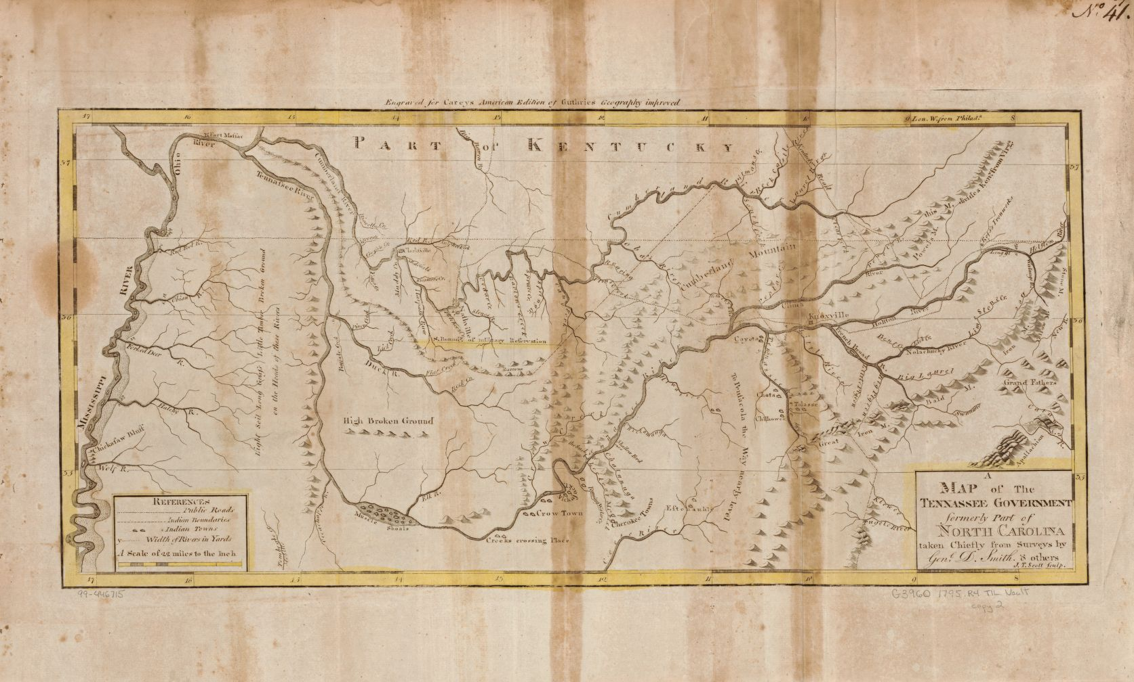

Figure 1-1: Map of Middle Tennessee 1795
Courtesy of the Library of Congress. John Reid, Publisher. A map of the Tennessee government, formerly part of North Carolina. [S.l, 1795] Map. Retrieved from the Library of Congress, https://www.loc.gov/item/99446175/.
Figure 1: Map of Middle Tennessee 1795
During the ruthless winter of 1779-1780, the first permanent settlers arrived at Cedar Bluff on the Cumberland River and attempted to claim the land. Richard Henderson flipped this stretch of land by paying eight thousand pounds to the local Cherokee tribe and selling it to Captain James Robertson (See Figure 1-2) and his group of settlers incoming from North Carolina. These settlers numbered two to three hundred and packed cattle, supplies, and horses on their Westward journey and settled around the Cedar Bluff and French Lick region (See Figure 1-1). However, before too long, they began to experience anxiety concerning their lasting security, as other Native American tribes did not wish to honor the Cherokee’s transaction with Henderson. Thus was built Fort Nashboro. The skilled carpenters and American Revolutionary veterans utilized their unique tools and the local black locust trees to build the first work of Middle Tennessee architecture that fortressed the growing Western culture. It seemed as though the land might still be entirely unconquerable due to the friction between cultures.
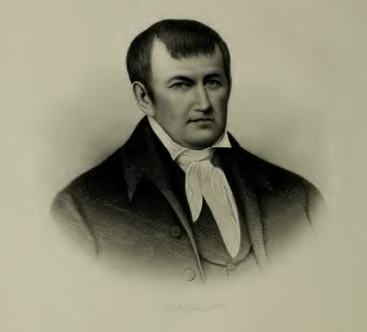
It is important to note that the region had, in fact, been explored before as French trappers and American hunters often utilized the area for their respective trades due to the increase in animal population, which was due to the presence of salt and bluegrass in the region. It certainly aided the ability to acquire and preserve meat. Following some of these profitable game paths, the settlers ventured into their future and what they deemed their land. Even today, some of these paths are now main highways leading into Nashville.

Figure 1-2: Captain James Robertson
Reprinted from H.W. Crew, The History of Nashville Tennessee (Nashville: Publishing House of the Methodist Episcopal Church, South, Barbee & Smith, 1890), 2.

While Captain Robertson led the supplies and cattle by land, others joined him by water. John Donelson led these three hundred women and children on flatboat by means of the Holston, Tennessee, Ohio, and Cumberland Rivers, respectively. Nearing a thousand in population in a short time, the settler’s credit for populating the Middle Tennessee area largely goes to Captain Robertson for his constant trail blazing and westward expansion recruitment.
Many years later, after Fort Nashboro was thoroughly settled, established, and maintained, and the Native American threat had been drastically reduced, Captain James Robertson moved his family just away from the fort to build and work a farm on land now known to be in the heart of Nashville. According to the claims and research of Wilbur Foster Creighton, a youth at the Centennial Exposition and contractor of the Parthenon in the 1920s, Captain James Robertson owned and farmed land that is now recognized as Centennial Park – the crowning cultural center in the heart of Nashville.
Research reveals that in 1783, John Cockrill, who was Robertson’s brother-in-law, married Ann Robertson Johnston, who had received the 640 acres of land as a grant from the North Carolina Legislature after her first husband died, becoming the first woman in Tennessee to receive a land grant in her own name. The land, and more specifically, the Cockrill house stood just near a spring that traveled northeast to feed into the French Lick, showing that the land was chosen and settled because of its natural features and promising stability for the private settlement. Thus, the ideal farming land that was to play an influential role in Nashville’s future identities is tied back to the earliest elite heroes – the founders of Nashville. However, women played an important role – one that in this case, must not be forgotten. Ann Robertson Johnston Cockrill, wife of John Cockrill and sister of James Robertson, was solely responsible for organizing students, becoming Nashville’s first teacher, along with establishing Nashville’s first Sunday school program. Nashville’s elite members were not always the trail-blazing men, but also the courageous women who ensured that the future generations of “Nashvillians” would be well educated.
The matter of education was to play an important role in Nashville’s development, and often, many knowledgeable people tend to credit education alone for any lofty classical identification Nashville might have with the past. But the most important factor in the development and growth of Nashville’s identity, as the individuals wished to unite under one social image or role, was the Romantic movement. Years after the Renaissance and Enlightenment, the ideal for classical sophistication grew. As the nation began spreading its western border after the War of Independence and establishing a democratic government, the population grew and spread rapidly. Along with this expansion, the cultural ideals of the ancient classical world were transplanted to the new social centers of the nation. Certainly, the classical world and its images sent messages of sophistication and pride, democracy and elitism. Schools and seminaries heavily instructed students in the classical languages, and the physical representations of such knowledge were evident most clearly in the architecture across the nation, including in the Middle Tennessee area.
The origins of the classical architecture movement can be largely attributed to Thomas Jefferson. Thomas Jefferson designed the Virginia State Capital in 1789, becoming the first American leader to plan new government buildings after ancient architecture. Of course, this passion for ancient architecture was no doubt fueled by the emphasis on and desirability of classical education of the elite. Someone was well educated if he or she was familiar with the classical cannon of languages and literatures. Even Sam Houston, Tennessee Congressman in 1823 and Tennessee Governor in 1827, valued his classical education, asking his teacher at the local academy to teach ancient languages. His request having been neglected, Houston set out to the world, armed with his Alexander Pope translation of the Iliad. “Homer and the wilderness – they gave shape to, and fed, his dream of greatness.” As Tennessee Governor in 1827, Houston rectified his tragic, young educational experiences by creating a state program that planned to establish a permanent fund for public schools.
Due to this sophisticated and elite classical education, present even on the flatboats with Ann Robertson Cockrill, the classics became ideal. The most prominent manifestation of the classical ideal of Nashville is inherent in the architecture of key structures in the city. The three earliest manifestations of classical architecture, symbolic of the classical ideal and education spreading like an unquenchable wildfire among the educated at the turn of the nineteenth century in America, were the Nashville Inn, the Bank of the United States of 1827, and the Davidson County Courthouse of 1829. The next most important classical designs were the additions to the personal residence of United States President Andrew Jackson – the Hermitage – in 1831. Named by James Patrick, the architectural historian, as “Tennessee’s first architect of the Greek Revival,” David Morrison designed symmetrical wings, Doric columns, a temple-form porch, and hierarchical massing that fanned the classical flames in Tennessee. Morrison also designed the Doric “tempietto” that became the funerary monument of Andrew and Rachel Jackson in the Hermitage gardens.
Around this same time, what is now known as the University of Nashville, previously named Cumberland College and Davidson Academy, grew from the same Middle Tennessee area. Many famous Nashvillians were largely influential in the growth and development of this institution, and it becomes significant when recalling the developing cultural identity of Nashville in the city’s youth. The University of Nashville had, in fact, been born of good fortune. A little over two years after Davidson County had become officially established, the North Carolina Legislature had passed an act on December 29, 1785 titled, “An Act for the Promotion of Learning in the County of Davidson.” This act granted two hundred and forty acres for the formation and expansion of Davidson Academy. Davidson Academy was founded by the Academy’s President of the Board of Trustees, the first minister of the First Presbyterian Church of Nashville, and the 1775 Princeton alumnus, Reverend Thomas B. Craighead. It was initially located on Gallatin Road (where the Spring Hill cemetery now lies) but moved across the Cumberland River to College Street (Now Third Avenue South). It then became Cumberland College.
Cumberland College gained the Greek and Latin professor and president of Princeton University in 1824. Dr. Philip Lindsley (See Figure 1-3) was then the second Princeton graduate to assume leadership of Cumberland College. Dr. Lindsley, also an ordained Presbyterian minister like Craighead, was as passionate as his contemporary Houston. When Dr. Lindsley arrived at the Western frontier of Nashville, he found a very illiterate city. While president, he expanded Cumberland College to become the University of Nashville, attracting the nationwide attention of other universities and students across the country. In an address at an anniversary commencement on October 4, 1837, just thirteen years after becoming the university’s president, Dr. Lindsley established what kind of education should be offered at the University of Nashville:
Our university must have the requisite teaching force also: Professors of every language, dead and living; of every science, in all its branches and subdivisons, in all its bearings and applications. To be more particular, there should be professors or teachers –
Of ancient classical language and literature;
Of oriental languages and literature;
Of modern European languages and literature;
Of mathematics, natural philosophy, and astronomy;
Of chemistry, geology, minerology, and comparative anatomy;
Of archaeology, in reference to ancient nations, governments, jurisprudence, geography, mythology, arts, science, and still existing monuments;
Of philology, eloquence, poetry, and history;
Of physiology, vegetable, animal, and comparative;
Of ethics, politics, logic, and metaphysics;
Of constitutional and national law;
Of political economy and national statistics;
Of architecture, sculpture, painting, drawing, engraving, and music;
Of engineering, civil, military, and naval;
Of mechanics, prinicples and practice;
Of agriculture, commerce, and manufactures;
Of fencing riding, swimming, and other manly and healthful gymnastics;
Of natural history in every department;
Of all the liberal professions;
Of Biblical literature;
Of religion, in such forms and modes as may be satisfactory to the judicious and reflecting portion of the community.
Revitalizing Nashville’s education, Dr. Lindsley saw Houston’s public education program to fruition. Indeed, Dr. Philip Lindsley, along with many other Nashvillians, increased literacy and fostered a value for education through the university. Thus, Nashville’s cultural identity as the “Athens of the West” was born.
Many Nashville historians credit Dr. Philip Lindsley with the famous reputational label on Nashville – the “Athens of the West.” Most scholars reason that it was his impression of the increasing educational programs and emphasis on the classics that led to this cultural reputation. However, when Dr. Lindsley first arrived the educational system was in disrepair in 1824. Elementary and secondary schools had not been developed, Cumberland College was not financially supported, religious educational institutions were competing heavily (perhaps at the expense of education), and the rate of literacy was probably below that of the first settlers at Fort Nashboro. When Dr.
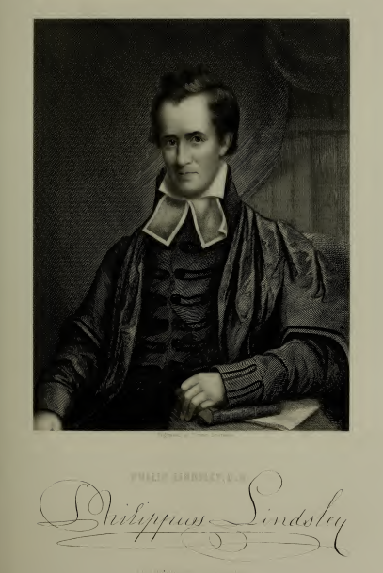

Figure 1-3: Philip Lindsley
Reprinted from H.W. Crew, The History of Nashville Tennessee (Nashville: Publishing House of the Methodist Episcopal Church, South, Barbee & Smith, 1890), 386.

Lindsley accepted the presidency of the college, he was traveling to a city that was near the Western front, faced by wilderness, illiteracy, and a political storm, as Andrew Jackson ran his fierce campaign for the Presidency. Lindsley’s motivation to move to the Southwestern front was stated in a letter to his friends: “Throughout the immense valley of the lower Mississippi, containing at least a million of inhabitants, there exists not a single college.” So was Dr. Lindsley influential in both building the reputation of “Athens of the West” and the educational system that inspired such an identity? Indeed, given the latest research and primary sources, that is the most current, logical conclusion.
The phrase “Athens of the West” is said to have first appeared in one of Dr. Lindsley’s speeches in 1840, and many second this notion. As no one can be entirely certain of the origin of the classical connotation, it seems reasonable to agree with Henry McRaven who concludes that the “exact origin of the expression is lost in the obscurity of the past” and admits that most credit Dr. Lindsley with the phrase. The classical association is, at the least, credited to Dr. Lindsley in his former student and biographer Leroy J. Halsey who says:
But perhaps the most striking illustration of his influence as an educator is seen at Nashville itself – the scene of his longest labors, the home of his adoption, the resting-place where is ashes sleep. We have no citizenship at Nashville; and hence cannot be accused of partiality in what we are about to say. But of all we have seen and known, we my safely say, there is not city west of the mountains which seem [sic] to us so justly entitled to be called the “Athens of the West” as Nashville. And for that distinction we think there is no man to whom Nashville is so much indebted as Dr. Lindsley.
But the student merely credits Dr. Lindsley for justifying the identity, not specifically creating it.
Another contributor to the phrase that links Nashville with classical Athens is Felix Grundy. A highly influential figure of the time, Grundy “was confessedly the greatest criminal lawyer of the West.” Louise Davis, Metro Nashville’s official historian, also credits Grundy with using the expression around the same time as Dr. Lindsley, which she claims to be 1825 – just after Dr. Lindsley’s arrival to Nashville. She claims that Dr. Lindsley, upon seeing the emphasis and importance of education (which is, in fact, quite the opposite of what the latest research suggests the educational climate was at that time) when he arrived, exclaimed Nashville to be the “Athens of the West.” No evidence actually exists to suggest either of these men were fundamental in socializing the title that infers Nashville’s similarity to classical Athens, and the evidence suggested to support such a claim (that Nashville’s education was extremely impressive in the mid-eighteen twenties) is unfounded. Associating such a prestigious title with a former Princeton President and one of the best lawyers in the area certainly paints a picture of Nashville’s history that associates the culture’s identity around significant elite figures.
However, this research has led to other sources that predate the alleged 1840 speech and leave Dr. Lindsley and Grundy largely out of the picture. The earliest written reference to date can be found in a heated battle between editors of The Nashville Union and the Daily Republican Banner. On Tuesday, March 12, 1839, editors Allen A. Hall and S. Nye quoted The Nashville Union in an attempt to rebuttal the Jacksonian organ’s explanation of similarities between Boston and Nashville’s cultural lifestyles. Within this heated political word-fight, the title “Athens of the West” emerges that differs from previous statements and research relating the title strictly to Nashville’s educational reform (See Figure 1-4). The Nashville Union’s editor Colonel J. George Harris, who had been an editorial pupil of George D. Prentice in New England prior to the Nashville Union, states:
If Boston is called the ‘Athens of the East,’ we know not why Nashville may not be called the ‘Athens of the West’ – for certainly we never were in two places so strikingly similar, in manners, customs, fashions, and every thing that adorns civilized life – and if either takes the lead, it is the latter.
The Daily Republican Banner heated response was:
If Boston and Nashville so nearly resemble each other in point of “manners, customs, fashions, and every thing that adorns civilized life,” as the editor of the Union asserts, we wonder at his desire to abuse and misrepresent Mr. Bell for paying a visit to the former city.
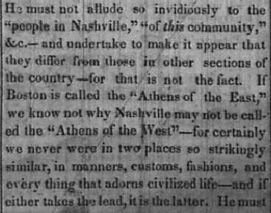

Figure 1-4: Colonel J. George Harris, The Nashville Union – March 11, 1839
Courtesy of Tennessee State Library and Archives.
Certainly, the title emerges in an entirely different context than is initially expected in light of previous scholarship on the matter. The classical identity of Nashville is credited here as the result of similarity between Nashville and Boston. Rather than the importance of classical education and a cultural hub that might be comparable to Athens alone, it results from a comparison of political origins between Boston and Nashville, leaving classical Athens out entirely, save for the reputational title. It should also be noticed that this was only two years after Dr. Lindsley’s brainstorming speech in 1837 as to how education at the university could be improved (especially expanding the classical elements) and a year before the alleged 1840 speech.
Considering the tone of voice and perspective of the editor of the Union, either two scenarios provide his justification for reinforcing the “Athens of the West” title. Either it has existed for a short time, and he provides a defense for its justified use by comparing Boston with a similar title to Nashville, or he is inventing the title himself, defending his creation. If the former is the case, then contemporary reasoning for the new cultural title is not immediately linked to education, but becomes so in light of the educational reforms at the time. In the event that the latter is the case, all who are currently credited with the expression (Lindsley, Grundy, and Halsey) took the cultural phrase from the Union, whose sole reason was to culturally tie the culture of Nashville to that of the East coast port city of Boston.
Numerous are the possibilities that explain why Colonel Harris would want to so readily compare one of the easternmost cities with one of the westernmost. No doubt probably the most likely is due to the Westward Expansion, of course, the Manifest Destiny of the new order in America. Since its early settlement, the land of Nashville was always promising as it was well-located by a navigable river and contained mostly fertile land. Of course, the alluring nature of the land is as equal in the westward movement as those Tennesseans who would play a direct and influential role in the expansionism of the United States. James Knox Polk, when elected President of the United States, increased the size of the nation by one-third from 1845 to 1849. But before Polk’s great program, Nashville was one of the cities on the New Frontier, as far from Boston as one could get. Another possibility was that Colonel Harris wished to compare Nashville to Boston to increase the prestige of Nashville as a western city as it began to grow and improve. Relating a smaller western city with a well-established eastern one would go far to attract attention to Nashville and increase its glory.
Whether Colonel J. George Harris was the first to label Nashville with the culturally adaptive title “Athens of the West,” he was certainly one of the earliest to pen the official title and provide explanation as to its existence in 1839, predating all other research thus far, save for Louise Davis’s 1825 claim. Perhaps all of these elite individuals of Nashville play an important role in developing the title, increasing the cultural worth of the city, but painting such an ideal portrait as to the elitist, educated origins and legend of such an identity is commonplace, especially since cultural identities are fairly fluid anyways.
As for Boston’s classical Athens identity, William Tudor labels Boston as the “Athens of America” and in the early nineteenth century as “Athens of the East” in a letter dating 1819, describing the democracy and cultural and intellectual advancements of the city. William Tudor was an editor and co-founder of the North American review, co-founder of Monthly Anthology, and co-founder of the Boston Athenæum, one of the oldest independent libraries in the United States. Boston was not the first to use the title in 1819, but other cities such as Philadelphia claimed the “Athens” title as early as 1733. Therefore, many cities in America were attempting to claim a romantic prestige by claiming they were a modern day equivalent to ancient Athens in all its glory and overemphasized fame. In order to justify their new identity, Boston in the early nineteenth century was led by a leadership elite, “composed of men of family background, liberal education, and managerial experience in a variety of enterprises, [who] used their personal talents and substantial financial resources to promote the cultural, intellectual, and humanitarian interests of Boston to the point where it would be the envy of the nation.” This elite group in Boston saw that the customs and culture were equivalent to their notions of democracy and education. As they were beginning to form a new republic early in Boston’s history, “many prominent citizens tended to find new inspiration in the ideals of Athenian democracy [or their perception of it] with its exalted sense of art and literature, philosophy and citizenship.”
When Colonel Harris related that the manners, customs, fashions, and everything that adorns civilized life was equal in both Boston and Nashville and stated that Nashville was more the leader of the two, he attempts to weave a creative narrative that increased morale and pride in Nashville despite the disrepair of the education systems at that time. Certainly, his motivations would include speaking highly of his month-long residency in Nashville.
Therefore, Nashville’s cultural identity as “Athens of the South” proceeded from the romanticized view of the classics and the prestige of the educated elite’s infatuation with ancient Athens cultural icon to resemble, embody, and retain the elite status quo. However, in Nashville’s history, this cultural identity does not remain stagnant or undeveloped as the people flock to their created identification. As the states proceeded into civil war, Nashville might have been greatly affected in every way, but the Athens identity then addressed a new audience, as the impact of the war redefined democracy, lifestyle, and customs of the growing city (See Figure 1-5). Emerging from war, Nashville now shifted the “Athens of the West” identity to reflect the “Athens of the South” transition and a new upcoming century and the first centennial for Nashville and the entire state of Tennessee.

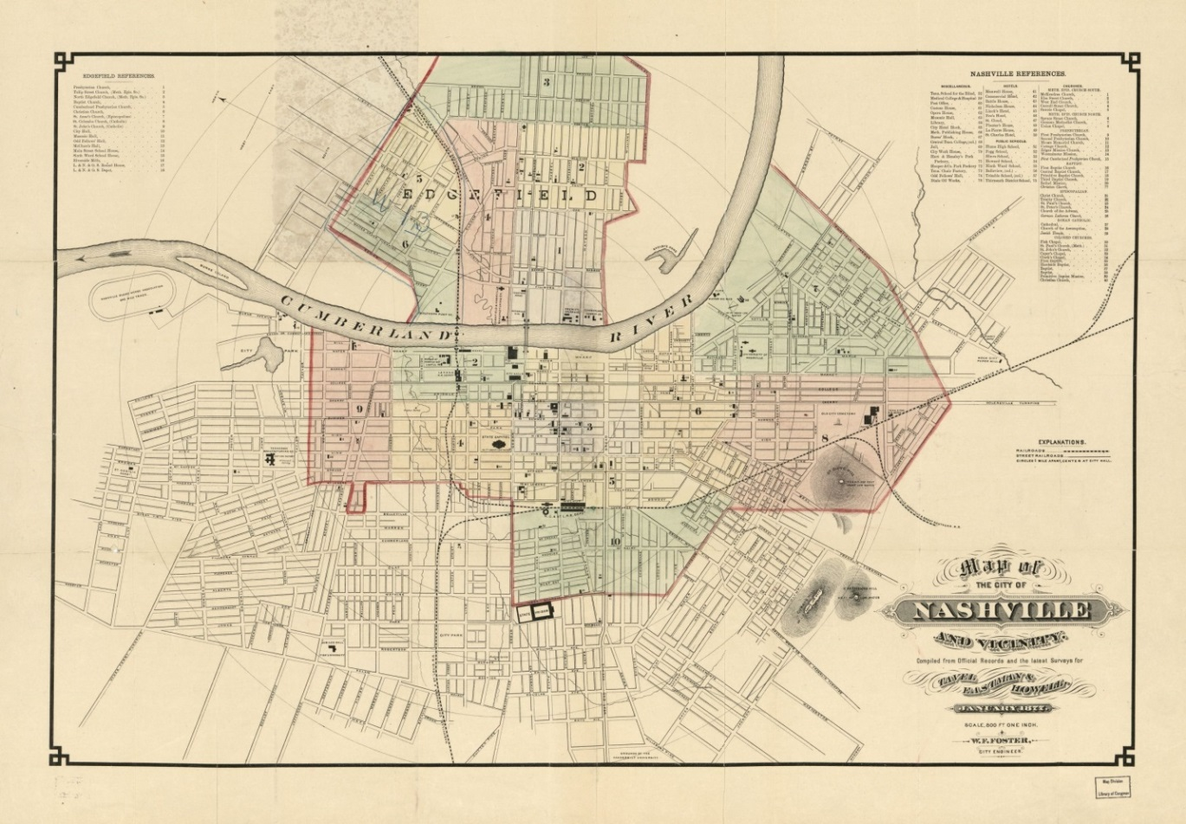

Figure 1-5: Map of the city of Nashville and vicinity 1877
Courtesy of the Library of Congress. Wilbur F. Foster, Map of the city of Nashville and vicinity. [S.l.: s.n, 1877] Map. Retrieved from the Library of Congress, https://www.loc.gov/item/2011590011/.

Chapter II – The Centennial Exposition: Enter Parthenon

As the nineteenth century progressed, so did the cultural identity of Nashville. Withstanding the slivering of the social fabric of the nation before, during, and after the civil war, Nashville’s classical cultural identity as “Athens of the West” was not as prominent as it once was. Even the famous History of Nashville Tennessee by H. W. Crew, a source filled with some of the most minute details from primary sources that form Nashville’s history, does not draw attention to the “Athens of the West” or “Athens of the South” titles when it was published in 1890. Yet for certain individuals, the history of Nashville and the classical identity that had been forged was of the upmost importance when it came to revitalizing Nashville as a cultural, economic, and political hub for the South at the turn of the next century. Though there is no known specific shift in the usage of “west” and “south” in the cultural label, the final decade of the nineteenth century played a large role by continuing this identity and readapting it at the close of the nineteenth century with the formation of the Tennessee Centennial Exposition and its result – the Parthenon’s emergence in Nashville.
A particular stretch of land appears to be immediately associated with this revitalization – as immediately associated as it was with the initial settlement of Nashville. The land given to Ann Robertson Johnston Cockrill by the state of North Carolina was to come under the jurisdiction of the Tennessee Fair Association after the Civil War. As state fairgrounds, the use of the tract began moving from private to public, opening itself to all in the area. In 1884, the Tennessee Fair Association readapted the land to become a second racetrack in Nashville, calling it West Side Park; the other racetrack was Cumberland Park and is now known as the Tennessee State Fairgrounds. West Side Park only remained a racetrack for the city for about a decade when certain individuals in the city began a movement that changed the course of Nashville’s history.
Douglas Anderson, who was a Nashville attorney, proposed in a letter to the editor of The Chattanooga Times, “Tennesseans should celebrate the occasion [the centennial of entering the Union – an interesting proposal in the midst of the Civil War’s aftermath] by holding a Centennial Exposition.” The proposition was well received by the elite but did not take immediate root. Another proposition was made by Colonel William C. Smith in 1894 to Nashville’s Commercial Club that they should follow through with Anderson’s proposition. There, he presented:
Gentlemen – The financial depression and shrinkage in values in this city and throughout the country, which seems to have produced a condition of so much apathy and inactivity in commercial circles, suggests and demands that an organized effort be made to divert the attention of our own people, if possible, from general depression, by setting on foot some enterprise that will interest them especially in [sic] behalf of our own State, and that will tend to enlist their aid and cooperation in furthering the interests of the city of Nashville in particular. . . The agitation of the subject with reference to such an enterprise, and the anticipation of these events, would, I confidently believe, give new life to the people of our city.
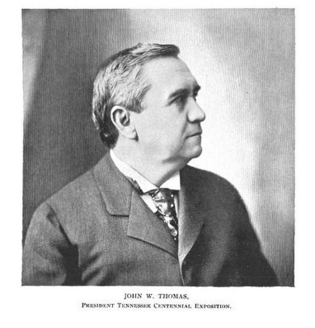
Given the recreational nature of the nation and economy in the 1890’s, it comes as no surprise that these ideas began to formulate in the minds of several Nashvillians. Chicago’s famous Columbian Exposition of 1893, as well as similar expositions in major cities such as Cincinnati, Atlanta, Buffalo, and St. Louis, inspired the Nashvillian elite to catch onto the trend.
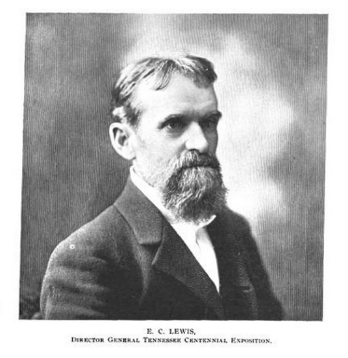
Nashville agreed to the idea of a centennial celebration in the form of an exposition in Nashville. James Head, former state legislator and publisher of the Nashville American, was appointed by the Commercial Club after Colonel Smith’s proposition. The committee was then formed with Major Andrew W. Willis as the Director General. However, after attempting to fund the Exposition on the state and federal levels, they both no longer held their positions on June 8, 1895 after an agreement that the administration ought to have more appeal to the community and have the ability to obtain more stock subscriptions. Naturally, the President of the Nashville, Chattanooga, and St. Louis Railway companies, John W. Thomas (See Figure 2-1), assumed the role as President of the Centennial Exposition Company, and he personally selected Major E. C. Lewis (See Figure 2-2) as the new Director General, who took a leave of absence as a consulting civil engineer with the Dupont Company and the Louisville and Nashville Railway. Though these decisions are considered to have been made by Nashville collectively, they are the result of an elite governing body that recognized their own hard work and its result on Nashville. Evidence of this appears in a letter (See Figure 2-3) from the new Centennial President Thomas when expressing gratitude for a bell donated by a foundry for the Centennial Exposition which states, “[the bell] will not only be useful and ornamental, but will be a revelation to thousands of Tennesseans, who have no idea such work is being done in this State.”

Figure 2-1: John W. Thomas
Reprinted from Herman Justi, ed., The Official History of the Tennessee Centennial Exposition (Nashville: Brandon Printing, 1898), 16.

Figure 2-2: Major Eugene C. Lewis
Reprinted from Herman Justi, ed., The Official History of the Tennessee Centennial Exposition (Nashville: Brandon Printing, 1898), 17.

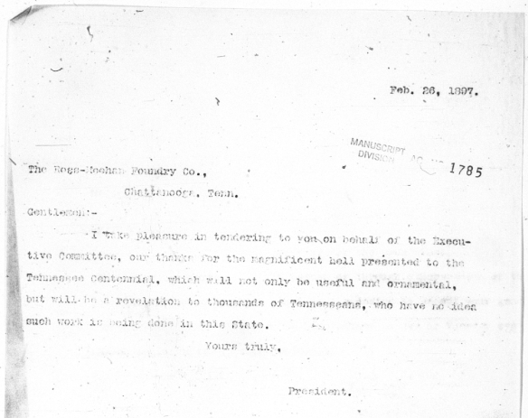

Figure 2-3: John Thomas to Ross-Meehan Foundry Co. – February 26, 1897
Courtesy of the Tennessee State Library and Archives. John W. Thomas. John Thomas to Ross-Meehan Foundry Co., February 26, 1897. Letter. From Tennessee State Library and Archives, Tennessee Centennial and International Exposition (1897) Collection 1895-1900.

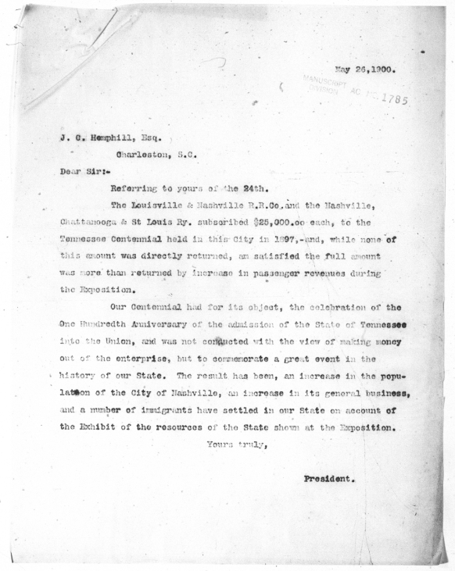
Indeed, such an endeavor, however costly, did have financial appeal for Nashville at the time. The nationwide depression after the “Panic of ’93” certainly aided Colonel Smith’s 1894 plea to the Commercial Club for an exposition in Nashville for Tennessee. The economy was a driving factor behind the formation of the Centennial Exposition. As orator Tully Brown mentioned during the Exposition’s closing speech in 1897, “We had little money, we had great courage; times were hard as flint, banks were popping and cracking all over the Union; every day newspaper columns were but records of bank failures and business enterprises being thrown into the hands of receivers.”

Figure 2-4: John Thomas to J. C. Hemphill, Esq. – May 26, 1900
Courtesy of the Tennessee State Library and Archives. John W. Thomas. John Thomas to J. C. Hemphill, Esq. May 26, 1900. Letter. From Tennessee State Library and Archives, Tennessee Centennial and International Exposition (1897) Collection 1895-1900.

President Thomas stated the alleged intentions of the Exposition three years after in a letter (See Figure 2-4) that described the railway’s financial outcomes. As he claimed, “Our Centennial had for its object, the celebration of the One Hundredth Anniversary of the admission of the State of Tennessee into the Union, and was not conducted with the view of making money out of the enterprise, but to commemorate a great event in the history of our State.” In light of Colonel Smith’s most attractive argument in his proposal and the economic condition of the time, it would certainly seem that if the main focus for such a venture was not a Nashvillian capitalistic endeavor, that the economic benefit was still a leading factor in the Exposition’s formation. As President Thomas continues in his letter, “The result has been, an increase in the population of the City of Nashville, an increase in its general business, and a number of immigrants have settled in our State on account of the Exhibit of the resources of the State shown at the Exposition.” Given the social, political, and economic fabric of the time, both the expressed purpose and the subliminal purposes all benefited Nashville by promoting the area, rejuvenating the economy, and showing the world that Tennessee, previously a Confederate state, was thrilled to be a participant of the Union for one hundred years.
No doubt, the enterprise and its marketing was a result of investment, networking, and promises. President Thomas himself proposed an investment in another letter (See Figure 2-5) addressed to Edgar Felton the President of the Pennsylvania Steel Company under the grounds that “this Exposition will doubtless increase the Railway mileage of the State, and largely increase the business of existing roads, especially our line, which will enable us to place more liberal orders for steel rail.” Yet another letter (See Figure 2-6) from President Thomas might recall the alleged purposes of the Centennial Exposition addressed to the South Carolina Exposition’s secretary Colonel John Averill three years after the Centennial Exposition’s close: “Our Exposition was a patriotic one; and in making the donations, we did not expect any return, and consider ourselves fortunate that it paid cost of construction and operating expenses in full. . . . no less than one thousand families have settled on the line of our road, many of whom were impressed with the desirability of having homes in Tennessee by what they saw at the Exposition.” It is hardly dubious that the growth of personal business and Nashville as a city had little or nothing to do with the purposes of the Centennial Exposition. Due to these connections from the new President of the Centennial Exposition Company, the cultural exhibit was delayed a year from the centennial anniversary, but was well underway this time.
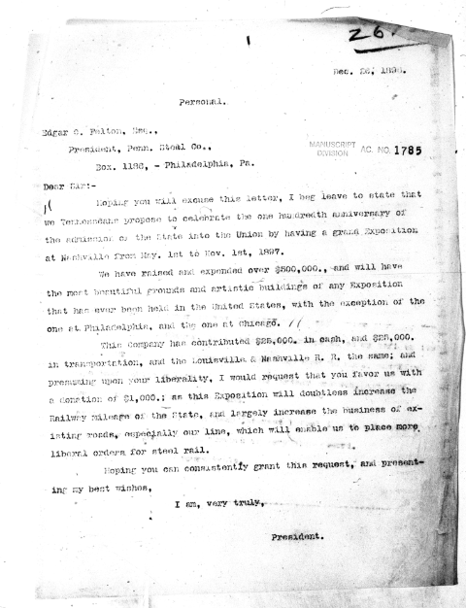

Figure 2-5: John Thomas to Edgar C. Felton, Esq. – December 26, 1896
Courtesy of the Tennessee State Library and Archives. John W. Thomas. John Thomas to Edgar C. Felton, Esq. Dec. 26, 1896. Letter. From Tennessee State Library and Archives, Tennessee Centennial and International Exposition (1897) Collection 1895-1900.
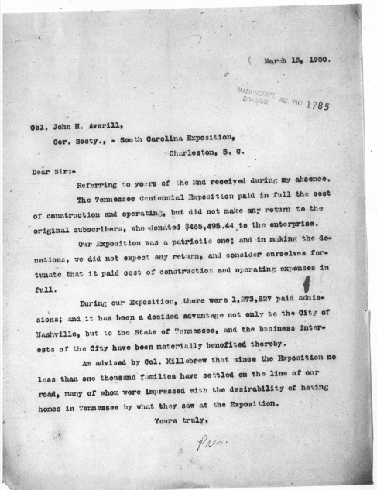

Figure 2-6: John Thomas to Colonel John H. Averill – March 13, 1900
Courtesy of the Tennessee State Library and Archives. John W. Thomas. John Thomas to Colonel John H. Averill. March 13 1900. Letter. From Tennessee State Library and Archives, Tennessee Centennial and International Exposition (1897) Collection 1895-1900.
It was now time to select a location. Hugh L. Craighead, W. L. Dudley, G. H. Baskette, John C. Burch, and W. B. Earthman, all important figures in Nashville’s history, were all members of the newly appointed committee who came together to vote on the grounds for the Exposition now that investments were gradually increasing, and the Nashville locals had voted on whether tax funds should be used. The majority of this committee agreed upon the location of West Side Park over Cumberland Park. The Board of Directors made this decision official on August 21, 1895.
Moving fairly quickly through the planning process, Director General E. C. Lewis presented his plans for layout of the grounds and position of the buildings to be constructed on site to the Executive Committee on September 12, 1895. The grounds would have multiple structures that centered around one particular building with the highest style of architecture at the time – an exact reproduction of the Parthenon (See Figure 2-7). The committee unanimously agreed on his plans.
The idea was to create a perfect city that recreated and resembled the past century of history in the state. This physical gesture paid tribute to Tennessee and more specifically, Nashville’s past. Housing at the Exposition manifestations of cultural identity, achievement, and meaning – the fine arts – the Parthenon would be readapted to reflect the cultural history of Nashville in light of the sophisticated identification with Classical Athens. However, the architectural style and the classical associations were not lost on the city of Nashville, but were entirely conventional to the cultural aesthetics.
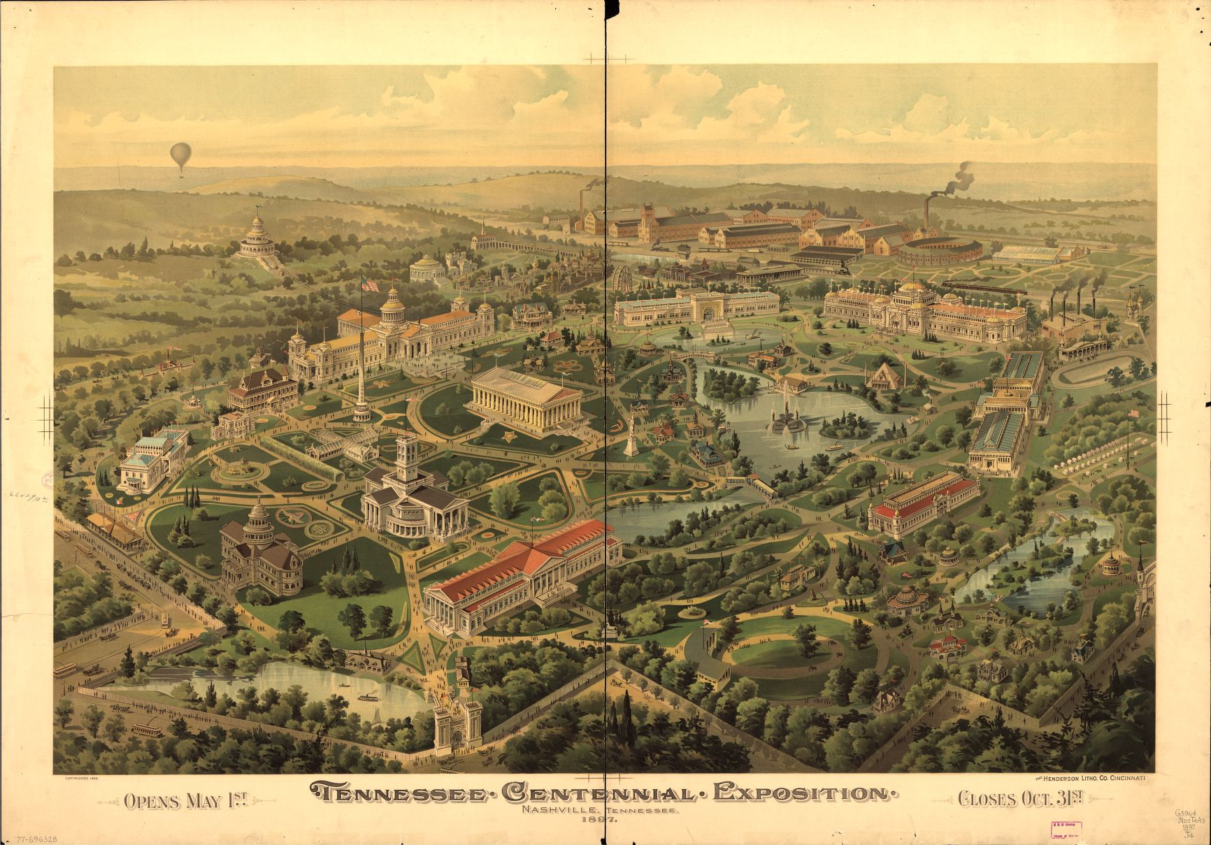

Figure 2-7: Tennessee Centennial Exposition, Nashville, Tennessee, 1897
Courtesy of the Library of Congress. Tennessee Centennial Exposition, Nashville, Tennessee, 1897. [n.p, 1896] Map. Retrieved from the Library of Congress, https://www.loc.gov/item/77696328/.

A lengthy but necessary and well-worded quote from Herman Justi as he writes, edits, and references states:
Situation, surroundings, atmosphere, motive, associations – all these contribute to render a masterly reproduction of the Parthenon perfect. In size it is, in detail it is believed to be, a recreation of what Ictinus built and Phidias adorned. All the best authorities were carefully studied, and Penrose, whose investigations seem to have been the most thorough, and whose conclusions appear the most probable, was religiously followed by the accomplished architect in charge. On a commanding site in the center of West Side Park, and crowning a lovely terrace, the Parthenon overlooks the beautiful valley of the Cumberland, facing the splendor of the rising sun. In the distance to the east rises the State Capital of Tennessee, erected not in honor of, but honoring the famous school of Grecian architecture of which its new neighbor, the reproduced Parthenon, is the best and greatest exemplification. In speaking of the architecture of the State House, it may not be amiss to observe that the Grecian school seems to dominate the Southern architecture generally, and that in the South this stately style long ago found its home. What has been already said on this subject by the lamented George W. Chambers is so well said, and is at once so true, that its insertion here will serve the double purpose of reminding the reader of an interesting fact and of recalling to his mind an accomplished artist and a delightful man. Mr. Chambers wrote:
Of the buildings already completed it would be invidious to speak comparatively, and indeed unnecessary where all is so admirably planned and designed. And yet I can not omit a brief word concerning the Parthenon. Not in its praise, for it needs none; nor of its history, for that is trite ; nor yet of the wisdom of choosing it as being adapted to the purpose, for that will be evident to all who enter it. The thought I had in looking at it on the day of my visit was that, strangely enough, it would perhaps, be less of a surprise to Southern visitors than other buildings commonplace enough in all respects. It will be perfectly familiar to them, and that, not because they have seen pictures of it, but because south of the Mason and Dixon line this is the type of architecture that was chosen for the stately homes as well as for State and public buildings. That choice of the classic Greek for all important work, domestic and national, is distinctly the choice of the South. It would seem that, approaching the parallel of Athens in this country, it was a sine qua non to follow its architecture. But however that may be, and whatever the cause, it will chance that the Southern contingent will look with familiar eyes upon the grand repose of the Parthenon. Of course, no one is going to bother himself much about what it all means, because we will all be too busy looking at and enjoying the beauty provided for us by the splendid energy and self-sacrifice of your people. But it might furnish a half-hour’s pleasant reflection in some shady corner, to note first that this same Parthenon seems externally to be the most consistent building on the grounds ; and to consider after, whether the large simplicity, the wide repose, and the impressive stability of it did not somehow belong to that old life, from Virginia downward, which can never come again.
In Major Lewis’s eyes, there was something still yet distinct about the Parthenon’s architecture despite that this classical style was the distinct choice of the South. Major E. C. Lewis’s daughter, Mrs. James S. Frazer of Laurel Hill, spoke on what made the Parthenon distinct among the other classical styles in the city. “Papa abhorred, positively abhorred, the gingerbread that was so stylish in his day, and in 1896, as director-general of the coming Tennessee Centennial Exposition, he had the idea of making a replica of the Parthenon as an illustration of the simplicity and beauty of Grecian architecture. He thought the building would be a stimulus in the right direction away from horrid gingerbread.” In order to create a new cultural aesthetic to resemble the last century’s claimed identity as “Athens of the South,” and break away from developers mold of cookie-cutter architecture, Major Lewis decided to bring in one of the most grand spectacles of architecture to make and prove his point. In order to continue this identity and formulate it for a growing city that would inspire growth in spite of the recent economic scare, he would make sure that the Parthenon excelled in replication and position on the Centennial grounds.
Major Lewis was a man who strived for the details. In order to replicate the Parthenon to ideal specifications, accurate measurements were needed. The Major and the Centennial Exposition Company were not hesitant to pull out all the stops to see that the Parthenon was the centered, crowning achievement of the entire event. Contacting King George of Greece, they received permission to replicate the Parthenon. In April 1896, the Major spent $500 on two volumes recommended to him by the curator of the British Museum. These texts provided him with plans for the Parthenon’s relocational readaption. They were Francis Penrose’s (mentioned in Herman Justi above) An Investigation of the Principles of Athenian Architecture, or the Results of a Survey Conducted Chiefly With Reference to the Optical Refinements Exhibited in the Construction of the Ancient Buildings at Athens and Adolph Michaelis’s German text Der Parthenon, mit Einen Texthaft. Receiving drawings (some from the French diplomat Jacques Carrey in 1674, showing the building thirteen years before the explosion in the Turkish-Venetian conflict), recordings, and architectural records from King George I of Greece, the Exposition Parthenon was underway. The Exposition Parthenon was the first building completed. Additionally, no other building at the Exposition was built intentionally as an exact replica like the Exposition Parthenon; it was the world’s only exterior replica of the Parthenon with that detail. Inside, the “Fine Arts Building” housed an extensive art gallery, reflecting Nashville’s artistic culture and American paintings.
While it is clear why the elite leaders of Nashville might desire to display the cultural might of Nashville at the turn of the century (See Figure 2-8), the particular selection of the Parthenon requires further analysis. Certainly, such architecture was respected and highly regarded as a symbol of the educated and elite. It is clear that the Major knew that if Nashville’s “gingerbreads” were to continue, that there would be nothing culturally rich and distinct about Nashville. To break the architectural mold that began to overtake the city, to reflect and symbolize the cultural identity of the past century as “Athens of the South,” and to reinforce such cultural identity by displaying the greatest of artwork within the shell of the Parthenon in place of the goddess Athena for the world to come to Nashville to see must have been the intentions behind its replication and readaption.
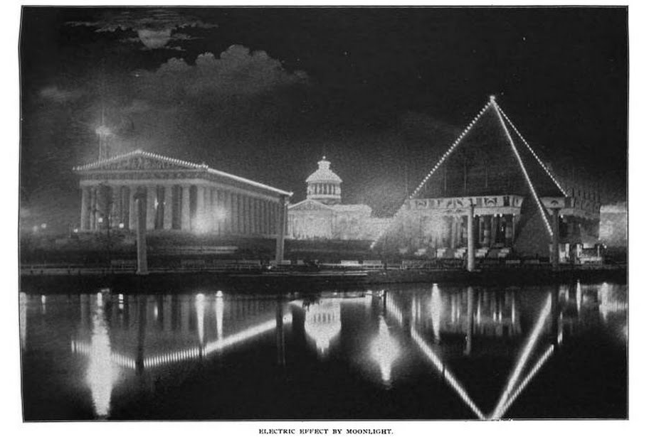

Figure 2-8: Electric Effect by Moonlight
Reprinted from Herman Justi, ed., The Official History of the Tennessee Centennial Exposition (Nashville: Brandon Printing, 1898), 83.

When the exposition opened, locals and visitors, in the final report of admissions numbering 1,786,016, saw the Parthenon replicated as a Fine Arts Building. “Within its classic walls during the period of the Exposition were gathered the most valuable works of art ever exhibited in the South, and one of the best loan collections ever seen in the United States.” Built by Robert Thomas Creighton of Foster and Creighton Company with Colonel William Smith as chief sculptor, the Parthenon housed over one thousand works of art that primarily displayed Romantic landscapes, classical antiquity, classical mythology, and life at the turn of the century.
Even though the Parthenon as the Fine Arts Building was an Exposition itself, visitors and locals would have enjoyed much more at the Exposition by exploring the life of African-Americans in the Negro Building, the life of the Southern lady in the Women’s Building. Also they would have experienced international cultures, foods, dance, and music at the Cuban Village, Streets of Cairo, and Chinese Village, the water ride “Chute the Chute,” the attraction “The Giant Seesaw,” and the History Building. Each day showcased a different celebration, people group, or activity from the opening day on May 1, 1897 to closing day October 30, 1897.
The Parthenon was well received, as was the exposition as a whole. On June 13, 1898, Public Auditor Frank Goodman reported that receipts were $1,101,285.84 with disbursements of $1,101,246.40, leaving the Centennial Exposition Company $39.44 in the black and making the Tennessee Centennial Exposition one of the few expositions that did not lose money. As Wilbur Creighton observes: “Captain Smith’s suggestion that an Exposition would divert public attention from the depression proved to have been true.” With a million dollars fluxed into the local economy, a profitable increase in transportation to Nashville, and an even further increase in new residents of Nashville, the Exposition paid off, even though it was not allegedly assembled for the purpose of economic and political gains.
When the Tennessee Centennial Exposition was still a formation of an idea in 1894, there was an intention to create a Fine Arts Building and leave it on the grounds permanently alongside the History, Architecture, and Education Buildings. When Major Lewis proposed that the Parthenon be recreated as the Fine Arts Building, an idea that was received well by visitors and locals alike, there was no question that the Parthenon was to remain on the Centennial Expositional grounds. In a letter to President Thomas on June 13, 1898, Major Lewis explained that he placed Robert Creighton in charge of dismantling and leaving certain buildings and that a few more than expected were still left:
In addition to the assets furnished, we have the following structures still standing upon the grounds, which, held intact, would be of great value, but are worth as salvage, only about $10,000: Parthenon, History Building, Auditorium, flag staff, two band stands, Rialto and two small bridges, one pagoda, Emergency Hospital, Children’s Nursery, and several other minor structures. The grounds are leased, and payment arranged for until September 16, 1898, and you therefore have till that time, without further arrangement, to remove these structures in order to have them bring any value to you.
The fact that the Parthenon remained until it was rebuilt with materials that are more permanent in 1920 implies that most committee members and most administratively involved desired to keep the Parthenon on the grounds. The exterior grade plaster only lasted a short time like the original occurrence of the Athenian identity and needed rejuvenation; the new Parthenon under the direct supervision of the newly formed Park Board would rebuild from the original foundation and bricks and carry the Athenian identity into a new century for Nashville.

Chapter III – Athens and the Parthenon: The Origin of Identity

When the Nashvillians thought about the Parthenon in the nineteenth century and decided to readapt the structure, they would have known a significant portion of its history. Yet despite the ancient uses of the sacred space and how it transformed through the history of Athens, the Nashvillians’ and the Western world’s romanticized view of the sacred ruins atop the high rock of the Akropolis persisted. Extracting the uses and history of the sacred space that the Nashville elite knew shows the romantic implications of choosing the ancient image over any other identity or role the original sacred space symbolized and portrayed throughout the history of Athens.
The origin of the Parthenon has its roots in the early fifth century and the Persian Wars. Victory over the Persians at The Battle of Marathon in 490 sparked patriotism in Athens. Had the tide of this battle turned, the entire Western tradition would have been drastically different, diminishing the Greek’s influence upon modern Western culture. Celebrating their victory, the Greeks constructed temples for the gods. Some researchers assert that the temple planned for the Akropolis was one of these temples. Most modern scholars and archeologists title the Akropolis temple the “Pre-Parthenon” and the “Older Parthenon,” since it was probably built in appreciation to Athena for her protection and victory in defeating the Persians at Marathon.
Before construction was finished on the “Pre-Parthenon,” the Persians invaded once more in 480, aiming for the heart of Athens – the Akropolis. They destroyed the city and its sacred structures. Deserting the city, the Athenians vowed to leave the Akropolis in ruins and the “Pre-Parthenon” unbuilt as a memorial for those Athenians who remained to defend and died in the siege. It should be taken into account that the “Hellenes had long followed a code by which the holy places of enemies were respected and spared during the war,” so the Greeks were thoroughly shocked at the Persians’ actions. In honor of those who sacrificed their lives defending the Akropolis, they swore:
[. . .] the famous oath said to have been sworn by the Greeks just before the Battle of Plataia in 479 [that] included this line: “I will not rebuild a single one of the shrines that the barbarians have destroyed but will allow them to remain for future generations as a memorial of the barbarians’ impiety” [cited from Lykourgos’s Against Leokrates] [. . . .] its citation in both the literary and the epigraphic records suggests that it was real.
Both the unfinished “Pre-Parthenon” and the oath taken after the Persian invasion become important to the history of the Parthenon.
With the newly formed Delian League and Athens as the head of the alliance due to their powerful navy, the poleis could donate money or ships to the war. Most donated money that amounted in fortunes, setting the stage for the possibility of a newly built Akropolis, though this was not in anyone’s agenda due to the ensuing Persian War and their oath. With the rise of Perikles as the political leader in 461, Athens reached its height of the Golden Age of Greece, a “time when art, theatre, philosophy, and democracy flourished to a degree not seen before and only rarely seen since.” After another raid and defeat in Egypt in 455, the tributes were transferred from their original location in Delos to the Akropolis, causing Athens to flourish financially under Perikles’ rule.
Sometime after this, the Delian League negotiated the Peace of Kallias with the Persians, ending the necessity for the League. With the treasury of the League in Athens and the war over, Perikles recommended the tributes be used to reconstruct temples and build various other structures, especially on the Akropolis, and the Plataian Vow be nullified. Perikles’ program was not accepted positively, however. Many Greek citizens saw the use of the Delian treasury for the funding of new embellishments in the city questionable. Justifying the use of Athens’s money, Perikles countered that it was given as a means of defense from the war and was therefore a sacrifice from those contributing to Athens. He moved to fund such works that would “bring her [Athens alone] everlasting glory.” Thereafter, all such oppositions to his building program, such as his chief opponent Thucydides, were ostracized. The goal of improving the city-state’s image using these funds remained a constant in the entire building program. The Periklian building program also sought to rejuvenate the local economy with these funds:
and while in process of completion, will bring that abundance into actual service, in that all sorts of activity and diversified demands arise, which rouse every art and stir every hand, and bring, as it were, the whole city under pay, so that she not only adorns, but supports herself as well from her own resources.
The powerful elite were behind the building program, and the Athenian Parthenon was really a symbol of their own power and might as the aristocracy, with the harshest labor delegated to the slaves of the city. But for others who did not support the program or had no say, perhaps the Parthenon and the entire building program was “a powerful symbol of their humiliation.”
Once approved, the project began under the “general manager and general overseer” Pheidias. The Parthenon was actually one of the first built in the program; Athenians wished to display their might, origin, and identity with the goddess Athena while rejuvenating the city and economy with the Delian funds. Since the Parthenon was not only a house for Athens’s goddess Athena, as it also doubled as a treasury for these Delian funds; therefore, the program’s completion was thought to take multiple generations. However, it was completed entirely under the rule of Perikles. The Parthenon, as well as the Nike temple, the Erechtheion, and the Propylaia on the Akropolis, was built during the highest point in Athenian history with the means for the best materials, contractors, and artistic skills available. Beginning construction in 447, the Greeks dedicated the statue of Athena in the Parthenon, one of Phiedas’s masterpieces, in 438 and completed the remaining architecture around 433-432.
The Parthenon functioned as a sacred space for the goddess Athena, as well as the entire Akropolis (See Figure 3-1 and 3-2). Built as an act of worship upon the Akropolis, these structures symbolize the various cultural roles and identities associated with Athena – cultural meaning that surfaces from their marble façades and adornments. By no means is the Parthenon alone the sheer focus of the Akropolis, though it might be one of the imposing examples of Greek architecture. To consider the Parthenon as a stand-alone structure and to dismiss the other sacred spaces within the presentation of identity on the Akropolis is folly.
When an ancient worshipper approached the Akropolis and ascended the steps into the sacred space dedicated to Athena, the first thing that worshipper notices is the sacred, small temple of Athena Nike (See Figure 3-3). This structure was the last in the building program, but was the first to remind Athenians of what the Akropolis represented, as it is placed on the old Mycenaean Defensive Bastion for the Akropolis. This small Ionic temple displayed sculpture to Athenians celebrating victory in battle. One identity of the goddess celebrated in their sacred space was Athena Nike – the Victory Goddess.
The Doric portal into the sacred space is the destination of the extensive steps that prepared the worshipper for the sacred site beyond. The Propylaia (See Figure 3-4) creates a doorway by which the ancient Athenian would have entered the heavenly city above. There they would have experienced a large bronze statue of Athena. Here she would have been probably around 30 to 50 feet tall with a base approximately 18 feet square. This Athena looked out over the Akropolis and faced the island of Salamis, the location where the Persian enemies were defeated. When viewed in this context, as the ancient Athenians would have viewed her, she resembles the city protector and warrior. Pausanias describes her:
There is first a bronze Athena, tithe from the Persians who landed at Marathon. It is the work of Pheidias, but the reliefs upon the shield, including the fight between the Centaurs and Lapithae, are said to be from the chisel of Mys, for whom they say Parrhasius, the son of Evenor, designed this and the rest of his works. The point of the spear of this Athena and the crest of her helmet are visible to those sailing to Athens, as soon as Sunium is passed.
This distance is roughly forty-three miles. A bright beacon for miles, the bronze statue of Athena would have blazed itself into the vision of those entering the sacred grounds through the Propylaia.

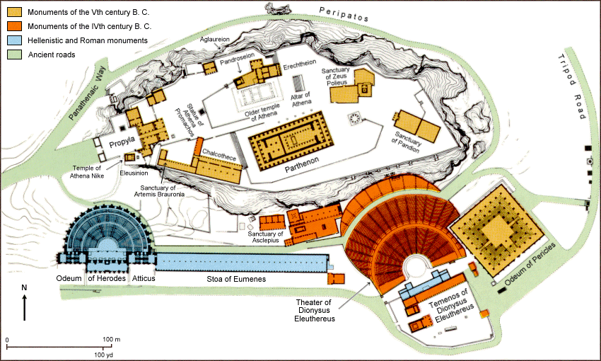
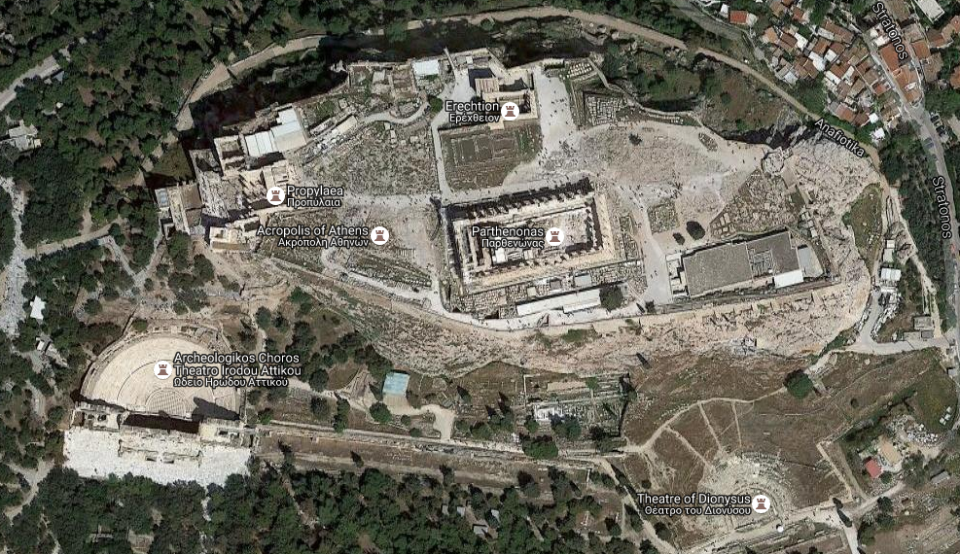

Figure 3-2: 2016 Map of the Akropolis
Obtained from Google, Inc., “Map of the Acropolis,” Google Maps, Inc. 2016. https://www.google.com/maps/place/Acropolis+of+Athens/@37.9715968,23.7254827,356m/data=!3m1!1e3!4m5!3m4!1s0x14a1bd1837f5acf3:0x5c97c042f5eb0df6!8m2!3d37.9715323!4d23.7257492.

Figure 3-1: Map of the Akropolis of Athens in Socrates and Plato’s Time
Obtained from Beranrd Suzanne, “Map of the Acropolis of Athens in Socrates and Plato's time,” Plato Dialogues. Dec. 30, 1998. http://plato-dialogues.org/tools/acropol.htm.
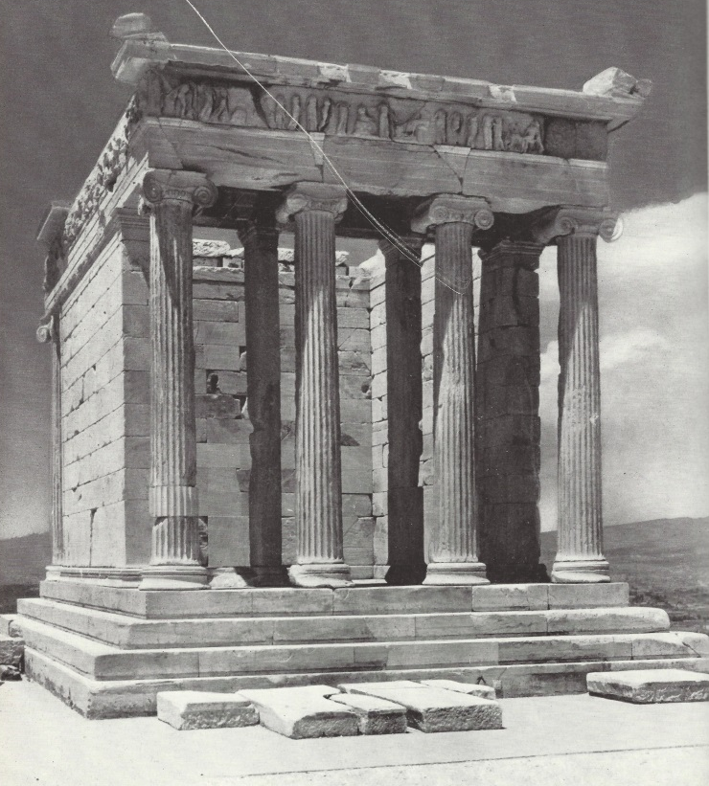

Figure 3-3: East Side of the Temple of Athena Nike
Reprinted from Gerhart Rodenwaldt and Walter Hege, Photographer, The Acropolis, 2nd ed. (Norman: U of Oklahoma P. 1957), Plate 58. Temple of Athena Nike. East Side.

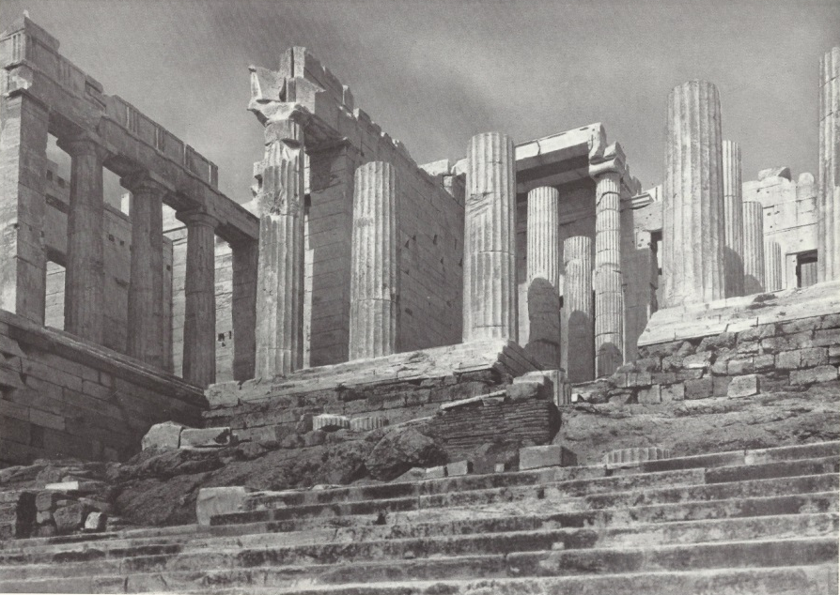

Figure 3-4: West Side of the Propylaea
Reprinted from Gerhart Rodenwaldt and Walter Hege, Photographer, The Acropolis, 2nd ed. (Norman: U of Oklahoma P. 1957), Plate 58. Propylaea. West Side.
The Parthenon (See Figure 3-5) contains another embodiment of the goddess Athena. Acting as a setting and display for the goddess, the structure of the Parthenon itself embodies the act of worship to Athena. Much genius and effort was behind each detail of the Parthenon, making it the most unique all of Greek structures. While Perikles appointed Pheidias “general manager and general overseer” of the building program, other architects oversaw construction and are named by historians as “Iktinos (named by Pausanias, Plutarch, and Vitruvius), Kallikrates (Plutarch), and Karpion (Vitruvius).” Plutarch lists the many materials, artists, and labors. With their expertise, the structure was completed in ten years, begun in 447, and dedicated in 438, with the remaining sculptures completed by 432-431. The oblong Doric temple with various Ionic elements rests 450 feet above sea level measuring 238 feet long by 111 feet wide by 65 feet tall, measuring to the peak of the pediments, and including the lower steps. Three key elements distinguish this temple from all others in Greece – the plan, the refinements, and the sculptures.
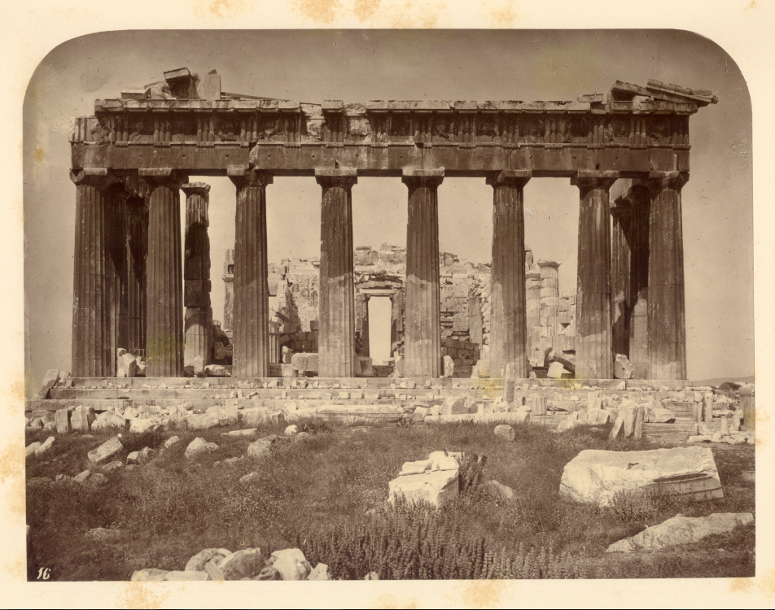

Figure 3-5: The Eastern Entrance to the Parthenon
Courtesy of the Nashville Parthenon. William James Stillman, The Acropolis of Athens, Illustrated Picturesquely and Architecturally in Photography (Boston: Museum of Fine Arts, 1870). The Eastern Entrance to the Parthenon.

Entering the hekatompedes naos, one’s attention was immediately drawn to the goddess Athena. Another major aspect of the room is the two-tier Doric colonnade format with ten columns along the sides and three columns in the back behind the statue of Athena, creating a backdrop. The architrave between the two levels of Doric columns (also with twenty flutes each) leads the mind’s eye directly to the statue of Athena, especially when viewing from the doorway. These optical illusions were inherent in the smallest detail to shift all focus to the statue of Athena. Furthermore, windows were probably at the upper east end to provide more light for the sacred image, while also providing enough light for the large recessed reflecting pool in the floor in front of her podium.
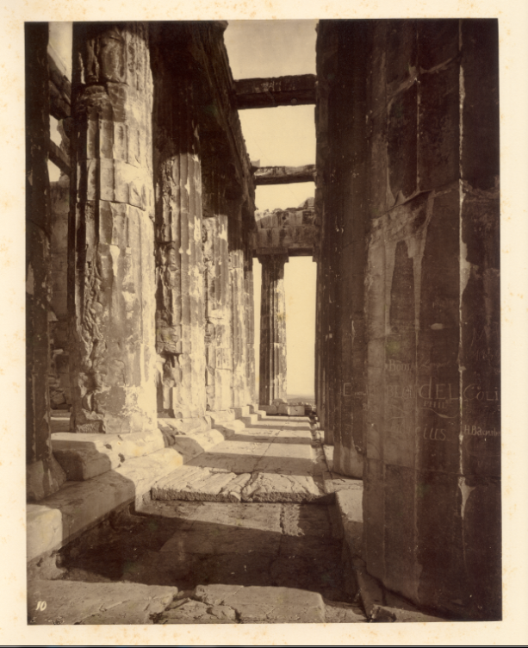

Figure 3-6: Western Portico of the Parthenon
Courtesy of the Nashville Parthenon. William James Stillman, The Acropolis of Athens, Illustrated Picturesquely and Architecturally in Photography (Boston: Museum of Fine Arts, 1870). Western Portico of the Parthenon.

Before the later title of “Parthenon” referred to the entire structure, it first referred only to the smaller back chamber. Considered as the residing place of Athena, it was also used to store the treasury of the city’s wealth. Concerning the actual use of the sacred temple in the function of the Akropolis worship, the title reveals some interesting implications. Originally, the sacred temple was referred to as “the temple” or ho neos or as the “Hundred-Footer or Hekatompedos, as the architects Mnesikles and Kallikrates referred to it in their treatise. However, by the fourth century B.C., it became wholly known as the Parthenon by Demosthenes in 345-344. The translation of parthenon (παρθενών) is a “place of the maidens” in comparison to parthenion (παρθενιον), which translates “place of the maiden.” The plural of the word (using the long “o” omega) parthenon could not mean the place of Athena alone. Regarding the actual use of the sacred space, the word could inform its role in ancient antiquity – something that still remains a large mystery. Most likely the name refers to a cult gathering place for the maidens of Athens, as suggested by Adolf Furtwängler in 1839. Furtwängler even associated the daughters of Erichthonios, one of the earliest legendary kings credited with the founding of the Panathenaic festival, which connects to Euripides’ play Erechtheus where Athena orders the burial of his daughters on the Akropolis in a special dedicated precinct. Wilhelm Dörpfeld built upon this idea when asserting that the maidens of the temple were not mythical dead princess but ergastinai or “worker women” who sewed the peplos for the Panathenaic festival, and that they weaved such cloth in the west rear chamber of the Parthenon.
This hypothesis is fairly substantial given what is known about the use of the Akropolis in celebration of Athena. The Panathenaic festival was an ancient procession to the Akropolis led by maidens carrying the peplos or “new robe” to dress the sculpture of Athena. But this large procession, as believed to have been depicted in the Parthenon’s Ionic frieze, did not clothe the bronze Athena, the image of Athena at the Temple of Athena Nike, or the large forty-foot ivory, gold, and gem imbedded statue of Athena in the Parthenon’s hekatompedes naos. Instead, this peplos covered a more humble image of Athena – an ancient, olive wood sculpture image of Athena that was sacredly housed in the Erechtheion after the building program.
The last to be built in the program, the Erechtheion (See Figure 3-7) was the temple of another identity of the goddess Athena for the people – Athena Polias, the city goddess. This structure is arguably more important than even the Parthenon for the ancient Athenians, since it housed the precious olive wood sacred image of Athena that they celebrate. Pausanias describes the Erechtheion even more in-depth than he does the Parthenon in his Description of Greece:
There is also a building called the Erechtheum. Before the entrance is an altar of Zeus the Most High, on which they never sacrifice a living creature, but offer cakes, not being wont to use any wine either. Inside the entrance are the altars, one to Poseidon, on which in obedience to an oracle they sacrifice also to Erechtheus, the second to the hero Butes, and the third to Hephaestus. On the walls are paintings representing members of the clan Butadae; there is also inside – the building is double – sea-water in a cistern. This is no great marvel, for other inland regions have similar wells, in particular Aphrodisias in Caria. But this cistern is remarkable for the noise of waves it sends forth when a south wind blows. On the rock is the outline of a trident. Legend says that these appeared as evidence in support of Poseidon’s claim to the land.
Both the city and the whole of the land are sacred to Athena; for even those who in their parishes have an established worship of other gods nevertheless hold Athena in honour. But the most holy symbol, that was so considered by all many years before the unification of parishes, is the image of Athena which is on what is now called the Akropolis, but in the early days the Polis (City). A legend concerning it says that it fell from heaven; whether this is true or not I shall not discuss. A golden lamp for the goddess was made by Callimachus. Having filled the lamp with oil, they wait until the same day next year, and the oil is sufficient for the lamp during the interval, although it is alight both day and night.
The more important identity was not the role of Virgin Victor as displayed in the Parthenon. This sacred olive image had fallen from the heavens. The role of the Parthenon during worship is hard to discern, but considering the location of the altars on the Akropolis, the Parthenon’s limited structural attrition in key areas, and known cultural emphasis on other structures and identities of Athena upon the Akropolis, it is easily reasoned that very few worshippers found themselves within its walls. The large image would have been seen from the exterior due to her size and to the controlled natural lighting, and worshippers would not have required entry. There, however, was one altar on the porch of the Parthenon. The northern additions to the initial foundations for the Parthenon overlapped a shrine (naiskos) and altar, so after the construction was complete, the small temple-like structure was rebuilt directly above its location, placing it between the seventh and eighth columns from the east end on the northern side with a circular alter nearby.
However, the function of the Parthenon changed drastically over the course of Athenian history. In fact, it served as a Christian church and Islamic mosque longer than it ever served the ancient Athenians as their sacred space dedicated to Athena. After Roman domination in 86 B.C. and the rise of Christianity in the Roman Empire, the Parthenon ceased to be associated with the Virgin Athena and instead became a house of the Virgin Mary. It served first as a Christian basilica and then became a church later in the thirteenth to fifteenth centuries. The use of the Parthenon as a Christian cathedral continued until it then became a Turkish mosque after the Turkish invasion in 1456, after the fall of Constantinople in 1453. War and conflict thread the entire history
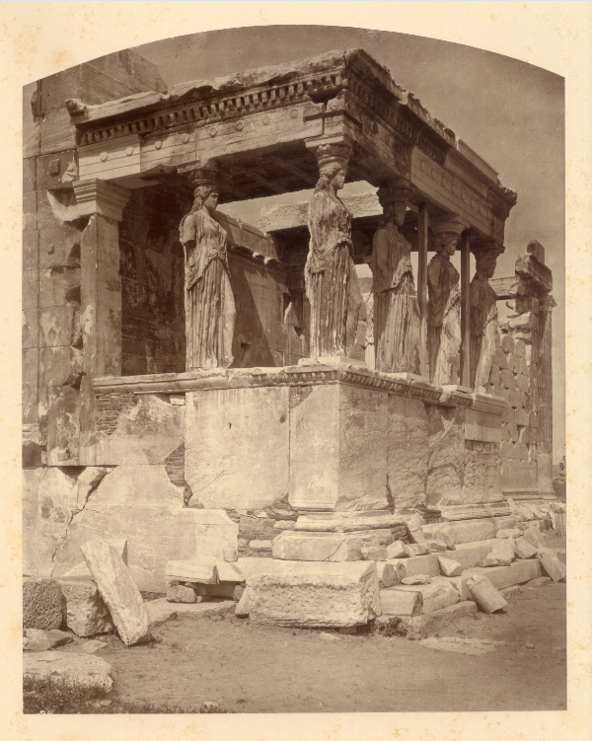

Figure 3-7: The Caryatids of the Erechtheion
Courtesy of the Nashville Parthenon. William James Stillman, The Acropolis of Athens, Illustrated Picturesquely and Architecturally in Photography (Boston: Museum of Fine Arts, 1870). The Caryatids of the Erechtheion.

of the Parthenon, reaching a pinnacle when the Venetians attempted to seize the city in 1687-1688. During the attack on the Akropolis, a mortar permeated the Parthenon’s roof, falling upon the stored ammunitions of the Turks. The Parthenon, “which had remained largely intact until then,” was extremely damaged. The Venetian General Francesco Morosini further damaged the Parthenon attempting to remove figures from the west pediment and three marble griffins. The official use of the Parthenon as a mosque continued in 1700 when one was constructed inside the ruins, but this last mosque in the Parthenon was removed due to structural deterioration in 1842.
On August 28, 1834, the Parthenon became an official ancient monument after the Treaty of Edirne in 1829. Then it was decided that the sacred space that had served pagan worship, Christian worship, and Islamic worship would then be entirely restored. Any material that could not be reincorporated nor made picturesque was to be sold off, per request of Leo von Klenze, chief adviser on architecture and archaeology in the royal court, to King Otto I of Greece. As Mary Beard points out the results:
All that the visitor can now see is what the archaeologists of the nineteenth century chose to leave behind: a handful of monuments with a fifth-century B.C. classical pedigree, standing in splendid (or uncomfortable) isolation, stripped of as much of their later history as possible. [. . .] This bare rock is the product of a vigorous programme of archaeological cleansing and by the standards of today’s archaeology a lesson in how not to landscape a restored site.
Most certainly, when scholars and classical enthusiasts viewed the Parthenon, they saw it as the new Greece wished them to see it – as Klenze said, “All the remains of barbarity [. . .] removed, here as in Greece, and the remains of the glorious past [. . .] brought into new light, as the solid foundation of a glorious present and future.” When the romanticized image of the Parthenon and Akropolis as a whole appealed to the elite in Nashville, who were planning the Tennessee Centennial Exposition in the 1890s, they had no other image to replicate other than the one highly cherished and valued – the restored ruins of ancient Greece. Standing as a symbol of democratic ideals, the arts, and the progression of humanity, it seems reasonable that Major Lewis and the other elite in Nashville would want to restore and cultivate these ideals within their growing city so as to further the interests of the city and its progression.

Chapter IV – The Akropolis of Nashville: Centennial Park

Before the Tennessee Centennial Exposition was over, rumors and ideas were circulating about the future of the expositional grounds. Those who attended the exposition, as well as those who organized it, longed to continue the image of Nashville during the exposition long after it had ended. On November 4, 1897, a letter (See Figure 4-1) from President Thomas addressed to Hon. J. M. Head provides reason to speculate that the discussion about developing a park system and the adoption of the expositional grounds by this park system had preceded many larger details of the Exposition itself:
While I shall use every exertion to secure the Centennial Grounds for a park, I do not wish it named as suggested by my personal friend, Mr. W. B. Earthman, of Murfreesboro, but think it should be named “Centennial Park”.
I do not think that this matter should be considered by the Directors of the Centennial Company; but, at the proper time, by a mass meeting of the citizens of Nashville, and I understand there is a movement in this direction being made by the friends of the enterprise.
Another letter (See Figure 4-2) mentions forming Centennial Park and is addressed to President Thomas from Major E. C. Lewis on October 13, 1898:
In connection with the matter of the fish in the lake at the Exposition grounds, if we do anything with your last suggestion about raising the Parks question again, it might be well to preserve the fish there.

Figure 4-1: John W. Thomas to Hon. J. M. Head. – November 4, 1987
Courtesy of Tennessee State Library and Archives. John W. Thomas. John W. Thomas to Hon. J. M. Head. November 4, 1987. Letter. From Tennessee State Library and Archives, Tennessee Centennial and International Exposition (1897) Collection 1895-1900.

Figure 4-2: E. C. Lewis to Maj. John W. Thomas, President – October 13, 1898
Courtesy of Tennessee State Library and Archives. E. C. Lewis. E. C. Lewis to Maj. John W. Thomas, President. October 13, 1898. Letter. From Tennessee State Library and Archives, Tennessee Centennial and International Exposition (1897) Collection 1895-1900.

This letter makes it abundantly clear that John W. Thomas, the President of the Nashville, Chattanooga, and St. Louis Railway companies and the President of the Centennial Exposition Company was also suggesting that a park system be created in Nashville and that “Centennial Park” was suggested to be a part of it.
Apparently, the idea had reached such fruition that names could be tossed between elite members over the Centennial Exposition Company. This coincides with the 1894 Tennessee Centennial Exposition meeting participants expressed their intent to create a Fine Arts Building and leave it on the grounds permanently alongside the History, Architecture, and Education Buildings. If the buildings were to be left on the grounds, there was obviously an understood idea amongst all involved in the project, even from its early stages – to create a city park system and let the expositional grounds be a part of that system to serve the people of Nashville civically.
In Nashville, actual recreational areas and parks did not exist at the time, unless the small private amusement parks and general open spaces or “commons” are considered. As Leland Johnson points out about the condition of parks at the time:
Some Nashvillians, after they became aware at the time of the Centennial Exposition of the potential of municipal parks, complained that the city had lagged behind others of its size in park development, but that idea was more illusory than real. It was true that the founders of the city had not included in their plat of the town several open city blocks to serve as public commons, as was done for instance at Memphis when it was platted in 1819, but the nationwide movement in support of urban parks had developed chiefly during the late 19th century. Of the 159 American cities with populations exceeding 25,000 in 1900, 37 had no public parks, 43 had less than fifty acres of parks, and 79 had more than fifty acres. The majority of those existing municipal park systems then were less than ten years old, created during the 1890s. Nor was the park development record better at the state and federal levels: Tennessee in 1901 had not one single state park, and the half dozen national parks were located in the Far West.
The idea of creating a park system in Nashville to keep up with other large and growing cities was nearly disillusioned. However, the idea was entirely contemporary with the growing value and interest in having open recreational spaces, especially in cities, where one could experience a purifying spiritual retreat with nature and recreational rejuvenation. No doubt, these spaces could be utilized for civil purposes such as community events or private business. Before the 1890s, Nashville had enough open greens surrounding the city that there was no need for an actual city-endorsed designated sacred grove for citizens. As the city grew from 17,000 in the 1860s, doubled by the 1880s, and reached 76,000 in 1890, the urbanization of the land required city action to secure sacred groves for continued civil use.
Some recreational areas did exist, such as Cumberland Park and West Side Park. Cumberland Park, the current location of the Tennessee State Fairgrounds, opened in 1891 off Nolensville Road and was used for harness or trotting races, the area’s most popular spectator sports before baseball, until the state passed legislation against wagering in 1906. West Side Park, which was previously the site of the Tennessee State Fair and was used for the Tennessee Centennial Exposition grounds, opened in 1884. West Side Park acquired the large crowds from the Island Track of Lysander McGavock, located near the current site of Metro Center, when it closed in 1884. These large crowds flocked to the future Centennial Park grounds, including Frank James who himself entered horses and won races at West Side Park. West Side Park remained a racetrack until the renovation of the grounds for the Exposition.
By 1900, Nashville’s population had grown to 95,000, beginning to limit the spaces for a parks system. The Centennial Exposition Company held tightly to the expositional grounds during this time. When Governor Benton McMillin signed the park act of April 3, 1901, Mayor James M. Head handpicked the five men who would compose the Board of Park Commissioners, most of whom had served on the administrative committees of the Centennial Exposition. These men were Major Fountain P. McWhirter, owner of Harris, McWhirter and Company; Benjamin Lindauer, a partner in the Herman and Lindauer wholesale dry goods firm and the largest dry goods firm in the South; Robert Dudley, president or director of a majority of important firms in the area such as Foster & Creighton Construction Company; Major Eugene C. Lewis, engineer and Director General of the Tennessee Centennial Exposition, owner of the Nashville American, and planner of the Union Station in Nashville; and Samuel A. Champion, General Counsel for the Centennial Exposition, previous law partner of James Head, and was quite politically powerful. It is necessary to note that the initial Park Board comprised of “well-to-do white males, leaders of Nashville’s aggressive commercial middle class” – most certainly a portion of Nashville’s elite.
The first Park Board met on Tuesday, April 16, 1901 at four in the afternoon in Mayor Head’s city hall office. There, after swearing an allegiance to the Constitution of the United States and the Constitution of the State of Tennessee, “Mr. Champion moved that Maj. E. C. Lewis be made Chairman. The motion was seconded by Mr. Lindauer, and Maj. Lewis was elected.” Between the first and second Park Board meetings, two parks, Watkins and Federal Parks, were under the development of the new parks system with no progress on the Exposition grounds. However, before any land could be officially developed, the Park Board saw fit to delegate a plan for the park system. Their two-point plan was as follows:
- There shall be a system of large parks, consisting each of fifty or more acres, one in each section or quarter of the city or adjacent thereto. The number of large parks shall not be less than four nor more than five.
- There shall be a system of small parks, consisting of a number of lots, plots, squares or tracts, all to be within the city limits, as said limits may be now or hereafter defined. The location of said interior parks to be evenly distributed over the entire city as a wise consideration of the conditions of the topography, geography, populosity, and economy may determine to be desirable.
With little funds available, the Park Board was revolutionary, but behind the likes of other cities such as New York with Central Park, developed in 1853 and widely recognized as “the first major public park in America.” Hoping to somehow acquire the historic land that was a 640-acre farm, owned by John and Ann Cockrill, a portion of Vanderbilt University’s campus, a station of the Natchez Trace, a staging area for troops in the War of 1812 and the Civil War, the Tennessee State Fairgrounds, West Side Park racetrack, and site of the Tennessee Centennial Exposition. Legal and financial negotiations began in 1902 when the Centennial Land Company announced that they would be subdividing and selling the “seventy-two acres of historical property.” On Tuesday, January 28, 1902 at three in the afternoon, Mr. McWhirter moved, and the Park Board approved, that Major Lewis would contact the President of the Centennial Park Land Company to begin negotiations.
These negotiations were far from smooth. Representatives from the Centennial Exposition Company – Samuel J. Keith, Johnson Bransford, Joseph H. Thompson, V. E. Shwab, and F. O. Watts – met with the Park Board where Major Lewis informed them of the Park Board’s eagerness to secure the grounds despite the lack of funds. The company desired to sell the land for $150,000 but would sell it for $125,000 to the city. Major Lewis disagreed that the land was worth no more than $72,000 but offered $100,000. Negotiations failed.
The Mayor, James Head, then pursued a route to gain the grounds. Catching the electric streetcar company, the Nashville Railway Company, in a complex litigation concerning bonds, the Mayor had Samuel Champion and James Brown pursue legal action that lasted over a year and went as far as the Tennessee Supreme Court. When the company restructured after its bankruptcy in 1901, the court appointed Percy Warner and E. C. Lewis as new managers of the streetcar company, removing it from the out-of-town investors and placing it in the hands of two powerful Nashvillians. Major Head acted quickly, knowing that Percy Warner wished to control the Cumberland Electric Light and Power Company. The mayor proceeded to bluff out Warner (who wanted to buy the CELPC, reconstruct the lines, and only pay two percent for exclusive Park Board improvements to compensate for his capitalist endeavors) by building a city-owned power plant and creating the stipulation that Warner could be granted his wish if the newly formed Nashville Railway and Light Company would purchase Centennial Park and give it to the city. Warner agreed, the Mayor ceased construction on the city-owned power plant, and Centennial Park was officially the Park Board’s first large park. On Monday, December 30, 1902, the Park Board officially and unanimously named the park, moved by Mr. Champion and seconded by Mr. McWhirter, as “Centennial Park.”
Dubious financial dealings were not the only haunting portion of Centennial Park’s acquisition and the Park Board’s early development. Major Lewis collided with the Tennessee Central Railroad plans of Jere Baxter, who received the support of Mayor Head. When Mayor Head announced his support of Baxter, Major Lewis officially severed himself from the city’s administration. At the last meeting of the Park Board in 1902, Major Lewis arrived late only to find that Samuel Champion had the Park Board resolved that it would elect chairmen without nominations and that Ben Lindauer was the new Chairman of the Park Board. Major Lewis would never again serve as chair, but would remain on the Park Board since he could not be removed; “he remained on the Board and was the most active of its members in park development, devoting much of its time and some personal funds to their improvement.” He worked without pay as an unofficial chief design engineer and construction superintendent for the city parks, and reflecting upon his resolutions about the Park Board, Major Lewis said, “It pains me to see things done wrong, so I preferred to do them myself rather than possibly. It might not be done quite so well by somebody else.”
Armed with Parthenon letterhead, the Park Board proceeded to meet in a building left in Centennial Park, draw up bylaws, and establish regulations for the new parks in the park system. After James Dunbar, Superintendent Creighton, and Wilbur Creighton, his son, tore down the Auditorium from the Exposition, they also made repairs to the already deteriorating exterior-grade plaster of the Parthenon. The Parthenon was then dressed up with a large development program for Centennial Park. This development program began with bath houses for the community for $7,500; some bass for the lake; two huge alligators (that were removed after the local wildlife population began to diminish); 850 trees and shrubs purchased by horticulturist W. F. Josolyne; flowers donated by florists George B. Moudler and Joy and Sons; and a general cleanup of the grounds, restored roads, boats for the lake, and repairs to the buildings costing around $18,000 (including general workers’ salaries). Cornelius A. Craig donated lawn swings for the development of Centennial Park, and Foster & Creighton Company donated crushed stone to repair the roadways, helping the Park Board compensate for their $25,000 budget. Many generous monetary donations also aided in the Board’s finances. Development still taking place, Centennial Park opened in May 1903 with the Parthenon still remaining at its core.
In 1906, Major Lewis had Robert and Wilbur Creighton begin more improvements of Centennial Park by placing a bandstand near the sacred groves surrounding the Parthenon and a bridge over Lake Watauga using the newly developed reinforced concrete – a construction material that attracted engineers’ attention across the nation. Major Lewis also oversaw the construction of multiple other structures around this time included the Shell Spring and the concrete replica of a ship’s prow, on which the figurehead of the U.S. Tennessee was placed in 1910. These still remain save for the bandstand, which was deconstructed due to its limited band space (it could only accommodate a small brass band). In 1909, the Park Board also began developing a playground in Centennial Park from the nationwide influence of the Playground and Recreation Association of America, in 1906, and one of its leaders, President Theodore Roosevelt, who emphasized these recreational spaces by announcing, “Playgrounds are a necessary means for the development of wholesome citizenship in modern cities.” Therefore, if Nashville were to remain a “modern city” and have “wholesome citizens,” Centennial Park and the other parks under the Park Board needed to include playgrounds.
However, Centennial Park began to become unfriendly to those seeking refuge in the sacred groves of nature at the park. The Parthenon itself was not as resolute as was the notion of “Athens of the South” in the minds of Nashville’s leaders since the pediment sculptures were falling by 1920. By this point, most of the original Park Board members, including Major Lewis, had died save for Robert Dudley. The new Park Board in the years thereafter consisted of M. T. Bryan, Robert T. Creighton, Whitfoord R. Cole, Lee J. Loventhal, Charles M. McCabe, and Percy Warner. These members oversaw the reconstruction of the Parthenon in more permanent materials and realigned the symbol with the cultural identity of the “Athens of the South.”
Russell E. Hart was commissioned to draw up plans for a new Parthenon. When Hart joined Freeland-Roberts, and his plans were intact, Freeland-Roberts decided upon using concrete for the life-size replicated symbol since marble was too costly. Foster and Creighton Company then received the contract to rebuild in 1922 with Park Supervisor Clarence Connell as the construction foreman. The permanent structure included a more accurate exterior and an exact interior, since the interior housed only visual art at the Exposition. More research had to be conducted and a permanent material discovered, since marble was far too expensive, an issue the ancient Greeks never faced. Hart decided the best material was reinforced concrete, the latest development in materials, and covered it with “newly patented concrete aggregate formulated by the John Early Studio in Washington, D.C.,” which could be colored to appear as marble and allow for red and blue trim. However, as Leland R. Johnson points out, despite their best efforts, trouble still loomed over the reconstruction of this cultural icon:
Removing the exterior plaster and wooden lath framing, the workmen installed metal lathing and wire mesh and hoisted concrete to the roof for pouring into the forms for the wall and columns. Early’s colored finish, composed of a mixture of cement, quartz, and Potomac River gravel, when applied to the concrete recreated the golden burnish of the ancient Parthenon [from the marble’s aging]. The exterior reconstruction was nearly completed by 1923 when a tornado tore off part of the building’s roof and the repairs exhausted the funds then available for the work. The Board therefore suspended the reconstruction while seeking additional funding and considering various plans for the design of the building’s interior.
More turmoil was to ensue. Conflict arose between the Park Board and Mrs. Sarah Bradford and the Art Commission. The Park Board desired to recreate the full Athenian Parthenon in Nashville, securing the relational identity with Athens and to use the basement of the Exposition Parthenon as an art gallery, while Mrs. Bradford moved for the interior to be a replica of the Hall of Sculpture at Pittsburg’s Carnegie Museum of Art. Debate became so fierce that the Park Board halted support of the Nashville Arts Commission in 1927. The Park Board continued with their plans for the conversion of the basement into an art gallery, “so as not to violate the spirit of the Parthenon, which was always a temple of some god, by placing painting upon its walls” as the Parthenon’s first Director Benjamin Franklin Wilson III states. However, evidence exists that at some point during construction of the exterior, plans were made to hang art, as the inner hekatompedes naos is lined with supports to hang artwork on the concrete walls. This plan was apparently abandoned for the awe the temple inspired. Even though the space was not used to worship Athena, it was still highly regard and respected, as Director Wilson continues, “Visitors going down these stairways [to the art gallery in the basement] are as effectually out of the Parthenon as though they went down the steps on the outside of the building” – the temple still held reverence despite its relocational readapation within the sacred groves of Centennial Park.
Needing assistance with his research, Hart hired William Bell Dinsmoor, “the foremost authority on ancient architecture” and professor of architecture at Columbia University in New York and in the American School of Classical Studies at Athens. The exterior of the Parthenon was completed in 1925, and the interior was completed in 1931. In every detail of the plan, the refinements, and the sculptures, the Nashville Parthenon is an extremely close replica. As Dinsmoor stated, “While there are several more or less faithful modern replicas of the exterior of the Parthenon, the only reproduction of the interior at full size is that which I designed in 1927 for the Parthenon in Nashville, Tennessee.”
Needing further help in sculpting and designing, Hart hired George Zolnay, who sculpted the pediments on the Exposition Parthenon, to recreate the metopes, while hiring Belle Kinney and Leopold Scholz to recreate the east and west pediments. Both Belle Kinney and Leopold Scholz coordinated with Russell Hart later to create the bronze doors. Once created, the large doors were brought into the Nashvillian Parthenon on ice because of their weight and placed on the hinges. The ice melted, and the seven and a half ton doors with lion medallions and serpent door handles were mounted. Additionally, the tilt and entasis of the columns, the convex curves in the stylobate, and all other refinements and features were reproduced accurately. Even though completed in roughly the amount of time as the Athenian Parthenon, the Nashvillian Parthenon used different materials, already had templates and casts, and, when opened on May 21, 1931, most importantly lacked the statue of Athena and the Ionic frieze. However, despite its incomplete nature, 10,757 tourists, three-fourths from Tennessee and the rest from 45 other states and 12 other countries visited in the first month, as reported by Director Wilson.
The Parthenon itself was a direct symbol of the cultural identity and heritage of Nashville embodying the “Athens of the South.” Its design and replication certainly appealed to the aristocracy of Nashville, from its prestigious columns to its highly regarded art collection. It was this educated elite that had fostered this identity in the early nineteenth century, and it was this educated elite that continued this identity through the architectural replication of the famous symbol of ancient Athenian history, culture, progress, and democratic ideas. Replicating the exalted sacred space still held scared meaning for some cultural leaders in Nashville until the prominence of the identity began to diminish due to other cultural advancements for which the city was credited. The twentieth century brought new challenges, struggles, and opportunities for America and for Tennessee specifically. The people of Nashville, who once flocked to the cultural prestige of relating themselves to a classical culture, considered to be the cradle of Western culture itself, now flocked to a new identity created within the ashes of World War I: “Music City.”
When WSM first signed on as an AM station in 1925, listeners took to the live broadcast of the Grand Ole Opry, the longest running radio broadcast in history. WSM Director George D. Hay hosted the “barn dance” on Saturday nights after the “Music Appreciation Hour” of classical music. In 1927, Director Hay introduced the barn dance saying, “For the past hour, you have been listening to music taken largely from the Grand Opera, but from now on we will present the Grand Ole Opry.” Some more prestigious citizens of Nashville were not in tune with the presentation of barn dancing on the new broadcasting technology, but the cultural identity of Nashville shifted from the hands of the elite to the entire population of Nashville, as the technology of the radio spread and entered homes across the nation. In 1932, a new radio tower had the strength to reach the entire nation with this Nashville identity, and this identity set the new cultural reputation of “Music City” as solid as the concrete in the replicated Parthenon. Though the cultural identity of “Athens of the South” still remains known to this day, the majority of the population in Nashville and across the nation are familiar with Nashville as “Music City” because of the commercial broadcasting waves of the early twentieth century.
The reign of the Park Board, an independent board that operated the city parks and continued the “Athens of the South” identity, ended on March 12, 1963 after sixty-two years with Chairman Edwin Crutcher. When the final meeting was called, the Park Board controlled four thousand acres of park grounds, one hundred full-time employees, and an annual budget exceeding one million dollars. The birth of “Metro,” the new city-county consolidation system, led the city, the city parks, and the Parthenon into its future management and preservation. This legacy and the cultural identities that the city now held were the responsibility of Metro and the newly formed Metropolitan Board of Parks and Recreation in 1963. Much to the pleasure of the newly formed Metro system, the parks could be more receptive to the sociopolitical movements in the communities and coordinate with other municipal aspects of the city. Concerning the former Park Board, Leland R. Johnson observes:
From the first, Board membership was balanced to reflect the interests of the city’s religious denominations, but no woman, black, or other minority was ever elected to the Board. While it established in 1912 the first park in the South and perhaps the nation for black citizens and worked closely with black leaders to provide recreational facilities for the city’s black community, it was not noticeably responsive to the civil rights campaign to end segregation. Even conservative columnist Dick Battle of the Nashville Banner had concluded by 1957 that the autonomous Board should be eliminated. Battle admitted the Board members were citizens of unimpeachable integrity, devoted not only to the park system but also to the progress of the city as a whole, but he declared that its political and financial independence inherently contradicted the “principles of democratic government.”
It is not dubious that the Parthenon and the cultural heritage and identity with Athens stood on the grounds of democracy. The emphasis on the classical education in Nashville was a large factor in informing the elite, but the image of the new stately orders of America in their democracy are symbolized in the architecture across the country. When the choice came to select a Fine Arts Building at the Tennessee Centennial Exposition, the Parthenon was not just chosen for its classical artistry and liberal significance. Athena was a cultural icon for the ancient Athenians to gather around and follow in their cultivated, civilized ways. When Nashville needed a similar symbol in the late nineteenth and twentieth centuries, the Parthenon played a similar role in depicting the condition of government and civil affairs. When the Park Board and the parks, including Centennial Park and the Parthenon, became under the governance of Metro, and the city adopted a second cultural identity as Music City, the Parthenon moved from the elite aristocracy of Nashville to the democratic inclusion of all of its peoples. The civic goddess’s temple now stood in Nashville as a part of the cultural fabric resembling the nature of democracy in the city, as a direct symbol of “Athens of the South.” A replicated sacred space within the confines of Centennial Park was once appreciated by a few select demographics of the city; now, it could be appreciated by all citizens despite race, religion, or identification. The architecture that once conveyed prestigious messages of Nashville’s elitism then conveyed a welcome for all to sit on its steps and enjoy the sacred groves of Centennial Park.
One way that Nashvillians enjoyed the Centennial Park and the Parthenon was at Christmastime. From 1954 to 1967, the Christmas tradition of the Harvey Scene, owned by Harvey’s Department Store, decorated the lawn next to the Parthenon (See Figure 4-3). 2 feet long by 75 feet wide, glossed with multicolored lights, music, and narrative of the Christmas story, the Nativity Scene was a centerpiece in the park for families to observe the religious values of the Nashville culture. 45 human figures, 78 animals, and 10 angels sculpted by Rebbecini of Italy attracted an average of a million visitors every year. At the time of Christmas, what sacred reservation the groves of the park had was enhanced by the depiction of the birth of Christ on the grounds. People came to pay respects to the origins of the Christmas tradition and celebrate the Christmas season with family and friends. Local families have had life-long memories of visiting "the main attraction in Nashville at Christmastime.” However, in 1968, the Nativity was damaged beyond what the Harvey's Department Store could afford to repair, so the collection was bought by a Cincinnati shopping center. To the dismay of Nashvillians by word through the Nashville Banner, the Cincinnati shopping center displayed the collection for two years before disposing of the set.
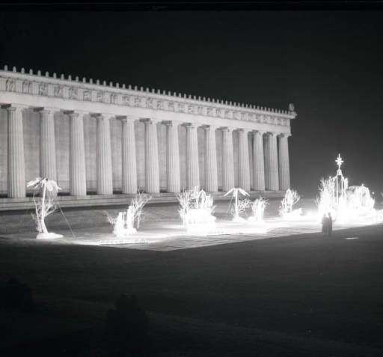

Figure 4-3: Nativity Scene at Centennial Park, Nashville, Tennessee 1953
Courtesy of Metro Archive. Nativity Scene at Centennial Park, Nashville, Tennessee 1953 (Nashville, 1953), Photograph. From the Metro Archive, http://digital.library.nashville.org/cdm/singleitem/collection/nr/id/6225/rec/86.

However, Lady Liberty herself was still missing from the center of the Parthenon – the meaning and centerpiece of the temple from the start. After the Nashvillian Parthenon’s opening in 1931, Belle Kinney and Leopold Scholz returned and approached the Board of Park Commissioners with plans to complete the structure with the missing Ionic Frieze and sculpture of Athena. The finances were not available, though the miniature four-foot sculpture they presented lived in the Parthenon thereafter. Thirty years later, “Sometime in the late 1960s a donation box appeared next to Belle Kinney’s model in the middle of the Parthenon. School children, visitors, and Nashvillians put their nickels, dimes, and dollar bills in that box over the next twelve years.” $30,000 was raised by 1982, enough to begin the program. After emerging victorious in the sculpting competition for the position in the program, 26 year-old Alan LeQuire began researching. He speculated a period of eighteen months for the project; however, it took over seven years. Unveiling the sculpture in May 1990, Athena was complete with the pedestal, the statue of Nike, the spear, the shield, and the serpent. Athena was later glided with 23:75 karat gold in 2002 with LeQuire and Master Guilder Lou Reed. Also during this time, the skin was painted to resemble ivory and the inside of her shield to depict the battle of the gods and giants.
Interpreting his research to the best of his ability, Alan LeQuire received much guidance to create the most accurate replica of a statue that had not existed in over seventeen hundred years. Coming to conclusions such as the leg-weight shift position, similar to the contrapposto position, and analyzing the different effects of weight shift, he further discovered that a simple wooden beam placed through Athena’s arm could easily bear the weight of the six-foot Nike. Following Dinsmoor’s measurements and speculations, LeQuire’s Athena measures 41 feet and 10 inches tall. After completing drafts of his Athena, he also had to plan a 15-foot shield with 31 figures in the Amazon relief, 21 figures on the pedestal for the birth of Pandora, and a 30-foot serpent.
Taking some liberty in his design, LeQuire inherited the spirit of Pheidias by creating perspective distortions and culminating themes introduced in the architecture. First, LeQuire created larger proportions such as her slightly larger head while her upper body decreases in proportion as her figure nears the base, so that her arms would almost touch her knees if placed at her side. These visual alterations, when viewed from below, make Athena look equal in proportion as she rises to the ceiling of the hekatompedes naos. Noting the design of the architrave between the two-tiered columns and its effect on the mind’s eye, he also placed Athena’s right hand holding Nike at the same level intensifying that focus on Athena and the crowning of her victory. Second, LeQuire features the civilization conquering barbarianism theme and the “Great Goddess” theme in his reliefs and embellishments on Athena. On the exterior of Athena’s shield, LeQuire depicts the famous battle between the Greeks and Amazons, including Pheidias and Perikles. On the interior of her shield, he recreated the battle between the gods and the giants. Lastly, on her sandals, he depicts the battle between the Lapiths and the Centaurs. All three recreate the metopes, excluding the Greeks battle with the Trojans, and establish the polarity theme of civilization triumphing barbarianism with the aid of Athena. Furthermore, as Athena’s belt and adornment on her breastplate and wrists, LeQuire sculpts serpents. As the symbol of the “Great Goddess” figure, the serpents parallel those from the bronze door handles and Erichthonius by her side. Lastly, officially modeling himself after Pheidias despite his trial and persecution, LeQuire created Pandora’s birth scene with himself in the relief with friends, family, and others involved in recreating Athena. Adding a unique American touch, LeQuire also trans-formed a McDonald’s flagpole into the mighty spear of the goddess, another symbol of her American rebirth. Noting the fuse of the American cultural identity with the goddess of ancient Athens indicates that LeQuire worked in the spirit behind the original readaption of the Parthenon – fusing the classical identity with the culture of Nashville. The commercial implications behind the use of the McDonald’s flagpole readily represent the modern Nashville culture, which is itself fused with the older Nashville cultures that have morphed and shifted through time.
Though he does not consider his educated interpretation to be faultless, he feels as though his style might bear some resemblance to Pheidias. He also considers Athena to be a “Lady Liberty, a living symbol of justice and democracy.” Comparing Athena to the Parthenon like a kernel to a shell, he feels as though he has given meaning and spirit to the monument. Transformed from a focus of worship, Athena’s rebirth in Nashville represents the continuation of the identity of the “Athens of the South” in modern Nashville and its ever-changing values. Though the identity of “Athens of the South” is not currently prominent amongst many Nashville citizens or visitors, its physical manifestation of the Nashville Parthenon and its Athena are nonetheless distinct and sacred amongst those that are aware.
Though the identity of the “Athens of the South” remains largely in the shadow of “Music City,” a special Conservancy exists that promotes and preserves these two identities of Nashville’s social fabric. The public statement of the Conservancy for the Parthenon and Centennial Park explains:
The Conservancy for the Parthenon and Centennial Park began in 1982 as the Athena Fund. Its original purpose was to raise funds to recreate the statue Athena, which stood in the ancient Greek Parthenon. This project led to further funding for the gilding of Athena and complete restoration of the miniature Pediment Sculptures. The Conservancy created a Docent Program and supports Parthenon educational programs, symposia speaker series, ongoing exhibits, Greek theatre and special projects. [. . .] We [also] fund this free outdoor music experience [Musicians Corner] in the park on Saturdays in Centennial Park. [. . .] The Conservancy is a for purpose 501(c)(3) nonprofit that serves a vital role in our community.
The function of the Parthenon in Nashville is far from the original ancient Parthenon and its role upon the Akropolis. In modern Nashville, visitors to the Parthenon enter the temple through a basement entrance to purchase a museum ticket so that they might explore the lower galleries and then the upper chambers. So long as a visitor can pay admission into the museum, anyone can enter the Parthenon to explore its treasures and appreciate its impressive qualities. The sacred space can be rented for special events, concerts, weddings, receptions, photoshoots, and much more, provided appropriate compensation is given. This stands in stark contrast to the original use of the ancient Parthenon – the ancient that was emphasized heavily in original romantic traditions of Nashville’s elite. When the ancient Parthenon became a church and mosque, its sacred use changed to adapt. As Nashville’s cultural fabric is altered, so the use and symbolism of the Parthenon has changed from a representation of the sophisticated ideals in art, democracy, and education to an attraction for all to enjoy and appreciate. Today, millions of visitors come to the park each year from around the world to appreciate the sacred areas of Centennial Park, whether the groves or the symbolic temple that represents the “Athens of the South” identity. The sacred groves of Centennial Park which frame the Parthenon have been and are still used for concerts, plays, exercise and recreation, movie showings, monumental dedications to important civil leaders, display of historic technology such as the steam engine Giant Locomotive 576 and the F-86 fighter jet, and any public gatherings of benefit to the community (See Figure 4-4). The Parthenon now lies in both modern Athens as an attraction and modern Nashville, the “Athens of the South,” as a museum attraction in Centennial Park’s recreational space. The Parthenon has yet another chapter in its history of adaptational uses within the meanings cultures apply to it, which places fuller meaning on Plutarch’s observance that the Parthenon, as a part of the Periklian building program, was, “created in a short time for all time.”
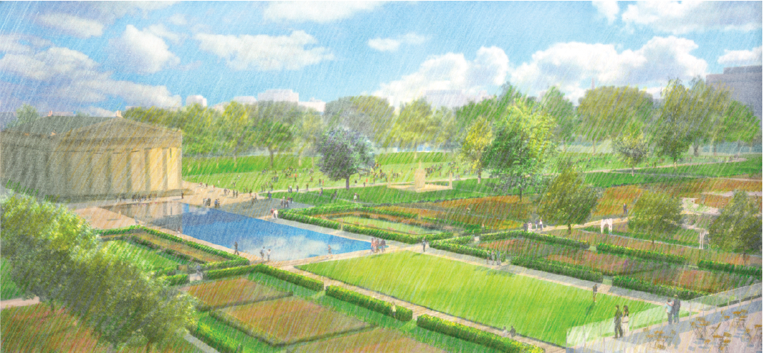

Figure 4-4: Future Master Plan for the Parthenon and Centennial Park
Reprinted from Gustafson Guthrie Nichol, “Looking Southeast toward the reflecting pool, formal gardens, and arrival plaza,” Centennial Park Master Plan (Nashville, December 2010), 21.

Bibliography
Anderson, William J., and R. Phené Spiers. The Architecture of Ancient Greece: An Account of Its Historic Development. Rev. and Rewrit. William Bell Dinsmoor. London: B.T. Batsford, 1927.
Ayrton, Elisabeth. The Doric Temple. New York: Clarkson N. Potter, Inc., 1961.
Beard, Mary. The Parthenon. Cambridge: Harvard UP, 2002.
Bowie, Theodore and Diether Thimme, eds. The Carrey Drawings of the Parthenon Sculptures. Bloomington: Indiana UP, 1971.
Bucy, Carole Stanford. “Ann Robertson Johnston Cockrill,” The Tennessee Encyclopedia of History and Culture, January 10, 2010, http://tennesseeencyclopedia.net/entry.php?rec=284.
Burt, Jr., Jesse C. “The Major Found the Plans”; Tennessean. Oct. 18, 1953. From the Metro Archives.
Burt, Jr., Jesse C. Nashville: Its Life and Times. Nashville: Tennessee Book Co., 1959.
Camp, John M. The Archaeology of Athens. New Haven: Yale UP, 2001.
Carpenter, Rhys. The Architects of the Parthenon. Baltimore: Penguin, 1970.
Clair, St. William. Lord Elgin and the Marbles. Oxford: Oxford UP, 1998.
Clayton, W. W. History of Davidson County, Tennessee with Illustrations and Biographical Sketches of its Prominent Men and Pioneers. Nashville: Tennessee Historical Society, 1880.
Connelly, Joan Breton. The Parthenon Enigma. New York: Alfred A. Knopf, 2014.
Crabb, Alfred Leland. Nashville: Personality of a City. New York: Bobbs-Merrill, 1960.
Craig, Lois A. The Federal Presence: Architecture, Politics, and Symbols. Cambridge: Massachusetts Institute of Technology P, 1978.
Creighton, Wilbur Foster. Building of Nashville. Nashville: Wilbur Foster Creighton, 1969.
Creighton, Wilbur Foster. The Parthenon in Nashville. Nashville: Wilbur Foster Creighton, 1968.
Crew, H.W. The History of Nashville Tennessee. Nashville: Publishing House of the Methodist Episcopal Church, South, Barbee & Smith, 1890.
Davis, Louise. “Advocate of Parthenon knew it’d be it,” Tennessean, September 26, 1988.
Davis, Louise. “Nashville Called ‘Athens of South’ Before Parthenon,” Tennessean, Dec. 30 1967.
Davis, Louise. “The Parthenon and the Tennessee Centennial: The Greek Temple That Sparked a Birthday Party.” Tennessee Historical Quarterly 26, no. 4 (1967): 335-353.
Davis, Louise. Nashville Tales. Gretna: Pelican Publishing Co., 1981.
Dinsmoor, William Bell. The Architecture of Ancient Greece: An Account of its Historic Development, 3rd ed. New York: W. W. Norton & Co., 1975.
Egerton, John. Nashville: The Faces of Two Centuries 1780-1980. Nashville: PlusMedia Incorporated, 1979.
Elderkin, G. W. Problems in Periclean Buildings. Washington, D. C.: McGrath Publishing Co., 1973.
Foster, Wilbur F. Map of the city of Nashville and vicinity. [S.l.: s.n, 1877] Map. Retrieved from the Library of Congress, https://www.loc.gov/item/2011590011/.
Gevinson, Alan. “Broadcasting Longevity,” Teaching History, 2016, http://www.teachinghistory.org/history-content/ask-a-historian/14557.
Google, Inc. “Map of the Acropolis,” Google Maps, Inc. 2016. https://www.google.com/maps/place/Acropolis+of+Athens/@37.9715968,23.7254827,356m/data=!3m1!1e3!4m5!3m4!1s0x14a1bd1837f5acf3:0x5c97c042f5eb0df6!8m2!3d37.9715323!4d23.7257492.
Graham, Eleanor, ed. Nashville: A Short History and Selected Buildings. Nashville: Historical Commission of Metropolitan Nashville-Davidson County, Tennessee, 1974.
Green, Peter and eds. of the Newsweek Book Division. The Parthenon. New York: Newsweek, 1978.
Green, Peter. The Shadow of the Parthenon. Berkley and Los Angeles: U of California P, 1972.
Hall, Allen A. and S. Nye. The Nashville Republican Banner, March 12, 1839. From Tennessee State Library and Archives.
Halsey, Leroy J. A Sketch of the Life and Educational Labors of Philip Lindsley, D.D. Hartford: Williams, Wiley & Turner 1859. Reprinted from Barnard’s American Journal of Education September 1859.
Harris, Colonel J. George. The Nashville Union, March 11, 1839. From Tennessee State Library and Archives.
John W. Thomas. John Thomas to Ross-Meehan Foundry Co., February 26, 1897. Letter. From Tennessee State Library and Archives, Tennessee Centennial and International Exposition (1897) Collection 1895-1900.
Johnson, Leland R. The Parks of Nashville: A History of the Board of Parks and Recreation. Nashville: Metropolitan Nashville and Davidson County Board of Parks and Recreation, 1986.
Justi, Herman, ed. The Official History of the Tennessee Centennial Exposition. Nashville: Brandon Printing, 1898.
Korres, Manolis. The Stones of the Parthenon. Los Angeles: J. Paul Getty Museum, 2000.
Kreyling, Christine, Wesley Paine, Charles W. Waterfield, Jr., and Susan Ford Wiltshire. Classical Nashville: Athens of the South. Nashville: Vanderbilt UP, 1996.
LeQuire, Alan. “Athena Parthenos: The Re-creation in Nashville,” Classical Nashville: Athens of the South, Kreyling, Christine, Wesley Paine, Charles W. Waterfield, Jr., and Susan Ford Wiltshire. Nashville: Vanderbilt UP, 1996.
Lewis, E. C. E. C. Lewis to Maj. John W. Thomas, President. October 13, 1898. Letter. From Tennessee State Library and Archives, Tennessee Centennial and International Exposition (1897) Collection 1895-1900.
Library of Congress. Tennessee Centennial Exposition, Nashville, Tennessee, 1897. [n.p, 1896] Map. Retrieved from the Library of Congress, https://www.loc.gov/item/77696328/.
Lloyd, Seton, Hans Wolfgang Müller, Roland Martin. Ancient Architecture: Mesopotamia, Egypt, Crete, and Greece. New York: Harry N. Abrams, Inc., 1974.
McRaven, Henry. Nashville: Athens of the South. Chapel Hill, N.C.: Scheer & Jervis, 1949.
Metro Archive. Nativity Scene at Centennial Park, Nashville, Tennessee 1953. Nashville, 1953. Photograph. From the Metro Archive, http://digital.library.nashville.org/cdm/singleitem/collection/nr/id/6225/rec/86
Nashville Parthenon. A Tale of Two Parthenons: Building Through Time. Nashville: Metropolitan Board of Parks and Recreation, 1996.
Nichol, Gustafson Guthrie. “Looking Southeast toward the reflecting pool, formal gardens, and arrival plaza,” Centennial Park Master Plan. Nashville, December 2010.
O’Connor, Thomas H. The Athens of America. Amherst & Boston: U of Massachusetts P, 2006.
Paine, Wesley, Laruen Bufferd, Laura Carrillo, Timothy Cartmell, Brenna Cothran, Dee Gee Lester, Karen Riley, Susan Shockley, Amanda Tackett, Linda Vanlandingham, and Chester Wade. The Parthenon. Nashville: The Parthenon, 2014.
Park Board. Park Board Meeting Minutes April 16, 1901. Minutes. Nashville: 1901. Park Board Minutes from Metro Archive.
Park Board. Park Board Meeting Minutes December 30, 1902. Minutes. Nashville: 1902. Park Board Minutes from Metro Archive.
Park Board. Park Board Meeting Minutes January 28, 1902. Minutes. Nashville: 1902. Park Board Minutes from Metro Archive.
Pausanias. Description of Greece Book I: Attica, trans. W.H.S. Jones. Loeb Classical Library. Cambridge: Harvard UP, 1992.
Plutarch. Plutarch’s Lives: Pericles, trans. Bernadontte Perrin. Loeb Classical Library. Cambridge: Harvard UP, 1984.
Reid, John. Publisher. A map of the Tennessee government, formerly part of North Carolina. [S.l, 1795] Map. Retrieved from the Library of Congress, https://www.loc.gov/item/99446175/.
Rodenwaldt, Gerhart and Walter Hege, Photographer. The Acropolis, 2nd ed. Norman: U of Oklahoma P. 1957.
Stillman, William James. The Acropolis of Athens, Illustrated Picturesquely and Architecturally in Photography. Boston: Museum of Fine Arts, 1870.
Suzanne, Beranrd. “Map of the Acropolis of Athens in Socrates and Plato's time,” Plato Dialogues. Dec. 30, 1998. http://plato-dialogues.org/tools/acropol.htm.
The Conservancy. “About the Conservancy,” The Conservancy, 2016, http://conservancyonline.com/about.
The Library Congress of Philadelphia. “Athens of America,” The Library Company of Philadelphia, 2007, http://www.librarycompany.org/artifacts/athens.htm
The Trustees of the British Museum. A Historical Guide to the Sculptures of the Parthenon. London: Balding and Mansell, 1971.
Thomas, John W., John Thomas to Colonel John H. Averill. March 13 1900. Letter. From Tennessee State Library and Archives, Tennessee Centennial and International Exposition (1897) Collection 1895-1900.
Thomas, John W. John Thomas to Edgar C. Felton, Esq. Dec. 26, 1896. Letter. From Tennessee State Library and Archives, Tennessee Centennial and International Exposition (1897) Collection 1895-1900.
Thomas, John W. John Thomas to J. C. Hemphill, Esq. May 26, 1900. Letter. From Tennessee State Library and Archives, Tennessee Centennial and International Exposition (1897) Collection 1895-1900.
Thomas, John W. John W. Thomas to Hon. J. M. Head. November 4, 1987. Letter. From Tennessee State Library and Archives, Tennessee Centennial and International Exposition (1897) Collection 1895-1900.
Thucydides. History of the Peloponnesian War Books I and II, trans. Charles Forster Smith. Loeb Classical Library. Cambridge: Harvard UP, 1991.
Tournikiotis, Panayotis, Gen. Ed. The Parthenon and Its Impact in Modern Times. Athens: Melissa Publishing, 1994.
Waller, William, ed. Nashville in the 1890s. Nashville: Vanderbilt UP, 1970.
Warren, Robert Penn. How Texas Won her Freedom: The Story of Sam Houston and the Battle of San Jacinto. San Jacinto Museum of History, 1959.
Wilson III, Benjamin Franklin. The Parthenon of Pericles and its Reproduction in America. Nashville: Parthenon Press, 1937.

Plutarch, Plutarch’s Lives: Pericles, trans. Bernadontte Perrin. Loeb Classical Library. (Cambridge: Harvard UP, 1984), 13.3.
John Egerton, Nashville: The Faces of Two Centuries 1780-1980 (Nashville: PlusMedia Incorporated, 1979), 13.
Carole Stanford Bucy, “Ann Robertson Johnston Cockrill,” The Tennessee Encyclopedia of History and Culture, January 10, 2010, http://tennesseeencyclopedia.net/entry.php?rec=284.
Cockrill Spring Marker lies in Centennial Park on the southern edge next to West End Avenue. The house would have stood sixty yards north of this marker.
Erected in 1946 by the “School Children of Nashville and Davidson County and the Tennessee Historical Commission,” the Cockrill Monument paying tribute to Ann Robertson Cockrill stands five hundred feet north of the West End Avenue entrance to Centennial Park. Francis B. Warfield proposed the monument to the Park Board on October 18, 1945.
Christine Kreyling, Wesley Paine, Charles W. Waterfield, Jr., and Susan Ford Wiltshire, Classical Nashville: Athens of the South (Nashville: Vanderbilt UP, 1996), 34.
Lois A. Craig, The Federal Presence: Architecture, Politics, and Symbols (Cambridge: Massachusetts Institute of Technology P, 1978), 23.
Christine Kreyling, Wesley Paine, Charles W. Waterfield, Jr., and Susan Ford Wiltshire, Classical Nashville: Athens of the South (Nashville: Vanderbilt UP, 1996), 3.
Robert Penn Warren, How Texas Won her Freedom: The Story of Sam Houston and the Battle of San Jacinto (San Jacinto Museum of History, 1959), 2.
Henry McRaven, Nashville: Athens of the South (Chapel Hill, N.C.: Scheer & Jervis, 1949), 56.
Christine Kreyling, Wesley Paine, Charles W. Waterfield, Jr., and Susan Ford Wiltshire, Classical Nashville: Athens of the South (Nashville: Vanderbilt UP, 1996), 37.
Ibid., 100.
Ibid., 101.
Ibid., 40.
Ibid., 6.
Ibid., 6.
H.W. Crew, The History of Nashville Tennessee (Nashville: Publishing House of the Methodist Episcopal Church, South, Barbee & Smith, 1890), 388-389. This source is the first comprehensive history of Nashville and is a facsimile edition of the original 1890 printing that is filled with primary source material.
John Egerton, Nashville: The Faces of Two Centuries 1780-1980 (Nashville: PlusMedia Incorporated, 1979), 101.
Christine Kreyling, Wesley Paine, Charles W. Waterfield, Jr., and Susan Ford Wiltshire, Classical Nashville: Athens of the South (Nashville: Vanderbilt UP, 1996), 7.
Alfred Leland Crabb, Nashville: Personality of a City (New York: Bobbs-Merrill, 1960), 170.
Louise Davis, “Advocate of Parthenon knew it’d be it,” Tennessean, September 26, 1988.
Henry McRaven, Nashville: Athens of the South (Chapel Hill, N.C.: Scheer & Jervis, 1949), vii.
Henry McRaven, Nashville: Athens of the South (Chapel Hill, N.C.: Scheer & Jervis, 1949), 50.
Leroy J. Halsey, A Sketch of the Life and Educational Labors of Philip Lindsley, D.D. (Hartford: Williams, Wiley & Turner 1859), 41. Reprinted from Barnard’s American Journal of Education September 1859.
Louise Davis, “Nashville Called ‘Athens of South’ Before Parthenon,” Tennessean, Dec. 30 1967.
H.W. Crew, The History of Nashville Tennessee (Nashville: Publishing House of the Methodist Episcopal Church, South, Barbee & Smith, 1890), 516.
H.W. Crew, The History of Nashville Tennessee (Nashville: Publishing House of the Methodist Episcopal Church, South, Barbee & Smith, 1890), 346.
Colonel J. George Harris, The Nashville Union, March 11, 1839. From Tennessee State Library and Archives.
Allen A. Hall and S. Nye, The Nashville Republican Banner, March 12, 1839. From Tennessee State Library and Archives.
The Library Congress of Philadelphia, “Athens of America,” The Library Company of Philadelphia, 2007, http://www.librarycompany.org/artifacts/athens.htm.
Thomas H. O’Connor, The Athens of America, (Amherst & Boston: U of Massachusetts P, 2006), xii.
Ibid., 92.
H.W. Crew, The History of Nashville Tennessee (Nashville: Publishing House of the Methodist Episcopal Church, South, Barbee & Smith, 1890).
Herman Justi, ed., The Official History of the Tennessee Centennial Exposition (Nashville: Brandon Printing, 1898), 14.
William Waller, ed., Nashville in the 1890s (Nashville: Vanderbilt UP, 1970), 104.
Leland R. Johnson. The Parks of Nashville: A History of the Board of Parks and Recreation (Nashville: Metropolitan Nashville and Davidson County Board of Parks and Recreation, 1986), 24.
Wilbur Foster Creighton, Building of Nashville (Nashville: Wilbur Foster Creighton, 1969), 143.
John W. Thomas. John Thomas to Ross-Meehan Foundry Co., February 26, 1897. Letter. From Tennessee State Library and Archives, , Tennessee Centennial and International Exposition (1897) Collection 1895-1900.
Leland R. Johnson. The Parks of Nashville: A History of the Board of Parks and Recreation (Nashville: Metropolitan Nashville and Davidson County Board of Parks and Recreation, 1986), 23.
Leland R. Johnson. The Parks of Nashville: A History of the Board of Parks and Recreation (Nashville: Metropolitan Nashville and Davidson County Board of Parks and Recreation, 1986), 23.
President John W. Thomas. John Thomas to J. C. Hemphill, Esq. May 26, 1900. Letter. From Tennessee State Library and Archives, Tennessee Centennial and International Exposition (1897) Collection 1895-1900.
John W. Thomas. John Thomas to J. C. Hemphill, Esq. May 26, 1900. Letter. From Tennessee State Library and Archives, Tennessee Centennial and International Exposition (1897) Collection 1895-1900.
John W. Thomas. John Thomas to Edgar C. Felton, Esq. Dec. 26, 1896. Letter. From Tennessee State Library and Archives, Tennessee Centennial and International Exposition (1897) Collection 1895-1900.
John W. Thomas. John Thomas to Colonel John H. Averill. March 13 1900. Letter. From Tennessee State Library and Archives, Tennessee Centennial and International Exposition (1897) Collection 1895-1900.
Herman Justi, ed., The Official History of the Tennessee Centennial Exposition (Nashville: Brandon Printing, 1898), 32.
Ibid., 32-33.
Herman Justi, ed., The Official History of the Tennessee Centennial Exposition (Nashville: Brandon Printing, 1898), 112.
Herman Justi, ed., The Official History of the Tennessee Centennial Exposition (Nashville: Brandon Printing, 1898), 112-113.
Jesse C. Burt, Jr. “The Major Found the Plans”; Tennessean. Oct. 18, 1953. From the Metro Archives.
Jesse C. Burt, Jr. “The Major Found the Plans”; Tennessean. Oct. 18, 1953. From the Metro Archives.
Christine Kreyling, Wesley Paine, Charles W. Waterfield, Jr., and Susan Ford Wiltshire, Classical Nashville: Athens of the South (Nashville: Vanderbilt UP, 1996), 125.
One of the major differences from the Exposition Parthenon and the Ancient is the placement of the figures in the west pediment on both ends of the Exposition Parthenon, since Jacques Carrey’s drawings from 1674 could not reproduce the east pediment. Christine Kreyling, Wesley Paine, Charles W. Waterfield, Jr., and Susan Ford Wiltshire, Classical Nashville: Athens of the South (Nashville: Vanderbilt UP, 1996), 125-26.
Wilbur Foster Creighton, Building of Nashville (Nashville: Wilbur Foster Creighton, 1969), 144.
Herman Justi, ed., The Official History of the Tennessee Centennial Exposition (Nashville: Brandon Printing, 1898), 120.
Wilbur Foster Creighton, Building of Nashville (Nashville: Wilbur Foster Creighton, 1969), 144.
Ibid., 144.
Herman Justi, ed., The Official History of the Tennessee Centennial Exposition (Nashville: Brandon Printing, 1898), 22.
Ibid., 448.
The history and existence of the Parthenon can be traced even further to the Athenians selecting Athena as their goddess over Poseidon, a theme in the architecture of the Parthenon’s west pediment.
John M. Camp, The Archaeology of Athens (New Haven: Yale UP, 2001), 47.
Joan Breton Connelly. The Parthenon Enigma (New York: Alfred A. Knopf, 2014), 72.
Ibid., 82, 121.
John M. Camp, The Archaeology of Athens (New Haven: Yale UP, 2001), 61.
John M. Camp, The Archaeology of Athens (New Haven: Yale UP, 2001), 72.
Plutarch, Plutarch’s Lives: Pericles, trans. Bernadontte Perrin. Loeb Classical Library. (Cambridge: Harvard UP, 1984), 12.1-2.
Ibid., 12.4.
Ibid., 12.4.
Mary Beard, The Parthenon (Cambridge: Harvard UP, 2002), 40.
Plutarch, Plutarch’s Lives: Pericles, trans. Bernadontte Perrin. The Loeb Classical Library. (Cambridge: Harvard UP, 1984), 13.4.
John M. Camp, The Archaeology of Athens (New Haven: Yale UP, 2001), 74.
Plutarch, in his historical accounts almost five centuries later, refreshed Greek citizens’ memory of their history that was gradually fading and explained in full detail every skill set needed for the Periklian program. Plutarch, Plutarch’s Lives: Pericles, trans. Bernadontte Perrin. Loeb Classical Library. (Cambridge: Harvard UP, 1984), 12.6-7.
Joan Breton Connelly. The Parthenon Enigma (New York: Alfred A. Knopf, 2014), 223.
Ibid., 227.
Pausanias, Description of Greece Book I: Attica, trans. W.H.S. Jones. Loeb Classical Library. (Cambridge: Harvard UP, 1992), 28.2.
Joan Breton Connelly. The Parthenon Enigma (New York: Alfred A. Knopf, 2014), 228.
John M. Camp, The Archaeology of Athens (New Haven: Yale UP, 2001), 74.
Plutarch, Plutarch’s Lives: Pericles, trans. Bernadontte Perrin. Loeb Classical Library. (Cambridge: Harvard UP, 1984), 12.6-7.
Seventeen columns stood along the sides with eight at each end (counting the corner columns twice) (See Figure 3-6), modifying the normal six column style of the Doric order. Below the columns, the stereobate, or lower two steps, led to the stylobate, or top step. On the stylobate, the columns’ shafts rose (each with twenty flutes) to the capitals of the Doric order. The entablature above the capitals and below the pediments includes the architrave just above the capitals and the Doric frieze with alternating metopes and triglyphs between the architrave and the pediments. Additionally, the Ionic frieze runs just inside inner porch around the Parthenon. Enormous amounts of sculpture adorn the above pediments and rooftop corners.
The interior plan of the Parthenon consists of four stages, beginning from the east end: the “front porch (pronaos) with six Doric columns, the ‘hundred-foot’ cella, or sanctuary proper (hekatompedes naos) [containing forty-six columns and housing the statue of Athena]; a separate back chamber, known in antiquity as the parthenon [the treasury room and believed to be the residing place of Athena containing four Ionic columns]; and a back porch (opisthodomos) [at the west end], also with six Doric columns.” John M. Camp, The Archaeology of Athens (New Haven: Yale UP, 2001), 75.
Joan Breton Connelly. The Parthenon Enigma (New York: Alfred A. Knopf, 2014), 230.
Ibid., 232.
Ibid., 230.
Ibid., 230.
Ibid., 230.
Mary Beard, The Parthenon (Cambridge: Harvard UP, 2002), 133.
Pausanias, Description of Greece Book I: Attica, trans. W.H.S. Jones. Loeb Classical Library. (Cambridge: Harvard UP, 1992), 26.5-7.
Joan Breton Connelly. The Parthenon Enigma (New York: Alfred A. Knopf, 2014), 90.
John M. Camp, The Archaeology of Athens (New Haven: Yale UP, 2001), 242.
The Trustees of the British Museum. A Historical Guide to the Sculptures of the Parthenon (London: Balding and Mansell, 1971), 8. John M. Camp, The Archaeology of Athens (New Haven: Yale UP, 2001), 242.
John M. Camp, The Archaeology of Athens (New Haven: Yale UP, 2001), 243.
Mary Beard, The Parthenon (Cambridge: Harvard UP, 2002), 99-100.
Ibid., 102.
Ibid., 100.
John W. Thomas. John W. Thomas to Hon. J. M. Head. November 4, 1987. Letter. From Tennessee State Library and Archives, Tennessee Centennial and International Exposition (1897) Collection 1895-1900.
E. C. Lewis. E. C. Lewis to Maj. John W. Thomas, President. October 13, 1898. Letter. From Tennessee State Library and Archives, Tennessee Centennial and International Exposition (1897) Collection 1895-1900.
Herman Justi, ed., The Official History of the Tennessee Centennial Exposition (Nashville: Brandon Printing, 1898), 22.
Leland R. Johnson, The Parks of Nashville: A History of the Board of Parks and Recreation (Nashville: Metropolitan Nashville and Davidson County Board of Parks and Recreation, 1986), 33.
Ibid., 39.
Ibid., 37.
Ibid., 37.
Ibid., 37.
Ibid., 43.
Ibid., 44.
Ibid., 45.
Park Board, Park Board Meeting Minutes April 16, 1901, (Minutes. Nashville: 1901.), 1. Park Board Minutes from Metro Archive.
Leland R. Johnson, The Parks of Nashville: A History of the Board of Parks and Recreation (Nashville: Metropolitan Nashville and Davidson County Board of Parks and Recreation, 1986), 45.
Park Board, Park Board Meeting Minutes April 16, 1901, (Minutes. Nashville: 1901.), 2. Park Board Minutes from Metro Archive.
Leland R. Johnson, The Parks of Nashville: A History of the Board of Parks and Recreation (Nashville: Metropolitan Nashville and Davidson County Board of Parks and Recreation, 1986), 47.
Ibid., 40.
Ibid., 48.
Ibid., 48.
Park Board, Park Board Meeting Minutes January 28, 1902, (Minutes. Nashville: 1902.), 7. Park Board Minutes from Metro Archive.
Leland R. Johnson, The Parks of Nashville: A History of the Board of Parks and Recreation (Nashville: Metropolitan Nashville and Davidson County Board of Parks and Recreation, 1986), 48.
Ibid., 50.
Ibid., 50.
Park Board, Park Board Meeting Minutes December 30, 1902, (Minutes. Nashville: 1902.), 19-23. Park Board Minutes from Metro Archive.
Leland R. Johnson, The Parks of Nashville: A History of the Board of Parks and Recreation (Nashville: Metropolitan Nashville and Davidson County Board of Parks and Recreation, 1986), 52.
Ibid., 52.
Ibid., 56.
Ibid., 61.
Ibid., 61.
Ibid., 66
Ibid., 289.
Wilbur Foster Creighton, The Parthenon in Nashville (Nashville: Wilbur Foster Creighton, 1968), 26.
Wilbur Foster Creighton, Building of Nashville (Nashville: Wilbur Foster Creighton, 1969), 146.
Leland R. Johnson, The Parks of Nashville: A History of the Board of Parks and Recreation (Nashville: Metropolitan Nashville and Davidson County Board of Parks and Recreation, 1986), 91.
Christine Kreyling, Wesley Paine, Charles W. Waterfield, Jr., and Susan Ford Wiltshire, Classical Nashville: Athens of the South (Nashville: Vanderbilt UP, 1996), 127.
Leland R. Johnson, The Parks of Nashville: A History of the Board of Parks and Recreation (Nashville: Metropolitan Nashville and Davidson County Board of Parks and Recreation, 1986), 91.
Ibid., 91-92.
Benjamin Franklin Wilson III, The Parthenon of Pericles and its Reproduction in America (Nashville: Parthenon Press, 1937), 42.
Ibid., 43.
Christine Kreyling, Wesley Paine, Charles W. Waterfield, Jr., and Susan Ford Wiltshire, Classical Nashville: Athens of the South (Nashville: Vanderbilt UP, 1996), 127-128.
Ibid., 128.
Leland R. Johnson, The Parks of Nashville: A History of the Board of Parks and Recreation (Nashville: Metropolitan Nashville and Davidson County Board of Parks and Recreation, 1986), 92.
Alan Gevinson, “Broadcasting Longevity,” Teaching History, 2016, http://www.teachinghistory.org/history-content/ask-a-historian/14557.
Leland R. Johnson, The Parks of Nashville: A History of the Board of Parks and Recreation (Nashville: Metropolitan Nashville and Davidson County Board of Parks and Recreation, 1986), 160.
Ibid., 160-161.
Leland R. Johnson, The Parks of Nashville: A History of the Board of Parks and Recreation (Nashville: Metropolitan Nashville and Davidson County Board of Parks and Recreation, 1986), 145.
Gary Floyd Judkins in discussion with the author, October 23, 2014.
Christine Kreyling, Wesley Paine, Charles W. Waterfield, Jr., and Susan Ford Wiltshire, Classical Nashville: Athens of the South (Nashville: Vanderbilt UP, 1996), 133.
Ibid., 133.
Wesley Paine, Laruen Bufferd, Laura Carrillo, Timothy Cartmell, Brenna Cothran, Dee Gee Lester, Karen Riley, Susan Shockley, Amanda Tackett, Linda Vanlandingham, and Chester Wade, The Parthenon (Nashville: The Parthenon, 2014), 45.
Alan LeQuire, “Athena Parthenos: The Re-creation in Nashville,” Classical Nashville: Athens of the South, Kreyling, Christine, Wesley Paine, Charles W. Waterfield, Jr., and Susan Ford Wiltshire (Nashville: Vanderbilt UP, 1996), 143.
Ibid., 144.
Ibid., 144.
The Conservancy, “About the Conservancy,” The Conservancy, 2016, http://conservancyonline.com/about.
Plutarch, Plutarch’s Lives: Pericles, trans. Bernadontte Perrin. Loeb Classical Library. (Cambridge: Harvard UP, 1984), 13.3.

