Helping Artists Utilize Big Tech: Optimizing Setlists Using Valence and Algorithm

Paul Zielenski
College of Media and Communication
Masters Project
Dr. Ken Blake, committee chair
Introduction
The road for artists finding their own way in the music industry has always been a challenge. Understanding what to do and what routes to take can be a daunting task. While the creative process is of utmost importance, understanding and optimizing the marketing of your works can optimize the chances of being scouted, or garnering fans. Understanding how to properly utilize stage time in a limited set, optimizing the progression of a show, and considering whom to network with for building potential tours are all critical but require having a considerable amount of information at one’s fingertips. With modern-day services investing so deeply into tech to better categorize the influx of music they receive, the fact that Spotify’s Application Programming Interface, or API, is free to artists with little effort on the front end is a huge assistance to developing an early to mid-range career for a musician. Creating an initial “how to” for artists to access and understand the information available via the API would put them in a position to create a positive trajectory for themselves. This project has developed, tested and published a computer script capable of extracting and analyzing key data from the Spotify API’s musical valence algorithms. The project also explores using data to optimize live shows, discusses the benefits such exploration might provide for artists, and outlines possible later expansion of the script’s capabilities and uses.
Origins of This Concept
While the development of this project began roughly a year and a half ago, the origins of this project have been a decade in the making. I have always had an interest and a passion for music and the music industry. The tough times and rocky situations music has pulled me through in my life have made me eternally grateful for its potential. Because of this, I cannot see myself committing to anything else than the growth and betterment of the music industry, as my way of giving back to the art form that helped me.
What initially pulled me into the music industry was a period in high school. Growing up, I loved music, but I had never considered working in music. I became interested only after a friend of mine who was a DJ contracted with the school to play homecoming – and especially after the school delayed paying him for six months for his services. I heard about the delay from him and was shocked and offered to help in any way I could. We fell into an artist/management relationship that had me discussing contracts, gathering song requests before shows, assisting in transporting gear and setting it up. It was a hands-on, boots-on-the-ground approach to the tasks presented. Helping my friend find his footing and filling in where he might have had issues or lack of expertise was fun for me. I found that I thoroughly enjoyed the work, and I quickly made it my focus for what I wanted to do. I scouted colleges and made it my track for the foreseeable future.
Cut to a post COVID music industry where everything is trying to get back on its feet after live music has been shut down for roughly two years. In the time between I had been going to college to develop a better understanding and pursuit of the craft. I had also been working off and on with independent artists to develop them and give insights on ways to improve. I hadn’t found much headway into the music industry, and things were still slow, so I decided to pursue a master’s degree and found myself at MTSU.
The project initially started with the idea of developing my ideas as a thesis. I wanted to look into the potential benefits of a system like this for artists and the understanding of the growth they would receive from it. During this time, I was in a media theory course with Dr. Ken Blake, where we were making use of large quantities of data and learning how to break it down into mappable, understandable data sets. I discussed the plan I had for my thesis with Dr. Blake, and he said while it was possible to study the theory and effects of creating something along these lines, it might also be good to create something that would allow artists to follow along the guides to discover and utilize the data itself.
At the time I was not as confident with my programming skills to create something that could do this, but I held onto the concept so that when the time came, I could discuss it further. I broached the topic with Dr. Blake again, and through Zoom calls and emails, we decided to shift away from a thesis and toward a project that involved creating an R script that would empower artists to easily leverage API data from big tech companies like Spotify.
This project took a lot to understand and create, but I feel as though the end made everything worth it. I believe that the results of the project are beneficial for artists and fall in line with what got me into the pursuit of the music industry in the first place. I believe that offering this to the public scene of the music industry to help artists grow and develop is the best way to utilize this project, as offering it selectively would not be ideal and would not sit right.
Rationale for focusing on the Spotify API
This project focused on Spotify’s API simply because Spotify is the largest streaming used globally. Simply numbers-wise, “Spotify is the world's most popular audio streaming subscription service with a community of more than 422 million Monthly Active Users and 182 million Premium Subscribers. With a presence in 183 markets, and more than eighty million tracks including over four million podcast titles, it has transformed the way people access and enjoy music and podcasts.” (Business Wire, Inc., 2022). This is impressive, but we see Spotify diversifying its projects, as its market price was hitting two-year lows at the end of Q1 2022 (News Bites Pty Limited, 2022). As of late, these projects have assisted in bandaging the decline of record sales, as per the Daily Herald,
Though downloads still account for 52 percent of digital sales, the figure declined by 8 percent last year and single- track downloads fell by 10.9 percent. Physical sales dropped 8.1 percent, though they remain the format of choice in a number of countries, including Germany with a 70 percent market share, Japan with 78 percent and South Africa with 62 percent.
In the U.S., digital revenue totaled $3.5 billion last year and accounted for 71 percent of the recorded music market.” (Paddock Publications, 2015)
Spotify elsewhere sees this adoption of alternative product sales. In 2022, they have started to implement their own ticket sales portal, attempting to enter the live music sales scene. With the diversification Spotify is presenting, a move to help artists develop could very well be in line with Spotify’s move to other markets in the music industry.
Touring has always been an artist’s main source of income. With most artists signing away most of their record incomes to labels to produce and market their albums effectively, utilizing and optimizing stage time is always an important, moving goalpost for most artists. The tools utilized by this project, namely the free, open-source coding language R (R Core Team, 2022), and Spotify’s innovative music deciphering AI algorithms, aim to ease this hassle for small to mid-level artists, who would not have the resources and teams to assist in these issues. To put it in a quick set of terms, Emily Saucier writes:
Spotify also collects more personal information from its users – things like age, gender and location – in order to give suggestions. As controversial as collecting personal data sounds, it works. Spotify can take the data it has collected about listeners and compare it with that of other users who are in similar groups. By doing this, they can give recommendations with much more accuracy.
The terms Spotify uses for these processes are "exploit" and "explore." When the AI exploits, it is using a user's listening history and habits. Not only does it collect your listening history, but it also looks at your habits. This means how long you kept a song playing, what you skipped, or the playlists you put together.
Explore means exactly the opposite. Instead of looking at one user's data, exploring means the AI is analyzing other users around the world. By doing this, BaRT (Bandits for Recommendations as Treatments) can find users who listen similarly to you and find new things based on others' preferences.
Spotify is a company that has established itself to stand firmly next to its competitors. As a streaming platform, it puts in a monumental amount of work to create a positive experience for its users. It is incredibly powerful learning AI is its main tool in not only pleasing users, but drawing new ones in.” (Saucier, 2022)
Spotify uses this algorithm to break down information to market and sell the latest music to individual consumers. But Spotify makes at least some of the algorithm’s information publicly available via the Spotify API to anyone who can gain access. The application process is as simple as making an account, and individuals are automatically approved. The information given by the API includes track-level data on upwards of eleven different musical characteristics, ranging from things as simple as song name and key, to more abstract information such as “energy” and “danceability.” Properly accessed and analyzed, data about these characteristics can allow artists to better understand what they intend to utilize when planning a set list for a show. For example, they can plot the show to ramp up in energy over time, or create a small break for themselves in the middle of a set by selecting songs with lighter vocal scores. They can also pay attention to the keys of the songs they select and to when each song appears in the set list, minimizing the need for instrument changes and saving themselves stage time.
Another aspect of touring, especially for mid-level artists, involves understanding whom best to network with and whom to create a booking with. The system devised in this project will search out artists with sound profiles similar to those of a target artist, allowing the target artist to identify ideal partnerships. Small and mid-level bands can use this information to form a solid billing, while larger artists can use it to scout new talent for openers of a major tour. The data also be used to quickly scout out large festivals, creating exciting opportunities in rapid time. Based on a study done, festivals also push more users to stream an artist’s music, creating a positive feedback loop:
We organized the data as a time series of streams per day that started 10 days before the concert day and ended 10 days after it (for a total of 21 days). The time series were normalized in two ways: (1) by calculating streaming for each day as a share of the average streaming (arithmetic mean) over the whole period and (2) by calculating streaming for each day as a share of the streaming on the concert day for each artist. The latter method enables the effective comparison of post-concert streaming statistics, as it gives each artist the same starting point (the concert day). For all but a few of the artists, streaming peaked on the concert day. (Danielsen, Kjus, Natale, & Lesage, 2019)
Such an analysis creates a benefit, as it adds data of individual users to the readable data in the future, creating a more concrete and consistent case to work from. The data could be used in a few months’ time to plan out tours of those who traveled to the festival location, offering new seeds of information to work with to better optimize routes.
Lately, the push from the technological side of the music industry has been to virtual concerts. With the creation of the Metaverse, groups have investigated potential investment opportunities to create new experiences for users. Imagine, for instance, the commercial potential of being able to sell a million front-row concert seats. However, with current virtual concerts, the response has been lackluster at best. Simply put, the technology is not advanced enough yet to offer the experience of a real event. As an article from Symbolic Interaction points out, virtual concerts pose multiple problems, starting with audio quality. “Han, a regular classical music attendee, first puts the difference in the offline and online concert experience down to the obvious discrepancy in the material quality of the sound (livestreams not being acoustic).” (Vandenberg, 2022). Virtual reality’s limited social interaction is a challenge, too. “Small-scale rituals are more limited in scope, but they are far more frequent. […] For every large periodic sporting event, wedding, rite of passage, or religious observation in which we participate, we engage in hundreds if not thousands of everyday mundane greetings, partings, conversations, and interactions.” (Vandenberg, 2022). These two features are key aspects of a concert and having them both lacking spells trouble for investing the future of an entire form of entertainment in one basket. While the threat of COVID put a scare through the music industry, it could be assumed that redoubling efforts in live music and optimizing processes in utilizing tech to better drive the live scene would create greater opportunities faster than waiting on technologies that have been sagging in performance to catch up.
Script operation
The script for this project operates by executing, in order, the following steps:
- Install, if necessary, and load the Spotifyr package (Thompson, et al., 2021), along with other common graphing and data-handling packages.
- Obtain authorization from the Spotify API by providing the user’s unique Spotify API credentials.
- Allow the user to specify the name of the artist whose tracks will be analyzed, save the name in a string variable, and assign “AlphaArtist” as the string variable’s name.
- Retrieve Spotify’s “Audio Features” data for the specified artist’s albums and singles and save the data in an R data frame called “AAFeatures.”
- Retrieve identifying information on the 20 artists whom Spotify deems most similar to the specified artist and extract the unique Spotify IDs for all 20 artists.
- Use a for loop to retrieve “Audio Features” data for each of the 20 similar artists’ albums and singles, combine the extracted data with the “Audio Features” data for the specified artist, save the data in an R data frame with “Audio_Features” as the data frame’s name, and export the data locally in comma-separated value format for possible further analysis.
- Produce, for each audio feature, a ridgeline plot showing the feature’s distribution for the specified artist and each related artist, with the ridges sorted by average feature score and representing all albums and tracks by each artist.
- Produce a stacked bar chart showing track counts by key for the specified artist and each related artist.
- Repeat Steps 7 and 8 but using only the “Top tracks” by the specified artist and each related artist.
- Repeat Steps 7 and 8 for collecting data on an artist's specific album in order to gain personal insights, allowing for more analytical understanding of an individual's music.
Example script output
With this script (See Appendix), output from a test run using Spiritbox as the specified artist may help illustrate the script’s capabilities. Below are the ridgeline and stacked bar charts generated for Spiritbox and their related artists.

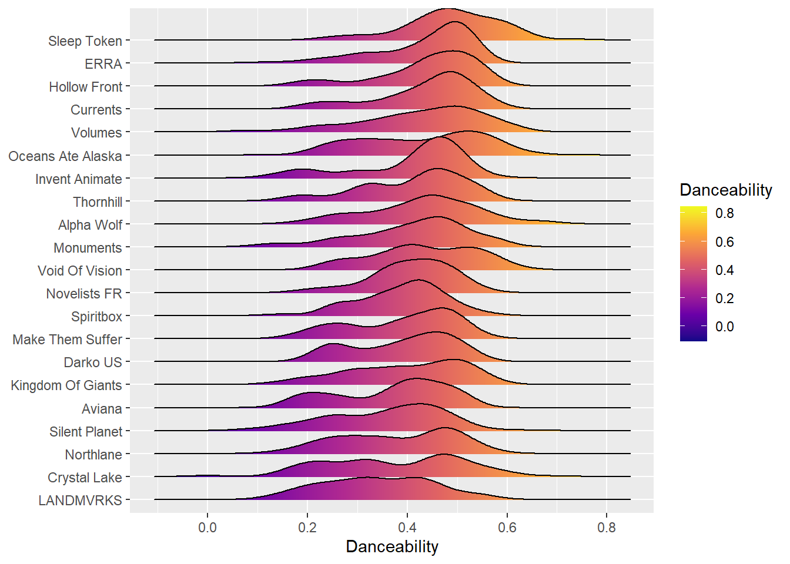
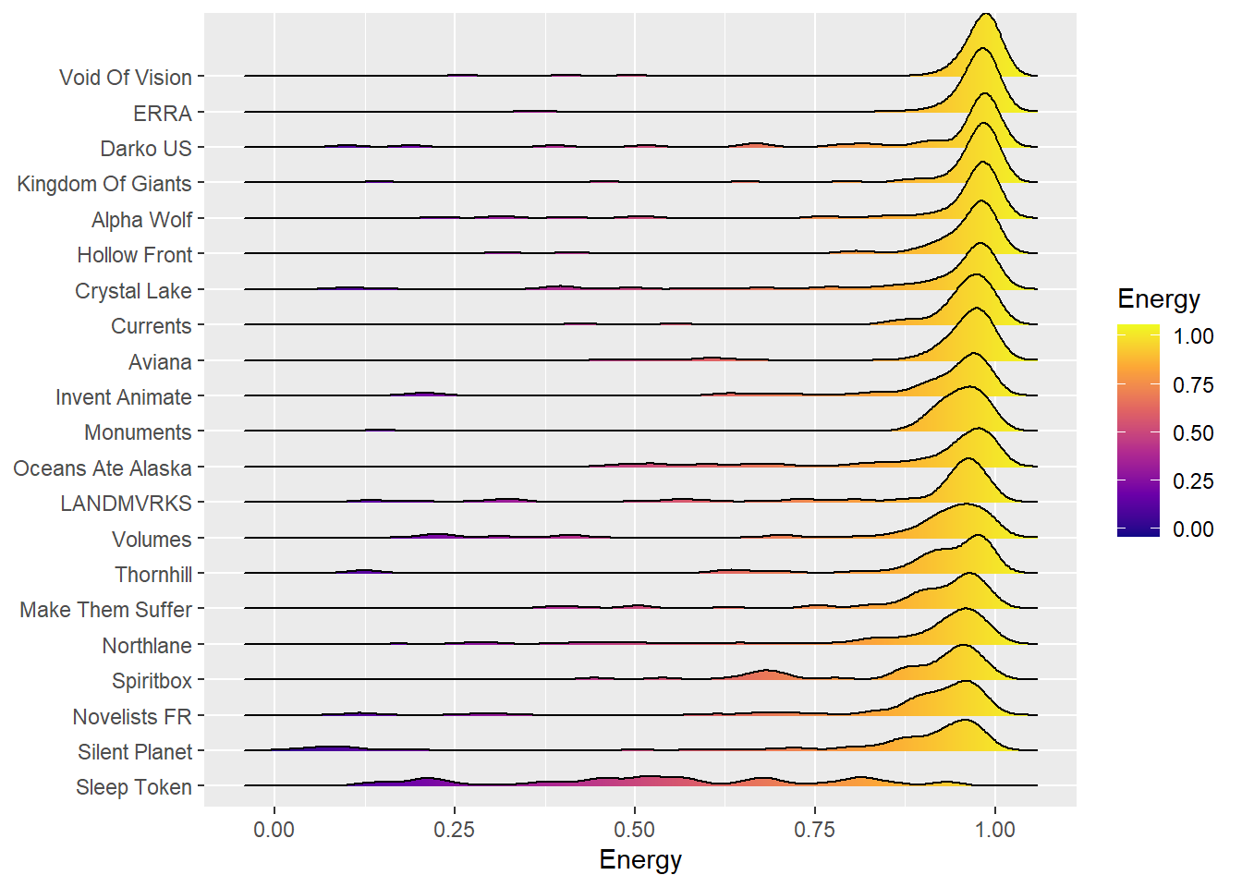

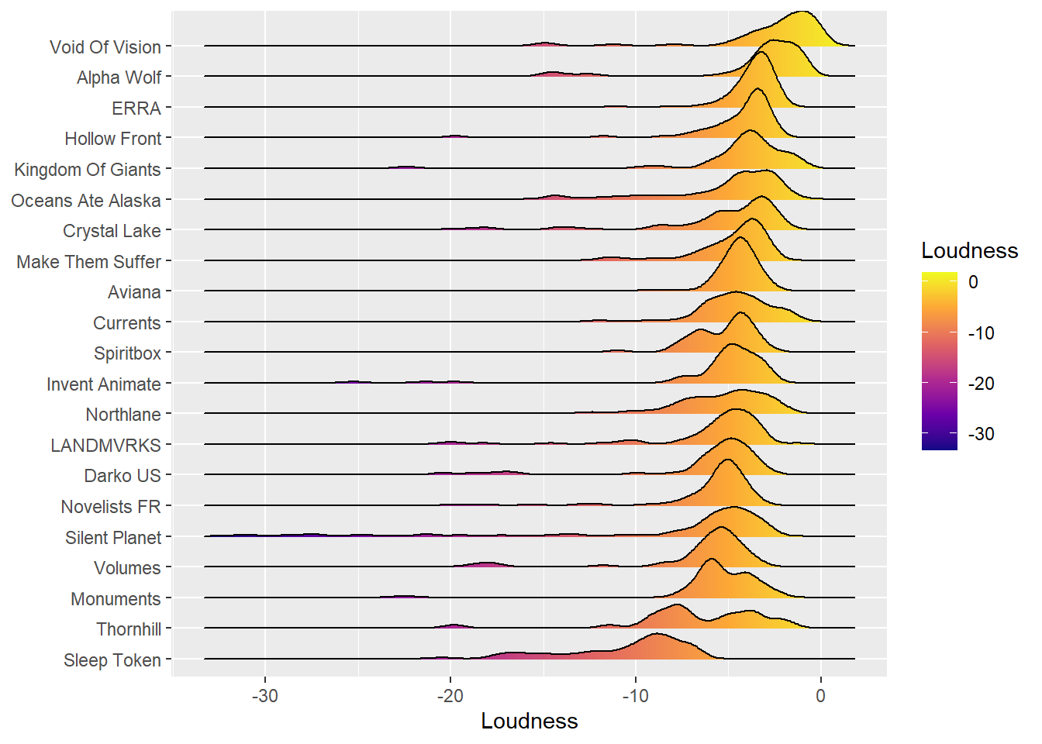
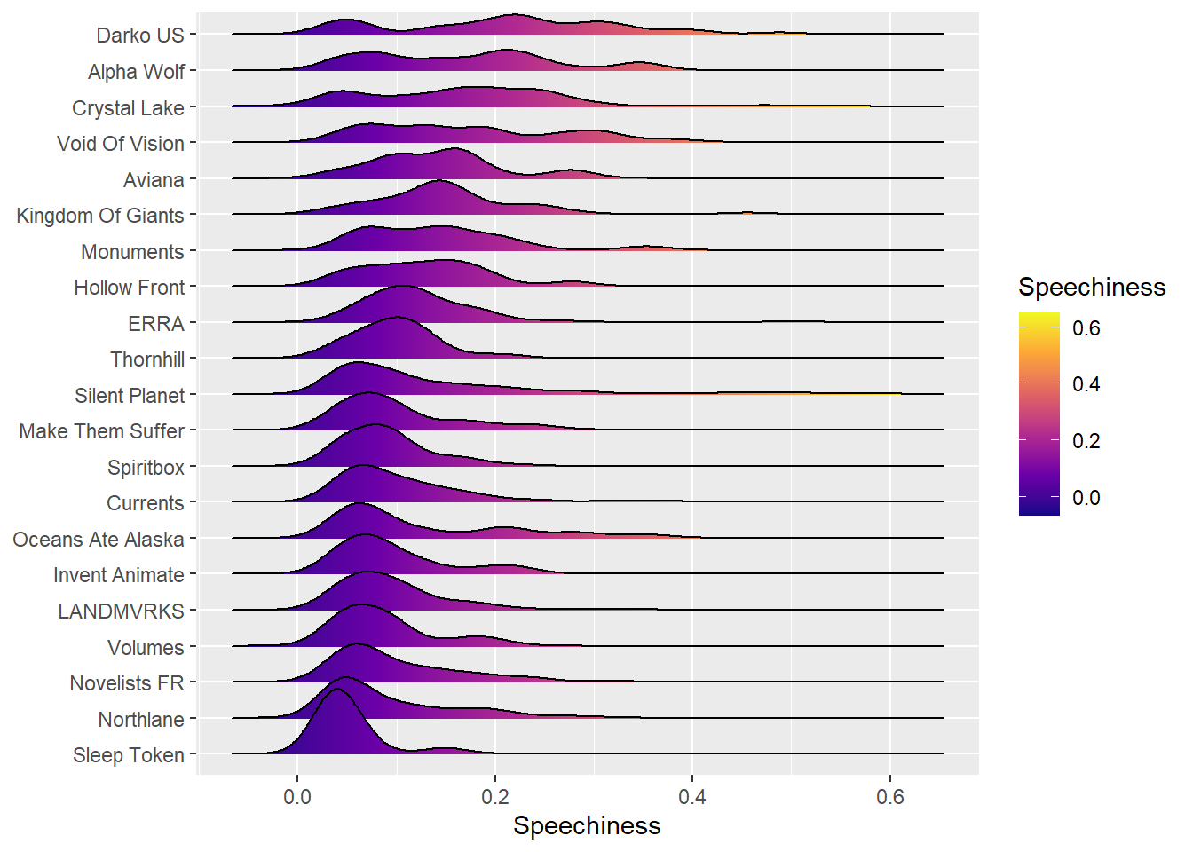

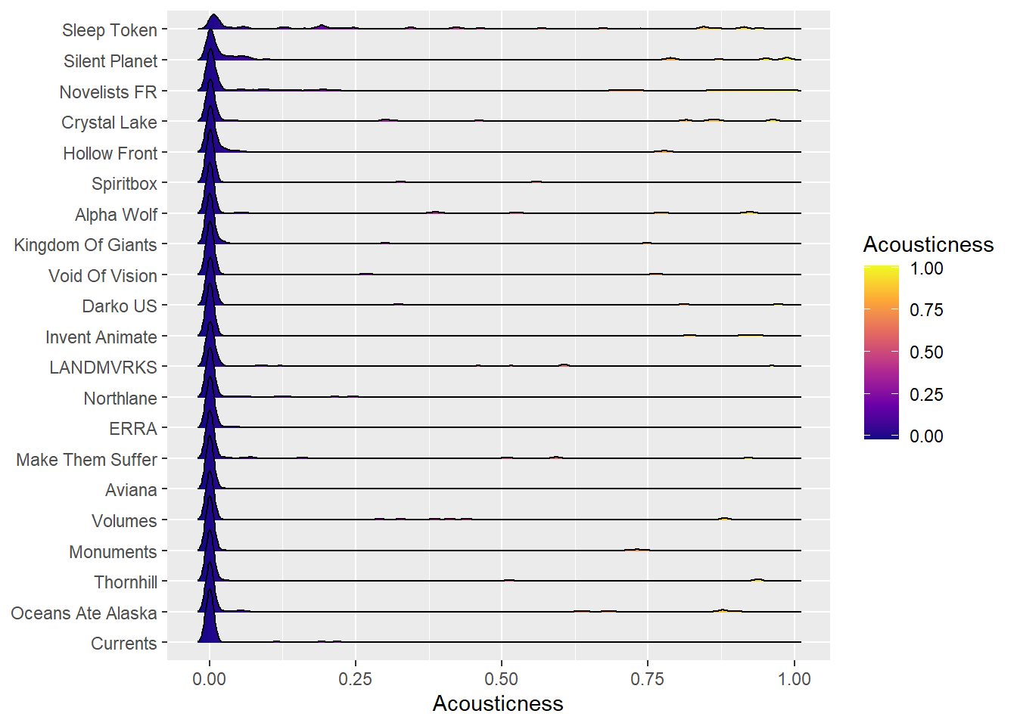
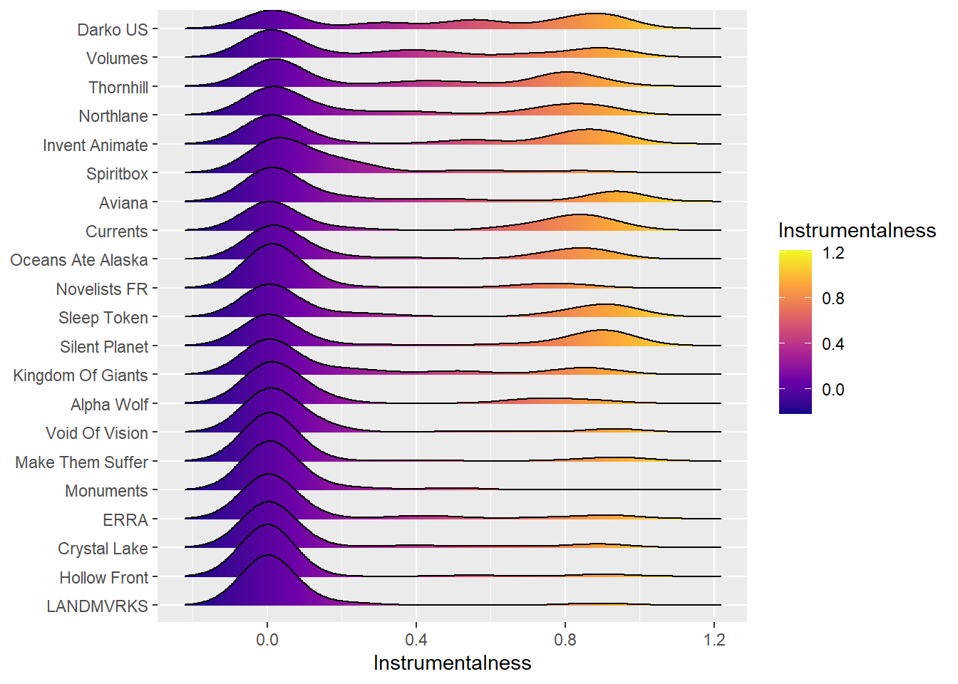

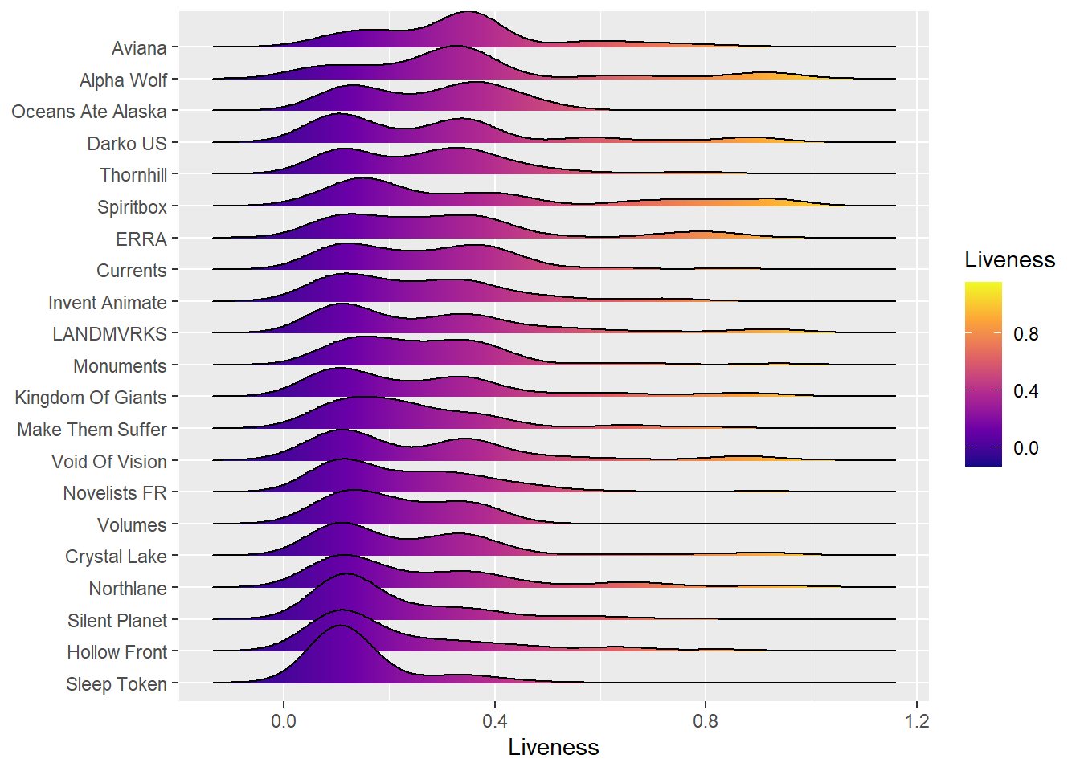

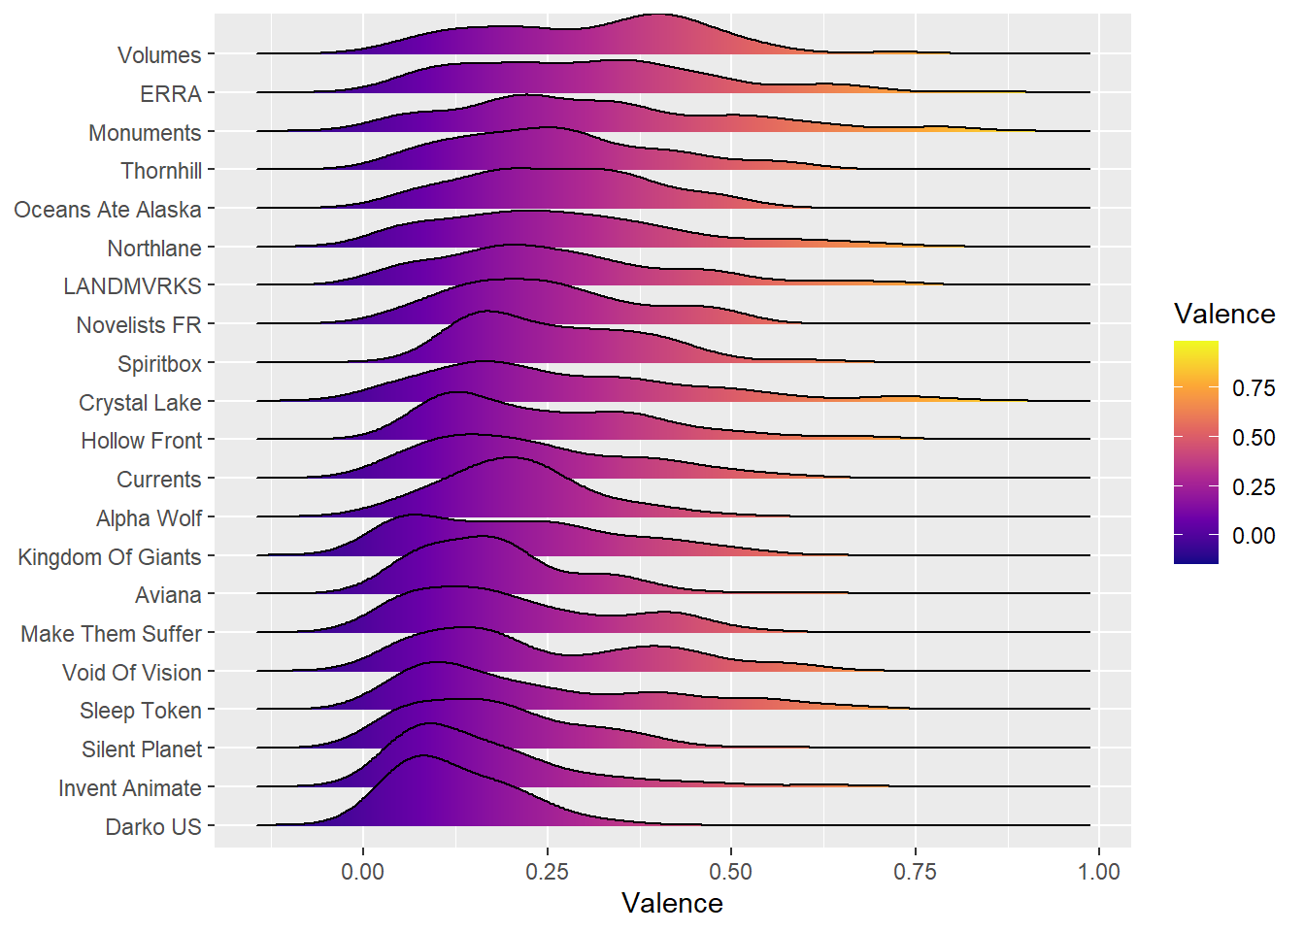
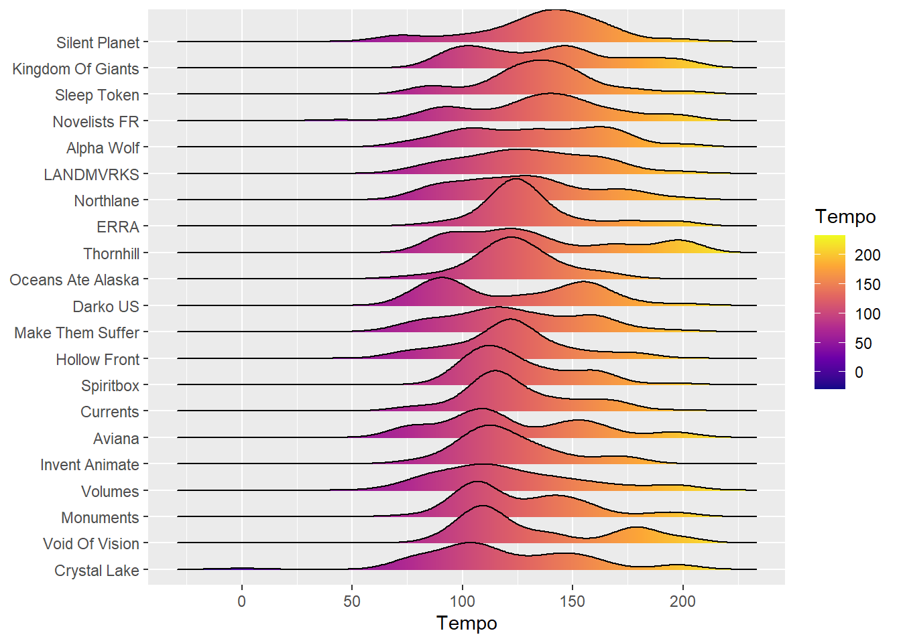
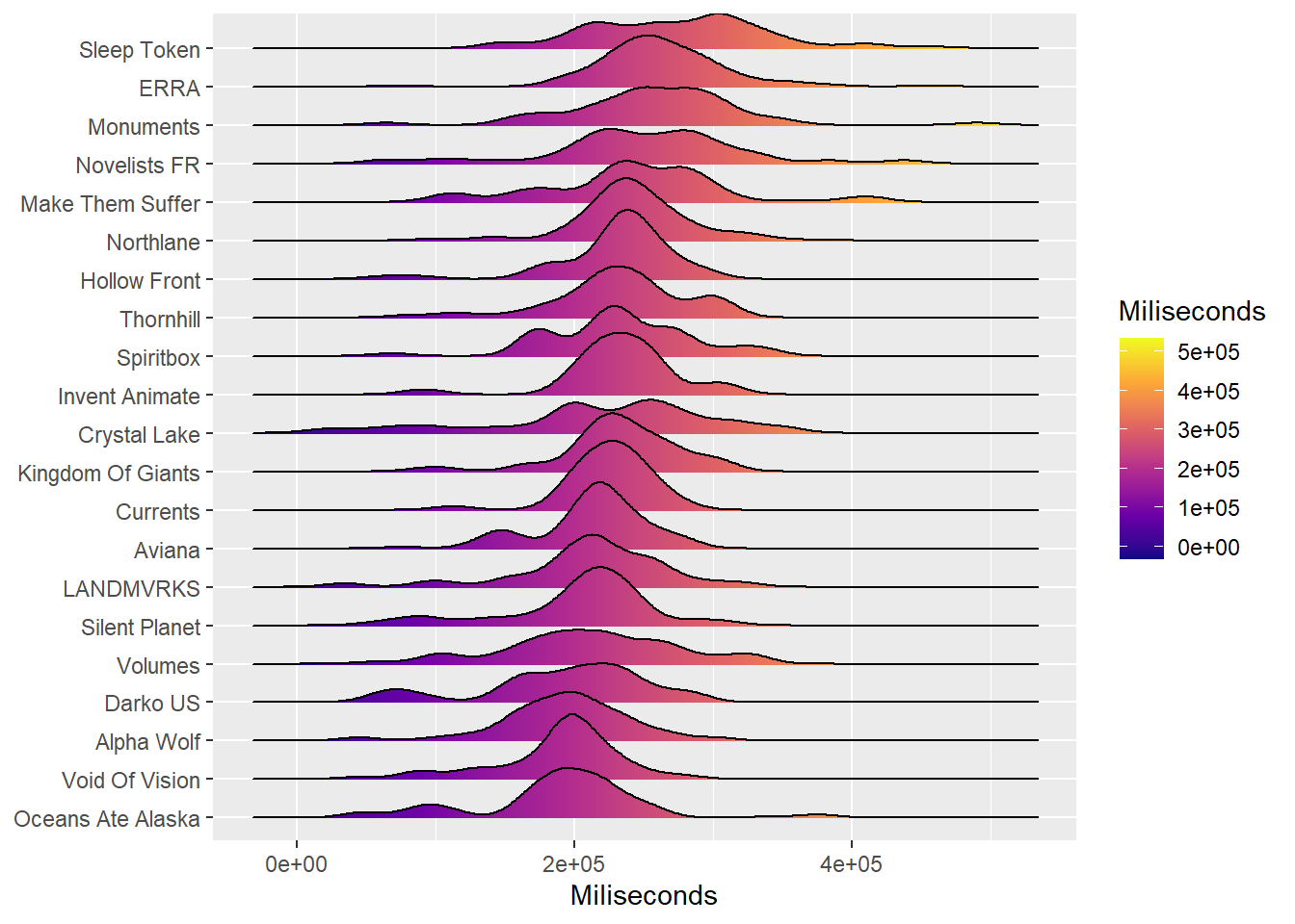
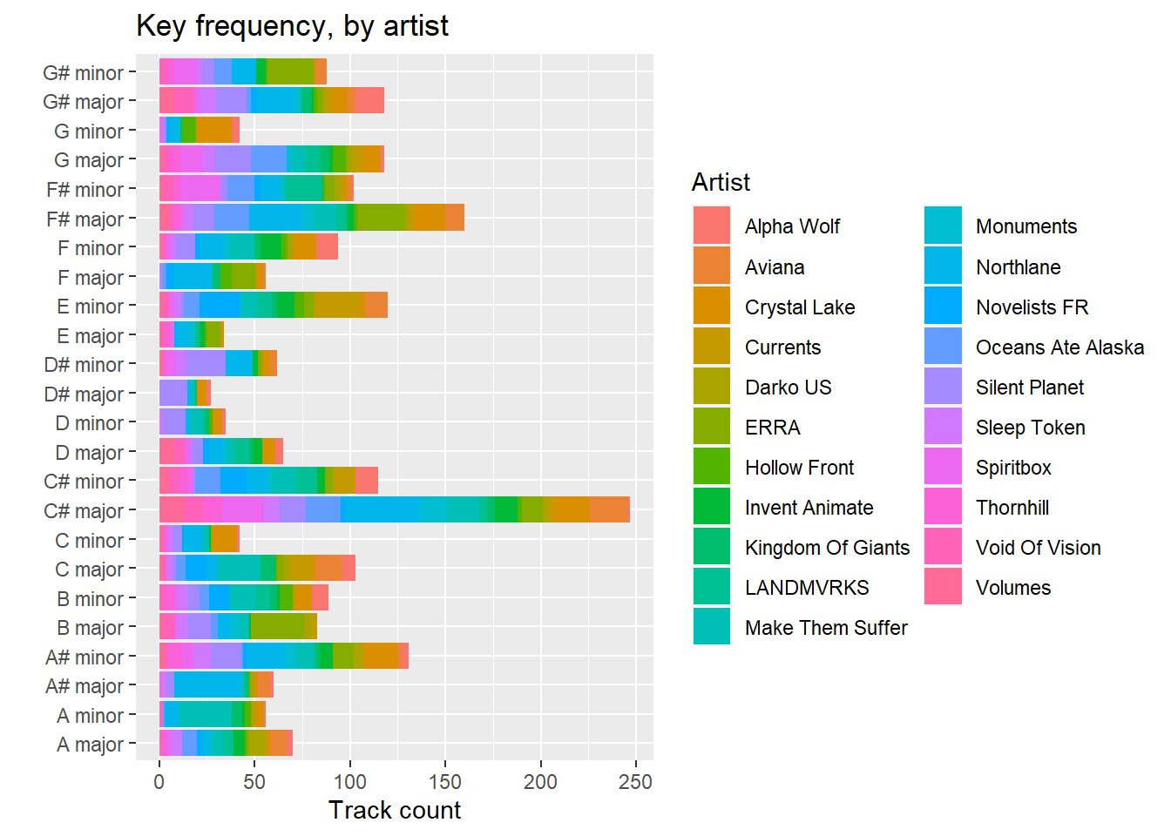

An Understanding of These Audio Features
Since these tables are based on common audio features, below is a list describing them:
Danceability: Creates an understanding of how easy it is to dance to a track, mostly tracked off regularity and the strength of beats in the track.
Valence: Covers the overall Positivity of a track. A song with a higher valence stat has a more upbeat and cheerful sound.
Energy: Covers the energetic feel of a song. Faster sounding songs or songs with lots of noise will have a high energy.
Tempo: Tempo keeps a track of a songs beats per minute; a higher BPM will create a higher score here.
Loudness: A track with loudness to it measured in decibels (Db) will chart high here. While a user can manage this on their end with volume controls, this is tracked off the scan of the initial upload to Spotify.
Speechiness: The presence of words in a song. This tracks the use of verbal input on a song and scores based on the actual verbal pieces of a track.
Instumentalness: This tracks the lack of words or vocals in a track. This plays interestingly with speechiness as it is not entirely inverse of one another.
Liveness: This is used to detect an audience in the track. Higher numbers mean the track likely indicates the track was recorded live.
Acousticness: Determines the acoustics of a song. Higher score is more likely to be made with acoustic instruments or without electronic assistance.
Duration: The length of a track (in Ms).
Key: Overall Key of the track. Using average pitch, it assigns a key to the song.
Deliverables
The deliverables for this project include:
- An annotated copy of the script, published in R Markdown format. R Markdown allows presentation of the script’s code, along with written explanations of the code’s operation and even output. For a basic example of a published R Markdown document, see: https://rpubs.com/drkblake/930235.
- A written document describing the script’s development, operation, output, validation, and potential uses.
- An archivable set of data files produced by an example run of the script.
Potential for further development
The further development of this project offers exciting potential as well. While the information was not currently available at this time, using anonymous location information from Spotify’s userbase, one could then optimize tour routes based on cities. This would be beneficial for many stakeholders in the music industry and modernize much of the older systems of the industry. The project’s concept is based on movements in the 1980’s music industry utilizing record sales data to plot concert touring. With record sales declining, and streaming becoming the new normal for consuming music, as well as the higher accuracy of data collection, this shift could leverage the industry and jumpstart live music in a post COVID environment. Closer work and ties would be needed with Spotify, however, as this data is difficult to access for the current average user. The individual artist can have access to this data, but the designing of a system that can access and utilize this data is hazardous to the artist, as if a system is implemented and not approved by Spotify, it can yield penalties against the artists account, up to suspension of services and freezing the account.

References
Business Wire, Inc. (2022). Spotify Technology S.A. to Announce Financial Results for Second Quarter 2022. Business Wire.
Danielsen, A., Kjus, Y., Natale, S., & Lesage, F. (2019). The mediated festival: Live music as trigger of streaming and social media engagement. Convergence: The Journal of Research into New Media Technologies, 714-734.
News Bites Pty Limited. (2022). Spotify Technology (SPOT: $135.17) drops 3.4% weakening below moving average price, hits 688-day low. News Bites - USA, NA.
Paddock Publications. (2015, april 25). Spotify, Pandora help slow decline in music record sales. Daily Herald (Arlington Heights, IL).
R Core Team (2022). R: A language and environment for statistical computing. R Foundation for
Statistical Computing, Vienna, Austria. URL https://www.R-project.org/.
Saucier, E. (2022). Spotify's Crazy-Smart Algorithm. UWIRE Text, 1.
Thompson C, Antal D, Parry J, Phipps D, Wolff T (2021). spotifyr: R Wrapper for the 'Spotify' Web API_.
R package version 2.2.3. URL https://CRAN.R-project.org/package=spotifyr.
Vandenberg, F. (2022). Put Your 'Hand Emotes in the Air:' Twitch Concerts as Unsuccessful Large-Scale Interaction Rituals. Symbolic Interaction, 425.

Appendix: R script
#Installing and activating required packages
if (!require("spotifyr")) install.packages("spotifyr")
library(spotifyr)

#Setting up credentials and getting authorization
#id <- 'PASTEYOURSPOTIFYIDHERE'
#secret <- 'PASTEYOURSPOTIFYSECRETHERE'
Sys.setenv(SPOTIFY_CLIENT_ID = id)
Sys.setenv(SPOTIFY_CLIENT_SECRET = secret)
access_token <- get_spotify_access_token()

AlphaArtist <- "Spiritbox"

#Getting the target artist's ID
#and track audio features
AAFeatures <- get_artist_audio_features(artist = AlphaArtist,
include_groups = c("album","single"),
return_closest_artist = TRUE,
dedupe_albums = TRUE,
authorization = get_spotify_access_token())
Alpha_ArtistID <- AAFeatures$artist_id[1]

#Get info on similar artists
Similar_Artists <- get_related_artists(Alpha_ArtistID)
Similar_Artists$name
Similar_Artists_IDs <- as.list(Similar_Artists$id)

Compare_Features <- AAFeatures
print("Getting data for:")
for(ID in Similar_Artists_IDs)
{This_Extraction <- get_artist_audio_features(artist = ID,
include_groups = c("album","single"),
return_closest_artist = TRUE,
dedupe_albums = TRUE,
authorization = get_spotify_access_token())
Compare_Features <- rbind(Compare_Features,This_Extraction)
print(This_Extraction$artist_name[1])
Sys.sleep(2)}
print("All data extracted")

Audio_Features <- subset(Compare_Features,
select = -c(album_images,artists,available_markets))

write.csv(Audio_Features,"Audio_Features.csv", row.names = FALSE)

# Ridgeline plots. See: https://r-charts.com/distribution/ggridges/

if (!require("ggridges")) install.packages("ggridges")
library(ggridges)
if (!require("ggplot2")) install.packages("ggplot2")
library(ggplot2)
if (!require("tidyverse")) install.packages("tidyverse")
library(tidyverse)

#Ridgeline plots

ggplot(Audio_Features, aes(x = danceability,
y = fct_reorder(artist_name,danceability),
fill = stat(x))) +
labs(x="Danceability", y=NULL) +
geom_density_ridges_gradient() +
scale_fill_viridis_c(name = "Danceability", option = "C")

ggplot(Audio_Features, aes(x = energy,
y = fct_reorder(artist_name,energy),
fill = stat(x))) +
labs(x="Energy", y=NULL) +
geom_density_ridges_gradient() +
scale_fill_viridis_c(name = "Energy", option = "C")

ggplot(Audio_Features, aes(x = loudness,
y = fct_reorder(artist_name,loudness),
fill = stat(x))) +
labs(x="Loudness", y=NULL) +
geom_density_ridges_gradient() +
scale_fill_viridis_c(name = "Loudness", option = "C")

ggplot(Audio_Features, aes(x = speechiness,
y = fct_reorder(artist_name,speechiness),
fill = stat(x))) +
labs(x="Speechiness", y=NULL) +
geom_density_ridges_gradient() +
scale_fill_viridis_c(name = "Speechiness", option = "C")

ggplot(Audio_Features, aes(x = acousticness,
y = fct_reorder(artist_name,acousticness),
fill = stat(x))) +
labs(x="Acousticness", y=NULL) +
geom_density_ridges_gradient() +
scale_fill_viridis_c(name = "Acousticness", option = "C")

ggplot(Audio_Features, aes(x = instrumentalness,
y = fct_reorder(artist_name,instrumentalness),
fill = stat(x))) +
labs(x="Instrumentalness", y=NULL) +
geom_density_ridges_gradient() +
scale_fill_viridis_c(name = "Instrumentalness", option = "C")

ggplot(Audio_Features, aes(x = liveness,
y = fct_reorder(artist_name,liveness),
fill = stat(x))) +
labs(x="Liveness", y=NULL) +
geom_density_ridges_gradient() +
scale_fill_viridis_c(name = "Liveness", option = "C")

ggplot(Audio_Features, aes(x = valence,
y = fct_reorder(artist_name,valence),
fill = stat(x))) +
labs(x="Valence", y=NULL) +
geom_density_ridges_gradient() +
scale_fill_viridis_c(name = "Valence", option = "C")

ggplot(Audio_Features, aes(x = tempo,
y = fct_reorder(artist_name,tempo),
fill = stat(x))) +
labs(x="Tempo", y=NULL) +
geom_density_ridges_gradient() +
scale_fill_viridis_c(name = "Tempo", option = "C")

ggplot(Audio_Features, aes(x = duration_ms,
y = fct_reorder(artist_name,duration_ms),
fill = stat(x))) +
labs(x="Miliseconds", y=NULL) +
geom_density_ridges_gradient() +
scale_fill_viridis_c(name = "Miliseconds", option = "C")

#Looking only at top tracks
Top_Tracks <- get_artist_top_tracks(Alpha_ArtistID, market = "US")
Artist_count <- 0
print("Getting data for:")
for(ID in Similar_Artists_IDs)
{Artist_count <- Artist_count +1
print(Artist_count)
This_Extraction <- get_artist_top_tracks(ID, market = "US")
Top_Tracks <- rbind(Top_Tracks,This_Extraction)
Sys.sleep(1)}
print("All data extracted")
Top_Tracks$track_id <- Top_Tracks$id
Top_Tracks <- merge(Top_Tracks, Audio_Features, by = "track_id")

#Ridge line plots of only top tracks

ggplot(Top_Tracks, aes(x = danceability,
y = fct_reorder(artist_name,danceability),
fill = stat(x))) +
labs(x="Danceability - Top Tracks Only", y=NULL) +
geom_density_ridges_gradient() +
scale_fill_viridis_c(name = "Danceability", option = "C")

ggplot(Top_Tracks, aes(x = energy,
y = fct_reorder(artist_name,energy),
fill = stat(x))) +
labs(x="Energy - Top Tracks Only", y=NULL) +
geom_density_ridges_gradient() +
scale_fill_viridis_c(name = "Energy", option = "C")

ggplot(Top_Tracks, aes(x = loudness,
y = fct_reorder(artist_name,loudness),
fill = stat(x))) +
labs(x="Loudness - Top Tracks Only", y=NULL) +
geom_density_ridges_gradient() +
scale_fill_viridis_c(name = "Loudness", option = "C")

ggplot(Top_Tracks, aes(x = speechiness,
y = fct_reorder(artist_name,speechiness),
fill = stat(x))) +
labs(x="Speechiness - Top Tracks Only", y=NULL) +
geom_density_ridges_gradient() +
scale_fill_viridis_c(name = "Speechiness", option = "C")

ggplot(Top_Tracks, aes(x = acousticness,
y = fct_reorder(artist_name,acousticness),
fill = stat(x))) +
labs(x="Acousticness - Top Tracks Only", y=NULL) +
geom_density_ridges_gradient() +
scale_fill_viridis_c(name = "Acousticness", option = "C")

ggplot(Top_Tracks, aes(x = instrumentalness,
y = fct_reorder(artist_name,instrumentalness),
fill = stat(x))) +
labs(x="Instrumentalness - Top Tracks Only", y=NULL) +
geom_density_ridges_gradient() +
scale_fill_viridis_c(name = "Instrumentalness", option = "C")

ggplot(Top_Tracks, aes(x = liveness,
y = fct_reorder(artist_name,liveness),
fill = stat(x))) +
labs(x="Liveness - Top Tracks Only", y=NULL) +
geom_density_ridges_gradient() +
scale_fill_viridis_c(name = "Liveness", option = "C")

ggplot(Top_Tracks, aes(x = valence,
y = fct_reorder(artist_name,valence),
fill = stat(x))) +
labs(x="Valence - Top Tracks Only", y=NULL) +
geom_density_ridges_gradient() +
scale_fill_viridis_c(name = "Valence", option = "C")

ggplot(Top_Tracks, aes(x = tempo,
y = fct_reorder(artist_name,tempo),
fill = stat(x))) +
labs(x="Tempo - Top Tracks Only", y=NULL) +
geom_density_ridges_gradient() +
scale_fill_viridis_c(name = "Tempo", option = "C")

ggplot(Top_Tracks, aes(x = duration_ms.x,
y = fct_reorder(artist_name,duration_ms.x),
fill = stat(x))) +
labs(x="Miliseconds - Top Tracks Only", y=NULL) +
geom_density_ridges_gradient() +
scale_fill_viridis_c(name = "Miliseconds", option = "C")

#All related artist tracks, by key

library(dplyr)
keys <- Audio_Features %>% count(artist_name, key_mode)
keys$Artist <- keys$artist_name

ggplot(keys, aes(fill=Artist, y=n, x=key_mode)) +
geom_bar(position="stack", stat="identity") +
coord_flip() +
ggtitle("Key frequency, by artist") +
ylab("Track count") +
xlab("")

#Related artist top tracks, by key

library(dplyr)
keys <- Top_Tracks %>% count(artist_name, key_mode)
keys$Artist <- keys$artist_name

ggplot(keys, aes(fill=key_mode, y=n, x=Artist)) +
geom_bar(position="stack", stat="identity") +
coord_flip() +
ggtitle("Key frequency, by artist") +
ylab("Track count") +
xlab("")

#Finding album features

“Album_Name” = get_track_audio_features('track id’s separated by commas')

“Album_Name” <- cbind(“Album_Name”, "Track"=1:nrow(“Album_Name”))

#installing plotly
if (!require("plotly")) install.packages("plotly")

library(plotly)

#Charting our album

plot_ly(Eternal_Blue, x = ~Track, y = ~danceability,

name = 'danceability',

type = 'scatter',

mode = 'lines+markers')

plot_ly(Eternal_Blue, x = ~Track, y = ~energy,

name = 'energy',

type = 'scatter',

mode = 'lines+markers')

plot_ly(Eternal_Blue, x = ~Track, y = ~loudness,

name = 'loudness',

type = 'scatter',

mode = 'lines+markers')

plot_ly(Eternal_Blue, x = ~Track, y = ~speechiness,

name = 'speechiness',

type = 'scatter',

mode = 'lines+markers')

plot_ly(Eternal_Blue, x = ~Track, y = ~acousticness,

name = 'acousticness',

type = 'scatter',

mode = 'lines+markers')

plot_ly(Eternal_Blue, x = ~Track, y = ~instrumentalness,

name = 'instrumentalness',

type = 'scatter',

mode = 'lines+markers')

plot_ly(Eternal_Blue, x = ~Track, y = ~liveness,

name = 'liveness',

type = 'scatter',

mode = 'lines+markers')

plot_ly(Eternal_Blue, x = ~Track, y = ~valence,

name = 'valence',

type = 'scatter',

mode = 'lines+markers')

plot_ly(Eternal_Blue, x = ~Track, y = ~tempo,

name = 'tempo',

type = 'scatter',

mode = 'lines+markers')

plot_ly(Eternal_Blue, x = ~Track, y = ~duration_ms,

name = 'duration_ms',

type = 'scatter',

mode = 'lines+markers')

