Performance Evaluation Inflation:
Factors Affecting the Exaggeration of Performance Ratings in the Air Force

by

Brandon Baker

A thesis presented to the Honors College of Middle Tennessee State University in partial
fulfillment of the requirements for graduation from the University Honors College

Spring 2017

Performance Evaluation Inflation:
Factors Affecting the Exaggeration of Performance Ratings in the Air Force

Brandon Baker

APPROVED:

__________________________
Dr. Joshua Harms
Criminal Justice Administration

__________________________
Dr. Lance Selva
Criminal Justice Administration

__________________________
Dr. Glenn Littlepage
Psychology

__________________________
Dr. Philip Phillips
University Honors College Associate Dean

ABSTRACT

The artificial inflation of performance on periodic evaluations is a well-documented phenomenon in private companies. However, while widespread inflation has been suspected in the Air Force, little research exists to confirm this. It is hypothesized here that the practice of awarding artificially high ratings on military performance evaluations is similarly high and not significantly different in nature from private sector evaluations. The survey conducted suggests that this is the case, and that officers tend to inflate in order to help a good troop, keep from appearing harsh, and retain personnel who otherwise would be cut. These results have important implications for the Air Force, as they reveal the shortcomings of performance reports, and highlight areas and strategies for improvement.

ACKNOWLEDGEMENTS

I would first like to thank my thesis advisor, Dr. Joshua Harms, of the Criminal Justice Department of Middle Tennessee State University. Dr. Harms was an invaluable resource about academic writing, helping me overcome my unfamiliarity of how research was conducted and written. He was always patient when some detail of the process confused me and was able to help me understand. He also put in a great deal of work helping me edit and revise this thesis, even on the weekends.
I would also like to thank Dr. Glenn Littlepage of the Psychology Department of Middle Tennessee State University. As the second reader for my thesis, Dr. Littlepage gave me good feedback to help improve my thesis. Also, before starting research, I had spoken to him about my idea, and received direction as well as good resources for reading on the psychological topics addressed in the paper.
I would like to thank all the people who helped expand my knowledge about the Air Force during this process and even beyond it. Captain Garrett Smith, Major Michael Gordon, Colonel Sharon Presley, and Dr. Tony Johnson, and all gave me insights into what it means to be an Air Force officer, as well as evaluating Airmen.
I would also like to thank the officers who took my survey. Their knowledge was immeasurably helpful and this thesis would not be what it is without their help.
Finally, I want to thank my family, for their support of me during this process. They functioned as my sounding board and were understanding when I needed to focus on my thesis and was less available.

Table of Contents
ABSTRACT iii
ACKNOWLEDGEMENTS iv
LIST OF TABLES vi
INTRODUCTION 1
LITERATURE REVIEW 4
Performance Evaluations in the Private Sector 4
Leniency 6
Impact of Evaluation 6
Memory Issues 8
Grade Inflation 9
Military Evaluations 13
Enlisted Performance Reports 13
Officer Performance Reports 16
Conclusion 18
METHODOLOGY 19
Sample 19
Variables 20
RESULTS 21
Descriptive Statistics 21
Importance of the EPR/OPR to the Air Force 22
Research Question One 22
Research Question Two 23
CONCLUSION 26
Improvements 26
360 Feedback 27
Weaknesses 28
Future Research 29
REFERENCES 31
APPENDICES 33
Appendix A 33
Appendix B 35
Appendix C 41
Appendix D 42
Appendix E 43
Appendix F 44

LIST OF TABLES

Table 1: Descriptive statistics ...........................................................................................21
Table 2: Importance of EPRs/OPRs .................................................................................22
Table 3: Questions addressing the prevalence of inflation ...............................................24

INTRODUCTION

Military members are tasked with defending the nation from all enemies, foreign or domestic. Because of this, as General Joseph Collins stated, “American people rightly look to their military leaders to be not only skilled in the technical aspects of the profession of arms, but men of integrity as well” (Integrity, n.p.). Both qualities are critical to the continued trust of the American people. To keep these high standards enforced, Officer Performance Reports and Enlisted Performance Evaluations (OPRs and EPRs) are used to determine if an Air Force member is meeting the aforementioned high standards. All personnel are subject to periodic evaluations. To clarify, enlisted personnel are those who have gone through Basic Military Training (BMT) and are classified as Airmen or Sergeants. Officers are those who have been commissioned, or appointed by the authority of the President, and are placed in command of enlisted personnel.
Since the inception of the military, it has been suspected that “inflation” has plagued this system of evaluations. Inflation refers to giving undeservedly high evaluation ratings for any reason. In the past, as many as 90% of airmen (the second rank of enlisted personnel, attained after graduating BMT) received an astounding five out of five on their EPR (Lousey, 2015). For those familiar with the Air Force, this makes little sense. Surely there are outstanding, mature Airmen out there, and the bar for performance is lower than what is required of Master Sergeants or officers, but Airmen have a reputation, like any new worker, of being less than stellar performers. To have 90% perform so exceptionally would be a dream for the Air Force, if it were true, but common sense and experience say that most Airmen are not performing at a five-out-of-five level, even if it says as much on paper.
So the question arises, why would a reviewer rate an Airman as excellent when it was not deserved? There are numerous reasons why a reviewer might rate an Air Force member more highly than his or her performance deserves, some more noble than others. Possible reasons for this will be explored in this project. However, regardless of the reasons behind it, this is a practice vehemently condemned by the Air Force. Air Force Instructions (AFIs) are the guidelines for most aspects of an Air Force member’s life and career. According to AFI 36-2406,
“Evaluation ratings are used to determine selections for promotions, job and school recommendations, career job reservations, reenlistments, retraining, and assignments. Therefore, evaluators at all levels must use caution to prevent inflation; it is important to distinguish performance among peers and is a disservice to ALL Airmen when OPR/EPR ratings are inflated” (AFI 36-2406, 2016, p. 77).

In other words, the Air Force needs to know exactly how good a person is at his or her job, so that it can determine how to proceed with that individual, whether that means discharging them, moving them laterally, or promoting them. Without accurate information, the Air Force runs the risk of making a misinformed decision. Therefore, it is vital that the Air Force understand the roots of inflation so that it can better combat it.
Essentially, the Air Force has a problem, because it cannot necessarily trust its own evaluations of who is the best and who is the worst. In a time where the Air Force has been severely downsizing (although the 2017 budget added personnel), knowing who is on top is crucial to success of the mission. For this reason, this thesis is focused on the problem of performance evaluation inflation in the Air Force. Specifically, it seeks to answer the following two research questions:
Research Question #1: How prevalent is inflation in the Air Force’s personnel evaluation process?
Research Question #2: What reasons might individuals give for inflating evaluation scores?
To that end, the following chapter will discuss the research that was done on this topic, along with the results. The literature review will discuss performance evaluation inflation in the private sector, the psychology of inflation, inflation of EPRs and OPRs, the Air Force’s response to inflation, and measures the private sector has implemented. Later some ideas the Air Force can use to further guard against inflation will be discussed.

LITERATURE REVIEW

Significant research exists in the area of performance evaluations. Evaluations in various forms occur all the time in various places and disciplines. For example, private sector companies evaluate personnel regularly, and educational institutions hand out grades to students, which is a measure of academic performance. These areas make up the majority of the research for performance evaluations. In order to understand evaluations and the way they are used, a number of aspects of both private sector business and grade evaluations will be discussed.

Performance Evaluations in the Private Sector
In any organization, it is not unusual to have superiors evaluate subordinates regarding their performance. These evaluations serve a number of functions, from marking outstanding personnel for promotions or raises to creating a paper trail to justify a firing. Following this line of thinking, an inaccurate evaluation can have enormous impact on the success of the company. However, this cannot be helped, as the head decision makers in an organization likely do not know every employee personally. Instead, they must rely on those who do, namely the employee’s direct supervisor. It makes sense that a person’s boss would know a good deal about their subordinates and is therefore qualified to evaluate them. As a result, the supervisor’s word is taken as gospel, which means whatever he or she says about an employee will typically go unchallenged. If the information used to determine promotions, downsizes, or job adjustments is faulty, the decisions may also be faulty. This is not the fault of the ones making the decisions since they, not unreasonably, believed the information they received was correct.
Before continuing further, it is necessary to understand how performance evaluations are conducted and the kinds of things they measure. Because common sense says at least some evaluations will be inaccurate, both intentionally and unintentionally, there is a sizable body of research in the private sector dealing with performance evaluations. For example, according to a study by Golman and Bhatia, “it has been suggested that managers willfully alter ratings in order to help workers, improve training or avoid conflict” (2012, p. 535). They also advocate that “more than half the population will be rated as above the actual average competence” (2012, p. 535). If this finding is true, then it should cast at least some doubt on the merits of performance evaluations, and this is not a new finding. In a study done in 1992, researchers found that it is “common for 60 to 70 percent of an organization's workforce to be rated in the top two performance levels” (Bretz et al, p. 20). Just like in the Air Force, while there surely are many employees who do an outstanding job, common sense and personal experience tell one that such a number is unrealistic. While some companies may be blessed with an overabundance of such outstanding people, this should be the exception, not the rule. Of course, since these evaluations are one of the only tools to measure employee performance, it is hard to say with certainty that they are wrong empirically. However, by studying psychological trends and comparing them to trends in evaluations, a case can be made that there is a high probability of inaccuracy.
There are many psychological factors that can influence how a supervisor rates a subordinate, and to review all of them would be beyond the scope of this thesis. However, several of the most prominent factors will be discussed. The focus will be on those who inflate ratings without knowing it or without intent for personal gain, such as receiving gifts or favors to give an employee a favorable rating.

Leniency
One major factor that can affect supervisors even unconsciously is the leniency bias, which, as the name suggests, is the tendency to be favorably biased when evaluating personnel. “The contamination of evaluation of employees by biasing effects such as the leniency bias has been widely acknowledged” (Drory and Ben-Porat, p. 1). Also, it may not necessarily stem from an overly kind or concerned supervisor. Instead, one study found if a supervisor is goal-oriented and spends a good deal of time trying to get employees to reach those goals, he has significant risk to inflate ratings since their performance reflects on himself as a boss (Drory and Ben-Porat, 1980). This may be unconscious, but this does not change the fact that the ratings are unfairly high. Air Force officers are expected to practice integrity above all. Regardless of the impact on an officer’s career, it is expected for them to tell the truth about their subordinates. Whether that means disciplining them for violating rules or documenting when one fails to meet expectations, nowhere should an officer’s image be a concern. That said, Air Force personnel are only human, so it is natural to worry about how his subordinate reflect his competency as a leader.

Impact of Evaluation
One issue that is similar to leniency bias is the worry that giving an accurate evaluation will have an undue negative effect on the person’s career. If a company is downsizing, or has a reputation for high turnover, a low score may end someone’s career with the company, even if that person is a relatively good performer. Up until 2017, this was true of the Air Force. The Air Force was as small as it had been since WWII, and it had little use for those who were evaluated as “average” or even “above average” simply because it did not have the money to retain extra people and it wanted to make the most of its resources. This seems reasonable, if a bit unfortunate for those cut, but for an officer who is evaluating his people, it can seem anything but reasonable. Giving average people an average rating is not as simple as it sounds, since it often indirectly meant kicking them out of the Air Force. Ending a decent employee’s career can be a struggle for a number of reasons. Leaders are only human, and most humans seek the approval of others, especially those closest to them. In many cases, supervisors have a fairly solid relationship with their subordinates and therefore care how they are perceived. Hiding behind “I call it like I see it” will not save an officer from the bad feelings caused by a less-than-favorable but accurate rating. It is always good for employees to like their boss, but the number one priority is doing what is best for the Air Force. That sometimes means making the tough decision and angering those below.
On the other hand, inflation may also be for purely pragmatic reasons. For example, if an officer has six subordinates, and six is not enough to staff the unit fully, it may be to the officer’s advantage to exaggerate the performance of mediocre persons, since the alternative likely means losing that mediocre person in the next round of cuts. This will only make the unit’s job harder, so the officer does what he needs to do to take care of the unit. It may be a breach of integrity, but convincing oneself that one is doing something out of necessity makes it easy. This is actually very plausible, since the Air Force often understaffs units due to its small size, although the issue should get better in the next few years as more people are enlisted and commissioned.

Memory Issues
For most supervisors, including those in the Air Force, performance evaluations are just one of the many tasks they must perform and they may spend “only a few hours per year assessing the performance of each employee” (Bretz et al, p. 21). Because of the number of responsibilities a supervisor must juggle, it may be hard to remember how a particular employee performed in the past year or months. Unless performance is exceedingly good or exceedingly poor, a supervisor may not remember many specific details. In this case, the supervisor’s memory could bring into question threats to reliability. Psychologists have found that memory, after a short period, is either stored in long-term memory or lost, so if one remembers data after a month, it will likely stay there for years. In other words, the difference in memory recall between a week and six months is less pronounced than one might think, but even so, it is still difficult to recall specifics months later.
Even if an officer does recall a good deal about the subordinate’s performance, he may have doubts about the subordinate’s level of fault. Since the events occurs some time before, worries that the expectations were unclear, there were extenuating circumstances, and other doubts can make a low rating hard to give. One of the responsibilities of an officer is to make the expectations known to the subordinate. If someone is unaware of what his or her job is, it would be easy to make a mistake. Essentially, if the officer cannot remember if he played a role in the failure to perform, a poor score may not seem justified.

Grade Inflation
Whether they realize it or not, all of America’s youth have been exposed to performance evaluations very early on in their life through grades. Grades are a measurement of performance in an individual subject during the period of a semester or year. The evaluators are the teachers and professors. Unfortunately, there are some problems with this system, and whether we want to admit it or not, there is a degree of variance in both the grading system of individual instructors, as well as the grades they give to specific individuals, although usually to a lesser extent. “Performance (such as a course grade) is a joint function of an individual’s ability (such as intelligence) and the situation (such as the instructor’s grading leniency)” (Moore et al, 2009, p. 843). In other words, the grade a student receives depends on both his own performance, which is in his control, as well as the reaction of the teacher to that performance, over which the student has less control. As such, there is always room for subjective feelings to come in and either raise or lower the grade. This is illustrated in the following example.
Suppose a generally high performing student deserved a B in a course by earning an 89. However, the professor gave the student an A, which starts at 90. In this case, the grade in the class is higher than what was earned. Now, the student had perfect attendance, participated in class, and always did put forth effort on the assignments, but had fallen short in a few areas. It is possible that because the student exceeded the expectations in some areas, the professor felt comfortable giving the extra point. However, as far as the official rubric in the syllabus was concerned, the student did not deserve the A. The professor had inflated the grade, plain and simple. Interestingly, some professors admit to doing this outright. They say on day one of class that they reserve the right to adjust grades however they see fit, depending on circumstances and the effort the person puts into the class. They make no secret of this fact. While this paper will not comment on the legality or morality of this, the impact of it must be discussed. In the above case, the inflated grade may not seem like a big deal, since it was a mere point and the student usually gets As. Since he always performed well academically, the A would not necessarily be out of character and not inconsistent with his usual skills. However, suppose that a student with a C average had an 83 in the same course, and the professor added seven points to give him an A, when he was barely making a B. That would have a much larger impact, and it would be hard to justify the significant addition of points. While the difference in an A and a B for the first student would only have been a few tenths of a point in his GPA, the C student getting an A instead of a B could make a big difference, especially in the first year or two of college. This GPA jump could make a difference when applying for scholarships, or when trying to get into graduate school. For example, for law school, the two biggest factors are the LSAT and GPA. If a student’s LSAT is fairly average, his or her GPA may be the driving factor for both admission and award offers. It is possible that an undeserved A, which slightly increased a student’s GPA, could increase the amount of money given in scholarships. This situation may seem a bit farfetched, but it is possible, and if there are other grades which are also inflated, that would have an even greater affect, further skewing the strength of an admission package. In the world or highly competitive programs, scholarships, and schools, very little can separate those who are accepted and those who are rejected, so every bit counts. Also, that inflated GPA could mean an unqualified student takes the place of a qualified one who legitimately earned his or her grades. All this is hypothetical, but it is not hard to see the implications. The legitimacy of grades to both employers and higher education institutions is something that is very important to maintain. However, it may be that this legitimacy is not as reliable as traditionally thought.
Research has shown that grade inflation is actually a very real problem that has been growing over the past few decades. Researchers have found “an average increase in collegiate GPA of .404 grade points between the years of 1965 and 1973 across a large sample of postsecondary institutions” (Kostal et al, 2016, p.11). Inflation slowed down in the mid 70s, but increased by .118 during the 80s, and by .13 grade points between 1995 and 2006 (Kostel et al, 2016). On the surface, such a significant increase in grades could be a very good thing. If the grades are fairly earned, it would mean students are continually doing better work and mastering material better. However, this is likely not the case, since “students appear to be devoting less time to study now than they have at any point since the1960s” (Kostel et al, 2016, p. 13). If grades are rising but effort is falling, students as a whole are getting smarter, classroom instruction is improving or the grades are unwarranted. The first explanation, while possible, is rather unlikely due to the increasing number or students attending both college and graduate school. As more students are admitted to colleges, it would be expected that the overall GPA would go down, just as average SAT scores go down as participation goes up. While the SAT is not a perfect predictor of college performance, the principle is sound. The more people are added to a college’s student body, the added people will bring down the overall intelligence of the group. As for improved instruction, this is an insufficient explanation on a large scale as “there is next to no evidence that improvements in instructional methodology have occurred on a wide scale in college classrooms” (Kostel et al, 2016, p. 13) although it may be true for some universities. It is logical to assume that some other factor is driving up grades, since it is more than likely not student effort, talent, or better teaching methods.
Since grades are given by individual instructors, they can be considered the chief evaluators of a student’s work. Therefore, if the average GPA is rising, it is because the teachers are giving higher grades, and as has already established, the higher grades are probably not deserved. There are several reasons why an instructor might give an inflated grade. There are many similarities to supervisors in the private sector, albeit with a different focus.
First, leniency is a common explanation for an instructor inflating grades. The hypothesis is that because student evaluations are sometimes used in determining promotions, tenure, and other things which affect a professor’s career, the professor has a personal reason to ensure evaluations are good. Research has shown that there is a positive correlation between grades and student evaluations (Griffin, 2004) and it makes sense that students who receive good grades (or grades higher than they expected) will likely have a more favorable view of the instructor compared to students who receive a less generous grade. Therefore it is possible to “pay” for good evaluations with good grades. Of course, it is possible that the professors who receive good ratings are actually good at their job and teach in a way that student can excel and earn the grades themselves. However, other studies suggest that lenient grading is positively correlated with high ratings from students.
Other reasons which are similar include feeling sorry for a student because of some tough circumstance he or she may be in or faced in the past. Also, professors might be more lenient when a student’s grade must meet minimum standards for other requirements (such as minimum standards for graduation, admission requirements for graduate programs, or professional standards). The professor might consider exterior standards when grading borderline students.

Military Evaluations
After having discussed the roots of inflation in general, we can discuss more specifically the Air Force’s evaluation system. It is necessary to understand how EPRs and OPRs are formatted and how they are used if we are to accurately determine the vulnerabilities to inflation. Because there is little formal research on inflation in this area, the principles seen in the private sector and in education will be applied, keeping in mind that the military operates differently than most organizations. However, military members are susceptible to the same pitfalls mentioned previously and there are more similarities than differences between the Air Force and private organizations.

Enlisted Performance Reports
Appendices C and D are the first and second page of an EPR form. This is the AF-911 for Master Sergeants and Senior Master Sergeants. The 910 and 912 are for Airmen through Technical Sergeant and Chief Master Sergeants, respectively. It consists of two questions that rate the personnel on a scale from one to five, along with a few open-ended comment sections. Essentially, an evaluator has four items in which to give an accurate representation of the enlisted member’s performance in the past twelve months. The focus is on leadership. Any significant projects, positions, or awards may be mentioned along with how well the member leads in those projects. The structure is pretty straightforward and simple. However, writing them is anything but straightforward, as there are certain ways of writing bullets that are better received than others. This can mean that two supervisors can write about subordinates who are exactly identical and even receive the same ratings, but one might have an edge depending on the writing proficiency of the evaluator. This would make sense, because if two personnel have identical ratings, the comments from the evaluator may be the determining factor. This throws even more doubt on the validity and reliability of an EPR. The performance of the one being evaluated plays second fiddle to the supervisor’s viewpoint and his ability to write as the boards prefer. To be fair, as per AFI 36-2406, statements which may be misleading are prohibited, such as “already working like a Senior Master Sergeant.” This statement can be taken as either saying the NCO is doing a job a Senior Master Sergeant would normally have or that the person is performing as a SMSGT would. Specifying the jobs the NCO has had is very much allowed, but as the Air Force wishes the evaluators to stick to measureable statements as much as possible, a subjective statement of the caliber of the individual is not allowed. The ones reading the EPR should be able to determine the quality of leader the NCO is by the other comments made. However, beyond completely subjective statements, there are clearly ways to write an EPR and ways which are not as effective.
As for how ERPs are used, it varies with the grade. Airmen through Tech Sergeant promotions are determined by the Weighted Airman Promotions System (WAPS). Under this, the last three EPRs are scored based upon the rating given, up to 250 points. This score is supplemented with few extra points from time in grade, decorations, and other factors, but the rating received on the EPR is the most significant factor. This point system makes it easy to see who are on top. If two personnel are tied, the comments come into play. For Senior NCOs, the WAPS system is used, but there are supplemental boards which also factor into the decision. These boards are formal reviews of the SNCO’s records and evaluations. Just how much these boards are weighted, is unclear, however, it is safe to say they are important parts of the promotion process. Because they rely less on the WAPS score, SNCO promotions are more likely to be affected by the subjective parts of EPRs and not just the ratings.
One interesting way the Air Force has tried to combat inflation in EPRs is the concept of “forced distribution.” As per AFI 36-2406, evaluators have “quotas” for scores:
Allocations are based on 5% of the total promotion eligible SrA, SSgt and TSgt population for Promote Now; 10% of the total promotion eligible SSgt and TSgt population for Must Promote allocations; and 15% of the total promotion eligible SrA population for Must Promote allocations. (AFI 36-2406, 4.19.6.1)

Under this system, “Only the top 5 percent, at most, of senior airmen, staff sergeants and technical sergeants who are up for promotion to the next rank will be deemed ‘promote now’ and get the full 250 EPR points” (Lousey, 2015). In this way, the Air Force has eliminated an outrageous number of Airmen getting perfect scores. Also, the number of “must promote” ratings, are also limited. There are tables in AFI 36-2406 which guide how many “must promote” ratings can be given, depending on the size of the unit. Interestingly, the number of personnel who are allowed to receive “promote now” ratings are often not enough to fill the available spots, thus pushing the “must promote” recipients into the slots.
Whether this new system is an improvement depends on your point of view. On one hand, it eliminates 90% of Airmen getting fives on EPRs and helps clarify who should be promoted. Even if every single person in the Air Force is perfect, it tells the Air Force nothing about who should be promoted. If everyone is a five, then being a five is not that outstanding anymore. Consequently, the Air Force needs to find a better way of evaluating and ranking individuals. This system helps in that regard. On the other hand, it can be argued that in some units that are outstanding, some personnel will be cheated out of a deserved four or five, whereas other units may give a four to undeserving members. This can foster undue competition among units. While it is good to compete with peers, having one person be promoted at the expense of the other is not a good way to build comradery. Of course, no plan is perfect, and the Air Force has only just implemented this in 2014, so it remains to be seen if anything changes for the better.

Officer Performance Reports
Appendices E and F are an AF 707. This form is used to evaluate all officers up to Colonel, but no General Officers. OPRs have essentially the same purpose as EPRs, to be a “snapshot” of the officer’s performance over the reviewing period. However, they are a little different. For example, they have no number scales like EPRs, only a “Does not/Does meet standards” choice, and this is only marginally useful. Clearly, if an officer does not meet standards, he or she is probably on the way out of the Air Force, and is certainly not promoting. Fortunately, this rarely occurs, since most officers are at least competent. Unfortunately, this means that the “Does/Does not meet standard” box is not very useful aside from documenting poor performance for further action. As a result, for those who are meeting standards, the strength of their evaluation comes entirely from the rating official’s comments, which are limited to six lines. Thus the OPR is even more susceptible to inflation than the EPR, since there is no clear scale on which to rate officers. At least with the EPR, regardless of the validity of the rating, it was clear who scored the best. However, for officers, the subjective observations of the rater are the only thing that matter. Of course, as with enlisted personnel, other factors are considered besides the OPR, such as education level, community involvement, and technical knowledge, but a huge part of the decision comes from the OPR.
One way that the Air Force has tried to make subjective observations objective is by having a specific way of writing OPRs. Raters are supposed to write bullet points on the accomplishments the officers, how impactful it was to the Air Force, and the magnitude of the impact. In this way, the rater can “show” how good of a leader or technical expert the officer is through what the person has done and how it was done, instead of “telling” how good of a leader he or she is. This is actually a good way of doing things and is quite effective at turning qualitative observations into something a little more concrete. The rater is compressing the officer’s performance into little soundbites, so that the review boards can quickly and easily understand the strengths of the officer. Conciseness and brevity are key since the rater must cram up to a year into six lines, and the longer each point is the fewer points can fit.
However, not all officers are stellar writers. All officers must be college educated, but that does not guarantee that they are strong in English. This is especially true for those in technical fields such as pilots or engineers whose majors did not require much writing. The Air Force does try to train its officers to write well, but it does not always succeed. Writing effective, concise bullets is a difficult skill to master, and some raters are better than others. Unfortunately, poorly written bullets, no matter how excellent the officer they represent, will virtually guarantee no promotion. Therefore, the skill of the writer is a major determining factor of the strength of an OPR.

Conclusion
While research about performance evaluations is nothing new, applying it to the military in general and the Air Force specifically is a new idea. Through comparison with the vast body of research on private evaluations and the way military evaluations are handled, it is possible to get a better understanding of how evaluators are likely to behave and how to better understand inflation on EPRs and OPRs. The current study will take this one step further by using surveys and interviews to assess and confirm the inflation of military personnel evaluations. Such an empirical examination does not currently exist in the literature.

METHODOLOGY

Although research exists on performance evaluations in the civilian sector, there is little when it comes to the Armed Forces. While the military operates similarly to a private company, there are some differences which may affect this issue, some of which will be discussed. A mixed-methods approach was used for the current study. One, an extensive review of past research that has focused on inflation, both in the military and from civilians, was presented in the last chapter. Two, a survey was administered to individuals known to have experience completing EPR’s and OPR’s, which asked questions such the average rating evaluators give to personnel, how they document changes in performance over time, and the quality of training the evaluators received. Three, an interview was conducted with Dr. Tony Johnson, who has much experience in both the Air National Guard and Air Reserve as both an enlisted member and an officer.

Sample
The sample of respondents was drawn from a number of active duty Air Force officers. Officers were selected who were known to have experience evaluating others and were at least competent at their jobs. In order to maximize the quality of respondents purposive sampling was used. Respondents ranged from 1st Lieutenants (O-2) to a Colonel (O-6) and had jobs ranging from Security Forces officers to Civil Engineers. A link to the survey was sent via email to roughly 40 officers. Of the 40, eight responded and six completed the online survey.

Variables
To go in further detail, all items were Likert scales, yes/no, multiple choice, or open-ended questions. The first two items establish consent and verify the respondent’s age. The next section of questions was used to gather information on how the rater completes military evaluations as well as how many personnel they rate. Respondents were asked to describe what factors went into the rating they give subordinates, including previous EPR’s/OPR’s completed by a previous evaluator, and the effects mitigating circumstances had on their evaluation. These will be discussed in further detail as descriptive statistics in the following chapter. Several items gathered information on the respondent’s personal habits regarding inflation and the reasons they inflated or compressed ratings. Others asked about the officer’s perceptions of inflation Air Force wide, as well as explanations of why evaluators might inflate or depress ratings. These will be used in the following chapter to address the two prior research questions. Participants were also asked exactly what Air Force evaluations are trying to accomplish. The survey concluded with three questions about the training they received on writing performance evaluations.
The responses provided a distinctly Air Force perspective on this issue, which is invaluable considering the limited research on this issue. All of this data and research was then combined to create this thesis. Primarily, the data was used to help answer two questions: 1) How prevalent is inflation in the Air Force’s evaluation process? 2) What reasons are used to explain why evaluators inflate ratings?

RESULTS

By analyzing the responses to the survey, much useful data was gathered. The following section has arranged relevant data and applied it to the previously discussed research questions. Some of it has been placed into tables to make it easily readable and accessible. This chapter also draws from the data conclusions which are then applied to the Air Force at large. These are later used to inform recommendations for policy change and improvement of the evaluation system.

Descriptive Statistics
The first set of data was used to paint a picture of the respondent’s experience evaluating and their evaluating style. The average rating the evaluators typically give was also included. This is expressed in Table 1. The typical respondent complete three EPRs and one OPR each year, and tended to give above average (4 out of 5) scores on EPRs and excellent scores (5 out of 5) on OPRs.

Table 1. Descriptive Statistics.
 | Mean | Median | Min | Max
EPR/year | 18.83 | 2.5 | 2 | 100
Prior EPRs used | 2.8 | 2.5 | 0 | 5
Average rating given on an EPR | 3.83 | 4 | 3 | 4
OPR/year | 1.6 | .5 | 0 | 6
Prior OPRs used | 3 | 3 | 0 | 5
Average rating given on an OPR | 4.75 | 4 | 4 | 5

Importance of the EPR/OPR to the Air Force
The data also showed what the evaluators thought of EPRs and OPRs. They were asked how important such evaluation methods were to the Air Force. The responses are shown in Table 2. As a whole, it was though that EPRs and OPRs were important, as their purpose is, in the words of one respondent, “To let the Airman know where they stand and provide details to future supervisors.” This is clearly a vital function. However, as the next section discusses, some evaluators undermine the system by not following the rules.

Table 2. Importance of EPRs/OPRs.
How important is the EPR/OPR | Responses (1-5 scale)
Not at all important | 0
Not very important | 0
Neutral | 1
Somewhat important | 0
Very important | 5
N | 6
Mean | 4.67

Research Question One
In response to Research Question One, the data gave some insight. The typical score given to enlisted personnel was 4 out of 5 while the same for officers was 5 out of 5. This is rather high, and it does line up with the concept of “firewall fives” discussed previously. Further, half of the responses admitted to personally inflating ratings, while the other half denied ever doing so. However, all denied ever compressing a rating. This proves that inflation does happen on some level, although it is not practiced by everyone. Also, since no one admitted to compressing ratings, it is reasonable to infer that there is a bias toward giving higher scores as opposed to lower scores. When asked about their perceptions of how common it was the results where a bit more uniformly affirmative, if a bit mixed. As Table 3 shows, a third thought all evaluators inflated, and another third thought half did it. The other third either thought most inflated or that inflation rarely happens. No one thought that it did not happen. Most believed it was systemic in nature and that it was hard not to inflate because of the culture. It should be pointed out that while every respondent believed at least a half of evaluators inflated, only half admitted to personally inflating ratings. This could be explained by the tendency in many individuals to deny personal guilt while blaming everyone else. Even one respondent first denied ever rating individuals higher than deserved, then admitted to “rarely” inflating ratings. This inconsistency may just be a mistake, or it may be an indication of a respondent being loath to admit unsanctioned behavior. Regardless, some respondents did admit to inflating, and all believed a good portion of evaluators do as well. This data, when compared with previous research, makes a strong case for the existence of widespread and systematic inflation.

Research Question Two
In regards to the second question, the tradition of inflation was one reason given for inflating ratings. In the words of one officer, “I gave ‘firewall 5s’ to good troops who, by the description of the EPR, were more likely in the ‘4’ category. This was because the system was inflated, and I did not want to penalize good troops for what everyone else was doing.” Another said that if leaders give accurate ratings, “they will be seen as overly

Table 3. Questions addressing the prevalence of inflation.
 | Number of Respondent
 | 1 | 2 | 3 | 4 | 5 | 6
Have you ever inflated ratings? | No | Yes | Yes | Yes | No | No
Have you ever suppressed ratings? | No | No | No | No | No | No
How frequently do you inflate or suppress ratings? | Rarely | Never | Rarely | Regularly | Never | Never
How often does inflation or suppression happen in the Air Force? | Rarely done | Half do this | All do this | All do this | Half do this | Most do this

harsh and ‘career killers’ if they are honest.” Also, things such as community involvement helped offset poor duty performance for some personnel, so they were rated
as doing a good job even when it was not the case. Other reasons included, “some supervisors don't want to hurt their subordinate's feelings” and “they often doubt themselves as a supervisor and wonder if they were clear about the expectations.” It was also mentioned that some officers want to make their subordinates look good, so they find “creative” ways to help them stand out, even when “creative” may mean less than upfront or honest. Overall, although there were a number of different reasons for inflating ratings, the majority fell into two major categories of motivations: 1) the evaluator is concerned about the negative effects an honest evaluation would have on the individual, or 2) the evaluator fears being viewed negatively if he or she gives honest yet low ratings.
Mitigating circumstances were also discussed that could justify inflation. For example, illness or trauma in the subordinate’s life could influence the rating or comments. On the other hand, inflation may also be for purely pragmatic reasons. This is one idea Dr. Tony Johnson spoke about. For example, if an officer has six subordinates, and six is not enough to fully staff the unit, it may be to the officer’s advantage to exaggerate the performance of mediocre persons, since the alternative likely means losing that mediocre person in the next round of cuts. This will only make the unit’s job harder, so the officer does what he needs to do to take care of the unit. It may be a breach of integrity, but convincing yourself you are doing something out of necessity makes it easy. This is actually very plausible, since the Air Force often understaffs units due to its small size, although the issue should get better in the next few years as more people are enlisted and commissioned. Of course, the Air Force may replace the person who was cut by moving someone from another base, but even if this does happen, it will take time. At least in the short term, there will be difficulties for the unit, regardless of whether or not the Air Force replaces the removed personnel.
There were a great number of reasons for why a rater would inflate evaluations, and many of them are not limited to the Air Force. Instead they are universal across organizations and institutions. While there were different reasons for it, there was general agreement that inflation was prevalent, if not widespread, in the Air Force.

CONCLUSION

The data gathered from the survey seems to indicate that inflation is fairly common in the Air Force, while there was disagreement on exactly how common it was. The reasons given for inflating ratings were also fairly uniform, but diverse, ranging from fear of being seen as harsh to trying to retain personnel.

Improvements
It is important to note that the forced distribution policy was viewed favorably by the survey respondents who felt that it had “fixed” the enlisted system. While the EPR system may have been modified with the forced distribution system, officer promotions have had no such improvements. The Air Force has a certain number of officers it can promote for each grade, and uses review boards to decide who moves up and who does not. While enlisted boards have a set number of points which is the cut off, and everyone over the line gets promoted, there is no similar function for officers. As a result, it is much less clear how strong a promotion package is, since it heavily depends on the interpretation of the reviewers as opposed to a fixed number. So by the time a promotion decision has been made, the officer’s performance has been through two rounds of subjective interpretation: the rater’s observation and evaluation and the board’s interpretation of said evaluation. This also casts doubt on the accuracy of an OPR, given how far removed it is from the actual performance. That being said, there is no denying that numbers alone cannot adequately capture the nuances of leadership specifically and overall performance in general. The OPR may or may not be as effective as a collection of numbers; however, there are very likely few ways it can be improved.

360 Feedback
There is a relatively new trend in civilian companies that is changing how performance reviews are done. Instead of the traditional way, where the direct supervisor evaluates the worker, information is gathered from many people with different relationships to the worker. This can include not only their superiors, but peers and even subordinates. In this way, a more accurate picture can be constructed of the individual’s performance. “This triangulation of data helps to eliminate some of the subjectivity of observation in an effort to enhance the trustworthiness of the assessment” (Schoepp and Skuba, 2014, p. 16). Also, by compiling information from different and multiple sources, different aspects of the one to be evaluated come out:
A subordinate's perspective likely will be distinctly different from that of the supervisor, who is traditionally charged with evaluating a manager's performance. Subordinates observe, and are affected, by managerial behaviors and decisions in ways which are not always evident to supervisors, especially leadership behaviors the "Boss" may seldom see demonstrated by the manager. (London and Beatty, 1993, p. 354)

For example, the worker may be polite with the boss, but rude to those under him or her. This rudeness may slow productivity, but the boss does not know it is the worker’s fault. On the other hand, the worker may be intimidated by his or her supervisor and does not speak up in meetings. However, his or her peers may hear the great ideas he or she has that never made it to the higher levels. These are examples of information a supervisor may not be privy to but are nonetheless important. It is possible that this system could benefit OPRs. One, it would help reduce the subjectivity of the supervisor’s observations and interpretations. Two, it would paint a more complete picture of the officer being evaluated. It would give better information while not having to resort to numbers like the EPR has.
That being said, there would be some downsides to this change, the first of which is the time commitment. To survey several members of an officer’s subordinates, peers, and superiors takes much more effort than simply observing the officer’s behavior and writing bullets on it. Also, this would be impractical to mandate across every part of the Air Force, as not all officers have subordinates or peers immediately near them. For example, pilots rarely have anyone under them. They just fly and rarely lead Airmen, and even if they did, it is doubtful that non-pilots would be able to comment on how effective a pilot is at his or her job. Despite these problems, I think it would be worth it, at minimum, to encourage supervisors to take multiple opinions into account when writing OPRs, even if the Air Force does not adopt a more comprehensive evaluation process.

Weaknesses
While there was a great effort to make this study as accurate and useable as possible, there are a few weaknesses. The first weakness was the fact that the survey was anonymous and that very few identifiers were collected. Therefore, although Air Force officers usually have good integrity, it would have been easy to change the truth a bit when responding. Just like any self-reported data, there are issues with reliability. There are some interesting trends in the responses which raise the possibility of someone not being completely forthright. This inability to verify the accuracy of individual responses does call into question the validity and/or reliability of respondents. However, the responses were fairly uniform across the board, so the minor possibility of some inaccuracy, whether intentional or unintentional, should not cast a significant amount of doubt on the study.
Another weakness was the small sample size. Eight responses is a tiny percentage of the number of Air Force officers, so the opinions and situations described may not be representative of the rest of the officer corps. More responses would lend more credibility to the findings. If more people took the survey, then this weakness would be reduced.
Finally, since EPRs and OPRs are subjective by design, there is no way of proving that there is widespread inflation in the Air Force without getting a large number of officers to admit to it outright. Given that the Air Force condemns inflating evaluations, it is unlikely that many officers would volunteer that they have been inflating ratings. Even if 10,000 officers were surveyed and every one of them believed inflation was widespread, that does not mean it is true, although likely. Therefore, the first research question cannot be completely answered by empirical evidence. However, educated guesses can be made based upon evidence from case studies and trends in the data.

Future Research
This study could easily be continued by collecting a larger sample, which would give it wider applicability and stronger validity. To expand it, more data could be gathered about the ways in which the officer can inflate evaluations. This could be used by the Air Force to make EPRs and OPRs more “inflation proof.” It could also help those who are reviewing EPRs and OPRs for promotions to better recognize inflation. Overall, while this study was limited in scope, it was significant given the scarcity of research on military evaluations. It is hoped that this research will be used and further expanded upon to better serve the Air Force and the rest of the Armed Forces, as it shows that at the very least this evaluation system is fundamentally flawed.

REFERENCES

AFI 36-2406 - static.e-publishing.af.mil. (n.d.). Retrieved October 28, 2016, from http://static.e- publishing.af.mil/production/1/af_a1/publication/afi36-2406/afi36-2406.pdf.
Bretz, R. D., Jr., Milkovich, G. T., & Read, W. (1992). The current state of performance appraisal research and practice: Concerns, directions, and implications(CAHRS Working Paper #92-15). Ithaca, NY: Cornell University, School of Industrial and Labor Relations, Center for Advanced Human Resource Studies. http://digitalcommons.ilr.cornell.edu/cahrswp/298
Dilworth, R. L. (n.d). Efficiency report inflation: a comparative analysis of U.S. Army and selected foreign military officer evaluation systems. U.S. Army Command and General Staff College, Fort Leavenworth, KS.
Drory, A., & Ben-Porat, A. (1980). Leadership style and leniency bias in evaluation of employees' performance. Psychological Reports, 46(1), 735-739.
Golman, R., & Bhatia, S. (2012). Performance evaluation inflation and compression. Accounting, Organizations And Society, 37534-543. doi:10.1016/j.aos.2012.09.001
Griffin, B. W. (2004). Grading leniency, grade discrepancy, and student ratings of instruction. Contemporary Educational Psychology, 29, 410-425.
Integrity - Gen Joseph L. Collins. (n.d.). Retrieved October 28, 2016, from http://afrotc.byu.edu/content/integrity-gen-joseph-l-collins.
Kostal, J. W., Kuncel, N. R., & Sackett, P. R. (2016). Grade Inflation Marches On: Grade Increases from the 1990s to 2000s. Educational Measurement: Issues & Practice, 35(1), 11-20.
London, M., & Beatty, R. W. (1993). 360-Degree Feedback as a Competitive Advantage. Human Resource Management, 32(2/3), 353-372.
Lousey, Stephen. (2015, June 19). Firewall-5s-are-history-quotas-for-top-ratings-announced. Retrieved October 28, 2016, from https://www.airforcetimes.com/story/military/2015/06/19/firewall-5s-are-history-quotas-for-top-ratings-announced/28975691/
Moore, D. A., Swift, S. A., Sharek, Z. S., & Gino, F. (2010). Correspondence bias in performance evaluation: why grade inflation works. Personality & Social Psychology Bulletin, 36(6), 843-852.
Schoepp, K., & Skuba, A. (2014). Effective Leadership Assessment: A 360-Degree Process. (cover story). Assessment Update, 26(2), 1-16.
Tosti, D. T., & Addison, R. M. (2009). 360-degree feedback: Going around in circles?. Performance Improvement, 48(3), 36-39.
Wolfgeher, S. L. (2012). Inflation of USAF officer performance reports analyzing the organizational environment. Unpublished master’s thesis, Naval Postgraduate School, Monterey, CA.

APPENDICES

Appendix A
IRB
INSTITUTIONAL REVIEW BOARD
Office of Research Compliance,
010A Sam Ingram Building,
2269 Middle Tennessee Blvd
Murfreesboro, TN 37129
IRBN001 Version 1.3 Revision Date 03.06.2016
IRBN001 - EXPEDITED PROTOCOL APPROVAL NOTICE
Friday, December 16, 2016
Investigator(s): Brandon Baker (student PI) and Joshua Harms (FA)
Investigator(s’) Email(s): brb5a@mtmail.mtsu.edu; joshua.harms@mtsu.edu
Department: Criminal Justice Administration
Study Title: Performance evaluation inflation: factors affecting the exaggeration of
performance ratings in the Air Force
Protocol ID: 17-2111
Dear Investigator(s),
The above identified research proposal has been reviewed by the MTSU Institutional Review Board (IRB) through the EXPEDITED mechanism under 45 CFR 46.110 and 21 CFR 56.110 within the category (7) Research on individual or group characteristics or behavior A summary of the IRB action and other particulars in regard to this protocol application is tabulated as shown below:
IRB Action APPROVED for one year from the date of this notification
Date of expiration 12/31/2017
Participant Size 100 (ONE HUNDRED)
Participant Pool Individuals with experience evaluating enlisted personnel and officers in
the US Air Force
Exceptions Permitted to conduct online survey and administer online consent
Restrictions Mandatory informed consent
Comments
Amendments Date
Post-approval Amendments
NONE
This protocol can be continued for up to THREE years (12/31/2019) by obtaining a continuation approval prior to 12/31/2017. Refer to the following schedule to plan your annual project reports and be aware that you may not receive a separate reminder to complete your continuing reviews.
Failure in obtaining an approval for continuation will automatically result in cancellation of this protocol. Moreover, the completion of this study MUST be notified to the Office of Compliance by filing a final report in order to close-out the protocol.
Continuing Review Schedule:
Reporting Period Requisition Deadline IRB Comments
First year report 11/30/2017 INCOMPLETE
Second year report 11/30/2018 INCOMPLETE
Final report 11/30/2019 INCOMPLETE
The investigator(s) indicated in this notification should read and abide by all of the post-approval conditions imposed with this approval. Refer to the post-approval guidelines posted in the MTSU IRB’s website. Any unanticipated harms to participants or adverse events must be reported to the Office of Compliance at (615) 494-8918 within 48 hours of the incident. Amendments to this protocol must be approved by the IRB. Inclusion of new researchers must also be approved by the Office of Compliance before they begin to work on the project. All of the research-related records, which include signed consent forms, investigator information and other documents related to the study, must be retained by the PI or the faculty advisor (if the PI is a student) at the secure location mentioned in the protocol application. The data storage must be maintained for at least three (3) years after study completion. Subsequently, the researcher may destroy the data in a manner that maintains confidentiality and anonymity. IRB reserves the right to modify, change or cancel the terms of this letter without prior notice. Be advised that IRB also reserves the right to inspect or audit your records if needed.
Sincerely,
Institutional Review Board
Middle Tennessee State University

Appendix B
1. Consent form
Inflation measurement
1. Principal Investigator: Brandon Baker
Study Title: Performance Evaluation Inflation: Factors Affecting the Exaggeration of Performance Ratings in the Air Force
Institution: Middle Tennessee State University
The following information is provided to inform you about the research project and your participation in it.
Please read this form carefully and feel free to ask any questions you may have about this study and the information given below. You will be given an opportunity to ask questions, and your questions will be answered. Also, you will be given a copy of this consent form.
Your participation in this research study is voluntary. You are also free to withdraw from this study at any time. In the event new information becomes available that may affect the risks or benefits associated with this research study or your willingness to participate in it, you will be notified so that you can make an informed decision whether or not to continue your participation in this study.
For additional information about giving consent or your rights as a participant in this study, please feel free to contact the MTSU Office of Compliance at (615) 494-8918.
1. Purpose of the study:
You are being asked to participate in a research study because of your own experience with theperformance review process in the U.S. Air Force. This current study seeks to measure the prevalence of rating inflation, and look for possible factors leading to inflation. Hopefully this could lead to a more efficient and effective means of evaluating military personnel.
2. Description of procedures to be followed and approximate duration of the study:
To participate in this study you merely need to answer the questions on the attached survey. It should take no more than 30 minutes.
3. Expected costs:
No costs are required of participants.
4. Description of the discomforts, inconveniences, and/or risks that can be reasonably expected as a result of participation in this study:
This research imposes no risk or inconveniences beyond simply asking you to complete the attached survey. No identifying information will be collected that would allow the researcher to identify yourself or any other participant. Responses are kept anonymous.
5. Compensation in case of study-related injury:
N/A
6. Anticipated benefits from this study:
a) The potential benefits to the military are better understanding of the evaluation process and potentially a more efficient and effective evaluation process.
b) The potential benefits to you from this study are knowing that you have contributed to the advancement of this scientific knowledge.
7. Alternative treatments available:
There are no alternative forms of participation. However, as a voluntary participant you can refrain from answering any particular questions, or you may withdraw from this study at any time without penalty.
8. Compensation for participation:
Compensation will not be provided to participants.
9. Circumstances under which the Principal Investigator may withdraw you from study participation:
N/A
10. What happens if you choose to withdraw from study participation:
You may withdraw from participation at any time without penalty.
11. Contact Information. If you should have any questions about this research study or possible injury, please feel free to contact Dr. Joshua Harms at 615-494-7829.
12. Confidentiality. All efforts, within reason, will be made to keep the personal information in your research record private but total privacy cannot be promised. Your information may be shared with MTSU or the government, such as the Middle Tennessee State University Institutional Review Board, Federal Government Office for Human Research Protections, if you or someone else is in danger.
I have read this informed consent document and the material contained in it has been explained to me verbally. I understand each part of the document, all my questions have been answered, and I freely and voluntarily choose to participate in this study. I agree to express my informed consent by completing the attached survey.
2. I am 18 * years old or older
Yes
No
3. How important, with one being not at all and 5 being very important, how important are EPRs/OPRs to the Air Force?
4. How many enlisted personnel would you estimate you rate per year?
5. If used, with 1 being not at all important and 5 being very important, how important are previous EPRs?
6. How many previous EPRs (if any) are taken into account when writing a current EPR?
7. If used, is a previous EPR weighted differently if written by another evaluator?
Yes
No
8. If yes, how differently are they weighted?
9. What would you estimate is the average rating you give to enlisted personnel across the board?
Not ready (for promotion)
Not ready at this time
Consider
Ready
Immediate promotion
10. How many officers would you estimate you rate per year?
11. How many previous OPRs (if any) are taken into account when writing a current OPR?
12. If used, with 1 being not at all and 5 being very important, how important are the previous OPRs?
13. If used, is a previous OPR weighted differently if written by another evaluator?
Yes
No
14. If so, how are they weighted differently?
Very negative Negative Neutral Positive Very Positive
15. On a scale of one to five, how positive are the remarks you typically give to officers on an OPR?
16. If the perceived performance of a person does not change since the last rating, does their score change?
Yes
No
17. Have you ever rated personnel higher than you felt the performance actually warranted?
Yes
No
18. Have you ever rated personnel lower than you felt the performance actually warranted?
Yes
No
19. At the time, what factors contributed to the higher or lower rating?
20. If you answered yes to questions 17 or 18, does the rating seem more or less justified than when you gave the rating?
Less Justified
About the Same
More Justified
21. Please give a general description of personnel you may have rated higher or lower than their
performance warranted (grade, job, changes in performance in career, etc)
22. How frequently do you inflate or suppress an OPR/EPR?
Never
Rarely
Sometimes
Often
Regularly
23. How frequently do you believe evaluators in the Air Force inflate or depress ratings?
This never happens
This rarely happens
Half of evaluators do this
Most evaluators do this
All evaluators do this
24. What is the purpose of the EPR/OPR to you?
25. Do any special circumstances influence OPR/EPR ratings, and if so, how much do these special circumstances change ratings (if any)?
26. Do you think inflating or depressing ratings is widespread, and, if so, why?
27. Do you view inflating or depressing ratings as good, bad, or indifferent? Please explain.
28. How do you believe the Air Force could combat rating inflation or depression?
29. How much personal training (not reading) did you receive on using EPRs/OPRs before evaluating your first subordinate?
None
A few pointers
Some informal training
Some formal training
A great deal of informal training
Other (please specify)
30. How many times have you been given training after the initial training (if any)?
31. Do you feel the training you received was adequate to give you a good understanding of how to use an EPR or OPR?
Yes
No
Your participation has been appreciated.
3. Thank You!

Appendix C
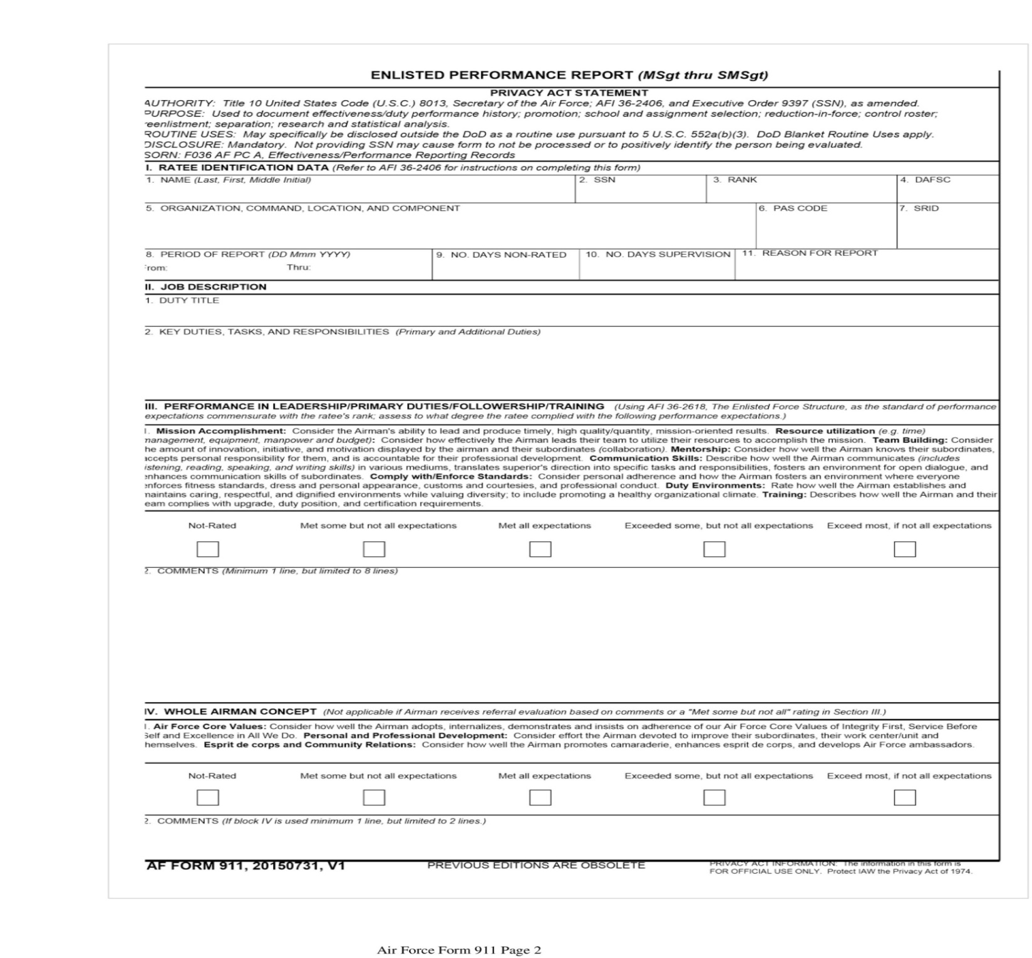

Appendix D

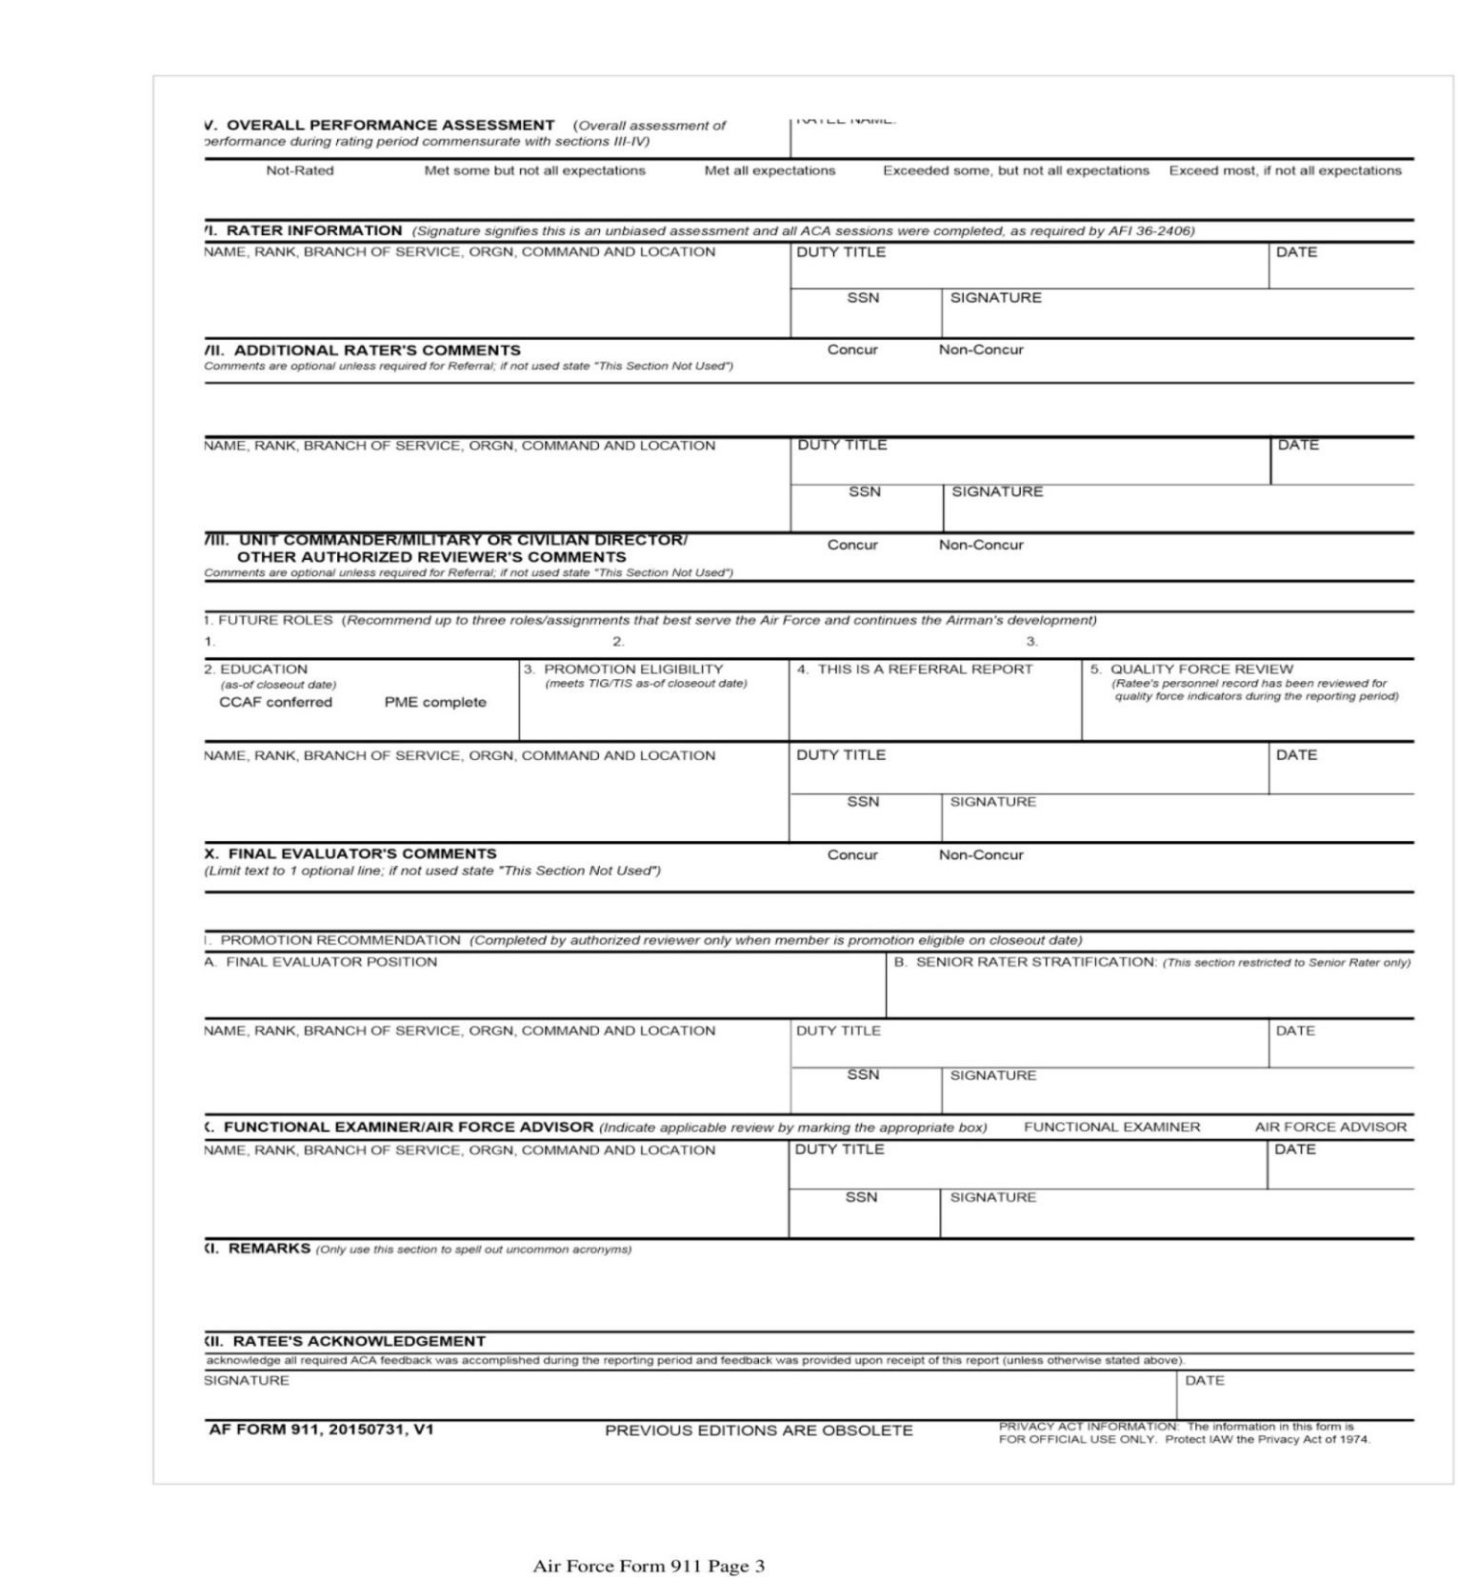

Appendix E
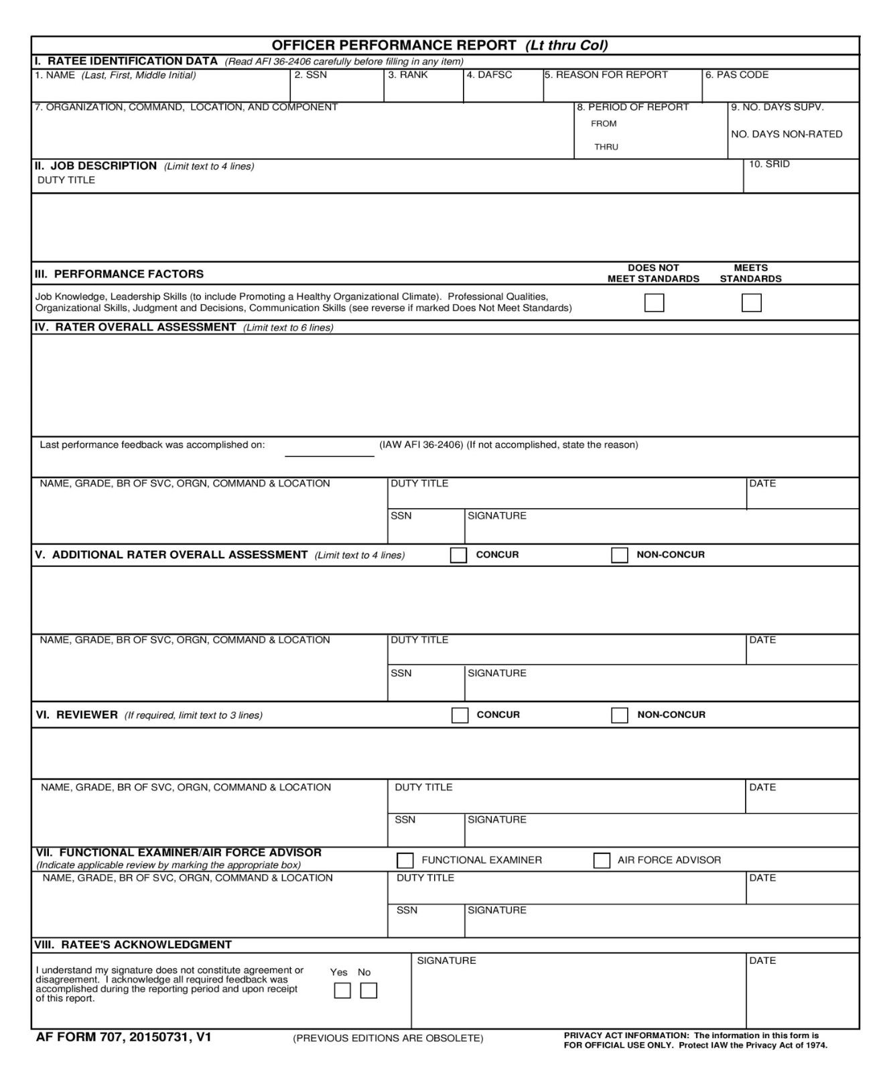

Appendix F
