Magic in the Making

An Exploration of the Role of Magic and Materiality in the Construction of Religious Legitimacy Among the Neo-Pagans of Middle and East Tennessee

By: Jeffrey LaPorte

A Thesis presented to the Honors College of Middle Tennessee State University in partial fulfillment of the requirements for graduation from the University Honors College
Spring 2018

Magic in the Making

An Exploration of the Role of Magic and Materiality in the Construction of Religious Legitimacy Among the Neo-Pagans of Middle and East Tennessee

by
Jeffrey LaPorte

APPROVED:

__________________________
Dr. Ida Fadzillah-Leggett
Sociology and Anthropology

________________________________________
Dr. J. Brandon Wallace
Sociology and Anthropology

__________________________
Dr. Will Leggett
Sociology and Anthropology

__________________________
Dr. John Vile
Dean, University Honors College

Abstract
In this thesis I conducted a study of legitimization within a religious minority community in Middle and East Tennessee, namely that of Neo-Pagans. In my field-work I noted that Neo-Pagans seemed to have an issue in regard to legitimacy, that they did not feel that their tradition was treated as a real religion by wider society. To explore this, I compared the way Neo-Pagans legitimate their religion with the way religious legitimization is typically constructed in our society to find the potential source of discrepancies. In this thesis I argue that much of the reason that Neo-Paganism is viewed as illegitimate stems from its practice of magic which promotes a different paradigm for the exchange of material goods and religious power then the one held by most of society in Middle and East Tennessee.

Table of Contents
3 – Abstract
5 – List of Figures
6 – Introduction
10 – Key Terms
13 – Research Methodology
15 – Legitimization of Neo-Paganism
24 – The Anthropology of Magic and it’s Neo-Pagan Corollaries
36 – Neo-Pagan Understanding of Magic
43 – Exchange Paradigm of Neo-Paganism
49 – Conclusion
51 – Bibliography
57 – Appendix 1- Purchased Items
58 – Appendix 2- IRB Exemption

List of Figures
19 – Figure 1: A bard performs in front of images of the God and Goddess
23 – Figure 2: Magical items for sale as props at a Halloween store
26 – Figure 3: An English coven’s self-description
27 – Figure 4: A typical smudging bundle
38 – Figure 5: Amulets featuring symbols form various traditions for sale at Nashville Pagan Pride
38 – Figure 6: Depictions of gods and skulls for sale at Nashville Pagan Pride
42 – Figure 7: Pre-packaged spells for sale at WicFest
42 – Figure 8: Detail on an adultery spell
42 – Figure 9: A description of sachet powders
42 – Figure 10: Mojo’s of various types for sale at Nashville Pagan Pride
45 – Figure 11: Crystals, wands, and bones for sale at WicFest
47 – Figure 12: Tarot decks, small altars, and wands show diversity of style at Nashville Pagan Pride

Introduction
In my first few semesters of anthropology classes, while reading the work of people who had chronicled “exotic” cultures in faraway places, I was periodically nagged by the feeling that anthropology belonged to a time before all our maps had been filled in and almost all the world’s peoples had been connected in global webs of communication and economic interdependence. However, all this was changed when I took the course The Anthropology of Religion and read Mama Lola: A Vodou Priestess in Brooklyn by Karen Brown. In the book Brown explores the world of the Vodou community of Brooklyn that most people, even others living in New York City, would never have known existed. In her book Brown provides the reader insights into the life of Mama Lola, her family history, and her religious practices; and it showed me that there are still unknown worlds to study even in our contemporary society, existing betwixt and between those we think we know. These worlds may never be shown in the media or on our maps, so it is only through the work of anthropologists that they can be studied and contribute toward a more complete vision of humanity.
Chronicling the specificities of religious diversity is a crucial part of increasing our understanding of the world and its peoples. Religion influences and is influenced by nearly every part of life in ways that are often neither simple nor obvious (Geertz, 1973), and diversity in religion can lead to differences between the practices and beliefs of cultures that are far more complicated than simply venerating different deities.
An example of this can be found in the concept of morality, a sphere of life where most would expect religious influence, as religions are often viewed as providing a framework for moral behavior (Kessler, 2008). However, this influence is far more nuanced than the delineation of right and wrong. The way a religious tradition discusses morality can vary greatly, and these differences reveal or actively shape how those that follow it view and interact with their world. Some traditions, for example, possess duty (or deontological) ethics, where an individual’s behavior is dictated by a series of laws or commandments that outline their obligations as an individual and a member of society (Kessler, 2008). In contrast other traditions emphasize virtue ethics where moral behavior is constructed as a struggle of self-transformation to emulate the ideal person (Kessler, 2008). While the two ideas are not mutually exclusive, the aspect that a religion emphasizes will have a profound effect on the people who adhere to it, for even if one fails to live up to, or openly flouts moral behavior, these moral ethics will shape how that failure or rebellion are conceptualized and framed, i.e. “I failed to do what I was meant to do,” versus “I failed to be who I was meant to be.”
Studying a religion anthropologically can provide insights even beyond the spheres of life like morality where we expect to see its influence. For example, most religious traditions possess an underlying economic element. Whether shared by a single village or entire nations, most religions provide a framework for resources and services to be exchanged in both material and spiritual circumstances (Weiner, 1933; Moro, 2013). These exchanges take place on multiple levels, in relationships between individuals, institutions and cosmic forces, both amongst themselves and with each other. The values that mediate these exchanges, or paradigms of exchange, both inform and are informed by a particular religious traditions beliefs and practices. Variations in these principles can therefore precipitate clashes between the members of different culture groups and religious traditions, a situation that is particularly pertinent in the case of minority traditions and their relationship with the larger culture.
My thesis seeks to argue that this is the case in regard to Neo-Paganism as practiced in Middle Tennessee, a region that is largely religiously dominated by Protestant Christianity. Neo-Paganism is an umbrella term for a group of traditions that have many different beliefs and practices but share a common community and ideological heritage and thus can are connected in a similar way that the various branches of Protestantism are (Berger, Leach, et. al 2003). All Neo-Pagan groups are centered around the study and revival of Pre-Christian indigenous European religions, primarily the worship of nature deities or nature itself and the practice of magic that forms a central part of their religious life (Berger, Leach and Shaffer, 2003). Neo-Pagans have been a significant presence in the U.S. for decades and have been formally recognized by the U.S. government since the incorporation of the Church of All Worlds in 1968 (Greene, 2016).
Today Neo-Pagan religions are estimated to have anywhere from 300,000 to over one million adherents in the United States (Higginbotham, 2002). However, despite their increasing numbers and visibility, many Americans still have a highly skewed or incomplete picture of these religions and their practitioners, due in part to cultural stereotypes surrounding Paganism as well as the intentional secrecy on the part of Neo-Pagans themselves. In many cases Neo-Pagans are solitary practitioners and Neo-Pagan groups (often called circles or covens) are loose, informal institutions who often have no dedicated building or permanent meeting place (York, 2003), with many of their members feeling the need to keep their religion a secret from the public at large and, at times, even from their friends and family (a state cheekily referred to as being “in the broom closet”) (Berger, 2003). This desire for secrecy has led to the adoption of “craft names” a common practice among Neo-Pagans. The craft name is a label of personal significance that is used to separate an individual’s religious and secular identity. This paranoia is not unfounded as many in America’s more conservative regions, especially among the Evangelical Christian community, consider neo-pagans to be a threat to their religion and society at large (Berger, Leach, and Shaffer, 2003). However, the explanation for Neo-Paganisms struggle with legitimacy cannot be fully placed on the shoulders of those who reject it because it conflicts with their own religious beliefs. Unlike many other minority religions, the legitimacy of Neo-Paganism is called into question even by those who consider themselves tolerant of other faiths. This stems from the perception that it is less “real” then other religions, in other words it is seen as lacking the legitimacy that many other faiths have.
My interest in Neo-Paganism’s legitimacy began in the classroom. Once in a Religious Studies class the professor polled the students on what religious tradition should be added to the curriculum for later semesters. After a bracket of polling, Neo-Paganism was in the last two and when it lost, the professor said something to the effect of “Good, the real religion won.” Though this sentiment was expressed in jest, it was strange to me as I was sure a professor would never joke about other small and relatively young faiths like Mormonism or Bahai not being real. This made me wonder what properties Neo-Paganism is perceived to possess that set it apart from other religions in the minds of scholars and lay people alike. I even experienced this feeling of questioning legitimacy myself; many times while conducting my research and fieldwork, this sentiment and others like it ran through my head, sabotaging my confidence in the religions sincerity and by extension the wisdom of my choice to study it.
At first glance, the religious traditions of Neo-Paganism felt fabricated, with the spells, rituals, and beliefs seemingly developed independently by each individual member or small group. While this was true in many respects I initially interpreted this feeling of manufactured-ness through my lens as a student of Religious Studies and a person raised in a Protestant tradition as a feeling that the religion was somehow “fake,” but I was wrong. As I spoke to more Neo-Pagan practitioners about their practice I saw that, not only where they aware of this process of continual invention and reinvention in their religion, but that it was a key aspect of what made their practices meaningful. I now contend that Neo-Paganism seems fabricated because it is a religion of “fabricators,” not in the modern connotation of liars or con-artists, but in the more etymologically obvious definition of manufacturers. The Neo-Pagans community is a community of makers; story tellers and craftsman, performers and artisans. A Pagan, as I will argue in this thesis, is thus defined by their own active involvement in creating the pieces and methods of their practice, a value largely expressed in their magic. Using magic, a Neo-Pagan engages in the active, conscious shaping of their religious life through learning, experimentation, and intuition. This by extension allows them to shape their own mystical reality.
Key terms
Before outlining the methods used in this thesis I need to provide definitions for the key terms that frame my arguments, beginning with the term “Neo-Pagan.”
“Neo-Pagan” is the term I have elected to use to refer to a collection of religious movements and groups that center their activities around the revival of Pre-Christian European religions in the modern era, necessitating the inclusion of a prefix to separate the contemporary practices from those they are reviving. Under this umbrella are many distinct groups like Neo-Druidism, Odinism (or Asatru), and Heathenry. The most significant subgroup of Neo-Pagans is Wicca, also called witchcraft. Wicca is the largest and most prominent Neo-Pagan movement today and many outside the Neo-Pagan community se the terms interchangeably (Berger, Leach, and Shaffer, 2003). However, all these movements share certain common characteristics like an emphasis on reverence for nature and the overt practice of magic rituals (Greene, 2016). While many practitioners identify themselves simply as Pagans, I have consistently referred to modern groups and persons as Neo-Pagans to avoid confusion with the pejorative categorization applied by Christians to their non-Christian neighbors.
The term “Magic” has a complex social and etymological history. Its roots go back to the Magi, priests of the Zoroastrian religion in the ancient Persian empire (Harper, 2001) who frequently practiced divination by various means. The word “magic” was therefore applied in the West to any attempt to divine the future, a definition that expanded in the medieval period to include supernatural acts that fell outside the boundary of the Christian religion and were therefore considered antisocial and evil. In academia the word “magic” is also sometimes used to refer to any religious action that attempts directly to alter or otherwise affect the material world (Van Gennep, 1908). However, outside the study of religion “magic” is most commonly used to refer to illusion and slight-of-hand or to a fictional power present in fairy tales and fantasy stories. It is not surprising then that magic, much like myth, has developed a pejorative connotation when attached to a person’s religious beliefs or practices particularly in the Christian world. For this reason, I shall restrict my use of the word “magic” when describing religious beliefs or practices to cases where the practitioners themselves invoke the terms. Neo-Pagans frequently describe their religious practices as magic or as containing a magical component. For many of them their study and practice of magic, either alone or in groups, is the focus of their religious life. While Neo-Pagans use many alternative spellings for magic such as magik and magick, I will stick to the common one to avoid confusion.
“Legitimacy” when applied the academic study of religion, refers to the way a religion and its accompanying beliefs and practices become accepted as real and authoritative both among those who adhere to the religion in question and in society at large. For this reason legitimacy is especially important to consider when studying new religions, like Neo-Paganism, where the perception of a religion held by society at large can have a significant impact on its followers and their ability to practice. Legitimacy also extends to the legal sphere and determines if a religion is viewed as possessing the authority and rights that other religions enjoy. Earlier I mentioned Neo-Paganisms “realness” as a religion, which could be more elegantly phrased as its authenticity. The perception of this authenticity and strategies to attain it are the principle components of religious legitimacy (Lewis, 2003).
Finally, the concept of “paradigm of exchange” needs to be discussed. It is the phrase that I have coined to refer to the way a religious tradition conceptualizes the transfer of goods and services as reflected in the way members are expected to act toward each other or in their dealings with the supernatural. A tradition may not have one paradigm of exchange that is applicable in all situations and may or may not reflect the way exchange occurs in the broader, secular, context. This is because and paradigm of exchange is not the same as an economic system; it is, rather, the particular way of thinking about economics and exchange that a religion promotes or reflects. In my field work I noted that the paradigm of exchange that was practiced in the religious life of Neo-Pagans created a unifying explanation for much of their community life and magical practice.
Research Methodology
For this project, I conducted extensive library research on Neo-Paganism, the anthropological understanding of magic and theories on the legitimization of religions. My research into the Neo-Pagans drew from both emic and etic (insider and outsider) perspective, including secondary sources like ethnographies (books by researchers providing in-depth descriptions of specific societies), articles from anthropological journals, and newspaper and magazine articles that discussed Neo-Paganism in the context of contemporary American societies. I also made use of primary sources like interviews and surveys conducted with members of Neo-Pagan communities by other researchers, blogs, magazine articles, Facebook pages, books written by practitioners, and how-to books meant to guide new members of this often-solitary faith.
I conducted field research after obtaining exemption from IRB (Exemption 18-1101, see appendix 2). I started my fieldwork by going to shops in Murfreesboro and the surrounding area that either catered specifically to Wiccans and Neo-Pagans or to a broader “New Age” or “Alternative” religious market. The owners of these places were often practitioners themselves, and after I explained my project, they allowed me to ask questions about their businesses and its connections to the wider pagan community.
In addition, I attended two public festivals, the first of which was a small gathering at a campsite near Chattanooga called WicFest that required significant payment for entry and lasted an entire weekend. My attendance at this event was my first experience attempting participant-observer field work, and I was frequently unsure of how to approach people, especially since most people at this event had come with a small group who they stayed with for much of the time. However, I soon discovered that almost all in attendance were vendors of various kinds ranging from proprietors of brick and mortar pagan shops to individuals and groups that made items to sell at festivals and online. These vendors were very eager to describe the use and function of magical items and to share stories of their experiences with magic, especially their pointed opinions on how things ought to be done. Another major component of WicFest were workshops that were scheduled every thirty minutes or so on topics that ranged from the instructional, like besom (witch’s broom) making, to broad aspects of Neo-Pagan practice, like the role of prayer in a practitioner’s religious life. Some of these workshops took place before I arrived, and others simply did not occur due to how sparsely attended the event was, but I was able to experience a workshop on spell casting and on clearing one’s chakras (points where energy pools in the body primarily located along the spine and joints).
The other major Neo-Pagan event I attended was the Nashville Pagan Pride day festival, which was held in a park area near the edge of the city. Despite their ostensibly similar nature, the two gatherings were conducted in very divergent ways. This was, for the most part was due to scale. Unlike the other gathering, no payment was required to attend the Pagan Pride festival (though small donation of cash or canned food was suggested) and this, coupled with its proximity to the city, contributed to it being larger than WicFest by an order of magnitude, with a few hundred people in attendance. The park where the Pagan Pride festival was held was roughly as large as the campground where WicFest had taken place, but all the activity was concentrated around a 150-200-hundred-yard path lined with tents and stalls from the vendors as well as a couple of food trucks near the gate and a ritual space at the end. Pagan Pride also had workshops as well as rituals that were performed at the opening, mid-point, and closing of the one-day festival.
I took field notes during these events and supplemented them with extensive written reflection afterward. Throughout my research I also purchased a variety of small items and photographed many more with permission of the vendors so that I could provide a visual and tactile reference for the artifacts I discuss in this project.
Though I attempted to approach this subject with objectivity and professionalism, I feel it is crucial to acknowledge and discuss my personal biases so that any affect they had on my work may be more readily acknowledged so I have done so throughout the paper where appropriate. Additionally, should a reader share any of the prejudices or reservations I had towards this subject, an account of how mine were affected by my research may be even more helpful and appropriate.
Legitimization of Neo-Paganism
Every institution, be it political or religious in nature, needs to be seen as a credible authority if it is to have any effect on the thoughts and actions of people. This quality is called legitimacy, and it is an especially crucial social resource for new religious movements like Neo-Paganism. Traditionally, when examining this phenomenon, scholars focused on what made individuals accept and reinforce the authority of the institutions in which they participated, but in the mid-century, scholars began to approach this question from the opposite direction and examined the processes by which an institution legitimized itself in the hearts and mind of individuals (Lewis, 11). German sociologist Max Weber proposed a tripartite solution to this query in “The Three Types of Legitimate Rule,” where he outlines three models of authority, legal, traditional, and charismatic (Weber, 1919). Legal authority stems from the notion that laws and rules have inherent value and that any edict or policy must be obeyed as long as it was implemented according to preexisting rules and laws. Traditional authority appeals to an innate trust in the social order and an interest in preserving it as it is or was, and charismatic authority is dependent on a devotion to a particular person (Weber, 1919).
One might expect new religious movements primarily to utilize charismatic authority to legitimize themselves especially because we frequently stereotype new religious movements as groups that have been “brain-washed” by a central charismatic figure. However, some new religious movements do not possess any appeal to charismatic authority, and among those that do, it is typically invoked in conjunction with other forms (Lewis, 2003).
Neo-Paganism itself possess few claims to charismatic authority, and within the boundaries of Weber’s model, it tends to appeal to tradition for legitimization instead. This appeal to tradition is used very differently than Weber imagined, as rather than utilizing the implicit, inertial authority of “the way things are,” Pagans present their practices as a revival of ancient traditions and invoke the authority of “the way things should be,” a type of legitimization common among new religious movements (Lewis, 2003).
Neo-Pagans have a complex relationship with legitimization that goes back to the origins of the word “paganism”. Until the twentieth century, there was no such thing as a self-identified Pagan as the term was solely used as a derogatory label for others or their practices. It was initially used in a religious context to delegitimize non-Christian religion in the Roman Empire (Davies, 2011). The Latin term Paganus originally meant “of or relating to the country side” as well as a non-combatant civilian when applied in a military context. The term acquired its religious connotation through the metaphors employed by various Christian apologetics, i.e. Pagans were those outside the “army” of Christ and the “city” of God (Cameron, 2011).
Language continues to subtly work against Neo-Paganism’s legitimacy in the modern day particularly in the way we conceptualize and talk about religion. One example of the way we talk about religion that is inherently delegitimizing to Neo-Paganism among other traditions is called the “world religions paradigm.” The world religions paradigm is way of thinking about and studying religion that emphasizes the “big five” world religions Christianity, Islam, Buddhism, Hinduism, and Judaism. These are often supplemented by the vague categories “indigenous religions” and “new religious movements” that are used to discuss and study all other religions (Cox and Robertson, 2013). This paradigm governs much of the understanding and discussion of religion both in academia and everyday life. Not only does this way of talking about religion serve to exclude or marginalize the traditions that do not cleanly fit into its categories, like Neo-Paganism, which is a new religious movement based in indigenous religion, it also serves to create a view that religious life all over the world is divided into discrete, hegemonic traditions, each of which possess an accompanying distinct set of beliefs, rituals, and symbols as well as a formal social institution and designated functionaries (Cox and Robertson, 2013). Neo-Pagans do not possess the centralized structure, definitive set beliefs, or a codified group of sacred texts and if these elements are used to distinguish different religious traditions Neo-Paganism would include thousands of distinct faiths. This, uncertainty of categorization coupled with their secretive nature and relatively recent origins, has made the study of Neo-Pagan groups a difficult and relatively recent practice, and this lack of knowledge around them only serves to increase the perception that theirs is not a true religion.
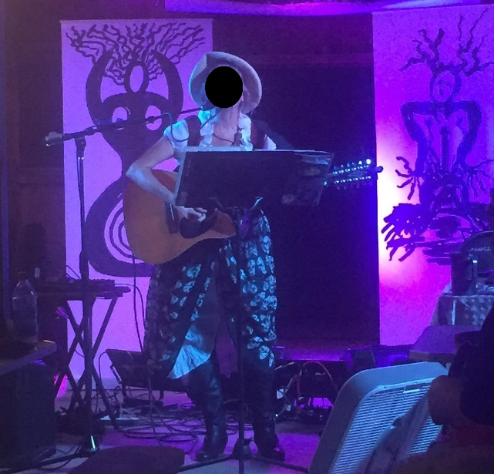
In my field work I witnessed the desire for and anxiety around legitimization expressed many times. Many practitioners that I spoke with who were in their 50’s and older reflected on how only a few short decades ago there were no public Neo-Pagan meetings or festivals in this area, and they had to keep their religious practices a secret from their neighbors, coworkers, and families out of fear of social stigma and ostracization (Dewr, 1998). One practitioner recounted a case of a woman she knew who kept her religious paraphernalia in a locked box in the trunk of her car as her practice was a secret to her own spouse. These people expressed hope and excitement in regard to increasing public acceptance of their movement that allowed them to live outside the dreaded “broom closet”. On the other hand, many Neo-Pagans revel in the transgressive
and taboo nature of magical practice. Religious imagery from other traditions was frequently appropriated in their paraphernalia, but whenever Christian imagery was involved, there was typically an element
of subversion or perversion. I observed a
very explicit example of this phenomenon
when I attended a Bardic Circle, a
semi-formal ceremony where people sing
songs and tell stories in the spirit of the
bards of old, when a woman led a song about a man who sells relics that include Jesus Christ’s foreskin and Joan of Arc’s testicles. The song was meant to shock and amuse its audience but also to revel in explicit blasphemy in order to reaffirm the Neo-Pagan values of questioning that which is held as sacred and beyond reproach.
Figure 1: A bard performs in front of images of the God and Goddess
These practices support the idea that Neo-Paganism and the magic practiced by its adherents is inherently transgressive and anti-social, a common perception that is antithetical to their legitimacy in society. Though I will later take a more extensive look at anthropological theories of magic, it is crucial here to note that this transgressive quality is explored in the theories of Emile Durkheim who sought to distinguish the practice of magic from religion but, unlike many theorists before him, Durkheim acknowledged that the two were inextricably linked and inform one another (Durkheim, 1915). As Durkheim was a sociologist he focused on what he perceived as the differing social contexts and purposes of religion and magic to form his distinctions (Olson, 2003). In his 1912 book Elementary Forms of Religious Life Durkheim asserted that magic and religion where both composed of the same two parts, beliefs, which are “states of opinion” (Durkheim, 1915), and rites, which are “modes of action” (Durkheim, 1915). These are distinguished from all other opinions and actions by their concentration on a set of concepts and objects that have been culturally determined to be special or set apart. This state is known as “sacred” and is distinguished in Durkheim’s work from all the common and pedestrian aspects of life that he calls “profane” (Durkheim, 1915). However, Durkheim explains, magical rites and beliefs, though often overlapping with those of religion, are simpler and more straightforward because they are dedicated to personal and utilitarian ends (Durkheim, 1915). For, while religion is introspective and focuses on the community and the common good, magic is practiced by an individual for their own benefit (Durkheim, 1915). This means magic is generally regarded as taboo and transgressive by the community at large and has a peculiar symbiotic and antagonistic relationship with religion for, as Durkheim explains “Magic takes a sort of professional pleasure in profaning holy things. …On its side, religion, when it has not condemned and prohibited magic rites has always looked upon them with disfavor” (Durkheim, 1915). Though he thinks magic and religion are very similar, Durkheim does not see magic as falling under the umbrella of religious studies and advocates a strong distinction between magic and religion (Durkheim, 1915).
While Neo-Pagan gatherings may revel in religous transgression, in many ways they are a living rebuttal to Durkheim’s assertions that religion and magic are separate and that “There is no church of magic” (Durkheim, 1915) because it is an inherently antisocial operation, as theirs is a religious community built around the practice of magic (Magliocco, 2004). The Neo-Pagan community does not shun socialization and constructs its community on the foundation of magical practice (Cunningham, 2004). Materials even exist to teach children about the magical concepts and its practice in the form of picture books that explain magic to children (Storm, 2012) and individual coloring pages and worksheets explaining particulars of Neo-Pagan practice in a child friendly manner that can be found on the internet. However, almost all Neo-Pagans I spoke with on the matter reflected Durkheim’s theories on magic’s place within wider society and his views about how it interacted with religion, only they articulated it as “other religions” as they see themselves as a religion no the magical alternative to one. Most Neo-Pagans believe that their religion is outside the mainstream and is being either overtly opposed by wider society or is at least, as Durkheim put it, “looked upon…with disfavor” (Durkheim, 1915). For example, there is a common joke among them that Catholicism is legalized paganism, showing that despite the fact that their religious practice is legalized, it is not socially accepted.
Ironically, one of the times that I was most inclined to question Neo-Paganism’s legitimacy, something that was thankfully never done consciously in the moment, was when individuals claimed that they were part of a fervently oppressed or marginalized religious minority and had to stay in the “broom- closet” so as not to face a later-day Salem. Ironically my feelings were born from the same discriminatory attitudes toward Paganism that they were describing, that even among those who consider themselves broadly tolerant of any and all faiths, they are still considered to be “not a real religion” and are therefore not granted the respect and protections that might be extended towards other maligned religious minorities like Islam. I also had clearly forgotten that things could be very different in places and especially times other than my own. Many of the people practicing Neo-Paganism today can remember when a crusade was led against Dungeons and Dragons for merely featuring the study and practice of witchcraft in a fictional context; and in my own lifetime similar vendettas have been directed against the likes of Harry Potter and even the Christian holiday of Halloween for the same reasons. The Neo-Pagan’s fear of persecution seems especially justified, if not entirely reasonable, by the fact that extra judicial killings of persons accused of witchcraft are not-uncommon in many places in the developing world and have even increased since 2000 (Horowitz, 2014).
I even had a notion that Neo-Pagans could not be systemically oppressed because so few were raised in Neo-Paganism and instead chose to be a part of it later in life (and less consciously I assumed the majority were young people going through some sort of “phase”). This was patently untrue. Many people at the first gathering I went to were into middle age and older and the few younger people I saw almost all had children in tow. At Nashville’s Pagan Pride Day, many of the attendees where young parents with infants and toddlers (and in one case a rabbit). There were also resources for sale to teach the basics of magic and other aspects of Neo-Pagan practice to children, and one of the workshops I attended specifically addressed that issue. The workshop leader’s advice to Neo-Pagan parents was to tell children that magic was a type of praying and to introduce them to the religion’s more “hands on” aspects which, she said, children tend to love. The type of people my imagination had unbiddenly conjured, who learn about witchcraft or other types of Neo-Paganism on the internet and go through an adolescent phase of attempting to use magic to meet revenge upon their enemies or ensnare a romantic partner, were even acknowledged by, and the target of gentle mockery from the practitioners at these events. “Teenagers meeting in graveyards” was even invoked as a shorthand for people more interested in the spectacular and transgressive aspects of magical practice then any spiritual or practical end. One story I was told at a spell-making workshop that lampooned this type of practitioner involved the local police finding a evidence of a ritual in a graveyard, in the center of which was a shoe box. The police brought the box to the witch who told me this story and handed her a pair of latex gloves and put some on himself before opening it. Inside the box were two Barbie Dolls smeared with human feces, which the witch determined had been part of a young woman’s misguided attempt to call down a “shit storm” on her enemies and those in attendance received this story with received with humor and knowing condescension.
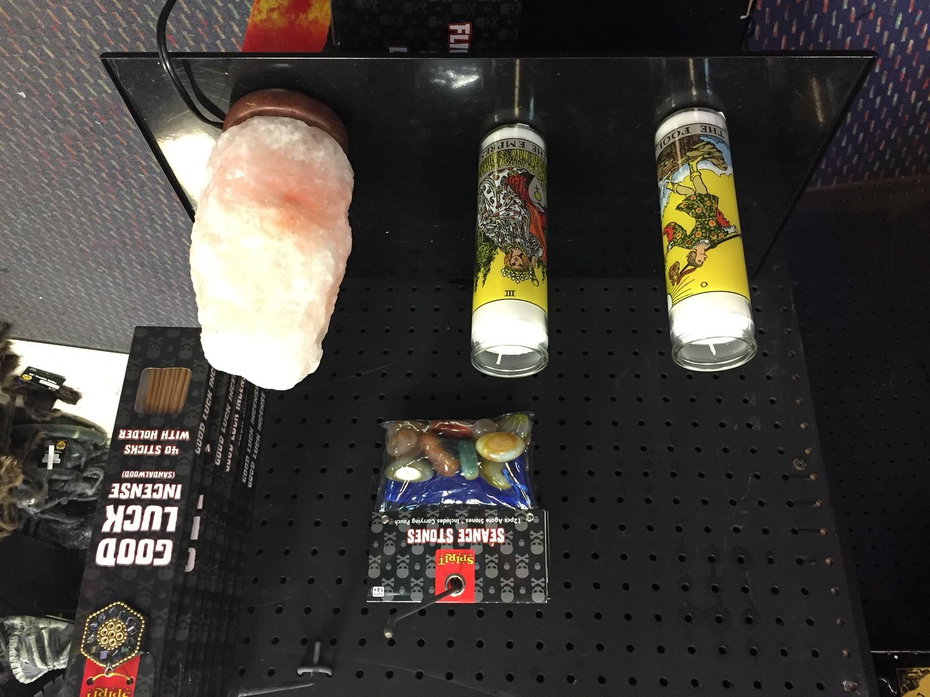
The association of Neo-Pagans with Halloween and Harry Potter extends beyond those who despise it. The popular perception of concepts like magic and witchcraft have contributed to the impediment of the legitimization of Neo-Pagan religions in the popular consciousness. To most Americans who do not actively fear them, witchcraft and magic are fictional creations confined to the realm of children’s stories and Halloween. However, Halloween is a very important
time to Neo-Pagans, who celebrate it as
the ancient Celtic harvest holiday of
Samhain, but outside Neo-Paganism the
practices and imagery they invoke are
often connected with the secular
celebration of the holiday. Some
Halloween stores even sell the same
wares sold at Neo-Pagan stores or the same type of items repackaged in a
more spooky style. The Neo-Pagans I met were not exactly averse to their community being associated with fantasy and fiction. Fantasy imagery and art is commonly used by Neo-Pagans and a few practitioners I met wrote fantasy novels that they sold at Neo-Pagan festivals, but when these connections are made by those who aren’t Neo-Pagans they feel it reinforces the idea that their religion is not a real one. The source of this delegitimization is the discrepancy between wider society’s conception of magic and the one that Neo-Pagans have among themselves. It is therefore crucial to examine the understanding of magic within Neo-Paganism.
Figure 2: Magical Items for sale as props at a Halloween store
The Anthropology of Magic and its Neo-Pagan Corollaries
In her 2004 book Witching Culture Sabina Magliocco an anthropologist and practitioner of Wicca, explores a unique feature of Neo-Paganism; namely, that it owes its existence to academics and researchers as much as to mystics and spiritualists (Magliocco, 2004). Sociologists, psychologists, and historians all have influenced (and in some cases, been influenced by) Neo-Pagans, but Anthropology has played a crucial role in shaping Neo-Paganism and its conception of magic. It is therefore crucial to examine the history of Anthropological definitions and theories of magic in order to provide context both for how the study of magic has been approached and how magic itself is viewed in that community.
The first anthropologists to study the religions of the world attempted to create a definition and theory of magic that would distinguish it from religion, this was done primarily in an effort to put the “superstitious” and “uncivilized” practices of other cultures into a separate category from the “real” religions, an attitude that stemmed from and reinforced the world religions paradigm (Cox and Robertson, 2013). In his book, Primitive Culture, published in 1871, Edward Tylor argued that all magical practices were not religious in nature but pseudo-scientific, logical systems that were based in fallacious assumptions about the natural world (Tylor, 1871). Tylor explained that magic and superstition where all part of a universal pre-religion that he called “animism” a phenomenon he defined as “the deep-lying doctrine of Spiritual beings, which embodies…spiritualistic as opposed to materialistic philosophy,” (Tylor, 1871) in other words, a belief in the animate spiritual quality of nature was the foundation of a universal world view among “primitive” people. Tylor claimed this religion was one that all others came from and as societies evolved from their “savage” stage to more complex forms, animism would be replaced by more advanced religions that where closer to his own, but that magical and superstitious belief was present even in advanced society in the form of “survivals” from these less advanced times (Tylor, 1871).
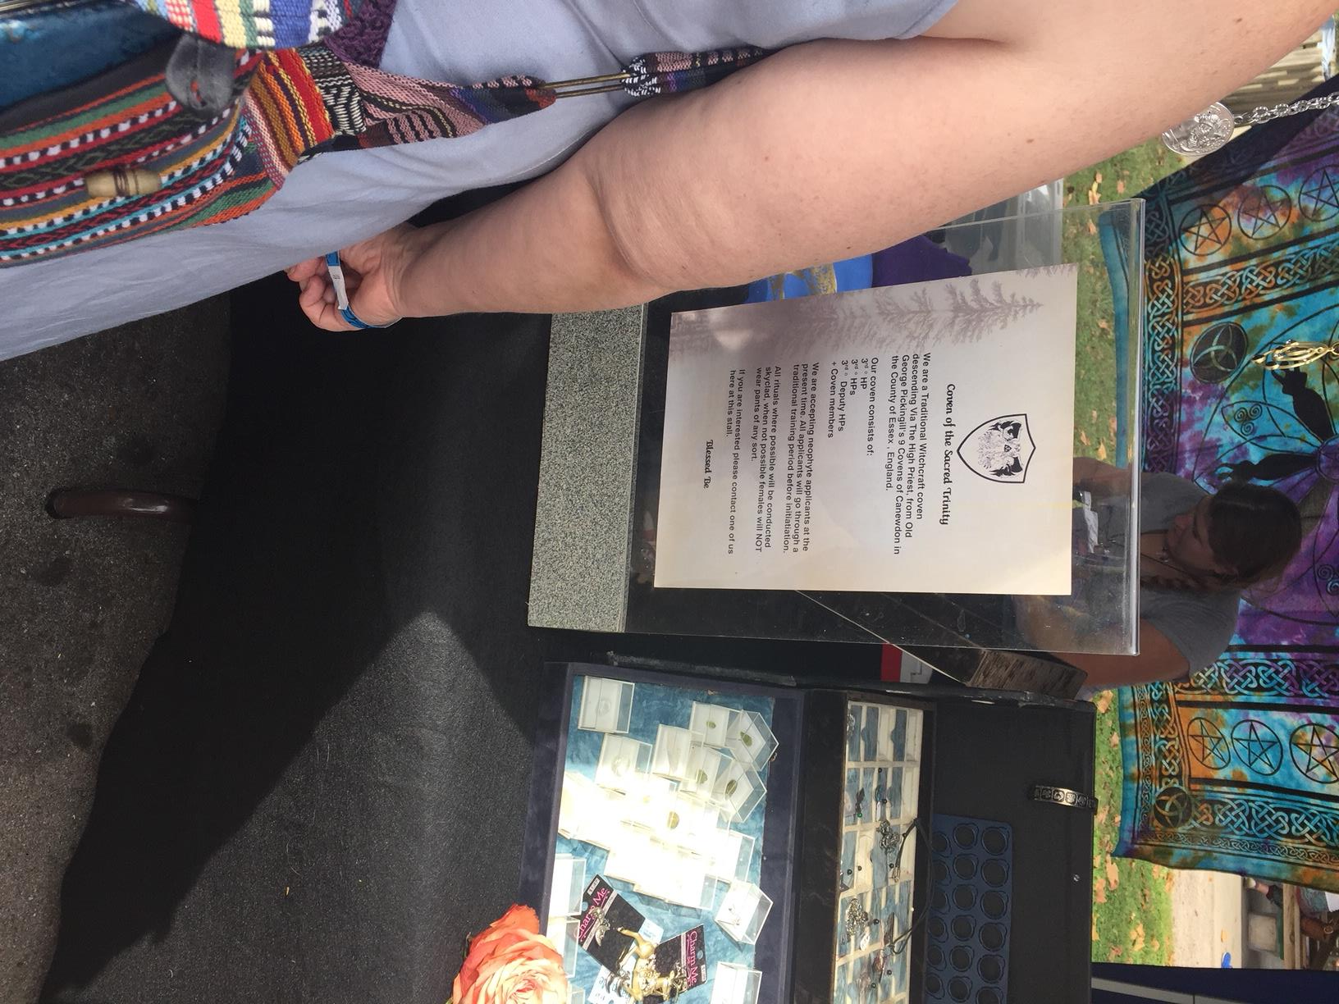
This notion of survivals was seized by many of the secret societies and
spiritualist groups (ancestors of many modern Neo-Pagan groups) that permeated the upper echelons of Anglophone society, sparking their interest in folklore and myth as they began to see their own religious activities as a connection to the past (Magliocco, 2004). This interest led to the founding of Neo-Paganism. In 1921, anthropologist and Egyptologist Margaret Murray published The Witch Cult in Western Europe, where she argued that medieval witches were real and that they were members of an underground remnant of a pre-Christian fertility religion (Murray, 1921). This notion was seized on by Gerald B. Gardener, the founder of the modern Wiccan movement who attempted to revive “the Craft” by writing a book on ancient pagan practices. However, he was not able to do so until 1954 when the Witchcraft Act of 1735 was repealed (Brood, Little, et al. 2016). The publication of his book Witchcraft Today marks the founding of the Wiccan movement, and many Wiccans still identify as Gardnerian Witches. I encountered some practitioners who rejected Gardener’s status as the founder of modern witchcraft however. One group included a coven from England who were selling t-shirts and other odds and ends at Pagan Pride day to cover their traveling costs. These people did not identify as Wiccans, a fact I
discovered when I mislabeled them as such
after seeing they called themselves a coven.
They told me with great pride that they
preceded Gardener and the movement that
sprung from his work and traced their lineage
to a figure called George Pickinghill and his
original nine covens of England. George
Pickinghill was a 19th century Englishman
who is attested to by several sources written
after his death that called him a “cunning man”,
an archaic term for a practitioner of folk healing and “white magic” (Hutton, 1999).
Figure 3: An English coven's self-description
The modern American version of Neo-Paganism came about when it found widespread popularity among the counter culture groups of the 1960’s and 70’s who frequently engaged in alternative forms of spirituality and religious expression. Study of Neo-Paganism is still occasionally grouped with the study of other counter culture spiritualties usually under the umbrella term “New Age” but a Neo-Pagan group can be distinguished from members of these other movements by the fact that they are inspired by Margaret Murray’s work. Such groups can be identified by the fact that they deliberately draw inspiration for their religious activities from nature-based traditions in Pre-Christian Europe.
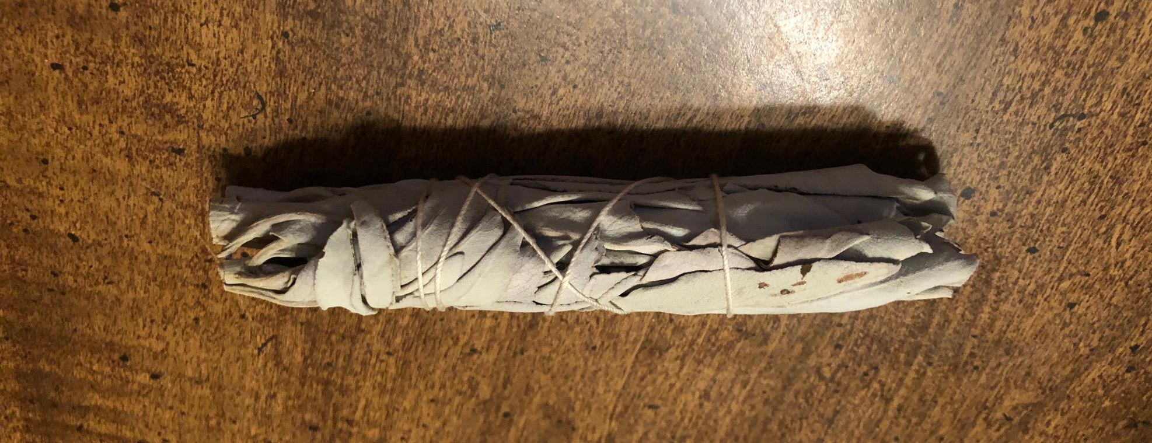
Contemporary Neo-Pagans still possess an interest in recreating survivals from Pre-Christian Europe as was evidenced by the frequent mentions of attending Renaissance fairs that I heard from vendors and attendees at the festivals I visited. The idea of their contemporary practices being survivals from an animistic past is also viewed in a way that is almost completely antithetical to Tylor’s original concept of cultural evolution (Magliocco, 2004). Rather than being seen as artifacts from a less civilized time, claims that one’s beliefs or practices are survivals from a distant animistic age are used to lend them authority and legitimization in a manner similar to Max Weber’s model of authority from tradition. In my time at Neo-Pagan events I heard several claims that practices came directly from or were inspired by the Druids, the ancient Norse, or Native American cultures. These claims were used to reinforce the authenticity of the practices being engaged in or the wares that were marketed. A clear example of the veneration of alleged survivals is the practice of smudging, the burning of sage mixed with other spiritually significant herbs in order
magically to cleanse or purify a
space so that residual energy does
not interfere with future endeavors.
This practice is given legitimacy by the pervasive claim that it originated from
pre-Colombian Native American cultures (personally I was
once told it originated with the Navajo, but the general native-ness is more often emphasized), whom the Neo-Pagans elevate for their assumed closeness to the natural cycles of the earth, the very qualities that Tylor would have labeled as animistic and primitive.
Figure 4: A typical smudging bundle
The conception of magic in Neo-Paganism was also influenced by the work of James Frazier, who in 1890 published The Golden Bough the first academic study focused magic (Olson, 2003). In this book, Frazier argued that the difference between magic and religion is that religion seeks to communicate with supernatural beings and enlist their aid, while magic “assumes that in nature one event follows another necessarily and invariably without the intervention of any spiritual or personal agency” (Frazer, 1890). Frazer says that in the eyes of a magician, magic works by manipulating natural laws and that the only way magic can fail is if one is opposed by another more powerful magician (Frazer, 1890). He also saw magic as being similar to science in that they both seek to manipulate natural laws for one’s own purpose and he calls magic “the bastard sister of science” as in his eyes, the only difference between them is their veracity (Frazer, 1890). He elaborates on this rather reductive view, saying “all magic is necessarily false and barren; for where it ever to become true and fruitful, it would no longer be magic but science” (Frazer, 1890). Frazer’s definition of magic is extremely limited even excluding most acts commonly referred to as magical, such as the assumed work of witches in medieval and renaissance Europe, as their work was supposedly powered by an outside entity, namely the Devil (Higginbotham, 2002). However, his work was valuable in developing a theoretical framework with which to discuss magical practices, which he articulated as the “laws” of magic (Frazer, 1890).
According to Frazer, all magic works according to the laws of sympathy, which is the assumption of an association between seemingly disparate things (Frazer, 1890). This takes two forms, the first is “law of similarity”, which can be phrased as like=like, or things that resemble each other are linked in some way. The second part is the “law of contagion” which states that “once in contact always in contact”, or that items and people maintain a link even after they have been separated (Frazer, 1890).
Frazer’s belief about magic’s relationship to science; that magical laws were based in a misunderstanding of natural laws and that magic was merely an attempt at science by less advanced cultures (Frazer, 1890), is not supported by the practice of magic in the Neo-Pagan communities but it still holds influence over how they are viewed as many people associate magic with a superstition and lack of education. In fact, modern Neo-Pagans are not without an understanding of science and view it as a separate but valid form of inquiry that they incorporate into their practice. For example, I was once instructed by a woman running a spell workshop never to perform a traditional healing spell for a person with cancer as this might encourage the growth of the tumor, demonstrating a cooperation in her practice between a magical and scientific world view.
Despite this Frazer’s rules of sympathetic magic were very influential and would form a foundation for latter theories of magic among academics and influenced the paradigm of exchange present in Neo-Paganism today. This can be seen in the work of Druid Isaac Bonewits who outlines the twenty-four laws that form a magician’s world view in his 1989 book Real Magic (Bonewits, 1989). Though it was written nearly one hundred years after The Golden Bough, Bonewits directly borrows from Frazer’s language even including a law of sympathy, contagion, and homeopathy (Bonewits, 1989). all terms Frazer used to explain his magical laws (Frazer, 1890). Similar to Frazer’s theories, Neo-Pagans also view magic and the exploitation of these natural laws as not dependent upon gods or other outside supernatural forces. As one guide book by and for Neo-Pagans states “magic (is) the movement of natural energies to create needed change… a natural, not supernatural process” (Cunningham, 2004). For Neo-Pagans it is not the inclusion of gods that separates magic from other practices it is how the gods and other supernatural and natural forces are related to: they are utilized and traded with, not merely worshipped, though this is also practiced.
Much of Frazer’s theory on magic was revised and criticized by Henri Hubert and Marcel Mauss who contested the work of James Frazer and his assertion that the magical laws he had identified were based in a flawed understanding of the natural world and abstract mental laws (Sorenson, 2007). Hubert and Mauss theorized instead that the sympathetic connections Frazer wrote about represented a subconscious adherence to a society’s classification system and underlying symbolic framework (Sorenson, 2007). or in Mauss’ own words, “In magic and religion the individual does not reason… Just as he has no need to reflect on the structure of his rite in order to practice it, or to understand the nature of his prayers and sacrifice, so he has no need to justify his ritual logically” (Mauss, 1972). This was tied to their idea that magic was not an act of an individual’s psychology but was instead a network of symbols, beliefs, and rites the manipulation of which played many crucial social functions (Pritchard, 1931). Hubert and Mauss’ observation that magic played a role in the governing of many societies caused confusion among them and their peers, as it was still assumed by scholars that all societies had a concept of “black magic” that was considered unlawful and immoral (Pritchard, 1931).
The anthropologist Bronislaw Malinowski spent many years living among the Trobriand Islanders, which gave him extensive firsthand experience with that culture’s magical practices finally bringing field work into the study of magic. Malinowski utilized the theory of functionalism, the idea that to understand an element of a society one must view it as part of a cohesive whole and discern how it serves this whole and attempted to explain magic in the context of the purpose it fulfilled for society (Olson, 2003). He rejected earlier scholar’s claims concerning primitive people who existed in a state of eternal mysticism, with no logic or reason, or that they reserved such things for the profane parts of their lives, keeping the sacred and religious aspects shrouded in superstition (Malinowski, 1954). Instead, Malinowski asserted that religion and magic were “a special mode of behavior, a pragmatic attitude built up of reason, feeling, and will alike” (Malinowski, 1954). To Malinowski there was no such thing as “black magic” only the occasional abuse of a normal, legal force for anti-social ends that was engaged in by small group of individuals for personal gain or in service of a more powerful member of the community (Pritchard, 1931).
Malinowski also rejected the use of social roles to determine the difference between magic and religion, saying that both clearly had individual and social aspects. For Malinowski what separated magic from religion was in the purposes they serve for society. Magic, in Malinowski’s view, took a more direct approach to serving the community’s needs and that “…in the magical act the underlying idea and aim is clear, straightforward and definite” (Malinowski, 1954). He contrasted this with religion, which he says, “has no purpose, it is not a means to an end but an end in itself” (Malinwoski, 1954). Malinowski’s theory of magic was based upon psycho-functional explanation, interpreting magic as an active pursuit where each word and action had a specific psychological purpose beyond its supposed material effect (Olson, 2003). Even though magic could not actually make the rain fall or keep bugs from crops Malinowski saw that it did serve the communities that practiced it because, rather than serving as a primitive form of science, magic went beyond science to provide people with a sense of control over the parts of their world that are seemingly chaotic and unforgiving (Malinowksi, 1954).
Famed British Mystic Aleister Crowley, a contemporary of Malinowski who influenced the practice of magic in many Neo-Pagan movements, mirrored Malinowski’s psycho-functionalist explanation when he described magic as “the capacity to alter consciousness at will” (Magliocco, 2004). Many Neo-Pagans see magic this way, as force that creates results by affecting human perception and disposition rather than supernaturally altering the state of the world (Magliocco, 2004), a view that falls far outside of traditional ideas of what magic is but is very similar to Malinowski’s theories. Among the Neo-Pagans I met, while some clearly believed their actions could directly affect the minds and fates of others, many regarded magic in a very practical way, as a system for ordering one’s own life and training one’s own mind to produce desired outcomes. However most of the practitioners did not seem too concerned with why their magical practice worked, taking a purely functionalist approach to their own religion they were primarily interested in the fact that it worked at all. In one of the spell making workshops I attended the facilitator said that, more than any external source of authority, spells should be based on one’s own experience, modified through trial and error based on what elements yield results and which do not. This has been observed by others who studied Neo-Pagans. After Margot Adler observed a group seemingly use magic to catch a large number of fish with their bare hands (by visualizing their transformation into bear hands) their leader told her “Magic is simply the art of getting results” (Adler, 1979).
E. E. Evans Pritchard produced a definitive work on magic in his 1937 book Witchcraft Among the Azande. In his work Pritchard helped to dissipate the opaqueness that plagued previous studies of magic by acknowledging that the Azande had two concepts that we would identify as magic but that played very different roles in their culture and society. Mangu is comparable to European witchcraft, it is a hereditary trait that physically manifests as a blackish growth inside the abdomen. This growth gives those that possess it several supernatural abilities including the power and drive to consume the souls of others. Alternatively, ngwa is a practice requiring rites and materials that can be used for benign or nefarious ends (Pritchard, 1937). Although Pritchard explicitly avoided forming any broader theories of magical action, prefacing his work by saying “Whether the moral distinctions made by this people about their magic are common to many societies can only be answered by future field workers” (Pritchard, 1931), his explanation of the Azande’s beliefs regarding magic and witchcraft explicitly outlines the distinction between the two phenomena.
Like the Azande, European cultures may have also made this distinction between witches, or supernatural malevolent entities that hide among us, and magic, a type of knowledge used for common and often benign purposes like healing and divination, though both practices were condemned by the Christian church. Evidence for this can be seen in medieval laws, which specify a difference between witchcraft and sorcery, while outlawing both practices (Maxwell-Stuart, 2001). This harkens back to earlier distinctions in the Hellenistic world between mageia, the divining arts of Magi and the predecessor to our word magic, and goeteia, an explicitly evil act derived from the Greek for “to howl” (Maxwell-Stuart, 2001). Margret Murray combined these two phenomena in The Witch Cult in Western Europe when she asserted that the witch trials were targeted persecution at a pre-Christian religion (Murray, 1921), but the example of the Azande shows us that competing religions are not necessary prerequisites to the hunting of witches (Pritchard, 1929). Another crucial component of Pritchard’s work on magic that is relevant to my research is his theory on how magic works. Unlike earlier theorists like Frazer or Tylor, Pritchard did not accept the idea that the people he was studying believed in the power of magic and witchcraft because they were to superstitious or primitive to realize the true cause of events. Since he realized that the Azande had a sense of perception, logic, and causation that was similar to his own, Pritchard determined magic was a cultural way of viewing the world, specifically a method of explaining events and causation (Pritchard 1929). As elsewhere in his work, he explains this using the Azande’s own terms explaining their metaphor of the umbaga. As Pritchard explains, in Zande culture, the meat of an animal killed in a hunt belongs equally to the first person who speared it and the umbaga the owner of the second spear that finally dispatches the animal (Pritchard, 1929). In this case the first spear represents the visible cause of an event while the second spear is the witchcraft that plays an equal role in accomplishing the deed and is an equally relevant factor were society is concerned (Pritchard, 1929).
While Pritchard’s work helps explain the origins of Neo-Paganisms views on magic, the anthropological theory of magic that most closely describes the way Neo-Pagan magic works is the emotionalist understanding that was proposed by R.R. Marett, a contemporary of James Frazer who, like Hubert and Mauss, agreed with Frazer’s description of sympathetic magic, but believed Frazer had missed the point of magic by attempting to explain it through a lens of logic and intellect (Marett, 1979). Marett purposed instead, that magic had its basis entirely in overpowering outbursts of human emotion and our tendency to connect these emotions to items or symbols which did not cause them. Marett purposed that these loci of emotional connection are made into “shadows”, or symbolic representations, standing in for the original object of the emotions projected on them (Marett, 1979). If one recognizes this process and actively engages with the “shadow” object’s symbolic significance, then the surrogate item, or symbol, can become endowed with magical intent which Marrett called mana (Sorenson, 2007), a Polynesian word meaning supernatural power and effectiveness. Marett also suggested that over time this mana gains its own independent identity thus creating gods and establishing an evolutionary relationship between magic and religion (Sorenson, 2007). While such evolutionary relationships are now largely discredited, the enduring part of his theory is the idea that every person engages in this sort of magical practice as part of what could essentially be called “human nature.” Marett’s Emotionalist framework was expanded upon by Lucien Lévy-Bruhl (Sorenson, 2007). Levy-Bruhl reconciled Marett’s conception of magic’s basis in individual emotion with Emile Durkheim’s notion that magic, and religion were rooted in the collective representations a culture or societies values. Levy-Bruhl articulated this with the conception of a new magical law, the “law of participation” (Levy-Bruhl, 1926). The law of participation suggests that all of the emotional representations created by the individuals in a society are in mutual participation with each other, creating and reinforcing a symbolic system (Levy-Bruhl, 1926). Magical action can therefore be conceived of as the manipulation of this system of mental connections through the emotional responses that created and reinforce it (Sorenson, 2007).
Neo-Pagan Understanding of Magic
The Neo-Pagan understanding of magic is similar to this symbolic system of emotional power. However, it articulated in more mystical terms, the emotional significance that gives power to items and words is called “energy,” and the system of connections it works through are called many grids or lay lines. In the use of these terms, Neo-Pagans blur the blur between a more grounded understanding of perceived power and a mystical, religious notion of supernatural power. In many ways these two are one and the same to Neo-Pagans. In the practice of magic Neo-Pagans make things or perform rituals that allow them actively to shape and re-shape the meanings and purpose of various symbols, and by doing this manipulate their energy to produce a desired effect.
Wiccan author Scott Cunningham outlines a typical Neo-Pagan, specifically a Wiccan, spell in his 2004 book Wicca: A Guide for the Solitary Practitioner. The goal of the sample spell is to pay a one-hundred-dollar phone bill, it involves lighting candles to represent the Goddess and God, divine figures representing the masculine and feminine aspect of humanity. Next a charcoal block would be used to burn an incense made of sage and cinnamon, two substances meant to evoke prosperity, this would be followed by making a representation of the phone bill itself on which to focus one’s attention before drawing an X through this representation to symbolize the end of its existence. While continuing to visualize the desired outcome, the practitioner rubs a green candle (the color of money and therefore of wealth) with patchouli oil while reciting an incantation that invokes the God and Goddess as well as various elemental and heavenly forces. The climax of the spell then takes place as the practitioner places the candle over the representation of the bill, sprinkles herbs around it and lights it. While the candle is lit, the practitioner visualizes the power from themselves and all the elements of the spell working to achieve their goal and when they can no longer sustain a visualization the candle is extinguished (Cunningham, 2004). Cunningham explains that this spell is not expected to summon money but will instead cause an unexpected or delayed payment to be made to him or for another financial obligation to be resolved leaving money for the bill (Cunningham, 2004). He also claims the forces that make magic work are natural force like magnetism that science has yet to fully explain saying that he does not understand how it works only that it does work, comparing it to someone using a toaster without having to know how to build one (Cunningham, 2004).
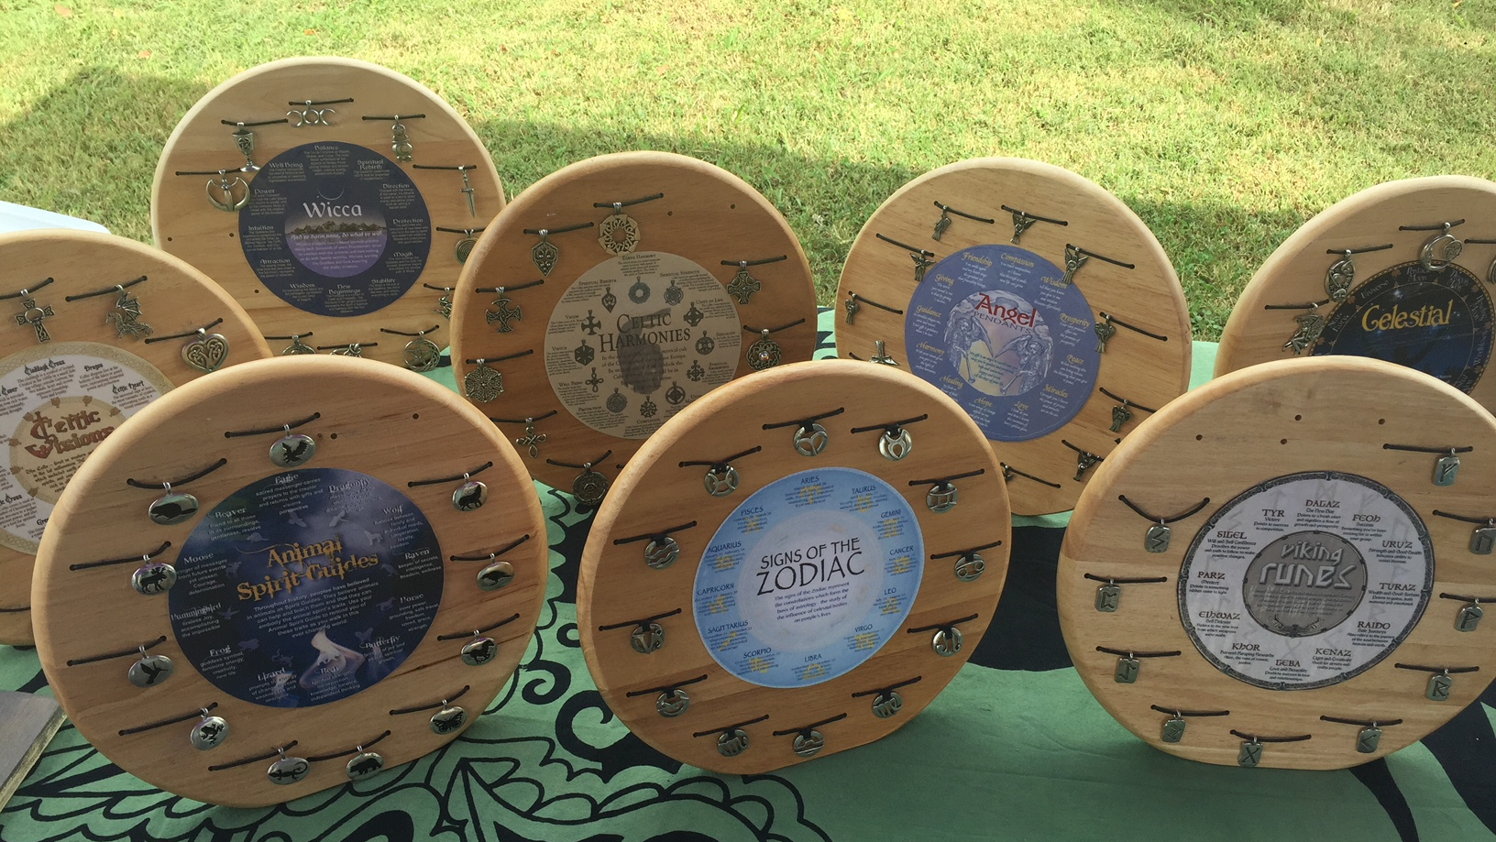
Physics may not have explained magic, but I think it is clear that in the phone bill ritual a practitioner interacts with a network of symbols that are reinforced by the emotional significance that they and others invest in them in much the same manner that Levy-Bruhl describes. Since Neo-Pagan magic is built around powerful symbols, they make use of any that they can, borrowing from a number of cultures. At the noon ritual of the Pagan Pride festival, the five participants were dressed in an ancient Egyptian style, and they took turns reading passages about the Egyptian gods in grandiose formal language reminiscent of that found in the King James Bible while occasionally using the sacred Hindu syllable “Ohm” before concluding with the common Neo-Pagan aphorism “do what though wilt is the whole of the Law.” This diversity of symbolism was also evident in the Neo-Pagan shops I visited. These stores were elaborately and eclectically decorated, sometimes to the point where I could not tell where the merchandise ended,
and the decoration began, but perhaps no hard barrier existed
between the two. Colorful flowing decorations like tapestries, beaded curtains, and prayer flags were common, and one shop featured four large shelves on one wall, each of which contained a collection of items and figures associated with one of the four classical elements. The iconography on display and items for
Figure 5: Amulets featuring symbols from various traditions for sale at Nashville Pagan Pride
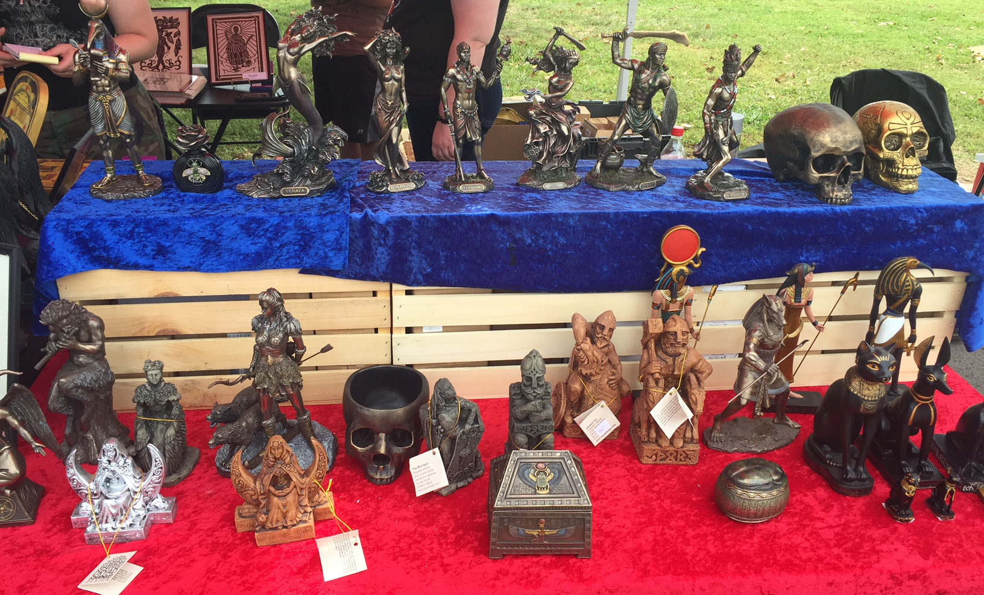
sale in these places reflected the influence of a wide variety of religious traditions. Small statues and amulets depicting deities of various traditions were often present either for sale or display. These
included classical Egyptian
and Norse gods featured
alongside depictions of the
Hindu pantheon and more
rarely members of the Celtic
or various African pantheons.
Imagery from Non-Polytheistic traditions was also present, the Buddha and Bodhisattvas, stars of David, and notably a significant number of Christian symbols and figures. Crosses, and depictions of the saints were not uncommon, but the various incarnations of the Virgin Mary enjoyed a very high profile in Neo-Pagan establishments.
Figure 6: Depictions of gods and skulls for sale at Nashville Pagan Pride
This was the first indication I had of the affinity some Neo-Pagans hold toward Catholic Christianity, that I mentioned earlier in the paper. This affinity stemmed from the notion that many Catholics practiced magic in a very similar form to Neo-Pagans, even if they would not identify it as such. The woman who ran a workshop on making spells that I attended described how her Irish Catholic mother had an altar to the saints where she would fervently pray whenever there was a crisis or simply something she wanted to change, treating the space similarly to a Pagans altar. She also claimed that all the great cathedrals of Europe were built at the intersection of ley lines (avenues for energy in the earth) that used to be the site of Pagan temples. Another attendee at the workshop, who was the featured musical act of the festival, contributed her idea that Virgin Mary’s iconography resembled that of the ancient Mesopotamian goddess Inanna and that when she was in Catholic school she did a form of magic using pictures of different saints in a note book, and was once told by a nun that if she really wanted something she should pray to Mary and “she would make her son do it.” In contrast when Protestantism was briefly mentioned, the reaction was varying levels of disdain. In comparison to Neo-Paganism and Catholicism, Protestantism was seen as puritanical, authoritarian, and most of all, ineffective. This view is consistent with the idea that Neo-Pagan magic is dependent upon the manipulation of a common symbolic language as Catholicism, with its myriad of Saints and frequent use of visual imagery, has a rich language of common symbol while many denominations of Protestantism have prohibitions against the depiction of the divine.
At this same workshop I was told guidelines for spells that gave me some more insight into how Neo-Pagans think about magic. The first guideline was that if one has to ask if a spell has worked, it has already failed. Despite the myriad of components involved, the most important aspect of a spell seemed to be one’s own confidence and focus as magic is explicitly an intentional self-fulfilling prophesy. It was also stressed that magic was in no way supernatural but was the manipulation of natural tools to achieve ones ends. A mistrust of magical information found on the internet was also reinforced. The woman running the workshop then shared a banishing spell that she said had been effective for her on many occasions, that involved writing the person’s name on a piece of paper and submerging it in a vial filled water along with a black stone, seven pinches of salt, and 7 cloves. The vial is then put the vial in the freezer and as long as it remains frozen the person named should be kept away from you. Sprinkling black salt on a door way was also mentioned as a good way to ward off unsavory visitors. Interestingly I encountered the woman who gave this workshop giving a similar one at the other festival I attended, possibly because of the larger crowd she gave a much more cautious message then when I saw her before, advising against the use of magic to attack others, when at the previous festival she mentioned how sometimes one had to “drop a house on somebody”. She also emphasized the importance of protecting oneself and cleaning one’s karma with special candles. She also stressed a practical caution, saying that wandering cats and dogs can interrupt and disturb a spell as just as a wandering spirit could. Finally, she spoke on the use and purpose of magical circles or bubbles, barriers formed from chalk or another physical substance, or by moving a magical item like a wand around oneself to make a barrier of energy. According to her these circles are needed to protect practitioners because during magic one is rises into higher dimensions than our native third.
An important part of Neo-Pagan magic is utilizing components that all have magical properties or symbolic meanings consistent with the goal of a spell. Because of this education on the meaning and use of different components is very important and appropriate sources for this knowledge seemed to be a matter of some contention. One woman I spoke to who was High Priestess of a local coven had very strong opinions on the subject. She expressed a deep-seated skepticism of any information that came from books and especially from the internet as well as an emphasis on a great deal of training and caution in regard to preforming spells, a process completely prohibited until a prospective initiate reaches the “1st degree” apparently a rank within the coven. The rationale for this was in her own understanding of magical energy which was that it necessitated interaction with positive and negative forces to be effective. This was analogized to static electricity, a transfer of power caused by the transfer of energy between positive and negatively charged surfaces, with the spellcasters task being to channel the resulting discharge of power.
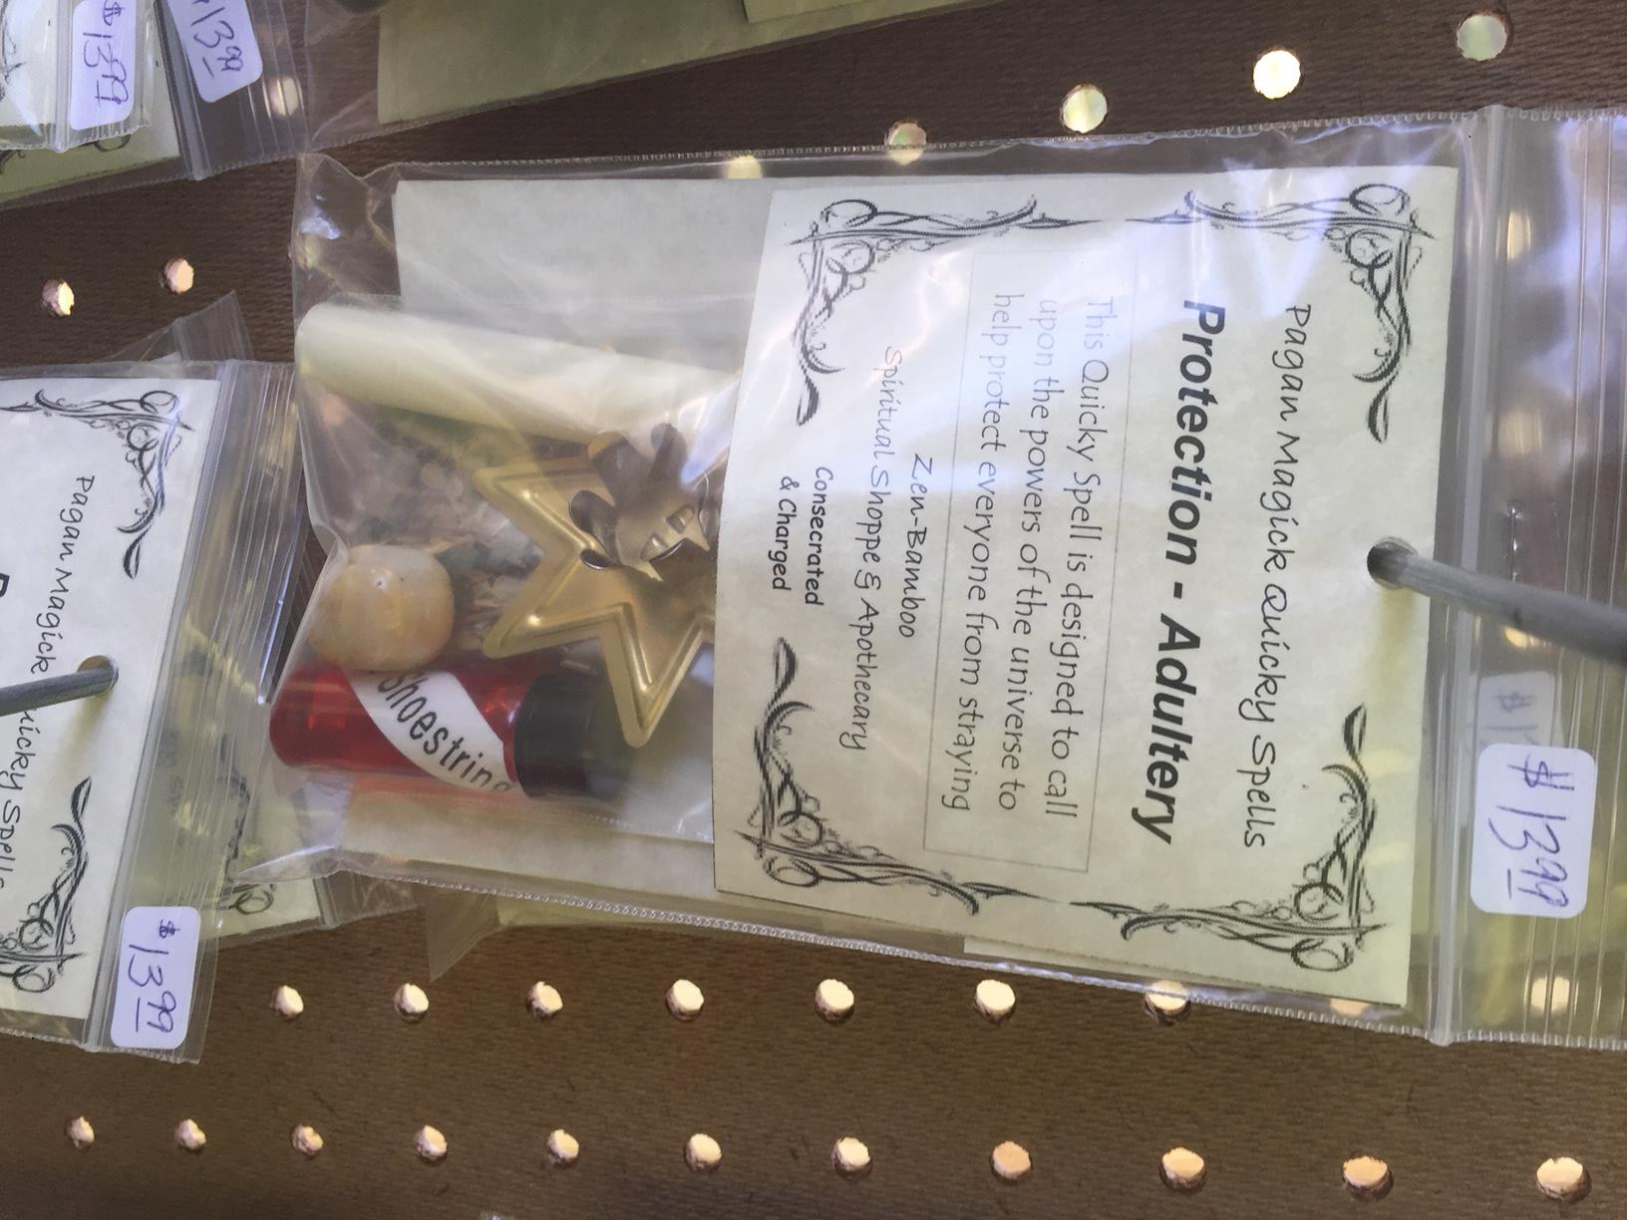
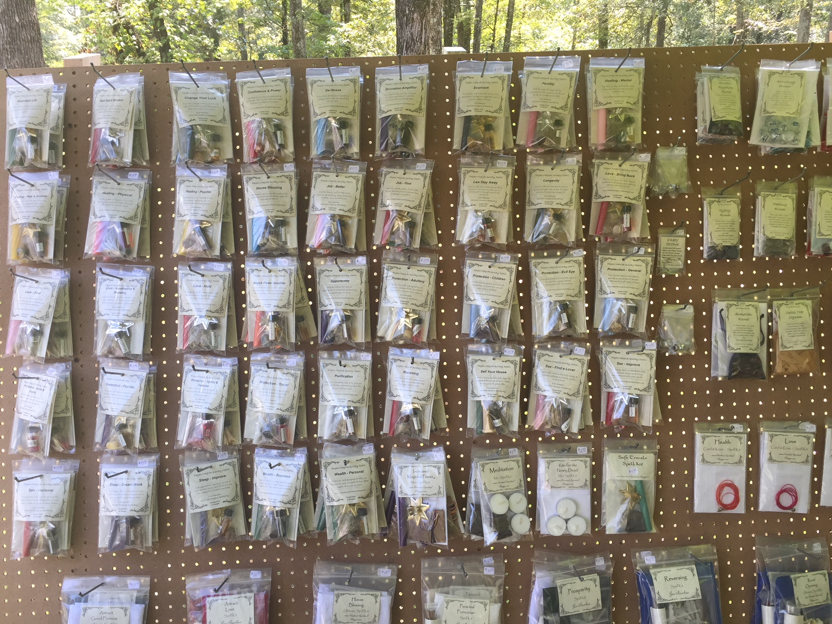
However, others took a different approach, when asked how they knew which stones had which properties, one practitioner shrugged and told me it was simply intuitive. Another, a vendor who came the second day of the festival, had devised her own solution to the problem and almost exclusively sold prepackaged spells that already contained all necessary components. The woman in question was new to Wicca and said she became interested in it and in magic when a witch had put a spell in her store, after which business became much better. The prepackaged spells ranged from large kits to small sandwich bags but all of them contained instructions a relevant candle and stone and at least one other component like special oils or a plastic statue of a relevant saint. Unlike the older practitioners to whom I talked, this woman did not have a distrust of magical knowledge found in books or on the internet as that is where she obtained the information for many of these spells. At the Pagan Pride festival, I encountered a vendor selling similar items which they called mojo’s or sachet powders depending on their container. While not a complete spell, these contained a collection of herbs oils and minerals that all shared a common purpose.

Figure 7: Pre-packaged spells for sale at WicFest
Figure 8: Detail on an adultery spell
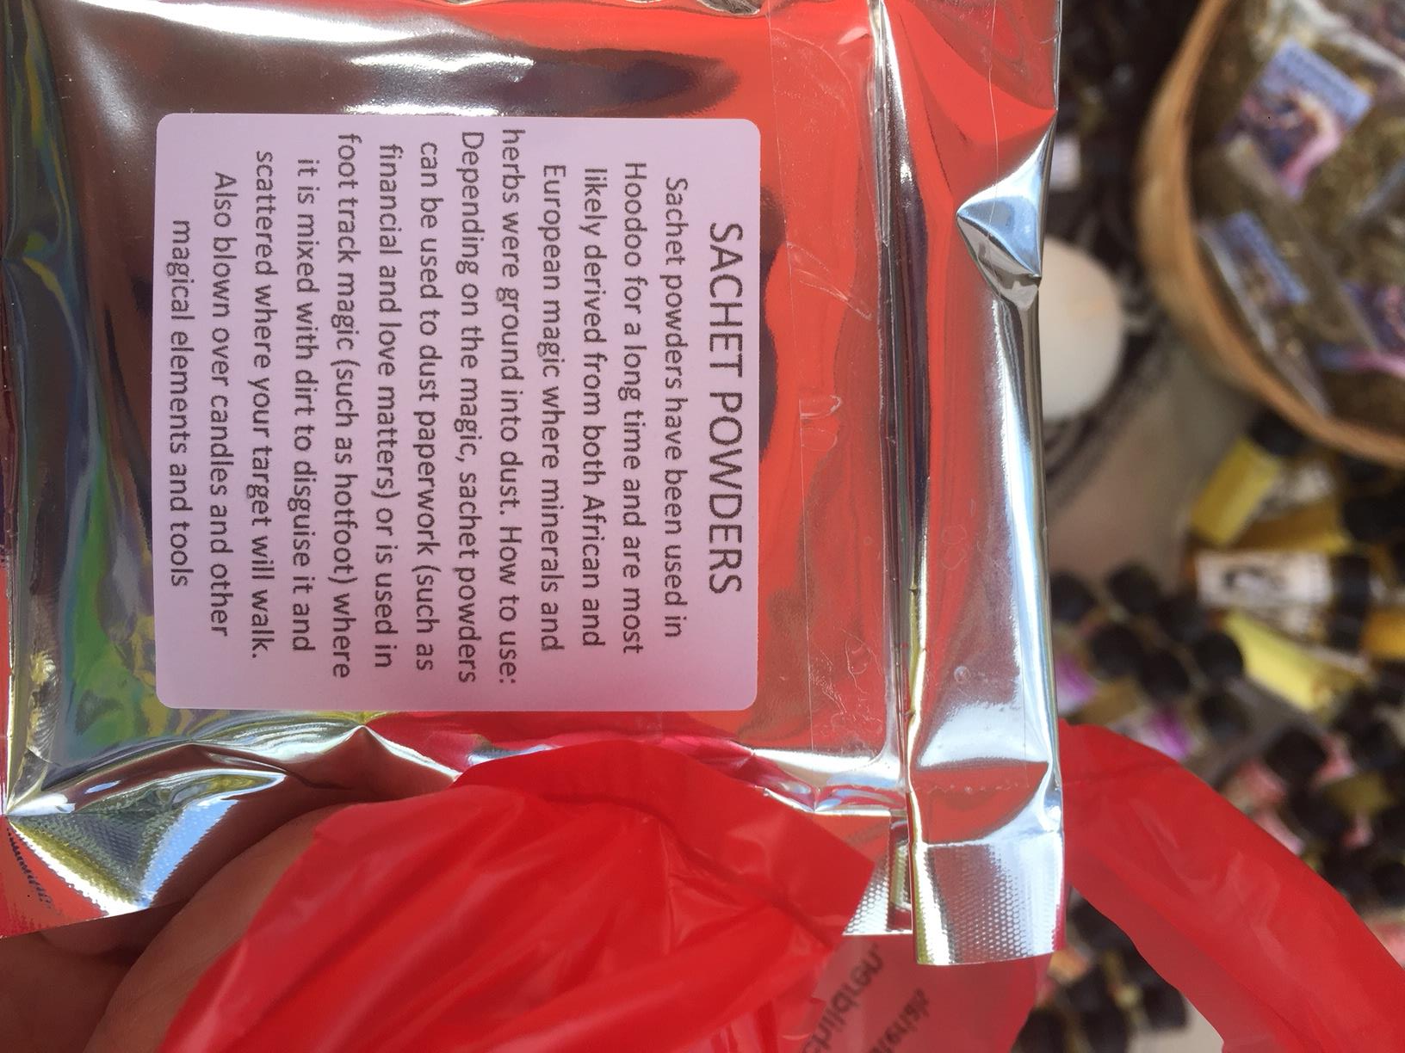
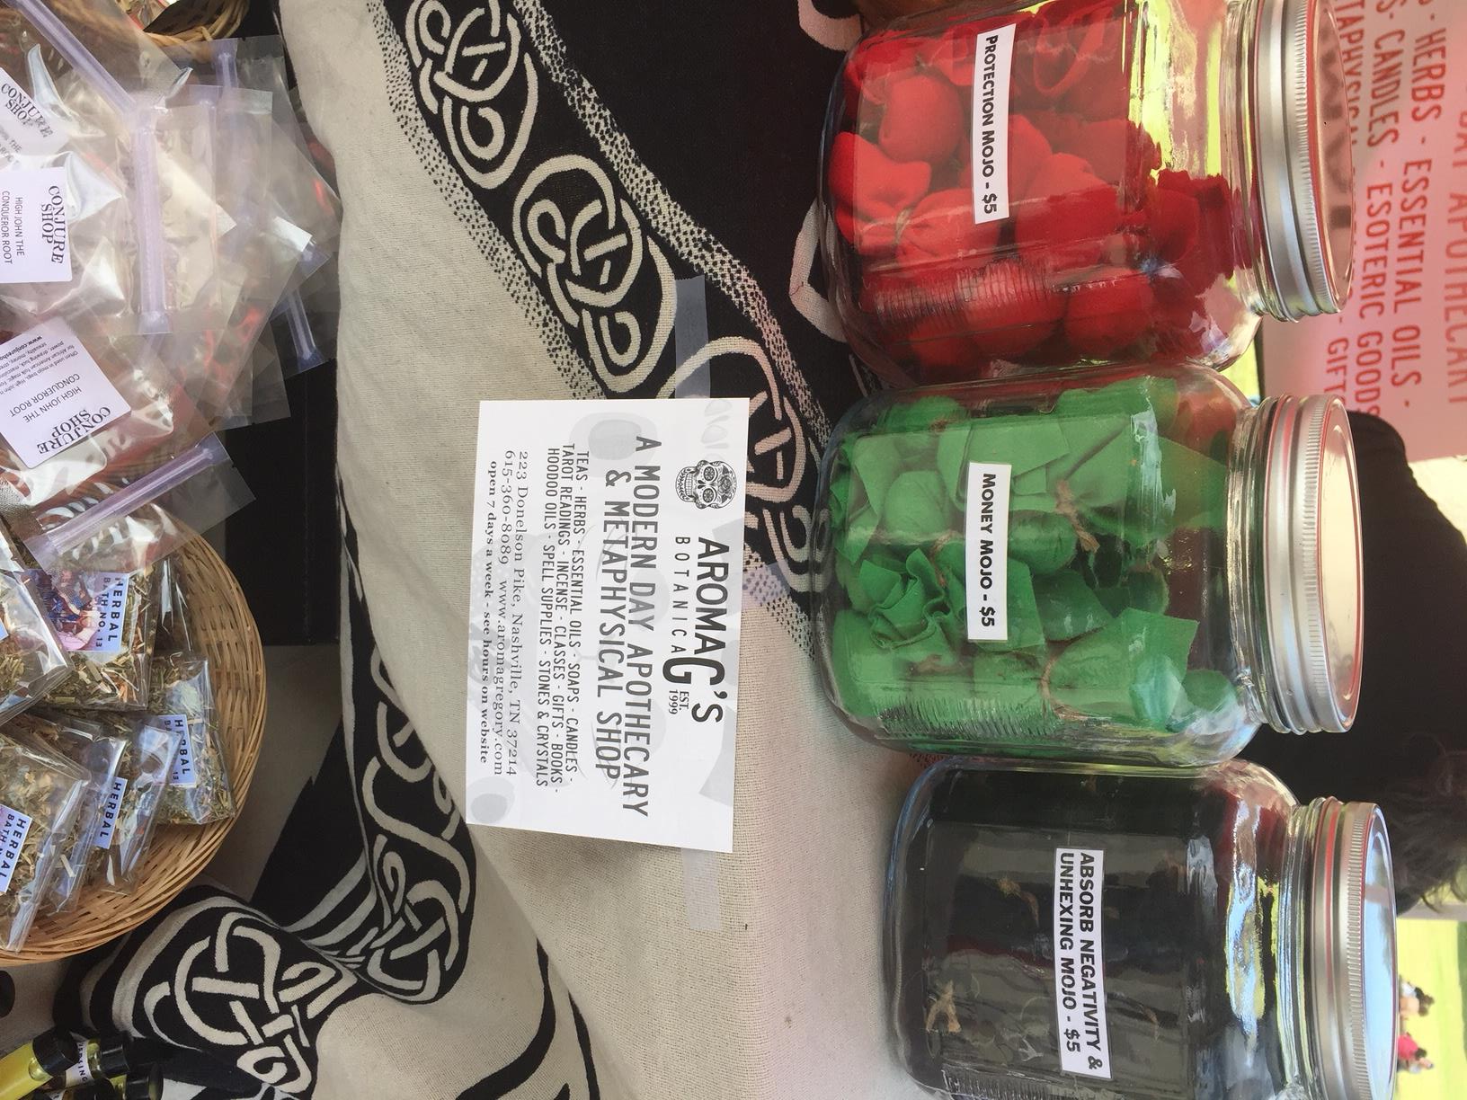

Figure 10: Mojo’s of various types for sale at Nashville Pagan Pride
Figure 9: A description of sachet powders
Throughout my field work, I asked many of the practitioners how they first learned magic and what it meant to practice it. I got many varying answers, but all centered around learning and then making and the transfer of energy. One told me one needs to learn to feel the magic properties and energies of the world and once this is accomplished you can rely on your intuition. Another told me that performing magic involved the altering of the girds of power that divided the earth and sky. One particularly notable account was told to me by a soldier who told me that, after a close call in Afghanistan he asked the universe “is there a reason I’m not dead” and heard a voice reply “yes.” He identified this voice as the Egyptian god Horus and decided to study gods and magic in response. One thing was always, clear; the universe was a market place whose currency was the energy that could be found in physical objects like crystals, and dyes, and herbs, as well as within people and their feelings of power, love, and belief. It makes sense then that the combination of these two things are found in the items that Neo-Pagans make to sell to each other and for personal use in their magic.
Exchange Paradigm of Neo-Paganism
The notion of energy creates a unifying lens through which Neo-Pagans practice of magic and their seemingly more secular mercantile activity can be seen to operate around the same set of principles and beliefs that form what I call the religions paradigm of exchange. It is this exchange paradigm based in the transfer of energy that creates the common praxis for Neo-Pagan identity. The people I spoke to described themselves as atheists, agnostics, deists, polytheists, and goddess worshipers, and no one I spoke to saw any of these labels as being prerequisite to, or incompatible with considering one’s self Neo-Pagan. The common theme in everything I heard from practitioners about their beliefs was an interest in learning and practicing methods of focusing and utilizing energy.
Like Marett’s theories of magic items imbued with mana, many of the people who sold Neo-Pagan religious paraphernalia either in stores or festival booths told me that their wares had been imbued with energy at their creation to make them magically potent and that money is another form of energy. Therefore, the transaction between them and their customers represents an equitable transfer of such energy, the same process that forms the basis of their magic.
The items sold at Neo-Pagan stores varied greatly but there were several common themes. Small items like crystals, candles, and incense were sold in almost every store I visited often with an explanation of their magical properties. This sort of information was everywhere, and shop owners were quick not only to explain the purpose and use of the items they sold but also to discuss and compare experiences with magical items should the customer in question also be a practitioner. The educational aspect of these stores did not stop with casual proprietor/customer dialogue. Each store I visited had at least a small shelf with books for sale, which typically concerned the practice of a particular kind of Neo-Paganism or different forms of divination and spells. These stores also often sold wares that were made by the owners or by other practitioners in the area. Often these were fairly simple things like elixirs or smudging bundles but some time these proprietors practiced more complex crafts like candle making, leather working, or blacksmithing.
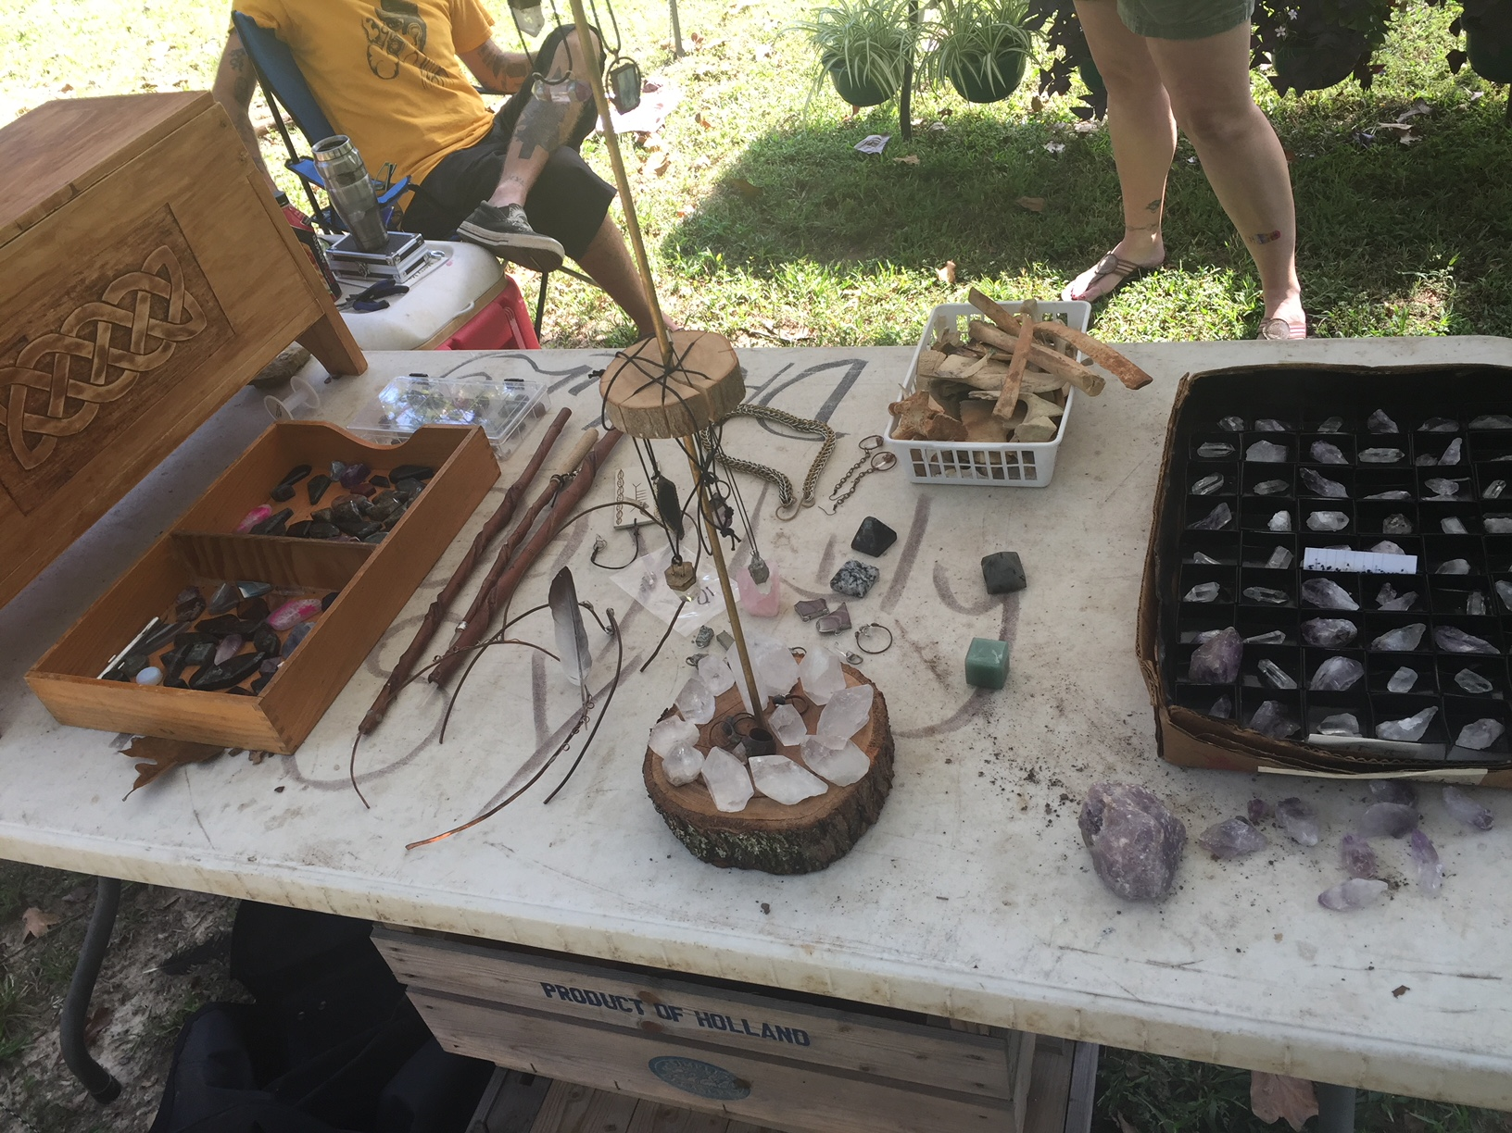
Based on my research and observations, it is apparent that practitioners of Neo-Pagan movements adhere to a system of exchange that revolves around mercantile and manufacturing activity, both in their dealings with each other and the supernatural. In fact, the distinction between these two spheres frequently becomes difficult to discern as the items practitioners sell and trade are often believed to be possessed of supernatural qualities and powers and I first encountered many important parts of Neo-Pagan practice through the description of items that were being made and sold. For example, I spoke with a coven of three elderly
women whose high priestess
showed me a collection of
athames (ceremonial daggers)
and magic wands for sale and
explained to me that these were the tools used to establish a magical circle that was a central part of any group or personal spell casting process as it protects those inside, a crucial function as magic requires opening oneself to energies that are potentially harmful. Another such item was a witch ball, a large metal globe meant to resemble the weights used to drown suspects during witch trials. After their primary purpose was served they were hung in the windows of buildings to scare witches away, or so I was told. Like many of the items and images formally associated with the hunting of witches, the balls have been reclaimed and are now filled with magical herbs and hung in Neo-Pagan homes and domiciles.
Figure 11: Crystals, wands, and bones for sale at WicFest
One frequently mentioned and marketed item was black salt, which refers to substance made from the ash and charred plant matter that is left over from the plethora of incense, spices, and herbs that are burned as a crucial part of almost any magical action. These are gathered and turned into a salt-like substance that possess the concentrated energies of all the spells that produced it. Elaborately decorated diaries and journals were very prevalent among vendors at the festival and had also been a common fixture in the Neo-Pagan shops I visited. A practitioner at the festival explained their significance to Neo-Pagan practice to me. Because magical practice is based in trial and error, using what works and discarding what doesn’t, it is very important for Neo-Pagans to write down all of their experiences and experiments with magic. I was told this book was called a book of shadows and is sometimes accompanied by a separate journal containing all of a practitioner’s educational experiences called a book of mirrors. The practice of using poppets was also explained to me in an encounter with the material object. A poppet is a type of magical item that bears a resemblance to the pop cultural notion of a voodoo doll. The figure is used for long term storage of energies and therefore its use is should not be taken lightly. The woman who told me about poppets even recounted a story about how a film crew for a documentary on the Bell Witch asked to borrow her poppet and she refused, not wanting it to be exposed to evil energies. Upon the film crew’s departure, she found several books flung from their shelves, confirming her suspicion that the film crew had harmful energies with them.
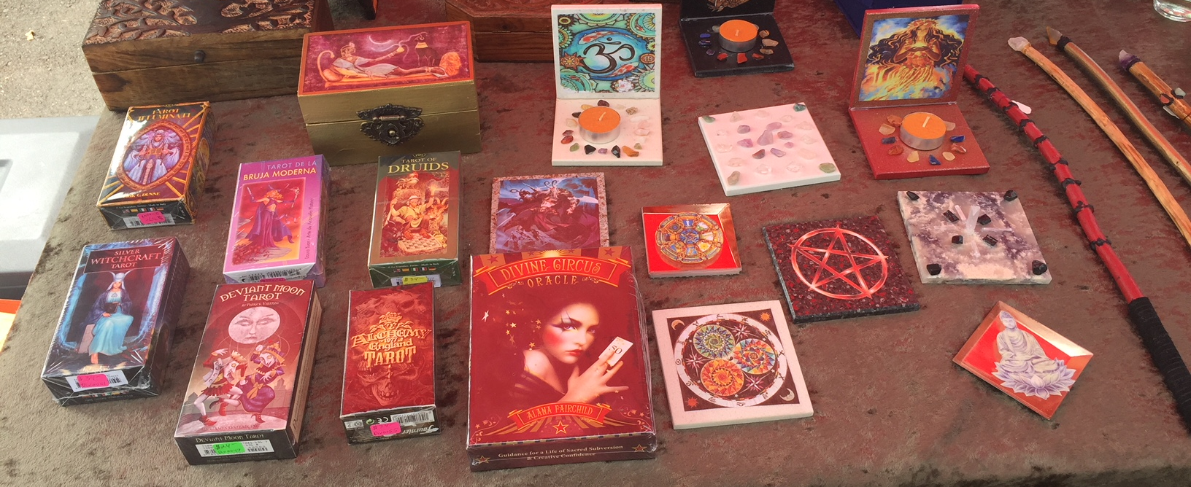
Many items were sold in many varieties each of which had different magical uses because of its material properties. Altar cloths that are used to cover the magical workspace have different patterns for differing purposes like repeating pictures of dollar bills for a spell focused on wealth and prosperity, the owner of which made a point of telling me that money is another form of energy and is therefore not anathema to the Neo-Pagan religion like it is in to certain other faiths. One vendor sold dozens of different loose-leaf teas, each said to give a different effect like lucid dreaming or an increase in magical power. Candles and crystals were especially common sights, and both came in seemingly endless different colors and configurations with distinct magical purposes. The great variety in the materials and items that Neo-Pagan sell isn’t only about offering a variety of magical powers, it is also an opportunity for the display of artistic expression and personal style. Nowhere is this more evident than in the case of tarot decks, decks of cards used to predict the future and gain insight that typically contain the 52 standard playing cards as well as 22 unique cards called the major arcana although even the number and names of cards is a matter of personal taste. Tarot decks are a common part of Neo-Pagan magical practice and come in hundreds of aesthetic varieties from ancient Egyptian to steampunk. For the most part this plurality of options serves no other purpose then to allow for the expression of personal identity by consumers and artists, so even when Neo-Pagans aren’t making their own magical tools, they are still intent on actively shaping their own practice through individuality.

Figure 12: Tarot decks, small altars and wands show diversity of style at Nashville Pagan Pride
Neo-Pagans communities are often constructed around mercantile and manufacturing activity. Practitioners trade religious paraphernalia that they have made by hand and they sell the same to finance their religious events. Businesses that manufacture and trade in Neo-Pagan religious items often serve as hubs for the community. These stores served as event spaces for classes or spiritual events a crucial function for a religion that lacks formal spaces of worship and community. One shop hosted a semiregular drum circle, and at another the proprietors taught semester long introductory classes to witchcraft as well as specific skills like reiki the Japanese practice of healing by sharing and directing energy flow through the body.
The paradigms of exchange that are practiced in Neo-Pagan communities’ contrast with those found in the broader American religious framework. Protestantism still largely monopolizes the perception of religious norms, particularly in Middle and East Tennessee were my observations where conducted. The paradigm of exchanges of Protestantism are largely framed in terms of charity when concerning material matters and in terms of miracles in spiritual matters. In other words, Neo-Pagans emphasize bartering and equivalent exchange among themselves and between them and supernatural forces while Protestants Churches give away resources and expect gifts from their practitioners and conceive of divine intervention along the same model. An example of this can be seen in healing practices, many American protestants practice faith healing where the afflicted or someone acting on their behalf, will ask God for aid in the hope that he will intervene and cure the affliction in question. Neo-Pagans in contrast will perform a spell that facilitates an exchange of energy between the person being healed and a source of healing power, be that deity, another practitioner, or an element of the natural world.
This contrast would be innocuous where it not for the fact that one tradition is relatively new and few in number while the other is so influential that it shapes the way we study and discuss religion. This disparity is the main source of Neo-Paganisms trouble with legitimization especially among those who do not reject it on religious or moral grounds and contributes to the view that it is “made up” or “not a real religion.” We tend to position religious legitimization in adherence to a set pattern of rituals and beliefs so Neo-Paganism feels made up because it is constantly being remade in ways that intentionally experiment with or subvert what has come before. One practitioner even said to me that being Neo-Pagan appealed to them because they liked to make things that no one else would.
Conclusion
In this project I hope to have given some insight into how Neo-Pagans, especially those in Middle and East Tennessee, construct their religious practice and community around mercantile activity and the adverse effects this has on their legitimization in wider society. However Neo-Pagans are incredibly diverse, and for every assertion I have made here, there is likely at least one practitioner who would disagree with my analysis. For example the practitioners of Asatru and Heathenry tend to be very different from other types of Neo-Pagans (Berger, Leach and Shaffer, 2003), and I only encountered one group that practiced this tradition, who upon my meeting them and with no prompting from me, quickly began to reassure me that they were not racist or homophobic and only wanted to “keep the old ways alive.” Their concern was well placed as many groups who profess belief in the Norse or Germanic gods have ties to white supremacist groups and the religion is sometimes used to allow gangs like the Aryan Brotherhood to meet and organize in prison, (SPLC, 1998). The values and goals of these groups conflict with those generally found in the rest of the Neo-Pagan community particularly in regards to social and political issues. Even among Odinists without explicit ties to white supremacy or other far right ideologies, there is notably less support for the equality of women and homosexuals then among the general Neo-Pagan population, however they are still more likely to support these positions then the average American (Berger, Leach and Shaffer, 2003). However, practitioners of Odinism are unavoidably Neo-Pagan by the simple fact that they seek to recreate and preserve a pre-Christian European religion and even beyond this surface definition they face many of the same barriers to acceptance that affect the other Neo-Pagan groups (Berger, Leach and Shaffer, 2003). How Odinist and non-Odinist Neo-Pagans conceive of its complicated and controversial place in society and how those who use it to support a racist ideology reconcile with the rest of Neo-Paganism could make for fruitful further study and shed more light on how Neo-Pagans legitimate certain groups and practices within themselves.
Religion shapes the lives of those who practice it a myriad of ways many of which are not obvious to us on the surface and in a religiously diverse society friction between different understandings of the world are inevitable. Through the anthropology of religion, we can begin to untangle this intricate web and see the ways religions shape our behavior, how those behaviors might clash with others, and what effect those clashes have on the groups involved. In this thesis I have attempted to outline one of these causal chains by showing how Neo-Paganisms practice of magic shapes its members understanding of the creation and distribution of religious authority and power, which clashes with the general public’s understanding of these things resulting in Neo-Paganism being delegitimized and occasionally disparaged.

Bibliography
1. Adler, Margot. Drawing Down the Moon: Witches, Druids, Goddess Worshippers, and Other Pagans in America. Viking Press, 1979.

2. Berger, Helen, Evan Leach, and Leigh Shaffer. Voices from the Pagan Census. University of South Carolina Press, 2003.

3. Bonewits, Isaac. Real Magic. Red Wheel/ Weiser, 1989.

4. Bowie, Fiona. “Anthropology of Religion.” In The Blackwell Companion to the Study of Religion, edited by Robert A. Segal, pp. 3-23. Blackwell Publishing, 2006.
5. Brood, Jeffrey, Layne Little, Bradley Nystrom, Robert Platzner, Richard Shek, Erin Stiles. Invitiation to World Religions 2nd edition. Oxford University Press, 2016.

6. Cameron, Alan G. The Last Pagans of Rome. Oxford University Press, 2011.

7. Cox, James L., and David G. Robertson. “The World Religions Paradigm.” The Religious Studies Project, 2013. Electronic Document,

8. Cunningham, Scott. Wicca: A Guide for the Solitary Practitioner. Llewellyn P Publications, 2004.

9. Dewr, Cecylyna. “Why Pagan Pride.” Nashville Pagan Pride Day, Inc., 1998.

10. Durkheim, Emile. trans. Joseph Ward. Elementary Forms of Religious Life. George Allen & Unwin Ltd., 1915

11. Evans-Pritchard, E.E. “Sorcery and Native Opinion.” Africa, vol.4 (1), 1931.

12. Evans-Pritchard, E. E. Witchcraft Oracles, and Magic Among the Azande. Oxford University Press, 1976 (1937).

13. Farrar, Janet and Stewart. A Witches Bible:The Complete Witches Handbook. Phoenix Publishing Inc, 1984.

14. Frazer, James George. The Golden Bough: A study of Magic and Religion. Oxford University Press, 2009.

15. Goetz, Judith P. and Margaret Diane LeCompte. Ethnography and Qualitative design in Educational Research. Academic Press, 1984

16. Harper, Douglas. “Magic.” Online Etymology Dictionary. Maoning Tech, 2001.
17. Higginbotham, Joyce & River. Paganism: an Introduction to Earth Centered Religions. Llewellyn Publications, 2002.

18. Hutton, Ronald. The Triumph of the Moon: A History of Modern Pagan Witchcraft. Oxford University Press, 1999.

19. Horowitz, Mitch. “The Persecution of Witches, 21st Century Style.” The International New York Times. The New York Times, 2014.

20. Levy-Bruhl, Lucien. How Natives Think translated by Lilian A. Claire. Martino fine books, 1926.

21. Lewis, James R. Legitimating New Religions. Rutgers University Press, 2003.

22. Mauss, Marcell. A General Theory of Magic. 2nd edition. Routledge Classics Press, 1972.

23. Magliocco, Sabina. 2004. Witching Culture: Folklore and Neo-Paganism in America University of Pennsylvania Press, 2004.

24. Malinowski, Bronislaw. Coral Gardens and Their Magic: The language and magic of gardening (Malinowski Collected works). Routledge Classics Press, 1937.

25. Malinowski, Bronislaw. Magic, Science and Religion and Other Essays. Doubleday Press, 1954.

26. Maxwell-Stuart, P.G. Witchcraft in Europe and the New World 1400-1800. Palgrave, 2001.
27. Murray, Margaret. The Witch-Cult in Western Europe. Oxford University Press, 1921.

28. Olson, Carl. Theory and Method in the Study of Religion. Wadsworth/Thomas Learning, 2003.

29. Petch, Alison. “Margaret Murray”. England: The Other Within, Oxford University Press, 2009.

30. Smith, Jonathan Z., Map is Not Territory: Studies in the History of Religions. E.J. Brill, 1 1978.

31. Sørensen, Jesper. A Cognitive Theory of Magic. New York, NY: Rowman & L Littlefield Publishers, 2007.

32. Stein, Rebecca L. and Phillip Stein. The Anthropology of Religion, Magic, and Witchcraft. 3rd edition. Prentice Hall Publishers, 2011.

33. Storm, Rayne. Everyday Magick: For Children of Earth-Based Spiritual Families. Schiffer Publishing Ltd., 2012.

34. Tylor, Edward Burnett. Primitive Culture: Researches Into the Development of Mythology, Philosophy, Religion, Art, and Custom. John Murray, 1871.

35. Weiner, Anette B, The Trobriander’s of Papua New Guinea. Holt, Reinhart, and Winston, 1933.

36. York, Michael. Pagan Theology: Paganism as a World Religion. New York University Press, 2003.

37. “New Brand of Racist Odinist Religion on the March.” Intelligence Report, Southern Poverty Law Center. March 15, 1998.

Appendix 1: Purchased Items
As much of my research was done by talking to vendors and merchants I felt morally obligated to purchase some of their wares afterward in order to thank them for their time as well as to provide visual, tactile and olfactory reference for the items mentioned in my thesis.
Such items include
A smudging bundle
A set of runes stamped on pieces of leather
A pre-packaged “magic intensifying” spell
Tea meant to cause lucid dreaming
a Tarot deck
A small rosary featuring the Virgin Mary, meant to be hung on a car mirror
A four soaps called “money drawing”, “garen gate”, “sage lavender”, and “dragons blood”
The books Everday Magick: for Children of Earth-Based Sprititual Families, and A Witches’ Bible the complete Witches Handbook, both cited above
Loose incense, a tote bag, and a polished stone, where also included gratis with various purchases.

IRB Exemption

